Economic Growth post Independence

Hariraj K

March 6, 2018

## India: A case study

The mid 20th century saw formation of new democratic nations worldwide. It has also seen countries become world leaders and rapid development like never before. Even though most countries saw industrilisation as the ideal way to economic development and prosperity.

## India GDP over the years

## Year GDP in Crores  
## 1 1951-52 286147  
## 2 1952-53 294267  
## 3 1953-54 312177  
## 4 1954-55 325431  
## 5 1955-56 333766  
## 6 1956-57 352766  
## 7 1957-58 348500  
## 8 1958-59 374948  
## 9 1959-60 383153  
## 10 1960-61 410279  
## 11 1961-62 423011  
## 12 1962-63 431960  
## 13 1963-64 453829  
## 14 1964-65 488247  
## 15 1965-66 470402  
## 16 1966-67 475190  
## 17 1967-68 513860  
## 18 1968-69 527270  
## 19 1969-70 561630  
## 20 1970-71 589787  
## 21 1971-72 595741  
## 22 1972-73 593843  
## 23 1973-74 620872  
## 24 1974-75 628079  
## 25 1975-76 684634  
## 26 1976-77 693191  
## 27 1977-78 744972  
## 28 1978-79 785965  
## 29 1979-80 745083  
## 30 1980-81 798506  
## 31 1981-82 843426  
## 32 1982-83 868092  
## 33 1983-84 936270  
## 34 1984-85 973357  
## 35 1985-86 1013866  
## 36 1986-87 1057612  
## 37 1987-88 1094993  
## 38 1988-89 1206243  
## 39 1989-90 1280228  
## 40 1990-91 1347889  
## 41 1991-92 1367171  
## 42 1992-93 1440504  
## 43 1993-94 1522344  
## 44 1994-95 1619694  
## 45 1995-96 1737741  
## 46 1996-97 1876319  
## 47 1997-98 1957032  
## 48 1998-99 2087828  
## 49 1999-2K 2246276  
## 50 2000-01 2342774  
## 51 2001-02 2472052  
## 52 2002-03 2570690  
## 53 2003-04 2777813  
## 54 2004-05 2971464  
## 55 2005-06 3253073  
## 56 2006-07 3564364  
## 57 2007-08 3896636  
## 58 2008-09 4158676  
## 59 2009-10 4516071  
## 60 2010-11 4937006  
## 61 2011-12 5243582

## Indian GDP share

Pre-Independent India remained an agriculture based nation. However there has been a rather steep decline in the agriculture based labour force.Census data indicated that the percent of farmers went down from 40% of the total population to 33% in 2011. However the IT boom in India have resulted in a significant increase in the Service sector. Intrestingly the growth of the Service sector remains almost negatively linear with respect to the increase in the Agriculture Sector.

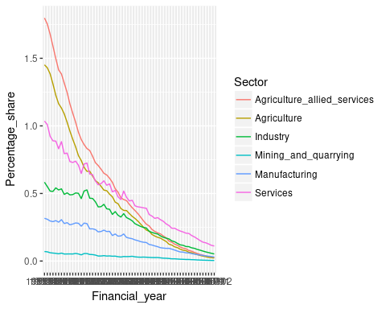 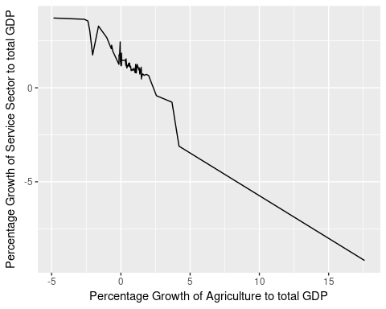

## Sector wise growth of Indian GDP

India being a nation with various lifestyle, it remains obivious that the GDP growth over the years are non constant.

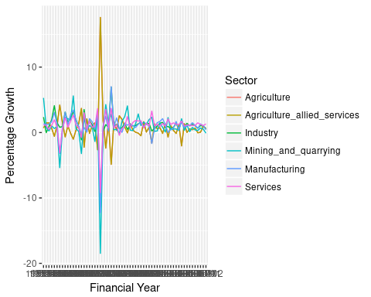 ## India and the World Though India remains one of the wealthiest countries in the world, it’s huge population makes it a nation with high income inequalities.India remained a closed economy for most it’s lifetime.Liberalisation of the economy in 1990 had an huge impact on the indian economoy.Indian economy had a growth more significant than the total world gdp growth. 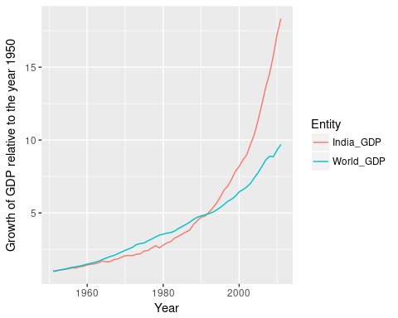 ## Conclusion Although the Indian approach towards finance managment tells a success story, other factors such as high population and high income inequalities remain a barrier India has to surpass to become a world superpower. Plotting real per capita GDP we infer that India still has a long way to go to achieve economic prosperty.The plot below shows the Real GDP of countries. 