Simple Supper:

Group 5 Project Proposal

Keith Butterfield & Samantha Schug

Metropolitan State University: ICS3251

**Organization Description**

Simple Supper is a new company that needs a web application that helps take the guess work out of dinner. The goal is that users are able to search for a recipe or add their own. They can than select up to 7 recipes for the week, and the application will generate a shopping list based on the recipe ingredients.

**Requirement specifications**

*Users*:

Application Users: Anyone that can browse to the URL can use this application

*Functionality goals and scope*:

* Users should be able to browse recipes.
* Users should be able to add recipes
* Users should be able to edit recipes
* Recipes should have a complete and measurable ingredient list
* Users can select up to seven recipes
* Users can generate a shopping list based off selected recipes

*Technical Process:*

The following languages will be used to create this application according to the project timeline:

HTML, JavaScript, MySQL, PHP, CSS

*Future goals and scope:*

* Allow users to create account
* Allow users to view past shopping lists
* Allow users to rate/review recipes
* Allow users to pick favorite recipes

**Database Objectives**

The objective of this database is to allow for the storage, update, and retrieval of recipes. The recipes have multiple ingredients with varying measurements. Each shopping list has up to seven recipes.

As a side note, it is not necessary for current functionality to store shopping list details, however in anticipation of future goals, that piece has been implemented.

**Database Design**

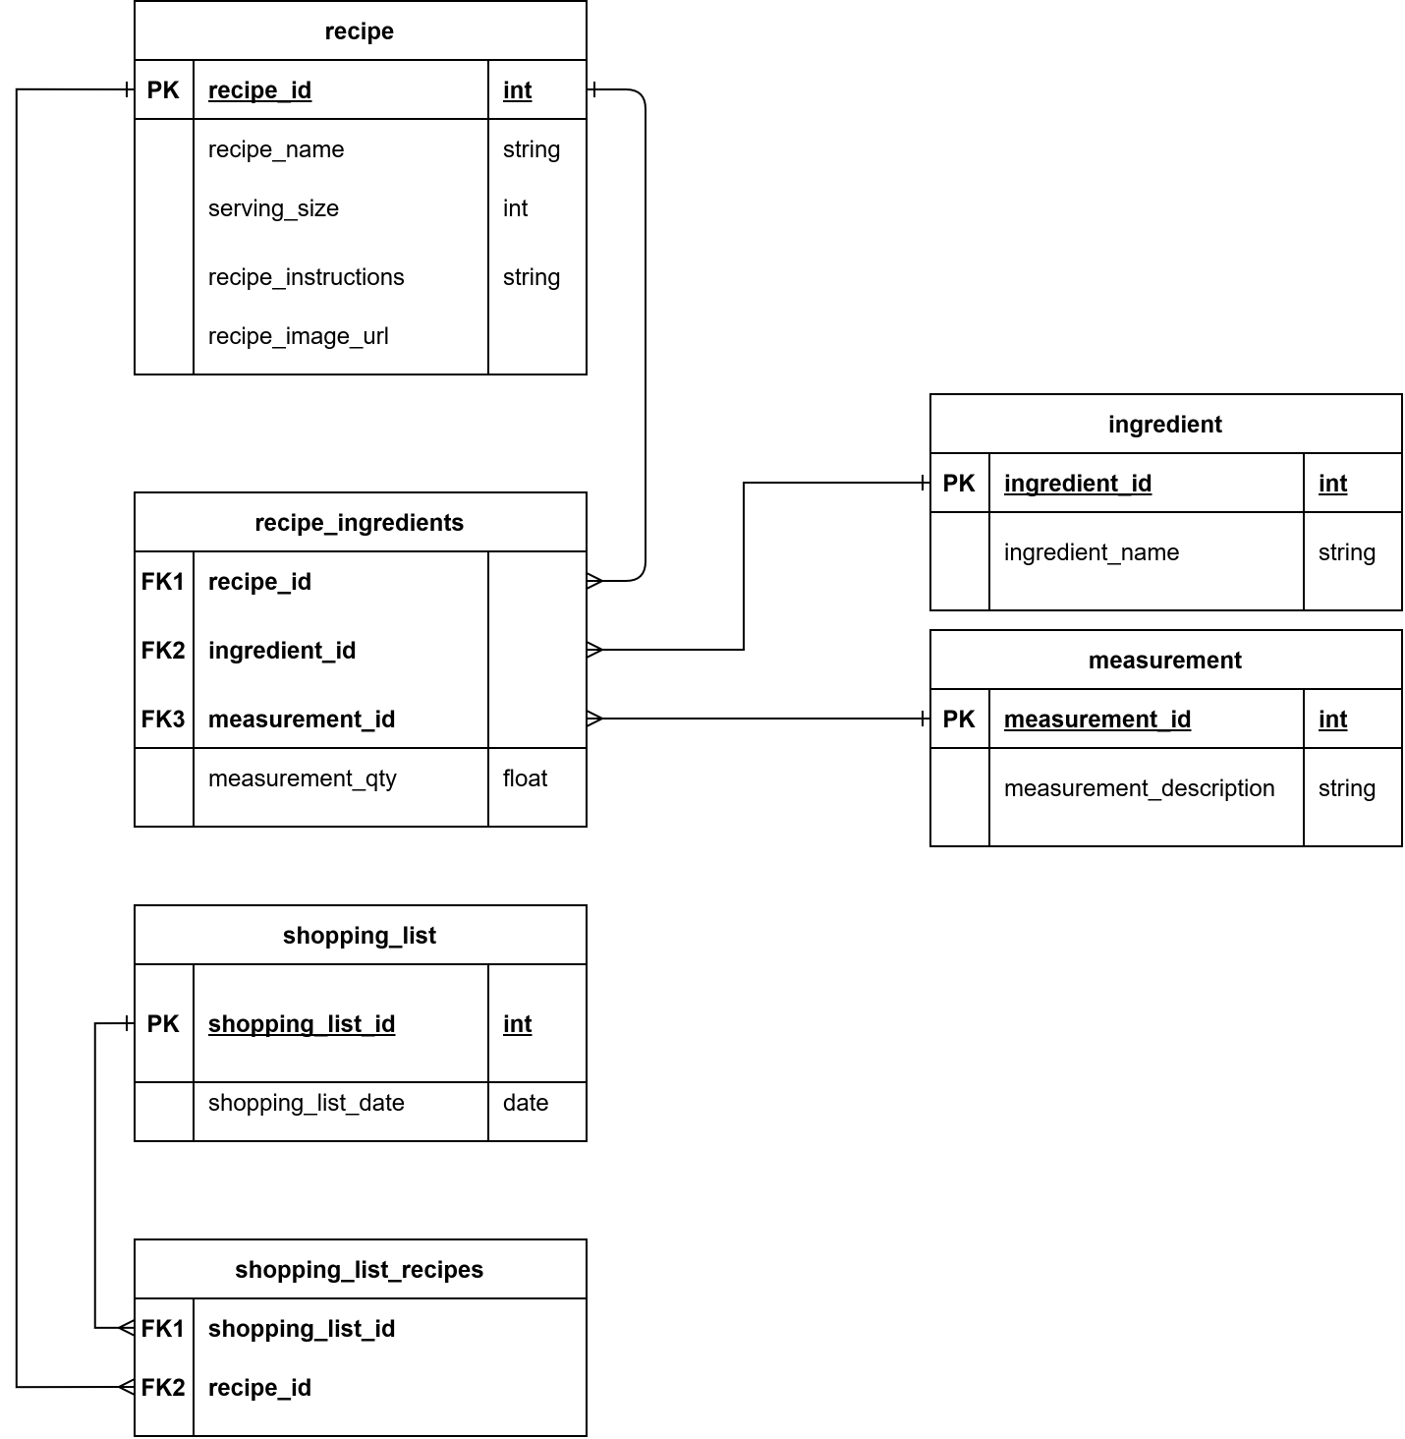

**Website Design**

!!!Website design using mock-ups or draft front end