Contents
BTR490 System 2016 2
(1) System Name and Team Number 2
(2) Team Members 2
(3) Client and/or Mentor 2
(4) System Overview 2
(5) Technology to be used 2
(6) Stakeholders 2
(7) A Diagrammatic Representation of the System 2
(8) System Components 2
Name of Component 1 2
Name of Component 2 3
(9) Who Did What Log 3

BTR490 System 2016

System Name and Team Number
Online refurbished phone store by team number 18

Team Members
Names of all team members-
Michael Vuong
Soutrik Barua
Sajjad Patel

Client and/or Mentor
Name: Y.R Distribution
Location: 235 Nugget Ave Unit # 7
Phone Number: 416-299-3630

System Overview
Our system will enable customers of the client to order refurbished phones from the company through their online store. It will allow a customer to look up the current inventory to see which products are available and allow them to place an order.

Technology to be used
Software to be used is Visual Studio 2015 for ASP.NET
Coding will be done in C#, AJAX, JavaScript, Html and Php.
No hardware required except for computers.

Stakeholders

Stakeholder | Role
Michael Vuong | Programmer
Sajjad Patel | Programmer
Soutrik Barua | Programmer
Y.R Distribution | Client
Seneca College | Administrator

A Diagrammatic Representation of the System

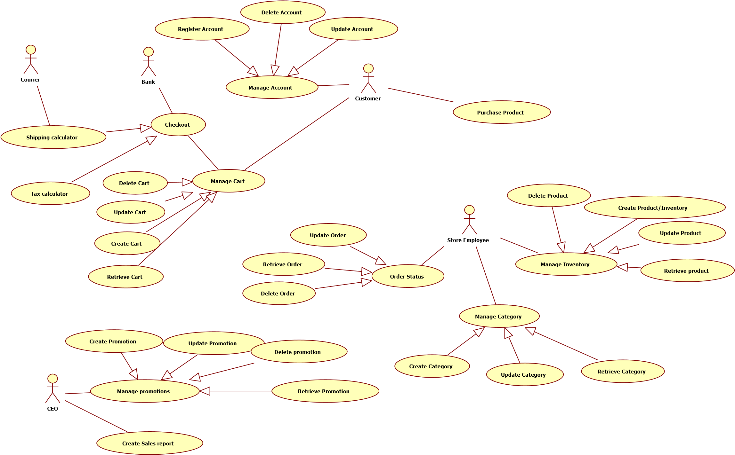

System Components

Account based components

Register Account
Use Case Name: Register Account
Author Name: Sajjad Patel, Soutrik Barua, Michael Vuong
Applicable Business Rule:
- Customer can register his/her account on the website only using e-mail.
Use Case Preconditions:
Person must have a valid e-mail address to go further on with the registration.
Use Case Successful Post Conditions:
A new account is made.
Main Flow:
- Customer clicks on register account
- System retrieves registration form
- Customer fills out their basic information,address,e-mail etc.
- Customer fills out the form and clicks register
- System updates registration
Alternative Flows:
- Wrong input field provided
  - System refreshes registration page with correct information pre loaded
  - User types in correct information in the incorrect fields
  - System updates registration

Delete User

Use Case Name: Delete Account
Author Name: Sajjad Patel, Soutrik, Michael
Applicable Business Rule:
- Customer can delete his/her account on the website only if registered
Use Case Preconditions:
Person must have a valid account
Use Case Successful Post Conditions:
An account is deleted.
Main Flow:
1)Customer clicks on delete account
2)System retrieves delete form
3)Customer fills out the form and clicks delete account
4)System updates user base.
Alternative Flows:
- Wrong input field provided
  - System refreshes delete page with correct information pre loaded
  - User types in correct information in the incorrect fields
  - System updates user base

Update User
Use Case Name: Update Account
Author Name: Sajjad Patel, Soutrik Barua, Michael Voung
Applicable Business Rule:
- Customer can update his/her account on the website with a valid account.
Use Case Preconditions:
Person must have a valid account
Use Case Successful Post Conditions:
An account is updated.
Main Flow:
1)Customer clicks on update account
2)System retrieves account information form
3)Customer fills out the fields to be updated on the form and clicks update account
4)System updates user base.
Alternative Flows:
- Wrong input field provided
  - System refreshes delete page with correct information pre loaded
  - User types in correct information in the incorrect fields
  - System updates user base
************************************************************************************

Category based components

Create Categories
Use Case Name: Create Category
Author Name: Sajjad Patel, Soutrik Barua, Michael Voung
Applicable Business Rule:
- Y.R Distribution: categories can only be created if certain products exists.
Use Case Preconditions:
Person that wants to make these changes must be signed in and must be a manager or an employee depending on the changes being made.
Use Case Successful Post Conditions:
- Category Must Be Created
Main Flow:
1)Employee/Manager Clicks on Categories
2)System retrieves all the categories
3)Employee/Manager Clicks Create Category
4)System Retrieves Create Page
- Employee/Manager fills in information and clicks Create
- System Creates Category
Alternative Flows:
- Sign in wrong
  - System opens password recovery page
  - User types in email address
  - System emails customer password
- Invalid Information
  - System redisplays page with red asterisk next to areas of invalid information
  - User fills in correct information and clicks create
  - System creates category

Delete Categories
Use Case Name: Delete Category
Author Name: Sajjad Patel, Soutrik, Michael
Applicable Business Rule:
- Y.R Distribution: categories cannot be deleted if product using those categories exists.
Use Case Preconditions:
Person that wants to make these changes must be signed in and must be a manager or an employee depending on the changes being made.
Use Case Successful Post Conditions:
- Category must be deleted
Main Flow:
1)Employee/Manager Clicks on Categories
2)System retrieves all the Categories
3)Employee/Manager Clicks Delete Next to Category to be deleted
4)System Deletes Category
Alternative Flows:
- Sign in wrong
  - System opens password recovery page
  - User types in email address
  - System emails customer password

Retrieve Categories
Use Case Name: Retrieve Category
Author Name: Sajjad Patel, Soutrik, Michael
Applicable Business Rule:
- Y.R Distribution: categories can be retrieved if they existed before.
Use Case Preconditions:
Person that wants to make these changes must be signed in and must be a manager or an employee depending on the changes being made.
Use Case Successful Post Conditions:
- Categories are retrieved
Main Flow:
1)Employee/Manager Clicks on Categories
2)System retrieves all the categories
Alternative Flows:
- Sign in wrong
  - System opens password recovery page
  - User types in email address
  - System emails customer password

Update Categories
Use Case Name: Update Category
Author Name: Sajjad Patel, Soutrik, Michael
Applicable Business Rule:
- Y.R Distribution: categories can be updated if already existed.
Use Case Preconditions:
Person that wants to make these changes must be signed in and must be a manager or an employee depending on the changes being made.
Use Case Successful Post Conditions:
- Category is updated
Main Flow:
1)Employee/Manager Clicks on Categories
2)System retrieves all the Categories
3)Employee/Manager Clicks edit Next to category to be edited
4)System retrieved edit page
5)Employee/Manager fills information to be changed
6)System updated category
Alternative Flows:
- Sign in wrong
  - System opens password recovery page
  - User types in email address
  - System emails customer password
- Invalid information
  - System retrieves page and displays it back to user with red asterisk next to fields to be fixed
  - User fixes information and submits correct information
  - System updates category
*************************************************************************************

Order based components

Retrieve Order
Use Case Name: Retrieve Order
Author Name: Sajjad Patel, Soutrik, Michael
Applicable Business Rule:
- Y.R Distribution: Wants to be able to retrieve orders if they existed
Use Case Preconditions:
Person that wants to make these changes must be signed in and must be a manager or an employee depending on the changes being made.
Use Case Successful Post Conditions:
- Order is retrieved
Main Flow:
1)Employee/Manager Clicks on orders
2)System retrieves all the orders
Alternative Flows:
- Sign in wrong
  - System opens password recovery page
  - User types in email address
  - System emails customer password

Delete Order

Use Case Name: Delete Order
Author Name: Sajjad Patel, Soutrik, Michael
Applicable Business Rule:
- Y.R Distribution: Wants to be able to delete order that was placed
Use Case Preconditions:
Person that wants to make these changes must be signed in and must be a manager or an employee depending on the changes being made.
Use Case Successful Post Conditions:
- Order must be deleted
Main Flow:
1)Employee/Manager Clicks on Orders
2)System retrieves all the Orders
3)Employee/Manager Clicks Delete Next to Order to be deleted
4)System Deletes Order
Alternative Flows:
- Sign in wrong
  - System opens password recovery page
  - User types in email address
  - System emails customer password

Update Order Status
Use Case Name: Update Order Status
Author Name: Sajjad Patel, Soutrik, Michael
Applicable Business Rule:
- Y.R Distribution: Wants to be able to update order that was placed
Use Case Preconditions:
Person that wants to make these changes must be signed in and must be a manager or an employee depending on the changes being made.
Use Case Successful Post Conditions:
- Order status is updated

Main Flow:
1)Employee/Manager Clicks on Orders
2)System retrieves all the Orders
3)Employee/Manager Clicks Update Next to order to be updated
4)System retrieves update page
5)Employee/Manager clicks on dropdown menu and click Processing or Shipped
6)System updates Order Status
Alternative Flows:
- Sign in wrong
  - System opens password recovery page
  - User types in email address
  - System emails customer password

Product based components

Create Product
Use Case Name: Create Product/Inventory
Author Name: Sajjad Patel, Soutrik, Michael
Applicable Business Rule:
- Y.R Distribution: Wants to be able to create products if it doesn’t exist
Use Case Preconditions:
Person that wants to make these changes must be signed in and must be a manager or an employee depending on the changes being made.
Use Case Successful Post Conditions:
- Product must be created
Main Flow:
- Employee/Manager Clicks on Products
- System retrieves all the products
- Employee/Manager Clicks Create Product
- System retrieved create page for product
- Employee/Manager Fills in information and clicks Create
- System Creates Product
Alternative Flows:
- Sign in wrong
  - System opens password recovery page
  - User types in email address
  - System emails customer password
- Invalid Information
  - System redisplays Page to User
  - User fixes the areas that have a red asterisk and clicks Create
  - System Creates Product

Delete Product
Use Case Name: Delete Product
Author Name: Sajjad Patel, Soutrik, Michael
Applicable Business Rule:
- Y.R Distribution: Wants to be able to delete products if already exists
Use Case Preconditions:
Person that wants to make these changes must be signed in and must be a manager or an employee depending on the changes being made.
Use Case Successful Post Conditions:
- Product must be deleted
Main Flow:
- Employee/Manager Clicks on Products
- System retrieves all the products
- Employee/Manager Clicks Delete Next to Product to be deleted
- System Deletes Product
Alternative Flows:
- Sign in wrong
  - System opens password recovery page
  - User types in email address
  - System emails customer password

Retrieve Product

Use Case Name: Retrieve Product
Author Name: Sajjad Patel, Soutrik, Michael
Applicable Business Rule:
- Y.R Distribution: Wants to be able to Retrieve products if they are deleted
Use Case Preconditions:
Person that wants to make these changes must be signed in and must be a manager or an employee depending on the changes being made.
Use Case Successful Post Conditions:
- Product must be retrieved
Main Flow:
- Employee/Manager Clicks on Products
- System retrieves all the products
Alternative Flows:
- Sign in wrong
  - System opens password recovery page
  - User types in email address
  - System emails customer password

Update Product
Use Case Name: Update Product
Author Name: Sajjad Patel, Soutrik, Michael
Applicable Business Rule:
- Y.R Distribution: Wants to be able to Update Product if they exist
Use Case Preconditions:
Person that wants to make these changes must be signed in and must be a manager or an employee depending on the changes being made.
Use Case Successful Post Conditions:
- Product must be Updated
Main Flow:
- Employee/Manager Clicks on Products
- System retrieves all the products
- Employee/Manager Clicks Edit Next to Product to be Edited
- System Retrieves Product Edit Page
- Employee/Manager Updates Product Information and clicks Submit
- System Updates Product Information

Alternative Flows:
- Sign in wrong
  - System opens password recovery page
  - User types in email address
  - System emails customer password
- Invalid Information
  - System redisplays product edit page with red asterisk next to fields of invalid information
  - User fills in correct information and clicks submit
  - System updates product
*************************************************************************************

Sales based component

Create Sales Report
Use Case Name: Create Sales Report
Author Name: Sajjad Patel, Soutrik Barua, Michael Vuong
Applicable Business Rule:
- Y.R Distribution: Wants to be able to Create Sales Report
Use Case Preconditions:
Person that wants to make these changes must be signed in and must be a manager or an employee depending on the changes being made.
Use Case Successful Post Conditions:
- Sales Report is Generated
Main Flow:
- CEO click on Generate Sales Report
- System retrieves all sales data and generates a linear graph
Alternative Flows:
- Sign in wrong
  - System opens password recovery page
  - User types in email address
  - System emails customer password
- No Data
  - System Puts N/A over every field and displays an empty graph
*************************************************************************************

Cart based components

Create Cart
Use Case Name: Create Cart
Author Name: Sajjad Patel, Soutrik, Michael
Applicable Business Rule:
- Customer creates a purchase cart
Use Case Preconditions:
- Customer must be signed in to the system
- Customer must not have a cart already in progress
Use Case Successful Post Conditions:
- A cart is created with products of the customer's choice

Main Flow:
- Customer chooses items from the catalogue
- Customer creates a cart based off the chosen items
- System creates cart
Alternative Flows:
- Item is currently not in stock
  - System displays current stock of item
  - Customer updates their cart to update based off the current stock
  - Customer clicks update
  - System Creates Cart

Update Cart
Use Case Name: Update Cart
Author Name: Sajjad Patel, Soutrik, Michael
Applicable Business Rule:
- Customer wants to update their cart
Use Case Preconditions:
- Customer must be signed in
- Customer must have a cart already created
Use Case Successful Post Conditions:
- Cart is successfully updated
Main Flow:
- Customer clicks cart
- System retrieves customers cart
- Customer updates the cart by adding or removing products
- Customer clicks update
- System recreates updated cart
Alternative Flows:
- Item is currently not in stock
  - System displays current stock of item
  - Customer updates their cart to update based off the current stock
  - System Creates Cart

Delete Cart
Use Case Name: Delete Cart
Author Name: Sajjad Patel, Soutrik, Michael
Applicable Business Rule:
- Customer wants to delete cart
Use Case Preconditions:
- Customer must have a cart already created
Use Case Successful Post Conditions:
- Cart is successfully deleted
Main Flow:
- Customer Clicks on Cart
- System retrieves customer`s cart
- Customer clicks delete cart
- System asks for confirmation
- System removes cart from system
Alternative Flows:
- Customer decides to not delete cart
  - Customer clicks no for confirmation
  - System redisplays cart with all chosen products

Retrieve Cart
Use Case Name: Retrieve Cart
Author Name: Sajjad Patel, Soutrik, Michael
Applicable Business Rule:
- Customer wants to review their current cart
Use Case Preconditions:
- Customer must be signed in
- Customer must have a cart already created
Use Case Successful Post Conditions:
- Customer retrieves previously created carts
Main Flow:
- Customer clicks on cart
- System displays list of carts created
- Customer can choose from current cart or previously created carts
- Customer chooses previously created carts
- Customer reviews information
Alternative Flows:
- Customer Chooses to update current cart
  - Customer clicks on current cart
  - Customer updates information on cart
  - Customer clicks update
  - System saves cart information
- Customer chooses to delete current cart
  - System clicks on current cart
  - Customer chooses to delete current cart
  - System displays confirmation message
  - Customer clicks confirms
  - System deletes current cart

Who Did What Log

Team Member | Work completed on this Project (be specific please)
Michael Vuong | Use cases
Sajjad Patel | Use cases
Soutrik Barua | Use cases

