# Supplementary Material

## A Hyperparameter Optimisation Figures

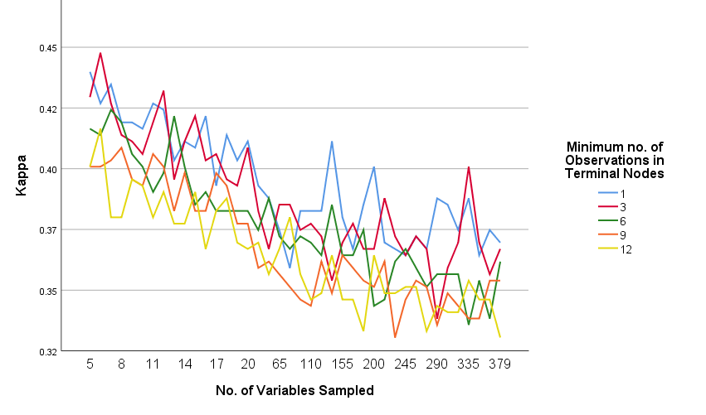

Figure A.1: Plotting the number of variables sampled against Cohen’s Kappa for different values of the minimum number of vectors of observations in the terminal nodes.

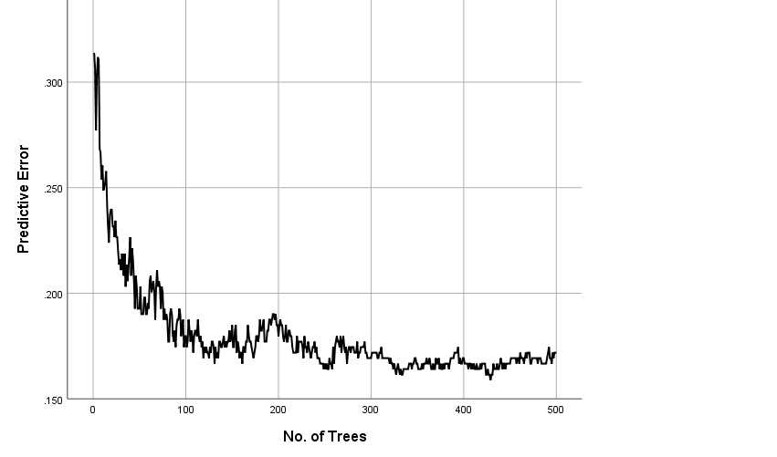

Figure A.2: Predictive error of the random forest as the no. of trees increase.

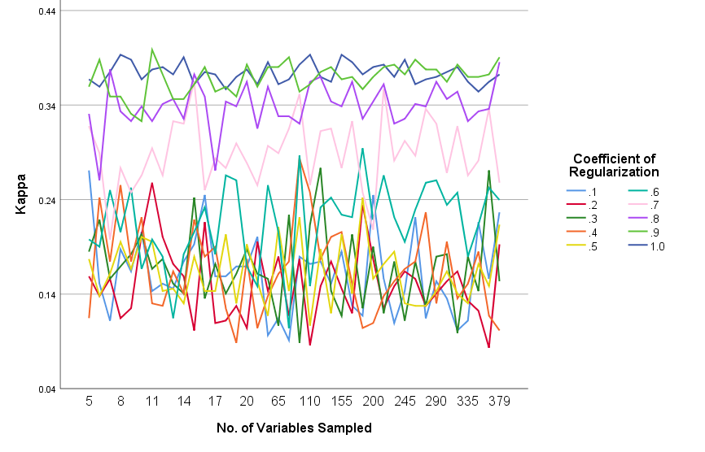

Figure A.3: Plotting the number of variables sampled against Cohen’s Kappa   
for different values of the coefficient of regularization for RRF.

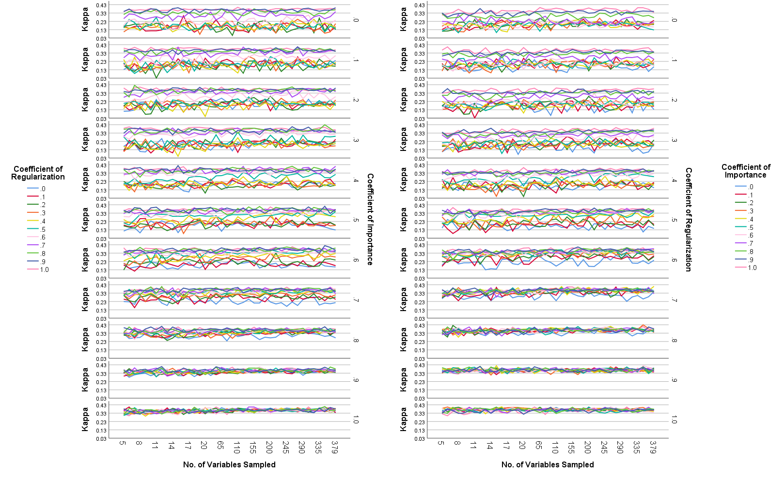

Figure A.4: Plotting the number of variables sampled against Cohen’s Kappa for different values of the   
coefficients of regularization and importance for GRRF.

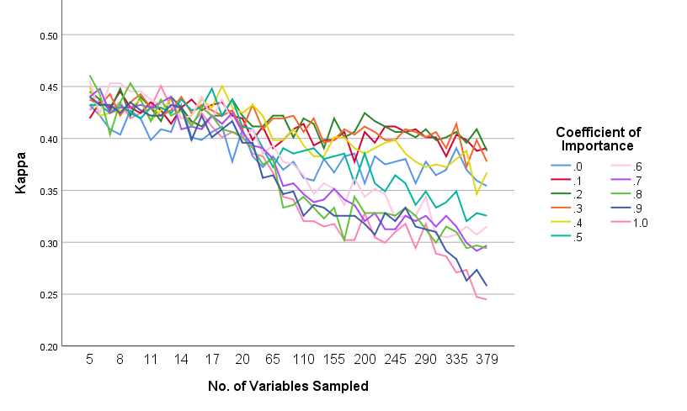

Figure A.5: Plotting the number of variables sampled against Cohen’s Kappa   
for different values of the coefficient of importance for GRF.

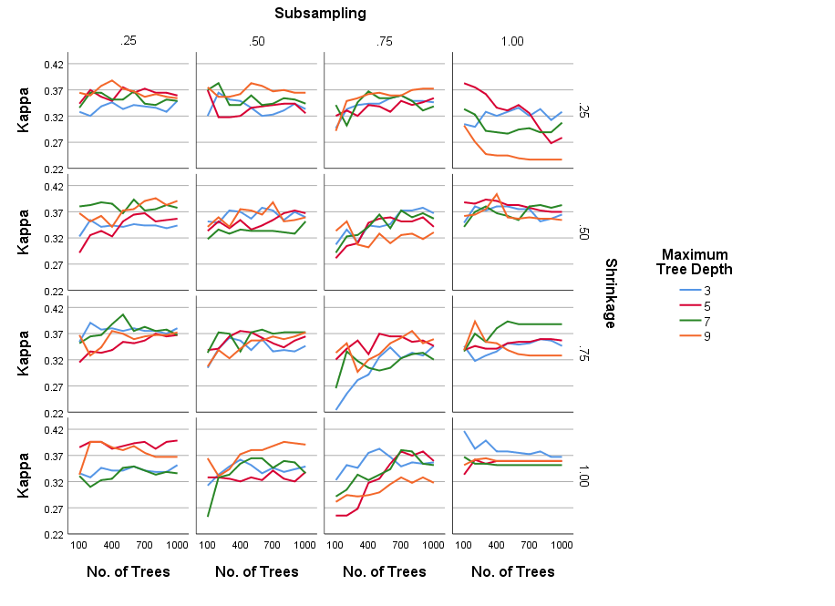

Figure A.6: Plotting the number of trees against Cohen’s Kappa for different values of maximum tree depth, shrinkage and subsampling for the Discrete AdaBoost model.

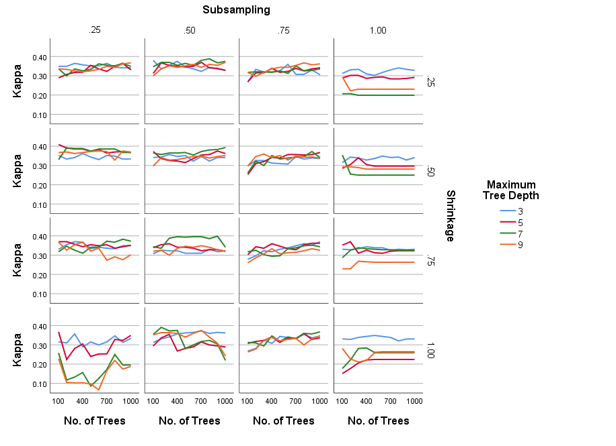

Figure A.7: Plotting the number of trees against Cohen’s Kappa for different values of maximum tree depth, shrinkage and subsampling for the Real AdaBoost model.

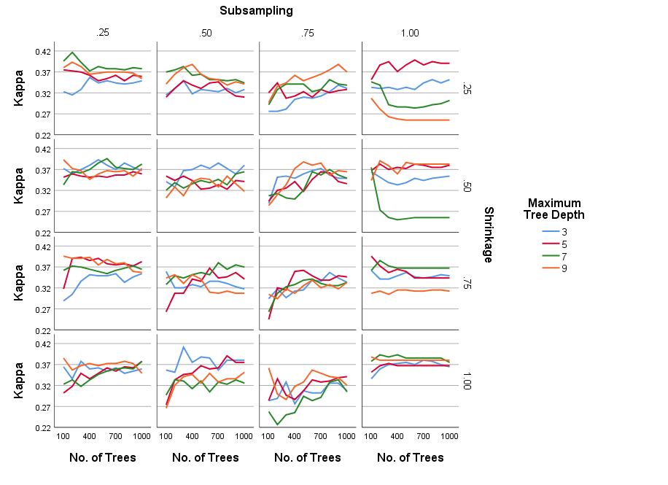

Figure A.8: Plotting the number of trees against Cohen’s Kappa for different values of maximum tree depth, shrinkage and subsampling for the Gentle AdaBoost model.

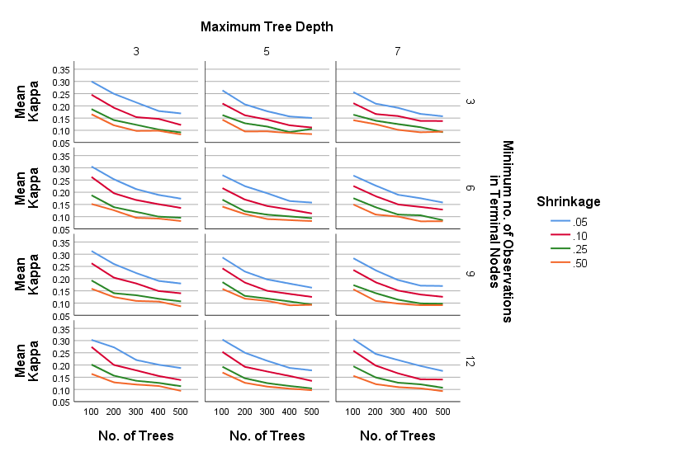

Figure A.9: Plotting the number of trees against an averaged Cohen’s Kappa for different values of the maximum tree depth, the minimum no. of vectors of observations in the terminal nodes, and different shrinkage parameters, for Gradient Boosting. Note that the Kappa values are averaged over the unused parameters.

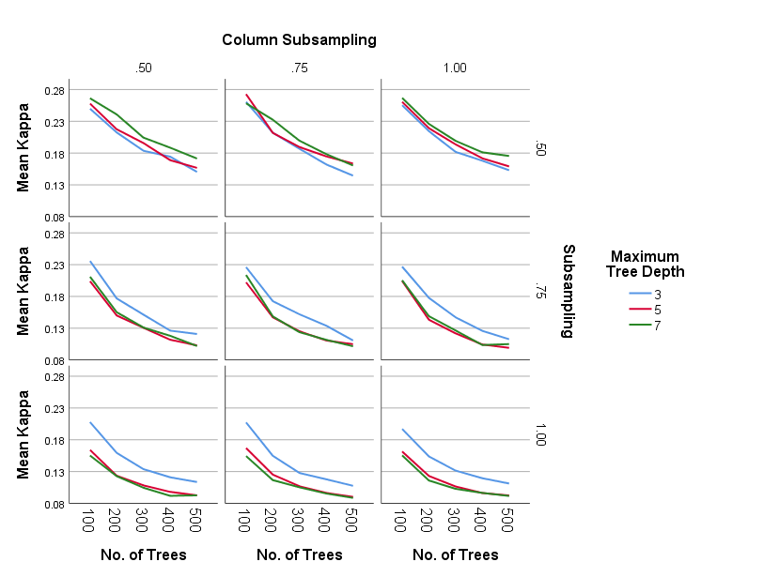

Figure A.10: Plotting the number of trees against an averaged Cohen’s Kappa for different subsampling and column subsampling percentages and different maximum tree depths, for Gradient Boosting. Note that  
the Kappa values are averaged over the unused parameters.

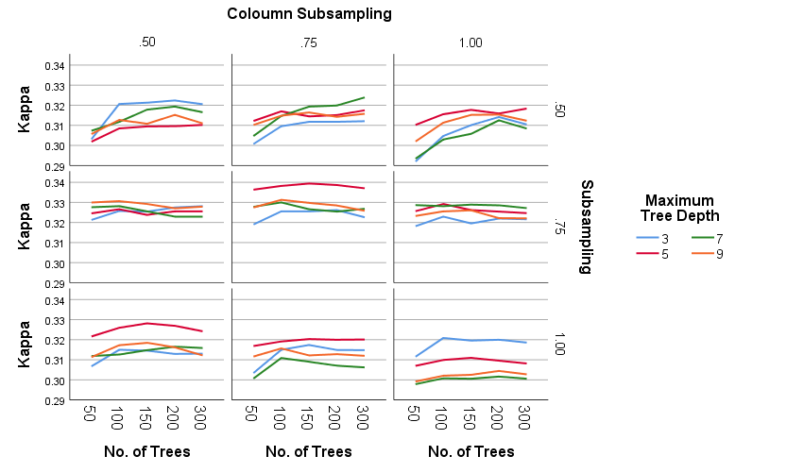

Figure A.11: Plotting the number of trees against an averaged Cohen’s Kappa for different subsampling and column subsampling percentages and different maximum tree depths, for Extreme Gradient Boosting.   
Note that the Kappa values are averaged over the unused parameters.

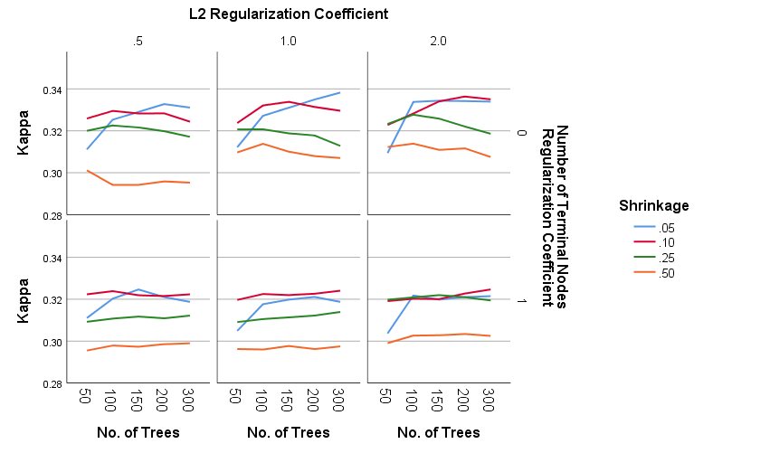

Figure A.12: Plotting the number of trees against an averaged Cohen’s Kappa for different L2 regularization coefficients, different number of terminal nodes coefficients and different shrinkage values, for Extreme Gradient Boosting. Note that the Kappa values are averaged over the unused parameters.

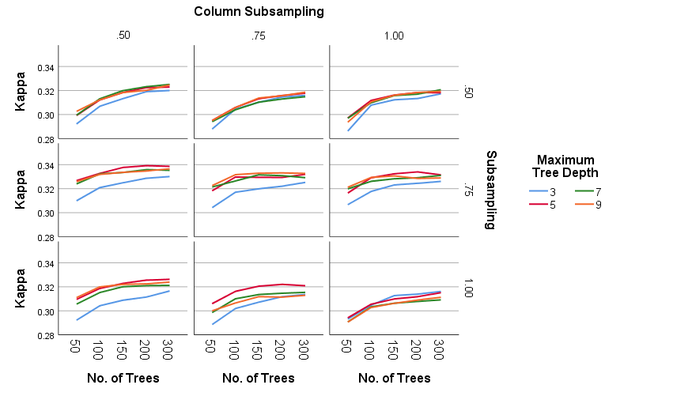

Figure A.13: Plotting the number of trees against an averaged Cohen’s Kappa for different subsampling, column subsampling and maximum tree depth parameters, for Extreme Gradient Boosting with dropout. Note that the Kappa values are averaged over the unused parameters.

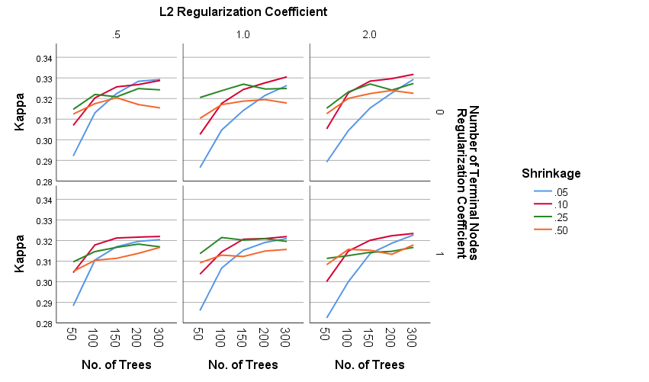

Figure A.14: Plotting the number of trees against an averaged Cohen’s Kappa for different L2 regularization coefficients, different number of terminal nodes coefficients and different shrinkage values, for Extreme Gradient Boosting with dropout. Note that the Kappa values are averaged over the unused parameters.

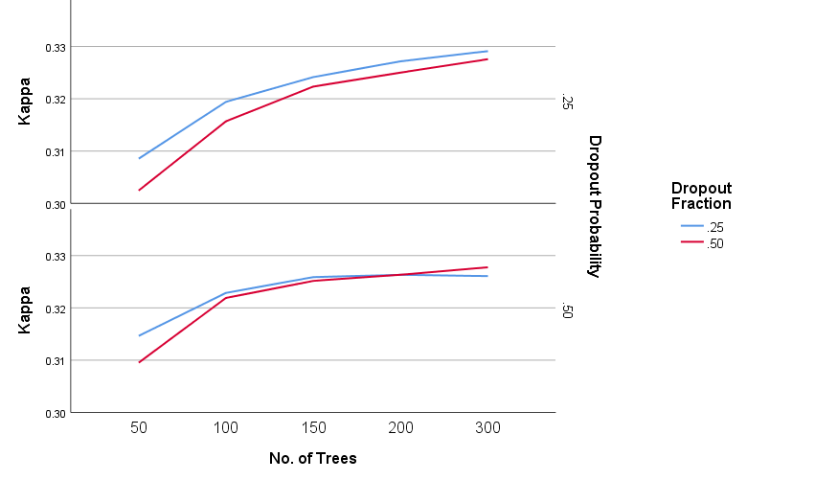

Figure A.15: Plotting the number of trees against an averaged Cohen’s Kappa for different dropout probabilities and dropout fractions, for Extreme Gradient Boosting with dropout. Note that the Kappa values are averaged over the unused parameters.

## B Feature Importance

|  |  |  |  |  |  |  |  |
| --- | --- | --- | --- | --- | --- | --- | --- |
| **RF** | | **RRF** | | **GRRF** | | **GRF** | |
| Team2.1.1.y | 2.71 | Team2.3.3.x | 6.92 | GK.4.x | 6.71 | GK.4.x | 16.31 |
| Team2.2.8.y | 2.40 | Team2.0.0.x | 5.61 | Team2.2.5.x | 6.12 | Team1.3.5.x | 4.63 |
| Team1.3.0.x | 2.39 | Team2.2.7.x | 5.44 | Team2.3.8.x | 6.07 | Team1.3.3.x | 4.32 |
| Team1.6.6.y | 2.29 | GK.6.x | 5.35 | Team1.3.3.x | 5.85 | Team2.2.5.x | 2.39 |
| Team2.2.2.x | 2.20 | Team1.2.2.x | 5.19 | Team2.0.4.y | 5.18 | GK.5.x | 2.32 |
| Team2.1.8.y | 2.17 | Team1.3.4.x | 4.83 | Team2.0.1.x | 4.96 | Team2.2.8.y | 2.31 |
| GK.2.x | 2.02 | Team2.2.1.y | 4.80 | GK.1.y | 4.84 | GK.6.x | 2.27 |
| Team1.3.2.x | 1.99 | Team1.6.2.y | 4.12 | Team2.1.1.y | 4.75 | Team1.3.0.x | 2.22 |
| Team1.2.5.x | 1.96 | GK.1.y | 3.45 | Team1.1.8.y | 4.23 | Team2.3.8.x | 1.96 |
| Team2.2.8.x | 1.96 | Team2.0.7.y | 3.31 | Team2.6.3.x | 3.69 | Team1.3.6.x | 1.93 |
| Team2.2.2.y | 1.95 | Team1.0.4.x | 3.20 | Team2.3.8.y | 3.49 | Team2.1.1.y | 1.80 |
| Team2.2.5.x | 1.94 | Team2.7.6.x | 2.80 | Team2.2.2.y | 3.46 | Team1.3.8.x | 1.76 |
| Team1.2.4.y | 1.93 | Team2.7.4.y | 2.64 | Team1.3.5.x | 3.02 | Team2.1.8.y | 1.64 |
| GK.4.x | 1.89 | Team2.1.4.y | 2.44 | Team2.2.8.y | 2.96 | Team2.3.2.x | 1.53 |
| Team1.3.3.x | 1.87 | Team2.1.5.x | 2.40 | Team1.0.4.x | 2.93 | GK.2.x | 1.52 |

Table B.1: The top 15 most important attributes for the RF, RRF, GRRF and GRF models.

|  |  |  |  |  |  |
| --- | --- | --- | --- | --- | --- |
| **Discrete AdaBoost** | | **Real AdaBoost** | | **Gentle AdaBoost** | |
| Team1.2.2.y | 2.18 | GK.2.x | 2.38 | GK.1.x | 1.69 | |
| Team1.2.3.y | 2.11 | Team1.0.2.x | 2.29 | GK.2.x | 1.63 | |
| Team2.0.2.x | 1.77 | Team1.1.1.x | 2.28 | Team1.0.3.y | 1.58 | |
| Team1.2.1.x | 1.75 | GK.1.x | 2.26 | Team1.0.2.y | 1.57 | |
| GK.2.y | 1.70 | Team1.1.2.x | 2.19 | Team1.0.2.x | 1.56 | |
| GK.2.x | 1.66 | Team1.0.1.x | 2.13 | GK.2.y | 1.55 | |
| Team1.0.2.y | 1.65 | Team1.3.3.x | 2.11 | GK.1.y | 1.55 | |
| GK.4.x | 1.60 | Team1.0.3.x | 2.07 | GK.3.x | 1.54 | |
| Team2.0.1.x | 1.58 | Team1.0.1.y | 2.06 | Team1.0.1.y | 1.51 | |
| Team1.0.3.y | 1.57 | Team1.0.3.y | 1.87 | Team1.0.1.x | 1.49 | |
| Team1.1.3.y | 1.56 | Team1.3.2.x | 1.86 | GK.3.y | 1.49 | |
| Team1.0.3.x | 1.51 | Team1.0.2.y | 1.85 | GK.0.x | 1.45 | |
| Team1.2.0.x | 1.50 | Team2.0.1.x | 1.80 | Team1.0.3.x | 1.44 | |
| GK.1.y | 1.50 | GK.3.x | 1.75 | Team1.0.4.y | 1.39 | |
| Team2.2.3.y | 1.50 | Team2.0.2.y | 1.74 | Team1.2.1.x | 1.39 | |

Table B.2: The top 15 most important attributes for both the Discrete, Real and Gentle AdaBoost.

|  |  |  |  |  |  |
| --- | --- | --- | --- | --- | --- |
| **Gradient Boosting** | | **Extreme Gradient Boosting** | | **Extreme Gradient Boosting  with Dropout** | |
| Team2.3.4.x | 9.37 | Team2.2.1.x | 5.32 | Team1.2.0.x | 4.17 |
| GK.4.x | 7.26 | Team2.2.5.y | 5.27 | Team2.2.1.x | 4.15 |
| Team1.3.8.x | 5.83 | GK.4.x | 4.97 | GK.4.y | 3.69 |
| Team1.3.3.x | 3.93 | Team2.7.0.y | 4.06 | GK.8.y | 3.49 |
| Team1.0.6.x | 2.96 | Team2.1.0.y | 4.01 | Team1.3.5.x | 3.45 |
| Team2.3.7.x | 2.93 | Team2.3.4.x | 3.96 | Team2.2.0.y | 3.39 |
| Team2.2.4.x | 2.80 | Team1.3.0.x | 3.88 | Team2.6.0.x | 3.30 |
| Team2.6.8.x | 2.57 | GK.8.y | 2.93 | Team2.3.0.x | 3.26 |
| Team2.1.8.y | 2.53 | Team1.6.0.y | 2.92 | Team1.0.0.x | 3.11 |
| Team1.2.0.x | 2.49 | Team1.2.0.x | 2.89 | Team2.2.0.x | 3.05 |
| Team2.3.6.y | 2.47 | Team2.3.0.x | 2.74 | Team2.0.0.y | 2.99 |
| GK.1.y | 2.29 | Team2.2.4.y | 2.72 | Team2.5.0.y | 2.86 |
| Team2.0.4.y | 1.81 | Team2.1.8.x | 2.66 | Team1.6.0.y | 2.82 |
| Team2.1.8.x | 1.80 | Team2.0.4.y | 2.55 | Team2.2.4.y | 2.59 |
| GK.8.y | 1.74 | Team2.2.0.x | 2.36 | Team2.7.0.y | 2.54 |

Table B.3: The top 15 most important attributes for the Gradient Boosting, Extreme Gradient Boosting, and Extreme Gradient Boosting with dropout models.