Adventist University of Central Africa

PHARMACY ANALYTICS AND MANAGEMENT SOFTWARE

CASE STUDY: KIPHARMA

A topic for a final year project, submitted to the faculty of Information Technology for approval

By

Cyusa Elvis, #24110

Majoring in

Networks and Communication Systems

April, 2024

**PART I**

**AS IS PROCESS MODEL**

**Introduction**

KIPHARMA Company Limited, founded in 1939 during the Belgian colonial period, has a long-standing presence in Rwanda's pharmaceutical industry. It restructured in 1976 to improve operations and expand its product range post-independence. The company overcame challenges during the 1994 genocide by modernizing infrastructure and innovating distribution strategies. A 2008 restructuring improved supply chain management and expanded its portfolio. By 2010, KIPHARMA had established itself as a leader in the pharmaceutical sector, significantly contributing to Rwanda's healthcare system. Today, it remains dedicated to enhancing healthcare delivery and accessibility nationwide.

KIPHARMA Company Limited operates through several key business models, including Pharmaceutical Distribution, Medical Equipment Supply, Supply Chain Management, Customer Service, Quality Assurance, Community Engagement, and Capacity Building. These efforts aim to ensure the availability of essential medications, provide advanced medical equipment, and engage communities. The focus is on the Customer Service model, particularly the efficient distribution of pharmaceuticals and medical supplies, due to its impact on service efficiency and customer satisfaction.

The manual, time-consuming process of pharmaceutical distribution and inventory management in KIPHARMA's Customer Service model underscores significant inefficiencies. Customers and healthcare providers face delays and inaccuracies in receiving medications and medical supplies, stressing KIPHARMA's resources and undermining its service quality. This highlights the critical need for digitalizing the distribution and inventory management processes to streamline operations and enhance customer interactions.

Modernizing the pharmaceutical distribution and inventory management processes is crucial for enhancing KIPHARMA's Customer Service. Adopting digital solutions can improve service delivery, reduce costs, and increase satisfaction, aligning KIPHARMA with Rwanda's digital goals and redefining pharmaceutical service standards.

**Modeling the Current Awareness System of KIPHARMA**

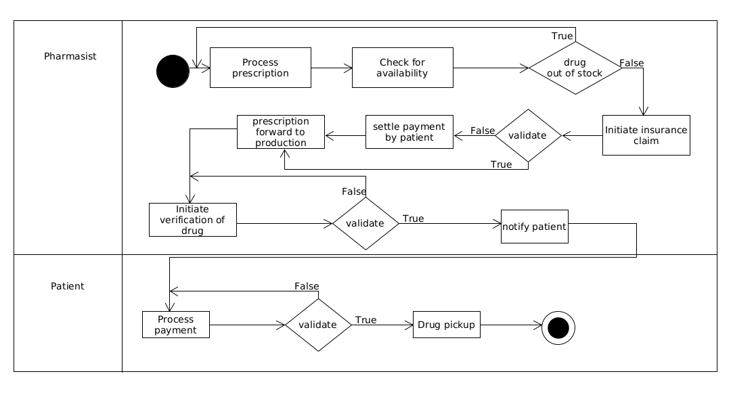**Figure 1: Pharma Track process model**

**Step 1:** Verification, Filling & Dispensing: The pharmacist ensures the doctor's order is accurate, prepares the medication, and provides it to the patient with clear instructions.

**Step 2:** The pharmacist confirms they have enough medication in stock before filling the prescription.

**Step 3:** Insurance Processing (if applicable): The pharmacist submits the prescription and patient's insurance details to initiate a claim.

**Step 4:** Payment for Uninsured Prescriptions: The pharmacist collects payment for medications not covered by insurance.

**Step 5:** Prescription Fulfillment: The pharmacist prepares the medication after verifying all details.

**Step 6:** Medication Verification:The pharmacist confirms the medication matches the prescription in the pharmacy system.

**Step 7:** Patient Notification: The pharmacist lets the patient know their prescription is ready for pickup.

Step 8: Payment Collection: The pharmacist finalizes the sale by collecting payment from the patient.

Above Diagram describe the current system, as shown the user doesn’t notify by the system on any action that is going to be taken.

**PART II**

**PROBLEMS WITH THE CURRENT SYSTEM**

**Performance**

**Throughput:**

* **Current System Challenges:** The existing manual process for pharmaceutical distribution and inventory management at KIPHARMA is characterized by low throughput, particularly during peak periods. This inefficiency arises from the system's inability to handle multiple requests simultaneously, leading to bottlenecks and prolonged processing times.

**Response Time:**

* **Delays in Notifications:** Users experience delays in receiving notifications for required actions. The reliance on manual communication methods means that updates are not immediate, leading to inefficiencies and slower response times. This can affect the timely execution of critical tasks and overall operational efficiency.
* **Manual Communication Delays:** Due to the reliance on manual communication methods, there are notable delays in updating users about their system status during transit. This impacts their ability to respond swiftly to any concerns or emergencies, as they do not receive real-time updates on their shipments and inventory status. Without real-time information, users are unable to make quick decisions to address potential issues, leading to further delays and disruptions.
* **Extended Data Compilation Time:** More time is needed to compile datasets for analysis and generate reports. The manual process of gathering, organizing, and analyzing data is time-consuming, delaying the ability to perform timely analyses and produce necessary reports for decision-making and strategic planning. This inefficiency can hinder the ability to quickly adapt to changing market conditions and customer needs.

**Information**

* **Input:** Users or stakeholders record pharmaceutical orders, inventory levels, and other critical data using paper-based and other traditional methods. This manual input process is prone to errors, time-consuming, and inefficient, leading to inaccuracies in data collection and entry.
* **Output:** There is no processed data available for users on inventory usage and trends. Without digital systems to analyze and present data, users lack insights into their pharmaceutical usage patterns, leading to difficulties in making informed decisions about restocking, inventory management, and predicting future needs.
* **Storage:** Historical information is primarily kept on paper records, making it difficult to access, search, and analyze past data. This reliance on paper-based storage hinders the ability to quickly retrieve historical data for auditing, reporting, or decision-making purposes.

**Economics**

**For Customers:**

* **Increased Costs:** Customers face additional expenses due to the necessity of physical visits to KIPHARMA offices for submitting orders and managing inventory. These costs include direct financial expenses related to travel as well as the opportunity cost of time spent away from work or other activities. The inconvenience and inefficiency of this manual process can lead to customer dissatisfaction and potential loss of business.

**For KIPHARMA:**

* **Operational Costs:** The manual processing of pharmaceutical orders and inventory management involves significant costs for KIPHARMA. These expenses include document storage, staff required to manage the process, and inefficiencies that could be reallocated to more productive tasks. The physical storage of documents also incurs costs for space and maintenance, adding to the overall operational burden.

**Control**

* **Lack of Secure Management:** The current manual system used by KIPHARMA for pharmaceutical distribution and inventory management faces significant issues related to document vulnerability. This system lacks adequate controls to safeguard the security and integrity of essential documents. Physical documents are susceptible to loss, damage, or unauthorized access, raising serious concerns for both customers and the organization. Implementing Pharma Insight’s data security and compliance features can address these issues by ensuring stringent data security measures, protecting patient information, and conducting regular security audits. This would enhance the overall security and integrity of KIPHARMA's operations, building trust among stakeholders and maintaining compliance with healthcare regulations.

**Efficiency**

* **Current System Challenges:** The existing pharmacy analytics and management software at KIPHARMA requires significant improvements in user-friendliness and user experience. The reliance on outdated technology systems, such as legacy software and manual processes, hampers efficiency by hindering the automation of routine tasks and effective data analysis. These outdated systems lack essential features and updates, leading to inefficiencies and increased error rates.

**Services**

* The current pharmacy analytics and management software falls short of user expectations regarding reliability, accessibility, and ease of use, resulting in widespread dissatisfaction. Users encounter frequent glitches and performance issues, making the system unreliable and difficult to navigate. As a consequence, users become disengaged and less effective in their roles, resorting to manual workarounds instead.