Adventist University of Central Africa

ADVOCATEGUARD INTELLIGENT ADVOCACY AND AWARENESS-RAISING PLATFORM FOR CHILDREN'S RIGHTS AND PROTECTION

CASE STUDY**:** NATIONAL CHILD DEVELOPMENT AGENCY (NCDA)

A topic for a final year project, submitted to the faculty of Information Technology

for approval

By

Hakizimana Serge, #24313

Majoring in

Networks and Communication Systems

June, 2024

**PART I**

**AS IS PROCESS MODEL**

**Introduction**

In the ever-evolving landscape of child protection, Rwanda's National Child Development Agency (NCDA) stands out as a beacon of progress. Established in 2020, the NCDA tackles the complex challenge of ensuring well-being for all Rwandan children through innovative programs and a holistic approach. Their mission is to ensure every child has the opportunity to develop to their full potential through early childhood programs, protection from violence and exploitation, and by fostering a safe and supportive environment within families and communities.

The National Child Development Agency (NCDA) in Rwanda, encompasses pivotal roles. These involve nutrition and hygiene program, child development, protect and promotion, strengthening families through the Tubarerere Mu Muryango (TMM), and providing specialized support for orphans and vulnerable children. Among these, I'll focus on Child Development, Protection, and Promotion, ensuring to safeguard children's well-being, equip them with essential skills, and empower them to flourish and reach their full potential.

The National Child Development Agency faces challenges in ensuring all children in Rwanda have access to quality development programs. Limited access to qualified Early Childhood Development Programs, persistent child protection issues, and a lack of widespread positive parenting education hinder progress. Additionally, with increasing technology use, protecting children online becomes a new concern.

In summary, Rwanda's National Child Development Agency (NCDA) and its mission to protect and promote well-being for all children. The NCDA faces challenges in providing access to quality programs, addressing child protection issues, and keeping children safe online. They actively seek solutions through partnerships and improved training.

**Modeling the Current System**

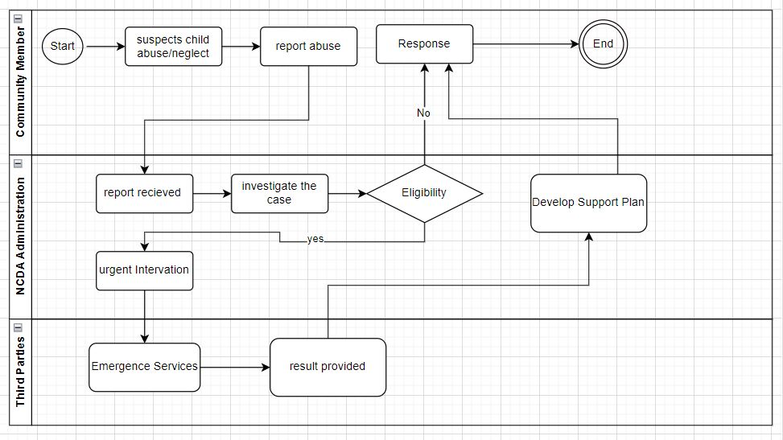

**Figure 1:** Modeling the Current System NCDA

Here's a step-by-step overview of how the current system of NCDA system Works:

**1st Step:** **The community member**The community member submits a report through our platform, providing details about the suspected case.

**2nd Step:** **The report is sent to the NCDA administration team**

The report is submitted based on specific pre-defined criteria (e.g. location, type of abuse). An NCDA social worker is assigned to the case based on workload and expertise.

**3rd Step:** **Social worker take decision based on values of the case**

If the risk is high and requires immediate intervention, the social worker:

Contacts emergency services (police, ambulance). Refers the child to a temporary shelter.

**4rd Step:** **The Emergence service**

Provide the necessary service for the child's needs and ensure safety, potentially involving: Family counseling, medical care referral and legal aid referral

**5th Step:** **End**

The social worker monitors the case progress and adjusts the support plan as needed. The case is closed when the child is safe, and the family has the necessary support in place.

**PART II**

**PROBLEMS WITH THE CURRENT SYSTEM**

**Performance**

**Throughput**

* **High Volume of Cases:** The current system struggle to handle a surge in reported cases, leading to delays in processing and response.
* **Limited Resources:** The current system have a shortage of trained professionals including social workers, healthcare providers, and early childhood development specialists. This limits the number of children they can effectively serve.

**Response time**

* **Underdeveloped Reporting Mechanisms:** The current system lacks a clear and efficient way for reporting child abuse and neglect, this lead delay intervention and support for vulnerable children.
* **Data Sharing Challenges:** Information sharing between different agencies involved in child development and protection slowdown assessments, service delivery and hindering timely decision making.

**Information**

**Input**

* **Inconsistent Data Collection:** Collecting data on children in different ways or use incompatible formats. This creates inconsistencies and makes it difficult to get a complete picture of a child's situation.
* **Lack of Standardization:** The current system lack of standardized tools and protocols for collecting information on child development, health, and abuse cases. This lead to inaccurate or incomplete data.
* **Limited Communication:** Poor communication between teams result to miss information or delays in sharing updates about a child's status.

**Output**

* **Inaccessible Information:** Information about a child's cases are not readily accessible to all authorized personnel who need it. This hinder collaboration and timely interventions.
* **Disjointed Communication:** Communication between teams about a child's case are fragmented, leading to duplication of effort or missed opportunities for coordinated action.

**Storage**

* **Storage Capacity Limitations:** The current system not have the capacity to handle the ever-growing volume of data collected on children. Investing in scalable storage solutions is crucial.

**Economics**

* The current system prioritize reactive interventions after problems arise, rather than investing in preventative measures. While addressing immediate needs is important, neglecting preventative efforts like early childhood development programs creates a false sense of cost-effectiveness.
* **The current system lack** proper cost analysis and optimization efforts, the system is not using resources efficiently. This lead to budget shortfalls and limit the system's reach.

**Control**

* **Data Security:** A data breach expose sensitive information about children and families, putting them at risk.
* **Limited Monitoring and Evaluation:** Weak monitoring systems make it difficult to track progress, identify gaps in service delivery, and hold different actors accountable. This lead to inefficient resource allocation and potentially ineffective interventions.

**Service**

* **Limited Feedback Mechanisms:** The current system lacks effective feedback mechanisms from families and children, it's difficult to identify areas in need of improvement and ensure that services are meet the needs of children and families.