


The Win32 Server

1. Intro:

This project, founded in early 2002 by Adam Szalkowski aims towards creating a network forwarding software CAPI 2.0 (ISDN) messages over a TCP/IP-based network.
Such software can be very useful in local area network environments, e.g. in a company intranet, where CAPI services such as Fax, Telephone and Data Transmissions are to be made available to a number of clients using only one ISDN Adaptor.
The CAPI2.0Proxy Team is right now creating several client and server implementations for both Microsoft Windows 9x/ME/NT/2k/XP and GNU/Linux. Ports to *your-choice-here*BSD and MacOS (X) have not yet been started but could theoretically be derived from the Linux code.
Enjoy our software and tell us if you have any problems or need other help.
2. Technical description :
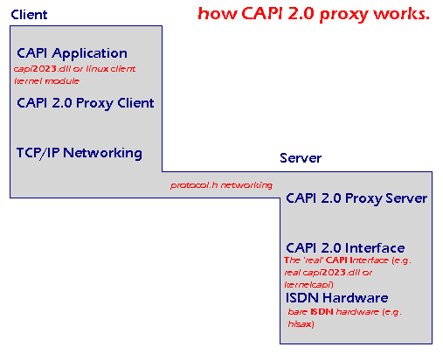

Applications running on the client computer send requests to the capi2032.dll (Windows) or kernelcapi (Linux). This message might for example be a command to send of a Fax or to create an Internet Connection. But the CAPI 2.0 Proxy has replaced capi2023.dll by a new library which redirects the application's request over a network to another computer running the server software. The server receives the request, parses it and calls his capi2023.dll (a "real" one) or his linux-kernelcapi with the parameters he got from the client. The reply form the CAPI software (maybe an error code or an incoming Fax) is sent back to the client, whose user-land application should be able to "understand" the incoming data.

- Installation:

  - Download the latest release from:
http://sourceforge.net/project/showfiles.php?group_id=43463

  - Unzip the .zip file to some location
  - Copy capi20server.exe to your Windows\System (Win 95/98/ME) or Windows\System32 (Win NT4/2k/XP) directory
  - NT4/2k/XP only: To install the capi20proxy server as NT service execute “capi20server –i”
  - That should be all!

- Starting the server:

Windows 95/98/ME:
  - Run “capi20server” (maybe create a link to capi20server.exe in you System directory)
  - To start the server in debug mode run “capi20server –debug”

Windows NT4/2k/XP:
- If you have installed it as a service as described above the server should start automatically when booting
- Alternatively you can use the same method as described above for Win 9x

- Uninstallation:

- NT4/2k/XP only: To uninstall the service execute “capi20server –u”
- Delete capi20server.exe :-)

- Support:

As this software ist not even a beta version, expect things to go wrong! :-)
But if you encounter any problems using this piece of software we will be there to help you!
You should prefer posting to the forum and to the trackers on sourceforge.net:
http://sourceforge.net/project/capi20proxy/

Another method is to post an email to capi20proxy-public@lists.sourceforge.net
This is our public mailing list.

- Joining our team:

Write an email to: capi20proxy-develop@lists.sourceforge.net
We always have some work for people who are good in Win32 and Linux C!
Or if you find a bug just fix it and mail us the changed code!

- The Win32 team:

Hmmm, that’s only me, Adam Szalkowski (butzist@users.sourceforge.net)
I’ve done all the Windows coding.

The protocol.h has been developed by Friedrich Lindenberg (frlind@frlind.de) and me.
He is now maintaining the linux server.

