1. Introduction
   1. Goal and Applications
      1. The goal

The main target of this thesis is to build up an automatic system which is possible to detect and localize pedestrians in static image. Our approach is to use robust extraction algorithm to extract a region of an image, and we use a classifier to decide whether this region contains pedestrian or not.

* + 1. Applications

Generally, object detection and localization is the fundamental thing of intelligent of camera. This can be applied to smart car to avoid accident to pedestrian. Camera on car can scan through street and detect pedestrian; and if there are pedestrians nearby car, it delivers alarm signal to driver. However, the performance of our approach is far below the need of realistic.

Another potential application of this thesis is that we can build up software which allows users to categorize their personal album images to proper catalogue.

* 1. Challenge
  2. Some background of object detection
  3. Overview of our approach

In an image, we use sliding window to densely scan at all position and different scales. In each window, we get its score, and we decide this window contains object or not is dependent on the threshold. After densely scanning image, we filter windows which exceed the threshold. We assume that our extract algorithm is robust which means that the score of window is still large (not maximum) even if this window slightly off center of object. And then, we use non maximal suppression (such as mean shift) to find the mode.

In process of extract a slide window to feature vector, we use robust extraction algorithm to avoid the noise effects of background. And HOG (histogram of gradient) seems to be the best choice because it is invariance with variety of background. In realistic, HOG is declared as the state of the art in extract feature vector to distinguish object or non-object.

INRIA pedestrian dataset is intensively used in training phase and testing phase. In training phase, there are 2416 positive windows and 1220 negative images; and there are 1126 positive windows and 453 negative images.

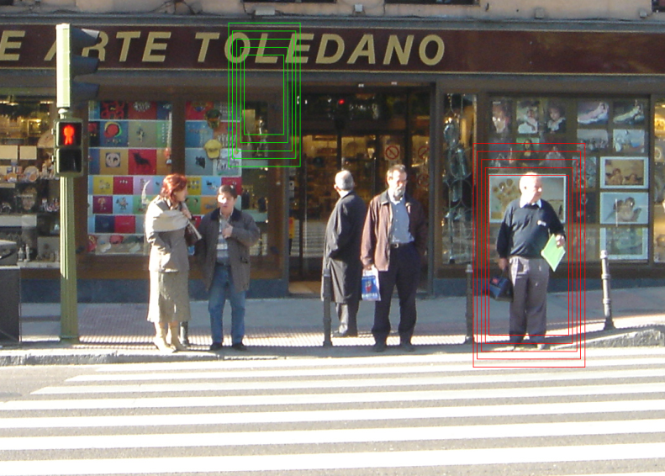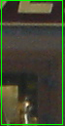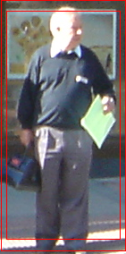

Pedestrian/ non-pedestrian classifier

Figure : Overview of detection method

1. At each point in image, we densely scan with multi-scale. (b) Sliding window is detected and extracted to feature vector which is input to pedestrian/non-pedestrian classifier.

**Overview of extraction algorithm**

* Normalize gamma, using equalizeHist function in OpenCv in each channel color.
* At each color channel, compute gradient of each pixel using centered mask, the info of gradient is the weight and orientation. And at each pixel, we choose color with greatest magnitude of gradient.
* Divide window into many equal squared cells.
* In each pixel, we calculate how it contributes to histogram of cell which contain it, as well as the neighborhood cells. (spatial and orientation histogram). (See figure 2)
* In the window, blocks are created by group of cells. Blocks can overlap each other.
* Concatenate histograms of blocks to form feature vector of window.

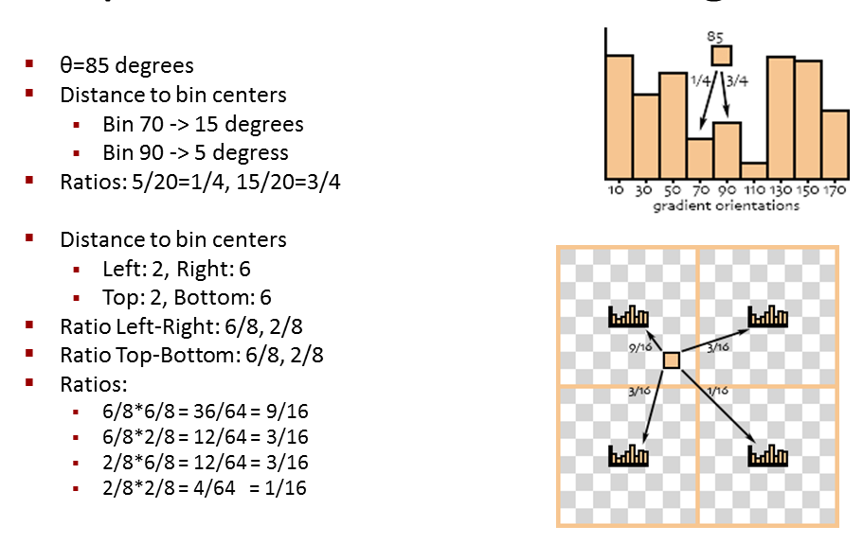

Figure : Example of Spatial & orientation histogram

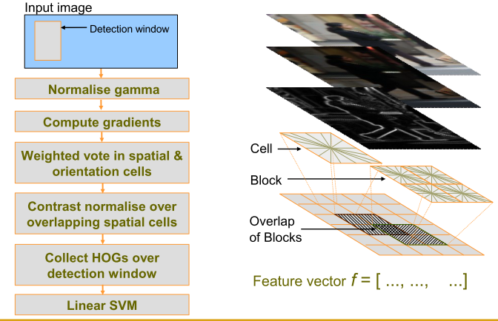

Figure : Overview extraction algorithm Histogram of Oriented Gradient

* 1. Overview of result

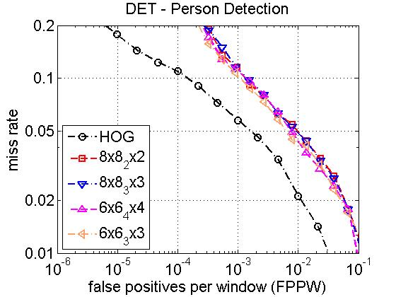

Figure 4: Performance of Dalal and us. Dalal’s curve is the first one (black).

* 1. Outline

1. Related work

2.1)

1. Overview of Detection Methodology and results
2. HOG
3. Some modified HOG
4. Multi scale object localization
5. Conclusion
6. Future work