Enc2DB: A Hybrid and Adaptive Encrypted Query Processing Framework
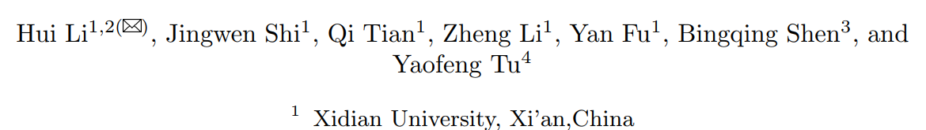
What: Biến Dbms phổ biến thành Secure Dbms
Why: An toàn dữ liệu khi dịch vụ Db trên Cloud (DbaaS)
How:
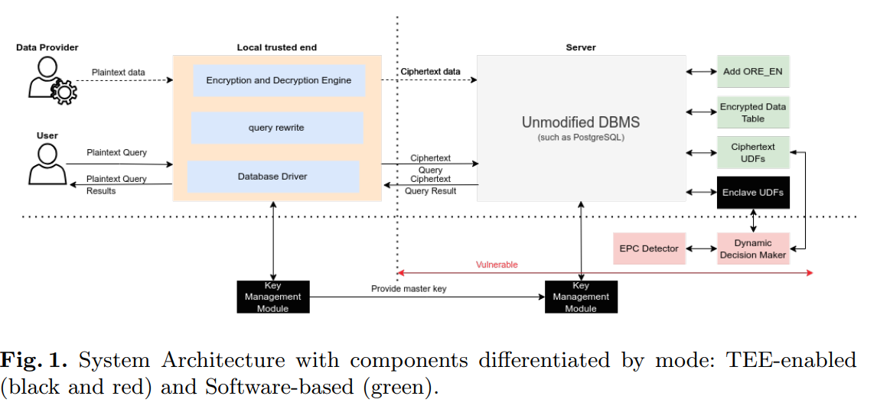
First propose the software-only mode, namely EncDB (Encrypted Database)
After that, we discuss how TEE can co-operate with EncDB by enabling complex tasks to run inside the Enclave, which leads to the second mode, Enc2DB
Loại mã Hóa | Client | Server
AES | encrypt, decrypt | Toán tử =
ORE | encrypt, decrypt | Toán tử =, >, <, cypher index
AHE | encrypt, decrypt | Toán tử +, agg add
MHE | encrypt, decrypt | Toán tử *, agg product

Kewords:
cloud service providers (CSPs)
Database Service (DBaaS)
property preserving cryptography schemes: mã hóa toàn thuộc tính
trusted execution environment (TEE)
SGX is a representative TEE framework proposed by Intel
secure area in the CPU (called an enclave)
homomorphic encryption: mã hóa đồng hình
fully homomorphic encryption (FHE)
Partially homomorphic encryption (PHE)
Property-Preserving Encryption (PPE)
openGauss, an open-source database proposed by Huawei
fork từ PostgreSQL 9.2 + cải tiến Huawei https://opengauss.org/en/
Enc2DB: A Hybrid and Adaptive Encrypted Query Processing Framework
UDFs (User Defined Functions)
protects the confidentiality and integrity of data and queries by placing sensitive data (tables, indexes and other metadata) in enclaves protected by trusted hardware (such as SGX)
Intel IAS (Intel Attestation Service)
ORE (Order-Revealing Encryption): là một loại mã hoá đặc biệt cho phép so sánh dữ liệu đã mã hoá mà không cần giải mã — tức là ta có thể biết thứ tự (lớn hơn/nhỏ hơn) giữa các bản mã, nhưng không biết giá trị thật.
AHE — Additively Homomorphic Encryption
(Mã hoá đồng cấu cộng)
MHE — Multiplicatively Homomorphic Encryption
(Mã hoá đồng cấu nhân)
AES — Advanced Encryption Standard
(Chuẩn mã hoá đối xứng tiên tiến)

Plan cài đặt/Demo
Option:
Install thử openGauss để tìm hiểu thử

Step 1: Implement Unmodified DBMS
Install Unbuntu server > 18
PostgreSQL 14
Step 2: software-only mode, namely EncDB (Encrypted Database)
Step 2.1:
one (or more) of AHE, MHE,
ORE ((PPE), toán tử so sánh =, <, >, BETWEEN
and AES algorithm on Server (mã hóa đối xứng)
Ciphetex UDFs
Step 2.2: on Client
Chooes JDBC driver
Encryption and Decryption Engine
Query rewriter
Step 2.3:
Query and insert from client
Expect: store encript data..
Step 3: trusted execution environment TEE
Tìm/thuê server support TEE (Intel SGX)
Thử Enable TEE

Tóm tắt nội dung

Abstract:
- Thách thức cần giải quyết:
An toàn dữ liệu khi dịch vụ Db trên Cloud (DbaaS)
- Các giải pháp hiện nay:
- property preserving cryptography schemes, which can perform certain operations over ciphertext without decrypting
- trusted execution environment (TEE)
- Giải pháp của Nhóm tác giả:
introduce Enc2DB, a novel secure database system, following a hybrid strategy on PostgreSQL and openGauss
Present micro-benchmarking test and and self-adaptive mode switch strategy that can dynamically choose the best execution path (cryptography or TEE)
Design and implement a ciphertext index

1 Introduction:
Hạn chế của các giải pháp hện tại: FHE, PHE, PPE
Ưu điểm của TEE, Db tiêu biểu là EnclaveDB
Đề xuất của tác giả:
hybrid and adaptive encryption query processing solution, namely Enc2DB
in our openGauss as well as in PostgreSQL
Based on the cryptography technologies such as symmetric PHE, order preserving encryption (OPE), and AES
Enc2DB proposes a hybrid solution make use of both software (cryptography) and hardware (TEE)

2 BACKGROUND AND RELATED WORK

2.1 Encryption Algorithm
Homomorphic Encryption
Property Preserving Encryption PPE

2.2 Trusted Execution Environment
TEE: xecution environments-trusted execution environment and common execution environment
All major CPU vendors have rolled out their TEE (e.g., ARM TrustZone, Intel SGX, and AMD SEV)

3. system architecture
first propose the software-only mode, namely EncDB (Encrypted Database)
After that, we discuss how TEE can co-operate with EncDB by enabling complex tasks to run inside the Enclave, which leads to the second mode, Enc2DB
Encryption and Decryption Engine: holds the encryption key, encrypts plaintext data, and decrypts the result received from the cloud
Encryption and Decryption Engine: holds the encryption key, encrypts plaintext data, and decrypts the result received from the cloud
Query rewriter: convert plaintext queries into the ones in ciphertext
Database Driver: JDBC, ODBC, …

3.1 Software-based mode, EncDB
a column in a table is to be stored in ciphertext form under one (or more) of AHE, MHE, ORE, and AES
Advantages: no hardware requirement, and it also has less deployment costs
Disadvantages: large redundancy of data, huge computational overhead

3.2 TEE-enabled mode, Enc2DB
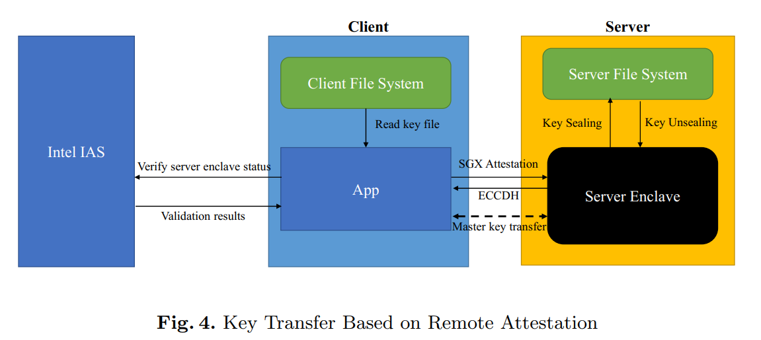
Truyền khóa mã hóa dựa trên cơ chế xác thực từ xa (Remote Attestation)

3.3 Self-adaptive switch between TEE-enabled and software modes
Static mode switch

Self-adaptive mode switch

4 FURTHER OPTIMIZATION
4.1 cipher index
4.2 within-SGX caching
4.3 SGX task pool for batched ecall
In an Enclave program, access to the enclave program from the untrusted side is done through a predefined bridge function called ECALL

5 Evaluation
5.1 Overall throughput
5.2 Self-adaptive mode switch test
5.3 Effect of within-SGX cache
5.4 Storage expansion
5.5 Effects of cipher index in software-only mode
5.6 Security study
6 Conclusion

