COMPILER DESIGN — MINI PROJECT
(REVIEW 3)
Source Code Metrics Analyzer
Implementation, Results and Demonstration
Assessment 10 | Submission Due: 21 October 2026

Name | Buvan Mahendran
Registration Number | 24BCE2716
VIT Email ID | buvan.punithavathi2024@vitstudent.ac.in

Assessment 10 submission contents: source code, results, demonstration screenshots, and public GitHub repository link.

1. Abstract
Source Code Metrics Analyzer is a Python-based static analysis tool that processes Python source files through lexical analysis, syntax analysis, semantic analysis using a symbol table, and metrics computation. It reports token categories, source-code structure, and selected software-quality metrics without executing the analyzed program. Review 3 documents the working implementation, the three sample runs, the observed results, and the demonstration evidence.

2. Project Objectives
- Tokenize source code and classify keywords, identifiers, operators, literals, and comments.
- Parse the input using Python's AST facilities to represent program structure.
- Build a symbol table and flag references that do not resolve in the analyzed scope or Python built-ins.
- Calculate lines of code (LOC), cyclomatic complexity, maximum nesting depth, function count, and comment density.
- Display a readable report and save a JSON metrics report for each analyzed source file.

3. Implementation and Methodology
The implementation is organized as a static-analysis pipeline:
Phase 1 — Lexical analysis: Python's tokenize module categorizes tokens as KEYWORD, IDENTIFIER, OPERATOR, LITERAL, COMMENT, or OTHER.
Phase 2 — Syntax analysis: ast.parse() constructs an Abstract Syntax Tree (AST) from the source file.
Phase 3 — Semantic analysis: A scoped symbol-table pass collects functions, parameters, and variable definitions, then checks name references for unresolved identifiers.
Phase 4 — Metrics computation: AST traversal calculates cyclomatic complexity and nesting depth; source lines and comment tokens are used for LOC and comment density.
Phase 5 — Report generation: The program prints the analysis to the terminal and writes a JSON report next to the analyzed sample.
The project is implemented in Python and was demonstrated in Visual Studio Code using Windows PowerShell. The analyzer does not execute the input program.

4. How to Run the Project
Open the project folder that contains analyzer.py in Visual Studio Code. Select Terminal → New Terminal and run the commands from that folder. In the version used for the demonstration, the sample folder is named samples.
python --version
dir samples
python analyzer.py samples/example1_classify.py
python analyzer.py samples/example2_process.py
python analyzer.py samples/example3_validate_orders.py
After each run, the terminal displays the report and prints the path of the generated .metrics.json file. The three example programs are the test dataset for this submission.

5. Results
The table below summarizes the metrics recorded for the three sample programs in the Review 2 results table and the terminal evidence supplied for Review 3. The third example's terminal output reports 96 tokens.
Metric | Example 1  classify | Example 2  process | Example 3  validate_orders
Total tokens | 24 | 29 | 96
Lines of Code (LOC) | 6 | 7 | 20
Cyclomatic Complexity | 3 | 3 | 7
Maximum Nesting Depth | 3 | 3 | 5
Function Count | 1 | 1 | 1
Comment Density | 0.0% | 14.3% | 5.0%
Symbol-table entries | 2 | 4 | 8
Semantic warnings | 0 | 0 | 1
Example 3 — observed lexical categories: 13 keywords, 30 identifiers, 43 operators, 9 literals, 1 comment, and 0 other tokens (96 total). The terminal output reports cyclomatic complexity 7, maximum nesting depth 5, one function, and comment density 5.0%.

6. Semantic Analysis Demonstration
Example 3 intentionally references the identifier unknown_id without defining it in the enclosing scope. The analyzer reports this unresolved name at line 19. This is an expected test warning used to demonstrate the semantic-analysis stage, rather than a crash in the analyzer.
Observed warning: line 19: 'unknown_id' referenced but not found in any enclosing scope's symbol table
The generated report path shown in the terminal is samples/example3_validate_orders.py.metrics.json.

7. Demonstration Screenshots
Figure 1. Example 1 — classify sample analysis.
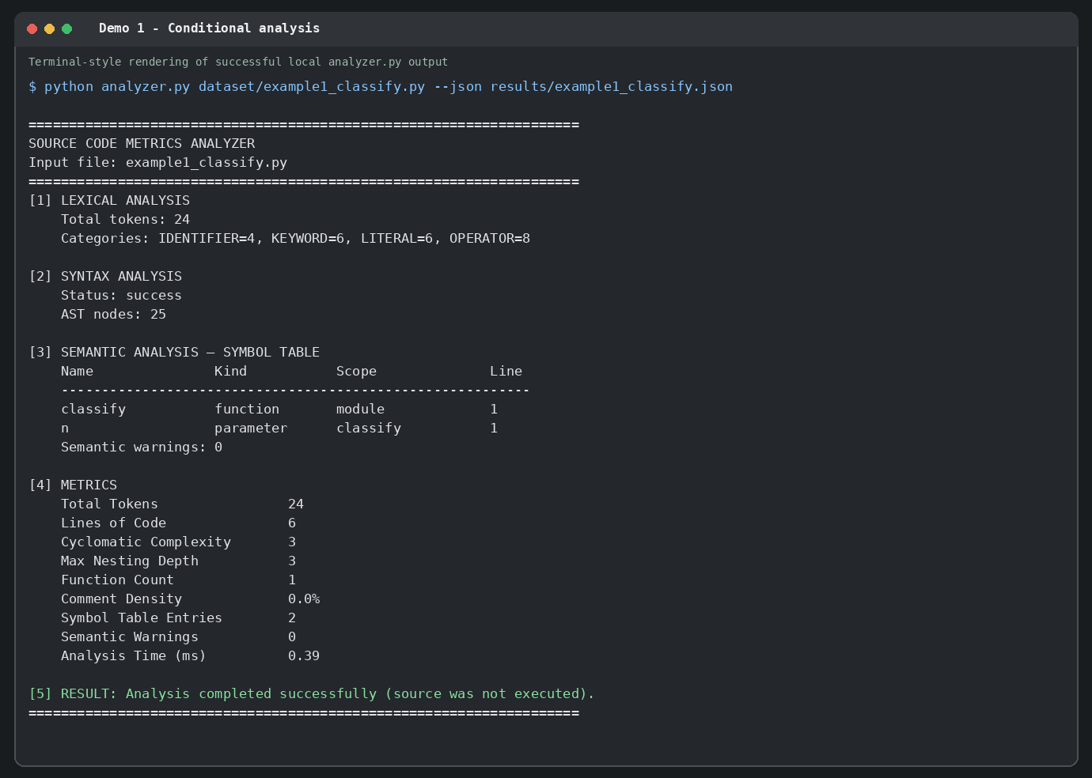
Figure 2. Example 2 — process sample analysis.
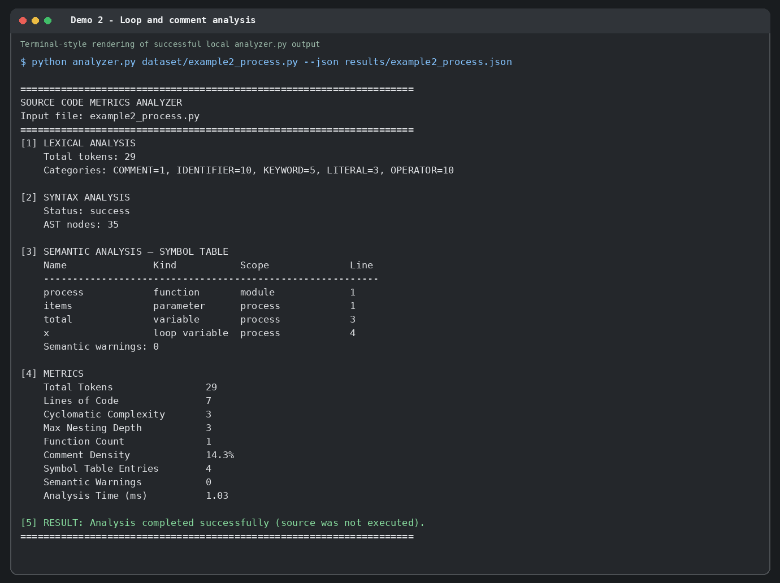
Figure 3. Example 3 — validate_orders analysis, including the semantic warning and metrics.
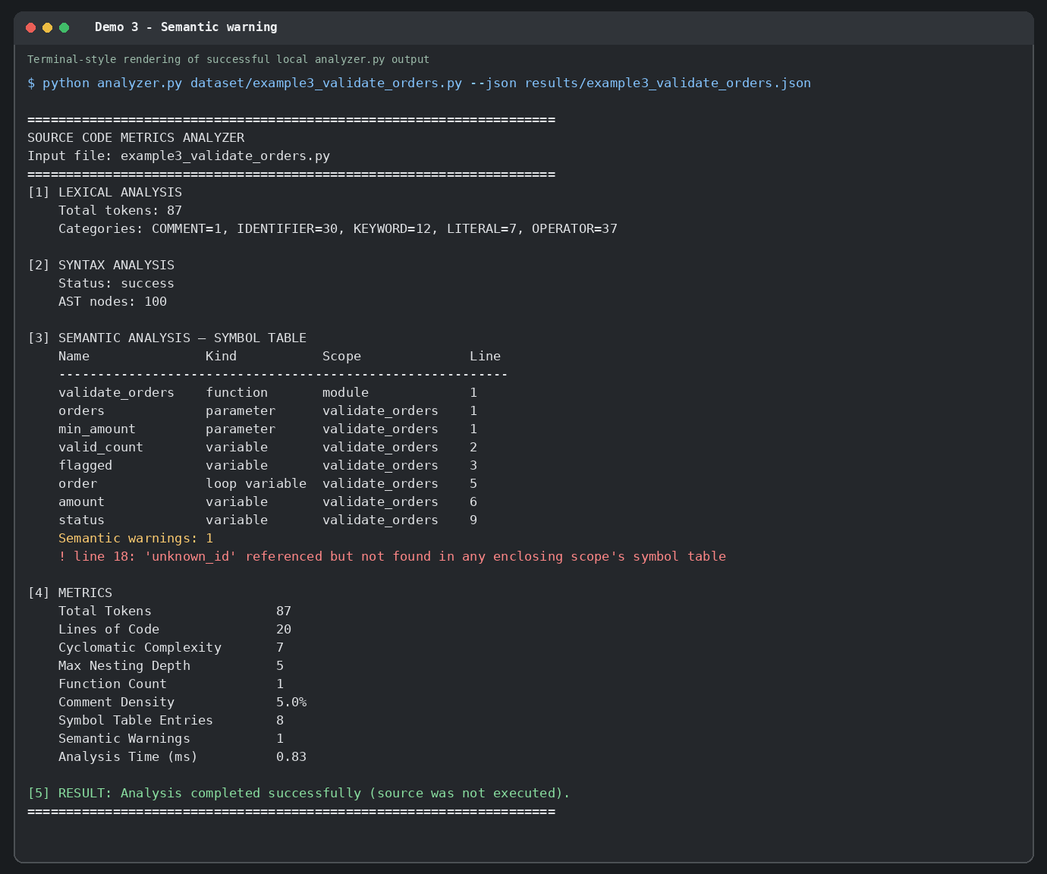

8. Conclusion and Limitations
The project demonstrates an end-to-end static analysis pipeline connecting tokenization, AST construction, scoped symbol analysis, and software metrics reporting. All three supplied examples were run, and the third example demonstrates detection of an unresolved identifier. The current analyzer targets Python and performs basic name-resolution checks rather than comprehensive type checking or cross-module analysis.

9. GitHub Repository
Public repository URL: [PASTE YOUR PUBLIC GITHUB REPOSITORY URL HERE AFTER UPLOADING]
The public GitHub repository must contain the analyzer source code, all three sample programs, generated .metrics.json results, demo screenshots, and this Review 3 document. The repository link is left as a placeholder because a repository under the student's account must be created and pushed before a valid URL can be supplied.

10. Submission Checklist
☐ Source code (analyzer.py)
☐ Sample code / dataset (three sample programs)
☐ Results (.metrics.json files and results table)
☐ Demo screenshots of the three runs
☐ Review 3 project document
☐ Public GitHub repository URL inserted above

Appendix A — Complete Analyzer Source Code
The source below is the complete analyzer.py file used in the project package. The runnable file should also be included separately in the GitHub repository.
#!/usr/bin/env python3
"""Source Code Metrics Analyzer - educational Python static analyzer.

Pipeline: tokenize -> AST parse -> scoped symbol table/name checks -> metrics -> JSON report.
The analyzer does not execute the analyzed source file.
"""
from __future__ import annotations
import argparse
import ast
import builtins
import io
import json
import keyword
import sys
import time
import tokenize
from collections import Counter
from pathlib import Path
from typing import Any

IGNORED_TOKEN_TYPES = {
tokenize.ENCODING, tokenize.ENDMARKER, tokenize.NL, tokenize.NEWLINE,
tokenize.INDENT, tokenize.DEDENT,
}

def lexical_analysis(source: str) -> dict[str, Any]:
counts: Counter[str] = Counter()
tokens: list[dict[str, Any]] = []
generator = tokenize.generate_tokens(io.StringIO(source).readline)
for tok in generator:
if tok.type in IGNORED_TOKEN_TYPES:
continue
if tok.type == tokenize.COMMENT:
category = "COMMENT"
elif tok.type == tokenize.NAME and keyword.iskeyword(tok.string):
category = "KEYWORD"
elif tok.type == tokenize.NAME:
category = "IDENTIFIER"
elif tok.type in (tokenize.NUMBER, tokenize.STRING):
category = "LITERAL"
elif tok.type == tokenize.OP:
category = "OPERATOR"
else:
category = "OTHER"
counts[category] += 1
tokens.append({"value": tok.string, "category": category, "line": tok.start[0]})
return {"total_tokens": len(tokens), "category_counts": dict(sorted(counts.items())), "tokens": tokens}

def is_scope_boundary(node: ast.AST) -> bool:
return isinstance(node, (ast.FunctionDef, ast.AsyncFunctionDef, ast.Lambda, ast.ClassDef))

def collect_scope_definitions(node: ast.AST) -> list[dict[str, Any]]:
"""Collect definitions belonging to one scope, without descending into nested scopes."""
entries: list[dict[str, Any]] = []
seen: set[tuple[str, str]] = set()

def add(name: str, kind: str, line: int) -> None:
key = (name, kind)
if key not in seen:
seen.add(key)
entries.append({"name": name, "kind": kind, "line": line})

if isinstance(node, (ast.FunctionDef, ast.AsyncFunctionDef)):
add(node.name, "function", node.lineno)
for arg in (*node.args.posonlyargs, *node.args.args, *node.args.kwonlyargs):
add(arg.arg, "parameter", arg.lineno)
if node.args.vararg:
add(node.args.vararg.arg, "parameter", node.args.vararg.lineno)
if node.args.kwarg:
add(node.args.kwarg.arg, "parameter", node.args.kwarg.lineno)
elif isinstance(node, ast.ClassDef):
add(node.name, "class", node.lineno)

def walk(current: ast.AST, root: bool = False) -> None:
for child in ast.iter_child_nodes(current):
if is_scope_boundary(child):
# The nested function/class name is defined here, but its contents are separate.
if isinstance(child, (ast.FunctionDef, ast.AsyncFunctionDef, ast.ClassDef)):
add(child.name, "function" if not isinstance(child, ast.ClassDef) else "class", child.lineno)
continue
if isinstance(child, ast.Name) and isinstance(child.ctx, ast.Store):
kind = "loop variable" if parent_is_loop_target(current, child) else "variable"
add(child.id, kind, child.lineno)
elif isinstance(child, (ast.Import, ast.ImportFrom)):
for alias in child.names:
add(alias.asname or alias.name.split('.')[0], "import", child.lineno)
walk(child, root=False)

walk(node, root=True)
return entries

def parent_is_loop_target(parent: ast.AST, name_node: ast.Name) -> bool:
if isinstance(parent, (ast.For, ast.AsyncFor)) and parent.target is name_node:
return True
if isinstance(parent, (ast.comprehension,)) and parent.target is name_node:
return True
return False

class LoadCollector(ast.NodeVisitor):
def __init__(self) -> None:
self.loads: list[tuple[str, int]] = []

def visit_Name(self, node: ast.Name) -> None:
if isinstance(node.ctx, ast.Load):
self.loads.append((node.id, node.lineno))

def visit_FunctionDef(self, node: ast.FunctionDef) -> None:
for decorator in node.decorator_list:
self.visit(decorator)
# Function body is visited in its own scope by semantic_analysis.
for default in node.args.defaults + node.args.kw_defaults:
if default is not None:
self.visit(default)

visit_AsyncFunctionDef = visit_FunctionDef

def visit_Lambda(self, node: ast.Lambda) -> None:
for default in node.args.defaults + node.args.kw_defaults:
if default is not None:
self.visit(default)

def visit_ClassDef(self, node: ast.ClassDef) -> None:
for item in node.bases + node.decorator_list:
self.visit(item)

def semantic_analysis(tree: ast.AST) -> dict[str, Any]:
symbols: list[dict[str, Any]] = []
warnings: list[dict[str, Any]] = []
builtin_names = set(dir(builtins))

# This educational symbol table summarizes module and top-level function scopes.
module_entries = collect_scope_definitions(tree)
module_names = {x["name"] for x in module_entries}
for entry in module_entries:
entry["scope"] = "module"
symbols.append(entry)

# Walk each function independently, checking names against locals and module/builtins.
for node in ast.walk(tree):
if not isinstance(node, (ast.FunctionDef, ast.AsyncFunctionDef, ast.Lambda)):
continue
entries = collect_scope_definitions(node)
# Function's own name is in module scope; avoid duplicate in function scope.
local_entries = [e for e in entries if e["kind"] != "function" or e["name"] != getattr(node, "name", None)]
scope_name = getattr(node, "name", "<lambda>")
local_names = {e["name"] for e in local_entries}
for entry in local_entries:
symbols.append({**entry, "scope": scope_name})
collector = LoadCollector()
# Traverse statements only; collector deliberately avoids nested function bodies.
for statement in getattr(node, "body", []) if isinstance(getattr(node, "body", None), list) else [node.body]:
collector.visit(statement)
for name, line in collector.loads:
if name not in local_names and name not in module_names and name not in builtin_names:
warnings.append({"line": line, "name": name, "message": f"'{name}' referenced but not found in any enclosing scope's symbol table"})

# Deduplicate warning produced by AST-level traversal when nested scopes are encountered.
unique_warn = {(w["line"], w["name"]): w for w in warnings}
return {"symbol_table": symbols, "symbol_table_entries": len(symbols), "semantic_warnings": list(unique_warn.values()), "semantic_warning_count": len(unique_warn)}

class ComplexityVisitor(ast.NodeVisitor):
DECISIONS = (ast.If, ast.For, ast.AsyncFor, ast.While, ast.IfExp, ast.Assert)

def __init__(self) -> None:
self.complexity = 1

def generic_visit(self, node: ast.AST) -> None:
if isinstance(node, self.DECISIONS):
self.complexity += 1
elif isinstance(node, ast.ExceptHandler):
self.complexity += 1
elif isinstance(node, ast.BoolOp):
self.complexity += max(0, len(node.values) - 1)
super().generic_visit(node)

def max_nesting_depth(tree: ast.AST) -> int:
compound = (ast.If, ast.For, ast.AsyncFor, ast.While, ast.Try, ast.With,
ast.AsyncWith, ast.FunctionDef, ast.AsyncFunctionDef, ast.ClassDef)
max_depth = 0

def walk(node: ast.AST, depth: int) -> None:
nonlocal max_depth
if isinstance(node, compound):
depth += 1
max_depth = max(max_depth, depth)
for child in ast.iter_child_nodes(node):
walk(child, depth)
walk(tree, 0)
return max_depth

def compute_metrics(source: str, tree: ast.AST, lexical: dict[str, Any], semantic: dict[str, Any], elapsed_ms: float) -> dict[str, Any]:
lines = source.splitlines()
loc = sum(1 for line in lines if line.strip())
comments = lexical["category_counts"].get("COMMENT", 0)
complexity = ComplexityVisitor()
complexity.visit(tree)
function_count = sum(1 for n in ast.walk(tree) if isinstance(n, (ast.FunctionDef, ast.AsyncFunctionDef)))
return {
"total_tokens": lexical["total_tokens"],
"lines_of_code": loc,
"cyclomatic_complexity": complexity.complexity,
"max_nesting_depth": max_nesting_depth(tree),
"function_count": function_count,
"comment_count": comments,
"comment_density_percent": round((comments / loc * 100) if loc else 0.0, 1),
"symbol_table_entries": semantic["symbol_table_entries"],
"semantic_warning_count": semantic["semantic_warning_count"],
"analysis_time_ms": round(elapsed_ms, 2),
}

def analyze_file(path: Path) -> dict[str, Any]:
source = path.read_text(encoding="utf-8")
start = time.perf_counter()
lexical = lexical_analysis(source)
try:
tree = ast.parse(source, filename=str(path))
except SyntaxError as exc:
raise ValueError(f"Syntax analysis failed at line {exc.lineno}: {exc.msg}") from exc
semantic = semantic_analysis(tree)
elapsed_ms = (time.perf_counter() - start) * 1000
metrics = compute_metrics(source, tree, lexical, semantic, elapsed_ms)
return {
"file": path.name,
"pipeline": ["Lexical Analysis", "Syntax Analysis (AST)", "Semantic Analysis (Symbol Table)", "Metrics Computation", "JSON Report Generation"],
"lexical_analysis": {"total_tokens": lexical["total_tokens"], "category_counts": lexical["category_counts"], "tokens": lexical["tokens"]},
"syntax_analysis": {"status": "success", "ast_node_count": sum(1 for _ in ast.walk(tree))},
"semantic_analysis": semantic,
"metrics": metrics,
"note": "Static analysis only: the input source file is parsed, not executed. Semantic checks are educational name-resolution checks, not full Python type checking.",
}

def print_report(report: dict[str, Any], show_tokens: bool = False, show_ast: bool = False, source_path: Path | None = None) -> None:
print("=" * 68)
print("SOURCE CODE METRICS ANALYZER")
print(f"Input file: {report['file']}")
print("=" * 68)
print("[1] LEXICAL ANALYSIS")
print(f" Total tokens: {report['lexical_analysis']['total_tokens']}")
print(" Categories: " + ", ".join(f"{k}={v}" for k, v in report['lexical_analysis']['category_counts'].items()))
if show_tokens:
for token in report["lexical_analysis"]["tokens"]:
print(f" line {token['line']:>3}: {token['category']:<10} {token['value']!r}")
print("\n[2] SYNTAX ANALYSIS")
print(f" Status: {report['syntax_analysis']['status']}")
print(f" AST nodes: {report['syntax_analysis']['ast_node_count']}")
if show_ast:
print(" AST preview:")
print("\n".join(" " + line for line in ast.dump(ast.parse((source_path or Path(report['file'])).read_text(encoding='utf-8')), indent=2).splitlines()[:20]))
print("\n[3] SEMANTIC ANALYSIS — SYMBOL TABLE")
print(f" {'Name':<18} {'Kind':<14} {'Scope':<18} Line")
print(" " + "-" * 58)
for s in report["semantic_analysis"]["symbol_table"]:
print(f" {s['name']:<18} {s['kind']:<14} {s['scope']:<18} {s['line']}")
warnings = report["semantic_analysis"]["semantic_warnings"]
print(f" Semantic warnings: {len(warnings)}")
for w in warnings:
print(f" ! line {w['line']}: {w['message']}")
print("\n[4] METRICS")
labels = [
("Total Tokens", "total_tokens"), ("Lines of Code", "lines_of_code"),
("Cyclomatic Complexity", "cyclomatic_complexity"), ("Max Nesting Depth", "max_nesting_depth"),
("Function Count", "function_count"), ("Comment Density", "comment_density_percent"),
("Symbol Table Entries", "symbol_table_entries"), ("Semantic Warnings", "semantic_warning_count"),
("Analysis Time (ms)", "analysis_time_ms")]
for label, key in labels:
value = report["metrics"][key]
if key == "comment_density_percent":
value = f"{value:.1f}%"
print(f" {label:<27} {value}")
print("\n[5] RESULT: Analysis completed successfully (source was not executed).")
print("=" * 68)

def main() -> int:
parser = argparse.ArgumentParser(description="Statically analyze Python source code and report software metrics.")
parser.add_argument("source", type=Path, help="Path to a .py source file to analyze")
parser.add_argument("--json", dest="json_path", type=Path, help="Write the complete analysis report to this JSON file")
parser.add_argument("--tokens", action="store_true", help="Print every classified token")
parser.add_argument("--ast", action="store_true", help="Print a short AST preview")
args = parser.parse_args()
if not args.source.is_file():
print(f"ERROR: input file not found: {args.source}", file=sys.stderr)
return 2
try:
report = analyze_file(args.source)
except (OSError, UnicodeError, ValueError, tokenize.TokenError) as exc:
print(f"ERROR: {exc}", file=sys.stderr)
return 1
print_report(report, show_tokens=args.tokens, show_ast=args.ast, source_path=args.source)
if args.json_path:
args.json_path.parent.mkdir(parents=True, exist_ok=True)
args.json_path.write_text(json.dumps(report, indent=2), encoding="utf-8")
print(f"\nJSON report saved to: {args.json_path}")
return 0

if __name__ == "__main__":
raise SystemExit(main())

Appendix B — Sample Input: example1_classify.py
def classify(n):
if n > 0:
if n % 2 == 0:
return "pos-even"
return "pos-odd"
return "non-positive"

Appendix B — Sample Input: example2_process.py
def process(items):
# sum of even squares
total = 0
for x in items:
if x % 2 == 0:
total += x * x
return total

Appendix B — Sample Input: example3_validate_orders.py
def validate_orders(orders, min_amount):
valid_count = 0
flagged = []
# Validate each order before counting it
for order in orders:
amount = order.get("amount", 0)
if amount >= min_amount:
try:
status = order["status"]
while status == "pending":
valid_count += 1
break
assert amount >= 0
except KeyError:
flagged.append(order)
else:
flagged.append(order)

if unknown_id:
flagged.append(order)
return valid_count, flagged

