

Noise Pollution Monitoring with IoT

Learn how we can use IoT to monitor noise pollution and its harmful effects on our cities.

# Understanding Noise Pollution

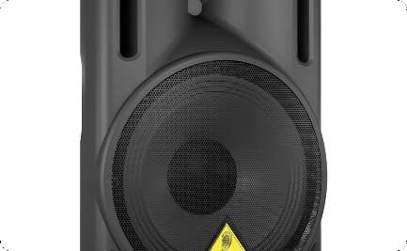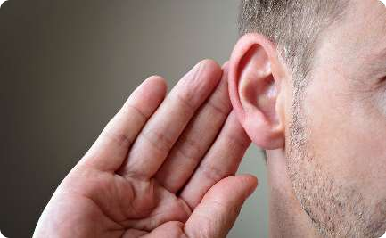

### What is It?

Noise pollution is unwanted or excessive sound that can cause irritation, stress, and even hearing damage.

### Impact on Health

Long-term exposure to noise pollution can lead to hearing loss, high blood pressure, and heart disease.

### Types of Noise

Noise pollution can come from traffic, construction work, music, and many other sources.

Introduction to IoT

What is It?

IoT stands for the Internet of Things. It refers to the network of physical devices, vehicles, home appliances, and other items that are embedded with electronics, software, sensors, and connectivity that enables them to connect and exchange data.

Capabilities

IoT has the potential to revolutionize the way we live and work, from optimizing traffic flow to enabling smart homes and cities.

Applications

IoT is used in various industries, from healthcare to agriculture, to improve efficiency and safety.

# IoT for Noise Pollution Monitoring

### Concept

**1**

**2**

**3**

**Implementation**

IoT-based noise monitoring systems can be installed in various locations, from residential areas to industrial zones, to collect and transmit noise data to a central system for analysis and

visualization.

IoT enables us to collect and analyze data from noise sensors to monitor noise pollution levels in real-time, and identify potential sources of noise pollution.

### Benefits

IoT-based noise monitoring systems can help cities and organizations identify noise pollution hotspots, and take appropriate measures to reduce noise levels and protect public health.

**Technical Aspects of IoT-based Noise Monitoring Systems**

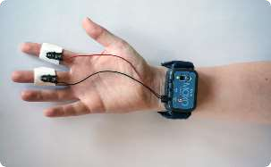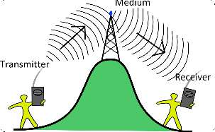

**Sensors**

Noise sensors can be installed on buildings, lampposts, or other structures to collect noise data.

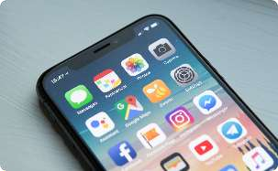

**User Interface**

Noise data can be presented to the public via web or mobile apps, enabling citizens to access

real-time information about

**Communication System**

IoT devices use wireless communication protocols such as Bluetooth, Wi-Fi, or LoRaWAN to transmit data to a central system.

**Central System**

Noise data can be analyzed and visualized using cloud computing platforms such as Amazon Web Services or Microsoft Azure.

Examples of Succes s ful IoT-Based Nois e Monitoring Sys tems

New York City

The city has deployed over 70 noise sensors across five boroughs to monitor noise pollution levels and develop targeted interventions.

Taipei

The Taipei Smart City Project uses IoT-based noise monitoring systems to develop noise pollution maps and inform city planning.

Copenhagen

The city has installed 20 noise sensors in parks and residential areas to monitor the impact of noise pollution on the environment and public health.

Challenges and Solutions

##### Data Privacy

Collecting and transmitting noise data can raise privacy concerns, especially if it includes personally identifiable

information.

##### Solutions

Calibrating sensors, using encryption and anonymization techniques, and collaborating with other agencies and organizations can help address these

challenges.

##### Accuracy of Data

Ensuring that noise sensors provide accurate and reliable data can be challenging, especially in noisy environments.

1

2

3

4

##### Integration with Existing Infrastructure

Integrating IoT-based noise monitoring systems with existing infrastructure such as traffic cameras or weather stations can be complex and costly.

## Conclusion and Future Possibilities



#### Brighter Future

IoT-based noise monitoring systems have the potential to improve our quality of life, protect public health, and enhance city planning.

#### Future Possibilities

Advancements in IoT, AI, and analytics can make noise monitoring systems even more efficient, accurate, and user- friendly.

#### Smart Cities

IoT-based noise monitoring is just one example of how smart cities can leverage technology to create more livable, sustainable, and enjoyable environments for citizens.