Brake Sensor Module – Documentation
Brake Sensor Module – Documentation 1
1. Introduction 3
2. Technical Overview 4
2.1 Brake Sensor Module Connection to Kickr Bike 4
2.1.1 System Integration and Function 5
2.1.1 System Integration and Function 5
2.2 Brake Sensor Wiring to Kickr Bike 5
2.2.1 Connection Overview and Hardware 6
2.3 Assembly Drawing and Bill Of Materials (BOM) 7
2.3.1 Bill Of Materials (BOM) 8
2.3.1.1 Notes for Assembly and CAD model: 8
3 Building Instructions 10
3.1 Mechanical Assembly 10
1. Preparation 10
3.2 3D Print Information 10
4.Software 12

1. Introduction
In a virtual bicycling simulator, accurate braking feedback contributes to a realistic and interactive riding experience. While speed and steering modules handle dynamic motion and directional control, a dedicated brake sensor ensures precise resistance mapping and stopping behavior within the simulation. The brake sensor module measures the pressure applied to the brake lever through a miniature pressure transducer integrated into the braking assembly. This pressure data is continuously read by an Arduino-based interface and transmitted to the simulation software for real-time response.
The brake sensor module is designed to replicate the mechanical and electrical characteristics of a conventional hydraulic or cable-based brake system. It provides analog data corresponding to brake force, which the simulator interprets as deceleration or braking torque. The combination of this pressure sensing with the virtual bike’s physics engine enables a seamless and natural braking feel. This documentation outlines the brake sensor’s function, mechanical setup, electronic integration, and fabrication details, allowing other users to reproduce or modify the system for similar simulation application

- Brake input is as important as speed and steering for a realistic bicycle simulator.
- Commercial trainers often do not offer an analog brake signal; they only simulate braking through software presets.
- The brake sensor module converts the rider’s mechanical input at a dummy brake lever into an electrical brake signal that the simulator can use (e.g. as a normalized value between 0 and 1).
- The module is based on an industrial pressure sensor (SICK PBT-RB060SG1MENR2R0Z, 0–60 bar, 0.5–4.5 V ratiometric, 5 V supply), which measures the hydraulic pressure generated inside a small pressure cylinder.
- Pressure in the cylinder is created by a brake cable that pulls on a piston via a 3D-printed load-cell flange and is balanced by a return spring.
- An Arduino board reads the sensor signal and sends the processed brake value to the simulation PC via Ethernet/UDP, using the same communication pipeline as the steering and speed sensors.

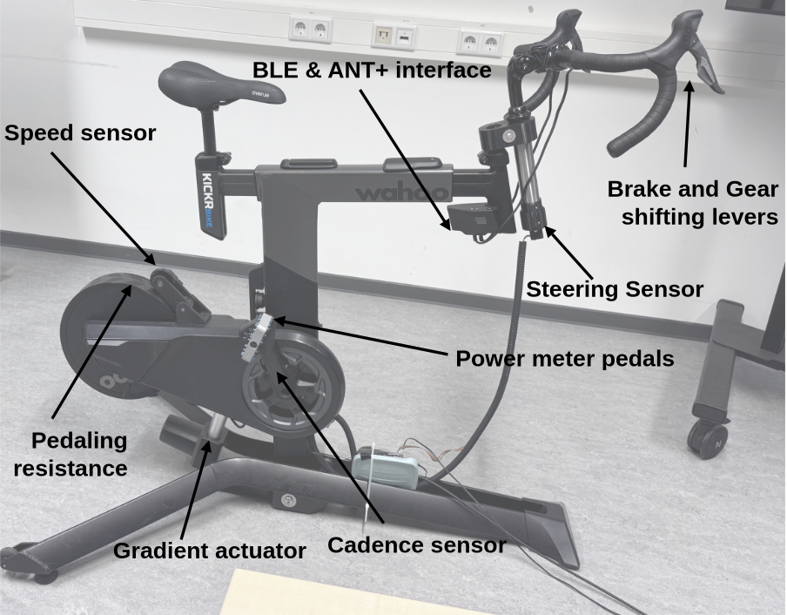

Figure 1: System:Sensors and Actuators

2. Technical Overview

2.1 Brake Sensor Module Connection to Kickr Bike

Figure 2: Mechanical integration - Steering Sensor Module Connection to Kickr Bike

- The Brake_lever_dummy (Item 8) is clamped to the handlebar in a position that feels similar to a normal front brake lever.
- A standard brake cable (Item 9) connects the dummy lever to the brake module housing mounted on the Kickr frame or a nearby support.
- Inside the housing, the cable pulls on the Load_cell_flange_V1 (Item 1), which in turn actuates the Pressure_cylinder_V1 (Item 2).
- The pressure cylinder is fitted with the industrial pressure sensor (Item 7 – based on SICK PBT-RB060SG1MENR2R0Z) at its process port (G ¼ A).
- The Circuit_board_holder_V1 (Item 5) and Lid_V1 (Item 6) form a small electronics enclosure that carries the Arduino (or custom PCB) and cable management.
- Figure X (System overview) shows the mechanical location of the brake module relative to the Kickr Bike and other sensor modules.

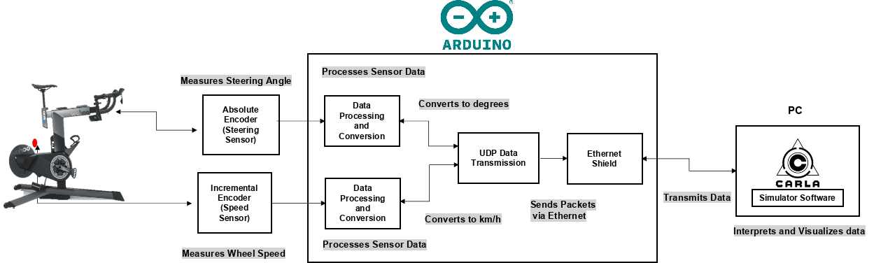
Figure 3: Brake sensor signal transmission and processing

2.1.1 System Integration and Function

2.1.1 System Integration and Function

- Rider squeezes the Brake_lever_dummy and then Cable tension increases in the Brake_cable
- The cable pulls the Load_cell_flange_V1, compressing the fluid inside Pressure_cylinder_V1 against the pressure sensor port.
- The pressure sensor outputs a ratiometric analog voltage (approx. 0.5–4.5 V for 0–60 bar) proportional to pressure.
- The Arduino reads this voltage via an analog input and converts it into a brake value in engineering units (e.g. bar, percentage, or normalized 0–1).
- The processed brake value is:
- Packed into a UDP message,
- Sent over Ethernet to the simulation PC,
- Interpreted in the simulator as a continuous brake command (e.g. front brake force).
- A return spring (Spring_V1, Item 4) resets the lever and relieves pressure when the rider releases the brake, guaranteeing a stable zero point.

2.2 Brake Sensor Wiring to Kickr Bike

Please refer to this Documentation:
Brake sensor Reference Documentationhttps://edg.uchicago.edu/tutorials/load_cell/

2.2.1 Connection Overview and Hardware

- Pressure Sensor (Item 7 – C-20009605-14)
  - Type: SICK PBT-RB060SG1MENR2R0Z or equivalent.
  - Range: 0–60 bar gauge, suitable for low-pressure hydraulic simulation.
  - Output: 0.5–4.5 V ratiometric with 5 V supply.
- Microcontroller
  - Arduino Uno compatible board, reusing the existing Ethernet/UDP infrastructure from speed/steering modules.
- Connectors
  - Screw terminal blocks or a small 3-pin plug inside the electronics housing.
  - Optional cable gland in the Lid_V1 for IP-rated feed-through.
- Power Supply
  - 5 V supply must be within ±10 % and limited-energy as required by the sensor’s UL/EN specification.

2.3 Assembly Drawing and Bill Of Materials (BOM)
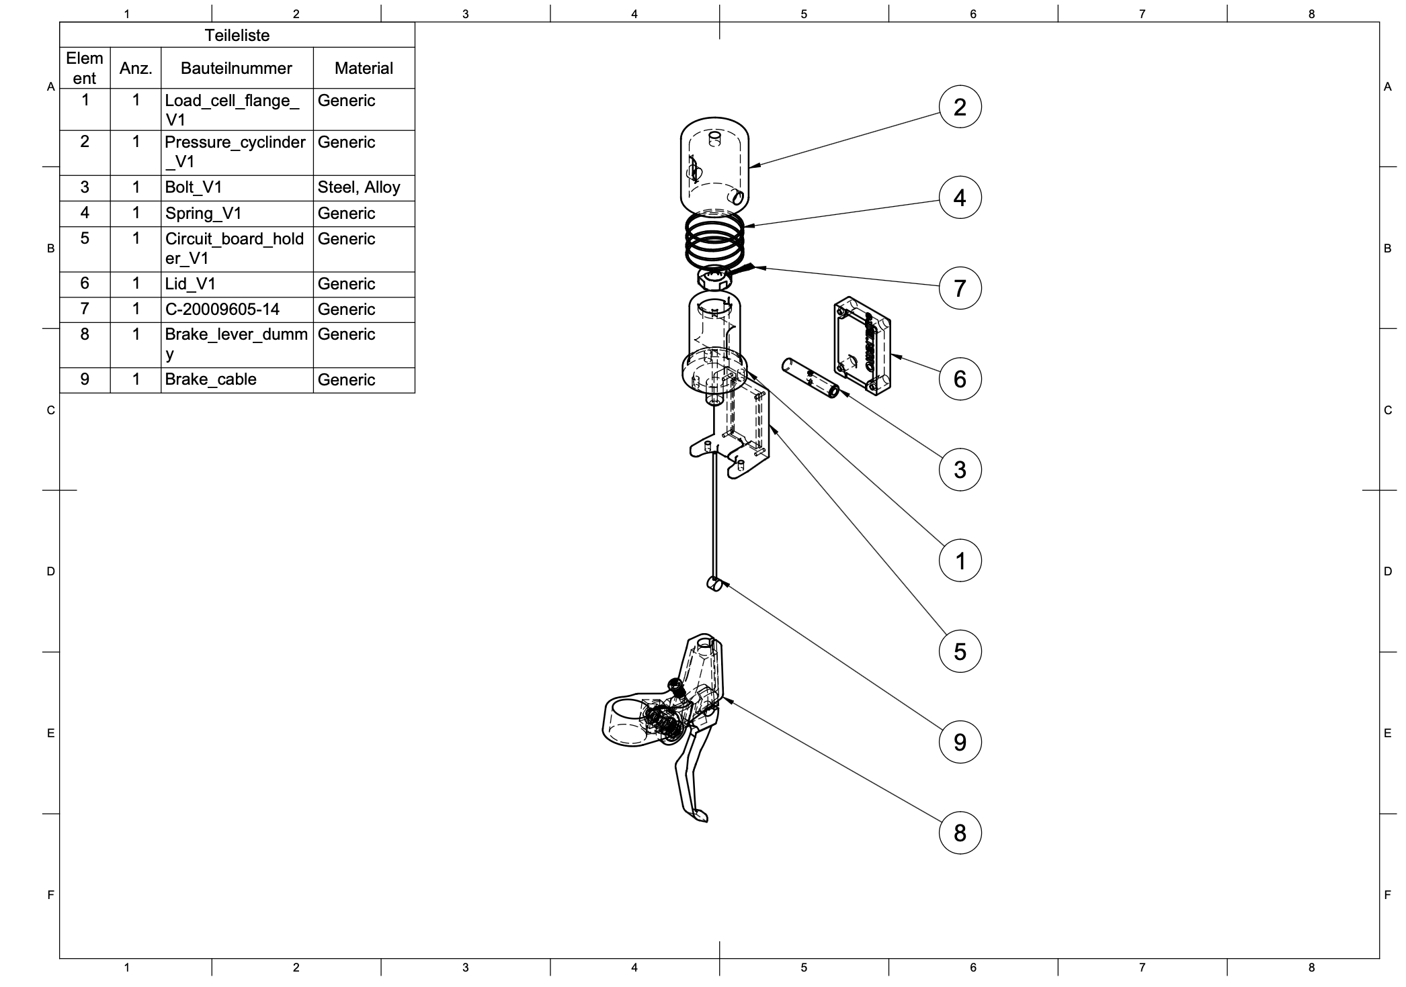
Figure 4: Assembly Drawing of the Brake Sensor

2.3.1 Bill Of Materials (BOM)

- Item 1 – Load_cell_flange_V1
- 3D printed structural part that converts cable tension into axial force onto the pressure cylinder piston.
- Item 2 – Pressure_cylinder_V1
- Contains the fluid chamber and piston interface.
- Provides threaded G ¼ A port for the pressure sensor.
- Item 3 – Bolt_V1
- Steel bolt used to connect flange, cylinder and/or to mount the assembly to the frame.
- Item 4 – Spring_V1
- Restoring spring; defines basic brake feel and returns the lever to its idle position.
- Item 5 – Circuit_board_holder_V1
- Enclosure base for the Arduino or PCB; includes mounting features and cable paths.
- Item 6 – Lid_V1
- Covers the electronics and provides a surface for labels or connector cut-outs.
- Item 7 – C-20009605-14 (Pressure Sensor)
- SICK PBT-RB060SG1MENR2R0Z, 0–60 bar, 0.5–4.5 V.
- Item 8 – Brake_lever_dummy
- Ergonomic lever body clamped to the handlebar; anchors outer housing of the brake cable.
- Item 9 – Brake_cable
- Standard bicycle brake cable plus housing; transfers lever motion to the load-cell flange.

Item | Qty | Part Name | Part Name / Reference | Description | Material/ Standard | Remarks
1 | 1 | Load Cell Flange | Load_cell_flange_V1 | 3D-printed structural part that holds the load cell and screws into the brake lever. | 3D Filaments PLA (1.75 mm) | [3D Filaments PLA link](https://www.3dmensionals.de/3dmensionals-pla-filament-2580?number=PSU3DM001V.2#attr=11255,11254,11271,4165,4164,21806,23697,24892,25436)
2 | 1 | Pressure Cylinder | Pressure_cylinder_V1 | 3D-printed structural part that converts brake-cable tension into axial force onto the load cell. | 3D Filaments PLA (1.75 mm) | [3D Filaments PLA link](https://www.3dmensionals.de/3dmensionals-pla-filament-2580?number=PSU3DM001V.2#attr=11255,11254,11271,4165,4164,21806,23697,24892,25436)
3 | 1 | Bolt | Bolt_V1 | Manufactured steel bolt for connecting cylinder and brake cable. | Precision Steel 8h6, 1.4301
4 | 1 | Spring | Spring_V1 | Spring to restore the position of brake lever and pressure cylinder when releasing manual brake force
5 | 1 | Circuit Board Holder | Circuit_board_holder_V1 | Enclosure base for the amplifier circuit board. Includes mounting features and cable paths. | 3D Filaments PLA (1.75 mm)
6 | 1 | Lid | Lid_V1 | Covers encloser containing amplifier. | 3D Filaments PLA (1.75 mm)
7 | 1 | Pressure Sensor | C-20009605-14 |  | Generic
8 | 1 | Brake Lever | Brake_lever_dummy | Brake lever for cable operated brakes with an M10x1 mm thread for cable tension adjustment. | Aluminium Alloy
9 | 1 | Brake Cable | Brake_cable | Standard bicycle brake cable | Steel cable
10 | 1 | Grid Circuit Board |  | Grid circuit board to be cut to fit the enclosure. Holds amplifier and connects wires. Not shown in drawing | Laminated circuit board | Product example
11 | 1 | Amplifier | Burr-Brown INA125 Instrumentation Amplifier | Amplifies load cell signal for transmission to Arduino. Not shown in drawing. | Semi-conductor | Burr-Brown INA125 Instrumentation Amplifier

Figure 6: Table - Bill Of Materials (BOM).

2.3.1.1 Notes for Assembly and CAD model:

3 Building Instructions

3.1 Mechanical Assembly
The following steps provide a clear procedure to ensure your mechanical assembly of the Speed Sensor is precise and reliable.

1. Preparation
Start by cleaning all the 3D printed parts—these include positions 1, 3, 4, 5, 6, 7, 8, 10, 11, and 12. Make sure to:
- Remove any leftover plastic or rough edges.
- Lightly sand or round off any sharp corners so that all joining surfaces are smooth and flush.
Next, gather all the necessary hardware and adhesives:
- Glue: Use rapid-setting cyanoacrylate (also called “seconds” glue) for bonding plastic components.
- Ball Bearings: F-688 type, quantity: 2 (Position 4).
- Washers: Flat metal washers, quantity: 2 (Position 5).
- Lock Ring: Retaining ring (Position 6).
- Screws: Small M2.5 x 8 fillister head screws for securing the encoder’s bottom plate.
- Connector Housing (Position 10) and Molex Socket Connector Housing
- Joint Shaft (Position 11) and Tension Spring (Position 12).

3.2 3D Print Information

To fabricate the mechanical components of the speed sensor system, we employed Fused Filament Fabrication (FFF) (a common 3D printing method that extrudes molten plastic layer by laye) using a Prusa i3 MK3 3D printer. This section provides key technical parameters and setup configurations to ensure reproducibility of the print results with similar quality and structural integrity.

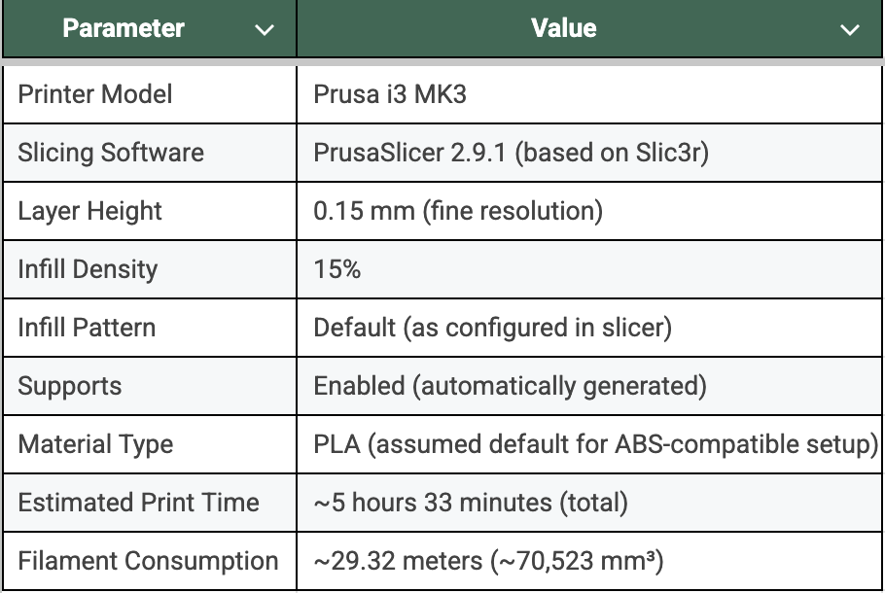
Figure 8: Table - 3D printring Information

Note: Automatic supports were essential for maintaining bore hole geometry, particularly in overhang regions where drooping or collapse may otherwise occur during printing.
Additional Recommendations:
- Post-processing: After printing, components were deburred and cleaned to remove any support material and residual brim structures. This ensures tight fits between bearings, shafts, and sensor housings.
- Tolerance Fit: It is recommended to maintain ±0.05 mm tolerance for critical bore fits, especially for bearing seats and shaft passages.
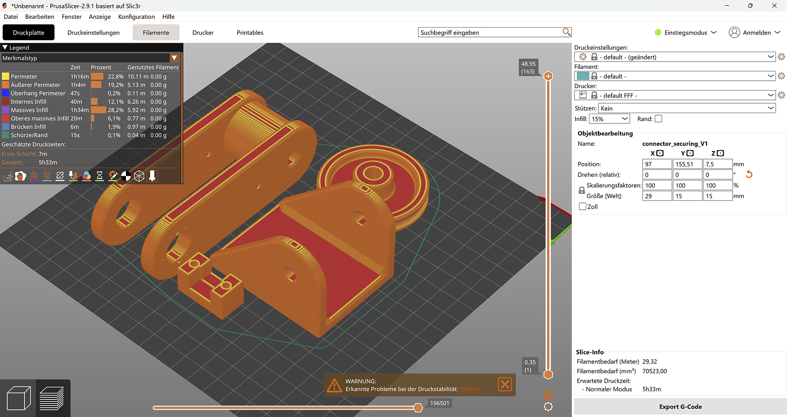
Figure 9: Screenshot Prusa G-code Viewer
The screenshot (Figure 9) from Prusa G-code Viewer shows the exact layout and orientation of all parts on the printer tray during slicing. This is critical for:
- Ensuring flat-base printing and stable adhesion to the build plate
- Maintaining correct dimensional references for mating parts
- Minimizing support material in critical surface areas
referencce link to G code MATHIS!!!

4.Software

- Reference to the prevailing documentation. (in github)

