Response to proof

The Tables I-III in the proof look very bad (I have a hard time understanding them myself). I have simplified the LaTex script for generating these tables, and hope this will help ease the transition into your format. It appears that your style is to minimize the use of horizontal lines within the tables. I have taken most out, but have left a few that I feel make interpreting the table much easier. Please consider leaving these horizontal lines in place. I have included below screen-shots demonstrating how the tables will ideally look. Please let me know if any additional tweaks need to be made to these tables, or if you have any additional questions. Thanks!

P.S. I also have a minor comment regarding Table IV, which I have included after the screen-shots for Tables I-III

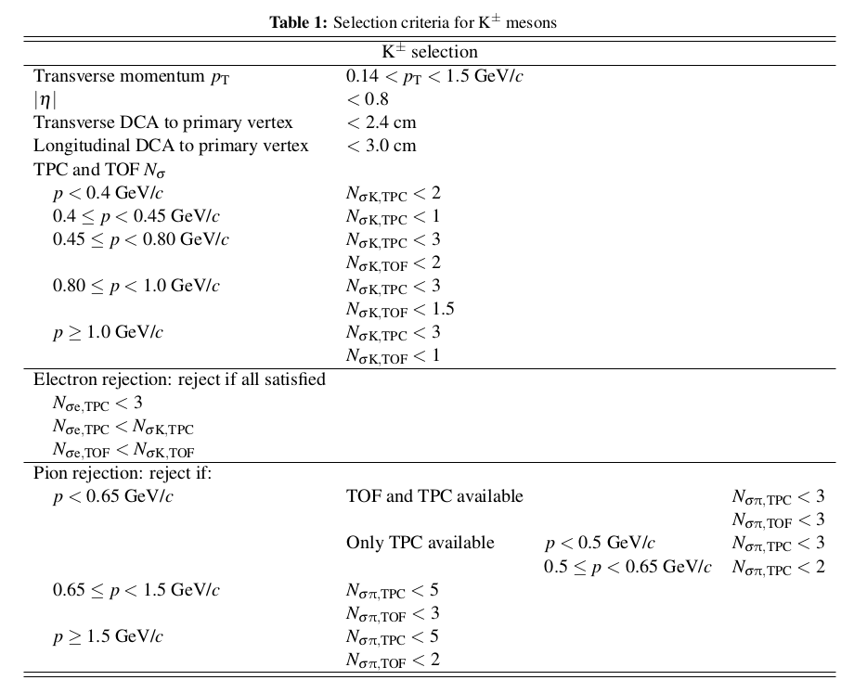

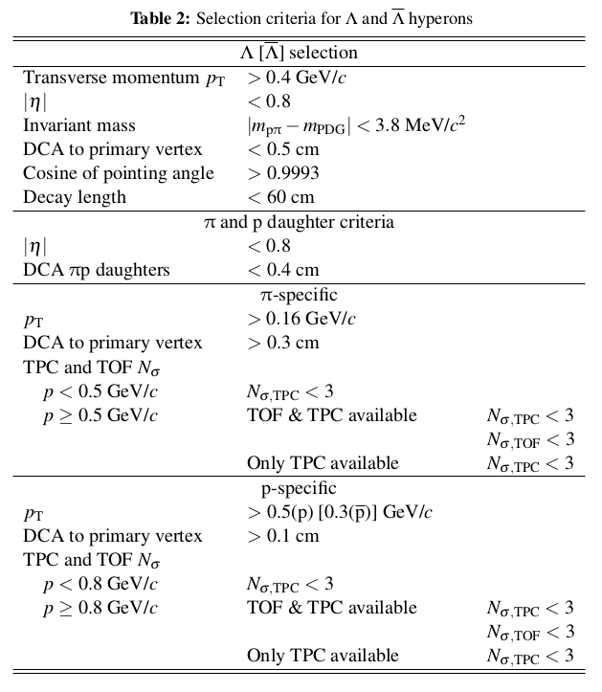

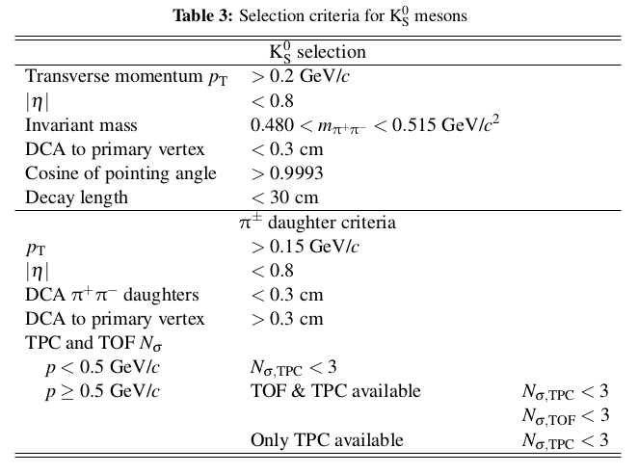
Table IV is essentially a collection of six tables in one. Therefore, I believe it best to keep each completely separate; i.e., instead of all sharing a common horizontal line below the “Source λ value” entries, the line should be broken for each sub-table. I have included both the version from the current proof together with how I believe the table should ideally look.

From current proof

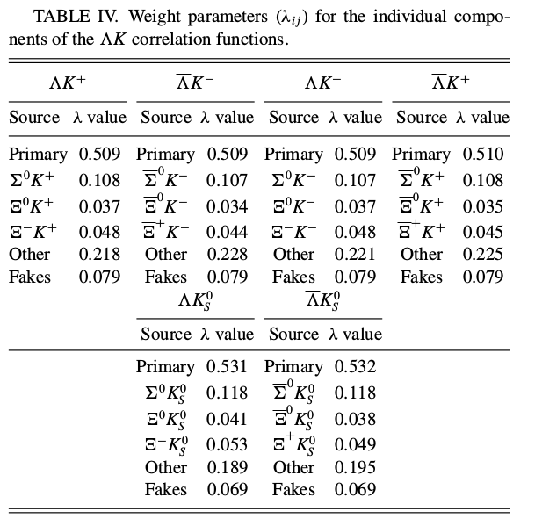

Ideal
