https://www.rfc-editor.org/rfc/rfc7230#section-3.1

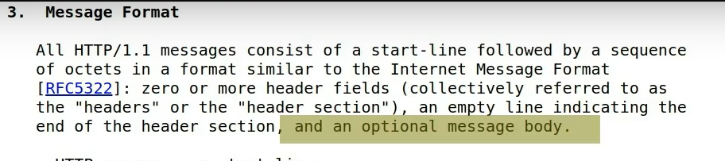

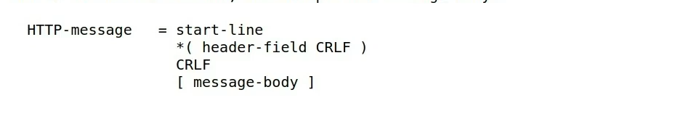

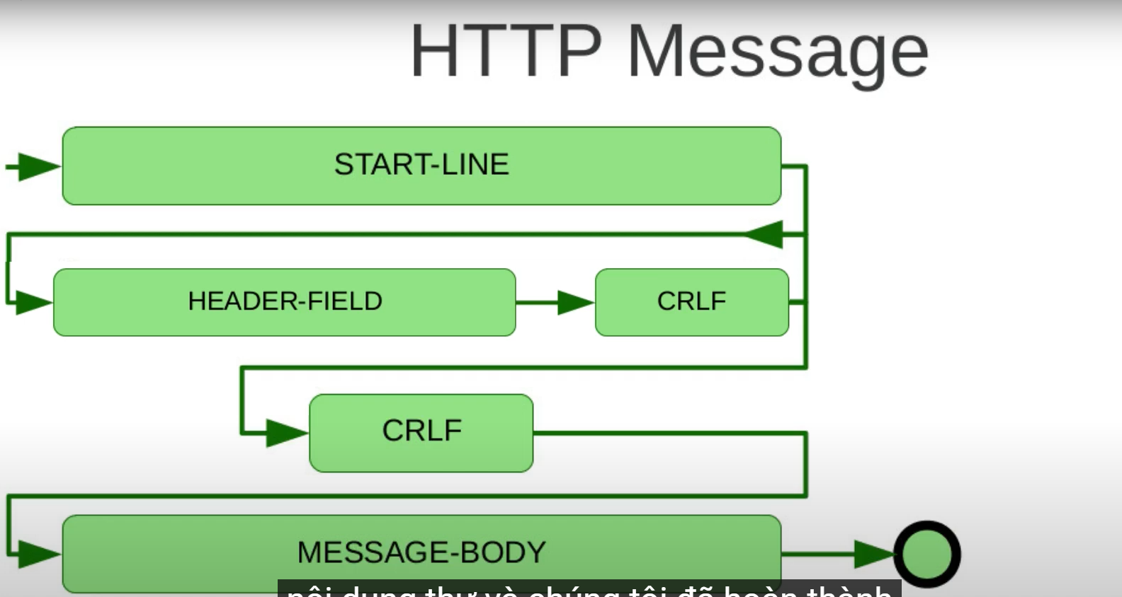

Start-line: là các request-line cho request hoặc status-line cho response

* request-line = method SP request-target SP HTTP-version CRLF (method = token)