Operation Quality Report
Analysis Period: 2024-04-19 to 2025-07-06

Service Health Score
33  🔴 At Risk | SLA Compliance: 64.2% (→1.5%)  Change Success Rate: 84.0%  CSAT Score: 3.61/5  Problem Closure Rate: 48.0%

Process Overview
Incidents | Changes | Requests | Problems
8977 | 50 | 50 | 50

Key Performance Indicators
SLA Compliance | Avg MTTR | P1/P2 Incidents | Backlog
64.2% →1.5% | 29.4h ↑25.2% | 1794 ↓84.5% | 0
Change Success Rate | Change-Induced Incidents | Request SLA | CSAT Score
84.0% | 0 | 75.8% | 3.61/5
Problem Closure Rate | RCA Completion
48.0% | 0

SLA Breakdown by Priority
Priority | Target (hours) | Total Tickets | Compliant | SLA Rate
P1 | 2h | 448 | 31 | 6.9%
P2 | 6h | 1346 | 208 | 15.5%
P3 | 24h | 3141 | 1495 | 47.6%
P4 | 48h | 4042 | 4029 | 99.7%

Trend Analysis
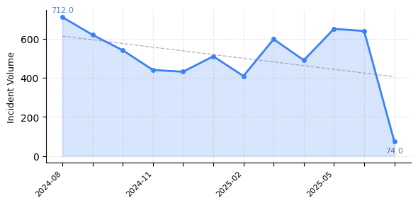

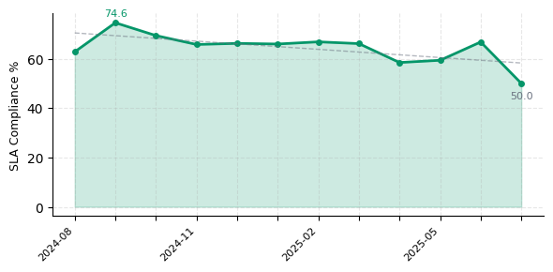

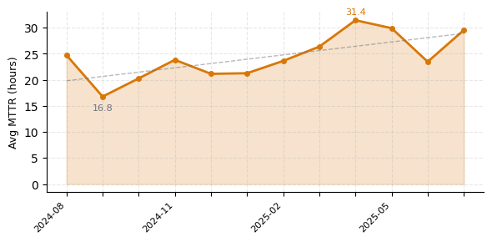

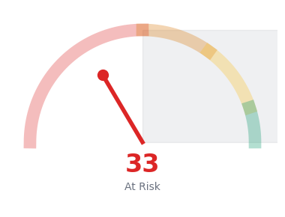

Risk Radar
[CRITICAL] Incident SLA compliance at 64.2%
Impact: Customer SLO commitments at risk

[CRITICAL] 9 changes caused incidents (18.0%)
Impact: Changes are causing service incidents

[WARNING] Category 'Compliance' MTTR is 67.8h
Impact: Extended resolution times affecting service levels

[WARNING] Category 'Customer Complaint' MTTR is 341.8h
Impact: Extended resolution times affecting service levels

[WARNING] Category 'Infra' MTTR is 70.3h
Impact: Extended resolution times affecting service levels

Recommended Actions
[URGENT] Review and optimize incident SLA compliance processes
Expected: Improve SLA rate by 10-15%

[URGENT] Implement post-change validation and monitoring
Expected: Reduce change-induced incidents by 50%

[HIGH] Strengthen change assessment and testing procedures
Expected: Improve change success rate to 95%+

[MEDIUM] Analyze and streamline incident resolution workflow
Expected: Reduce average MTTR by 20-30%

[MEDIUM] Analyze customer feedback and improve service delivery
Expected: Improve CSAT to 4.0+

Major Incidents
ID | Description | Priority | Resolution
80006875 | du_269399978864 | P1 | 29.7h
80001510 | du_603668284656 | P1 | -
80007959 | du_284454479271 | P1 | 44.8h
80005246 | du_249539738683 | P1 | 0.2h
80002519 | du_811061671688 | P1 | 28.3h

Generated on: 2026-01-29 01:20 | Confidential - Internal Use Only

