SLA Violation Attribution Analysis Report
Data Period: 2024-04-19 ~ 2025-07-06

Executive Summary
Total Tickets | Response SLA | Resolution SLA | Total Violations | High Risk Tickets
8,977 | 99.9% | 64.2% | 3,214 | 4,423

Critical Alert: Resolution SLA (64.2%) is significantly below the 95% target. P1 Resolution SLA is only 6.9% and P2 is 15.5%. Immediate action required.

High Priority Analysis (P1/P2)
P1 and P2 incidents require immediate attention. SLA targets: P1 Response 15min/Resolution 2h, P2 Response 30min/Resolution 6h.
 | Response SLA | Resolution SLA
P1 (n=448) | 98.9% | 6.9%
P2 (n=1346) | 99.7% | 15.5%

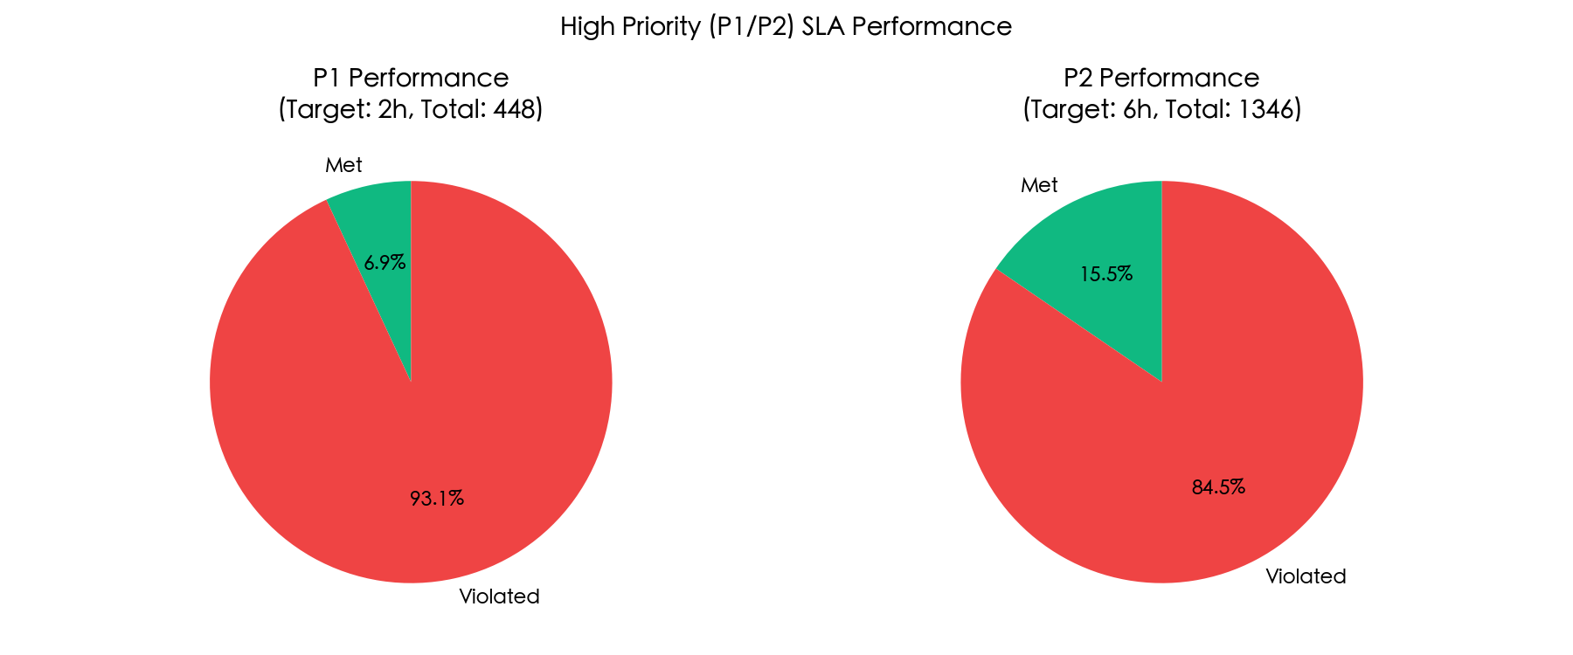

Monthly Trend Analysis
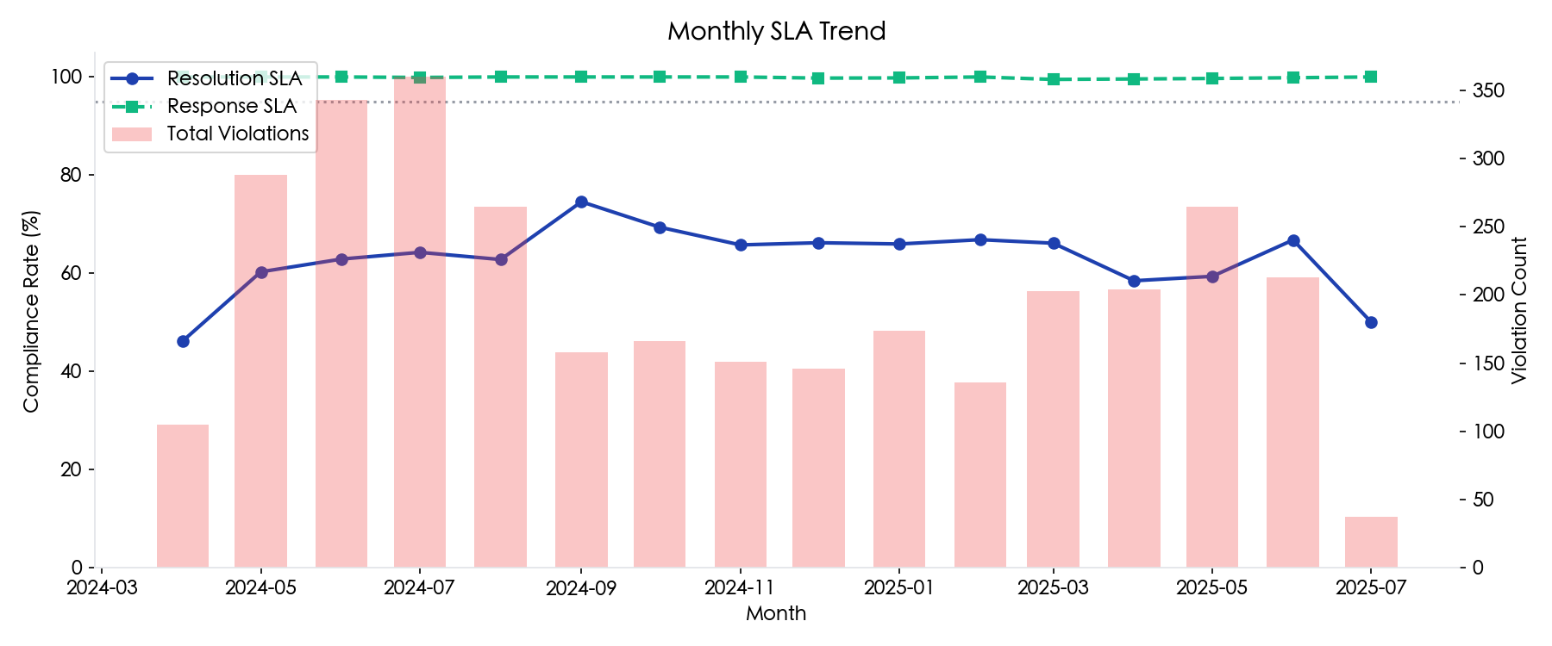

SLA Compliance by Priority
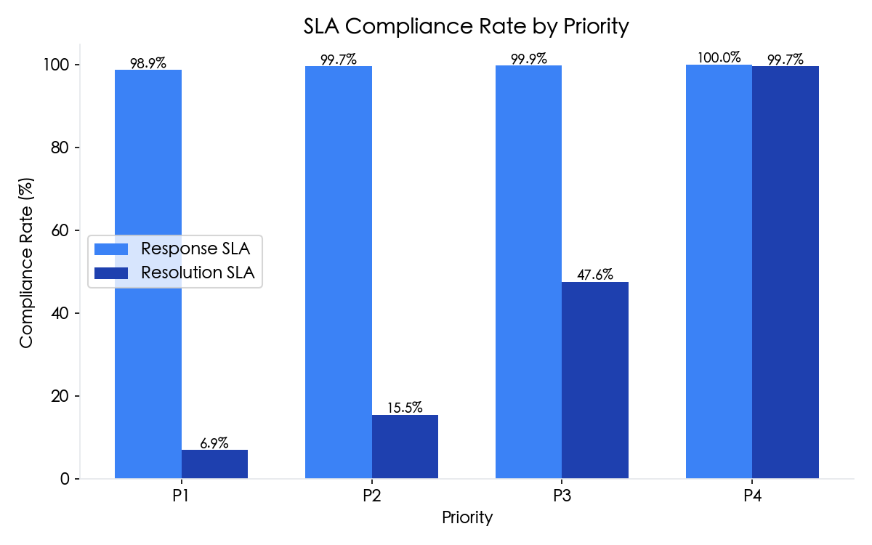
Priority | Response Target | Response SLA | Resolution Target | Resolution SLA | Total
P1 | 15 min | 98.9% | 2 h | 6.9% | 448
P2 | 30 min | 99.7% | 6 h | 15.5% | 1,346
P3 | 45 min | 99.9% | 24 h | 47.6% | 3,141
P4 | 60 min | 100.0% | 48 h | 99.7% | 4,042

Risk Analysis
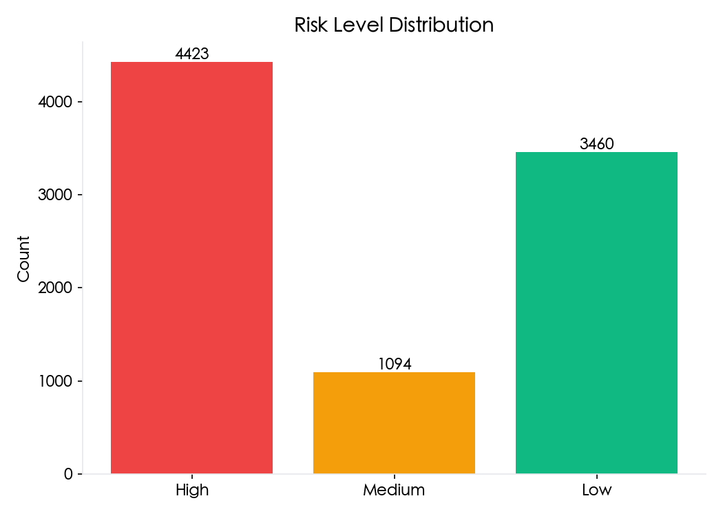

Attribution Analysis
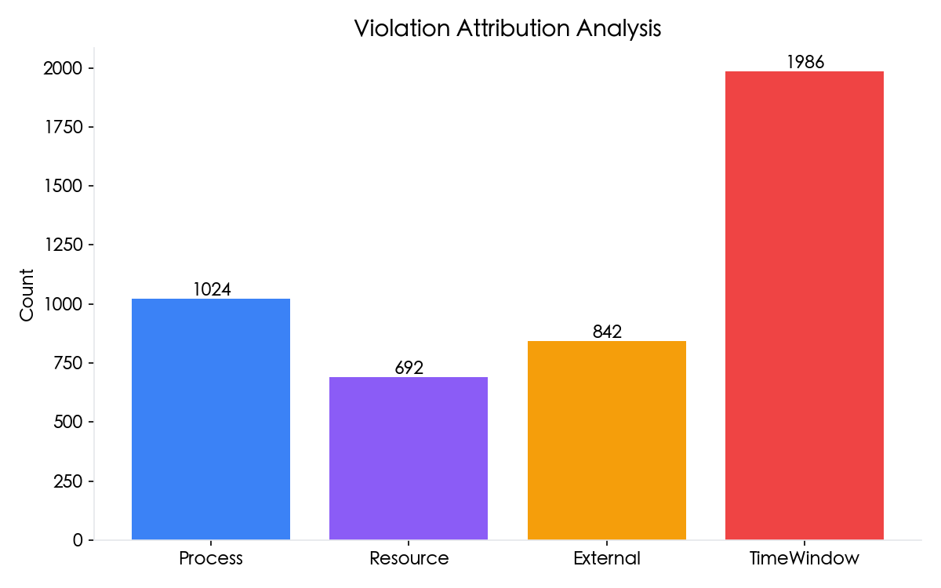
Process | Resource | External | TimeWindow
1,024 (23%) | 692 (15%) | 842 (19%) | 1,986 (44%)
Note: Attribution total (4,544) may differ from violation count (3,214) because a single ticket can have multiple contributing factors.

Violation Deep Dive
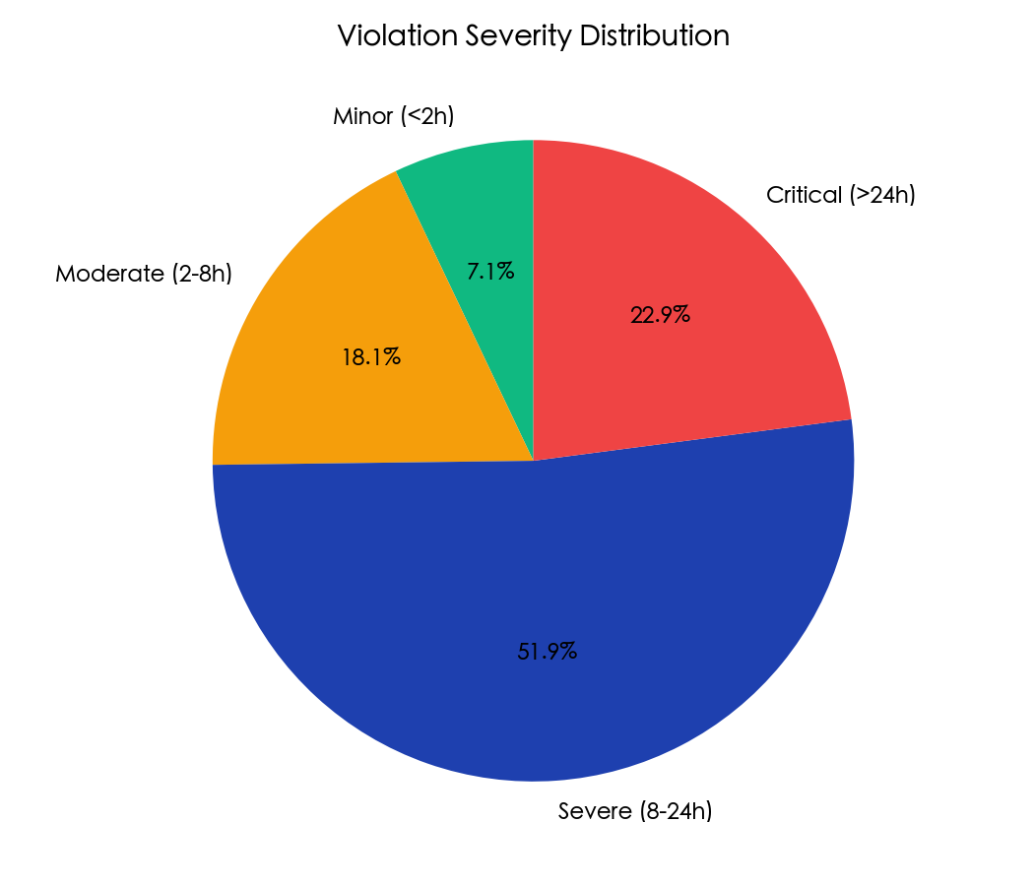

Violations by Category
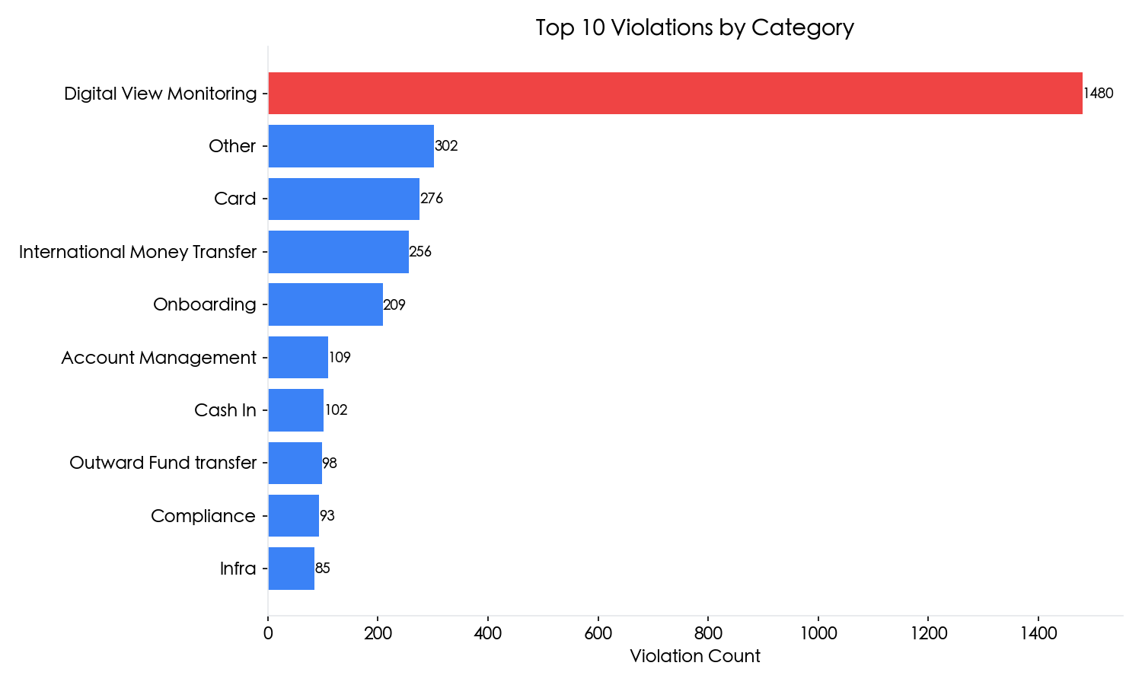

Improvement Recommendations
[CRITICAL] P1/P2 SLA Performance
P1 Resolution SLA is at 6.9% (target: 95%). P2 is at 15.5%.
• Establish dedicated P1/P2 response team with <15min initial response
• Implement automatic escalation after 50% SLA consumption
• Create P1 war room protocol with multi-team coordination
• Review P1/P2 classification criteria - ensure proper prioritization

[CRITICAL] Time Window Factor (44% of violations)
Majority of violations occur during off-hours (18:00-09:00) and weekends.
• Strengthen on-call coverage during 18:00-09:00 shift
• Implement weekend duty rotation with dedicated escalation path
• Consider automated triage and routing for off-hours tickets
• Evaluate 24/7 NOC coverage for P1/P2 incidents

[HIGH] External Dependencies (19% of violations)
Tickets pending on external teams or customers cause significant delays.
• Establish SLA agreements with dependent teams (internal OLAs)
• Implement automated customer follow-up reminders
• Create "pending external" dashboard for proactive management
• Define escalation triggers when external wait exceeds threshold

[HIGH] Process Improvement (23% of violations)
Reassignment and escalation delays contribute to SLA breaches.
• Reduce average reassignment count (target: <2 per ticket)
• Implement skill-based routing to minimize transfers
• Create clear escalation matrix with defined triggers
• Train L1 team on better initial categorization

[MEDIUM] Category Focus: Digital View Monitoring
This category accounts for 1,480 violations (46% of total).
• Review monitoring alert thresholds to reduce false positives
• Create runbooks for common scenarios
• Consider automation for repetitive tasks

[MEDIUM] Top Resolvers Workload
Top resolver has 154 violations. Consider workload balancing.
• Review workload distribution across team members
• Implement workload caps and automatic redistribution
• Identify training needs for lower-performing resolvers

Generated on 2026-01-28 23:05

