BO Workload Performance Report
Second/Third-Line Expert Analysis
Analysis Period: 2024-04-19 to 2025-07-06
Generated on: 2026-01-28 23:08:57

Table of Contents
(Update fields to generate TOC)

Executive Summary
Total BO Experts | Total BO Tickets | Average MTTR (hours) | SLA Compliance Rate | High Risk Items | Bottleneck Experts
6 | 2180 | 29.4 | 64.2% | 0 | 0

AI Insights:
### **Executive Summary: BO Workload Analysis Insights**

**1. Overall Health Assessment**
- **Moderate Performance with Structural Concerns:** While no high-risk items or formal bottlenecks are flagged, the operation shows significant strain. The 64.2% Global SLA rate is critically low, indicating widespread difficulty in meeting service commitments. The 29.4-hour Mean Time to Resolution (MTTR) is excessively high for typical support environments, suggesting inefficiencies in ticket handling and resolution processes.
- **Severe Resource Imbalance:** The tier structure is fundamentally misaligned. With only 6 Tier 2/3 (BO) resolvers supporting 24 total agents, the escalation path is narrow. This is compounded by **0 Tier 3** specialists, forcing all complex issues to be handled by a very small Tier 2 group. Tier 1 agents (18) lack sufficient backend support, which likely contributes to long resolution times and low SLA compliance.

**2. Most Critical Risk Points**
- **Capacity Crisis in Backoffice Support:** 6 BO resolvers are managing 24.3% of the total ticket volume (2180 tickets). This equates to an average of **363 tickets per BO resolver**, an unsustainable workload that directly causes the high MTTR and breached SLAs. This is the core operational bottleneck, even if not formally tagged.
- **Complete Absence of Deep Expertise:** The lack of a Tier 3 (subject matter expert) layer is a major strategic risk. Complex, recurring, or novel issues have nowhere to go for efficient resolution, creating a "ceiling" for problem-solving. This leads to ticket ping-pong, prolonged resolutions, and agent knowledge gaps.
- **Erosion of Service Quality and Agent Morale:** Chronically missed SLAs and long resolution times will damage client satisfaction. Furthermore, Tier 1 agents facing unresolved escalations and Tier 2 agents under constant overload are at high risk of burnout and decreased productivity.

**3. Items Requiring Immediate Attention**
- **Conduct a Urgent Capacity Review:** Immediately analyze the 2180 BO tickets by category and complexity. Determine what percentage truly requires Tier 2 vs. what could be resolved at Tier 1 with better training, knowledge base articles, or enhanced permissions. This is the first step to rebalancing the workload.
- **Launch a "Knowledge Elevation" Program:**
* **For Tier 1:** Implement targeted training and create quick-reference guides for the most common issues currently escalated to Tier 2. Empower them to resolve more.
* **For Tier 2:** Initiate a plan to develop Tier 3 capabilities. Identify top-performing Tier 2 agents and begin grooming them in specific complex areas (e.g., specific software modules, advanced network issues) to build a de facto expert layer.
- **Implement Tier 2 Queue Management & Prioritization:**
* **Short-term:** Establish clear triage and priority rules for the BO queue to ensure critical issues are addressed first, mitigating the highest business impacts.
* **Medium-term:** Advocate for the approved headcount of at least 1-2 Tier 3 specialists or an immediate increase in Tier 2 capacity to structurally address the 1:4 resolver-to-agent ratio, which is the root cause of performance issues.

BO Tier Classification
Auto-classification based on complexity index, priority handling, and specialization.
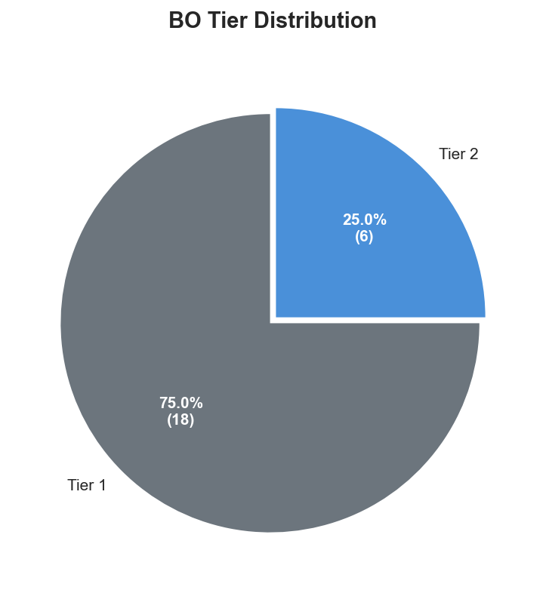
Resolver | Assigned Tier | Complexity Index | Total Tickets | Justification
Susan Smith | Tier 2 | 0.82x | 361 | Moderate P1/P2 ratio (18%); Moderately specialized...
Thomas Smith | Tier 2 | 1.79x | 389 | Moderate complexity (1.79x avg); Moderate P1/P2 ra...
Daniel Smith | Tier 2 | 1.73x | 375 | Moderate complexity (1.73x avg); Moderate P1/P2 ra...
Charles Smith | Tier 2 | 0.86x | 381 | Moderate P1/P2 ratio (21%); Moderately specialized...
David Smith | Tier 2 | 1.83x | 326 | High complexity (1.83x avg); Moderate P1/P2 ratio ...
Mary Smith | Tier 2 | 1.65x | 348 | Moderate complexity (1.65x avg); Moderate P1/P2 ra...

Single-Point Dependency Risk Matrix
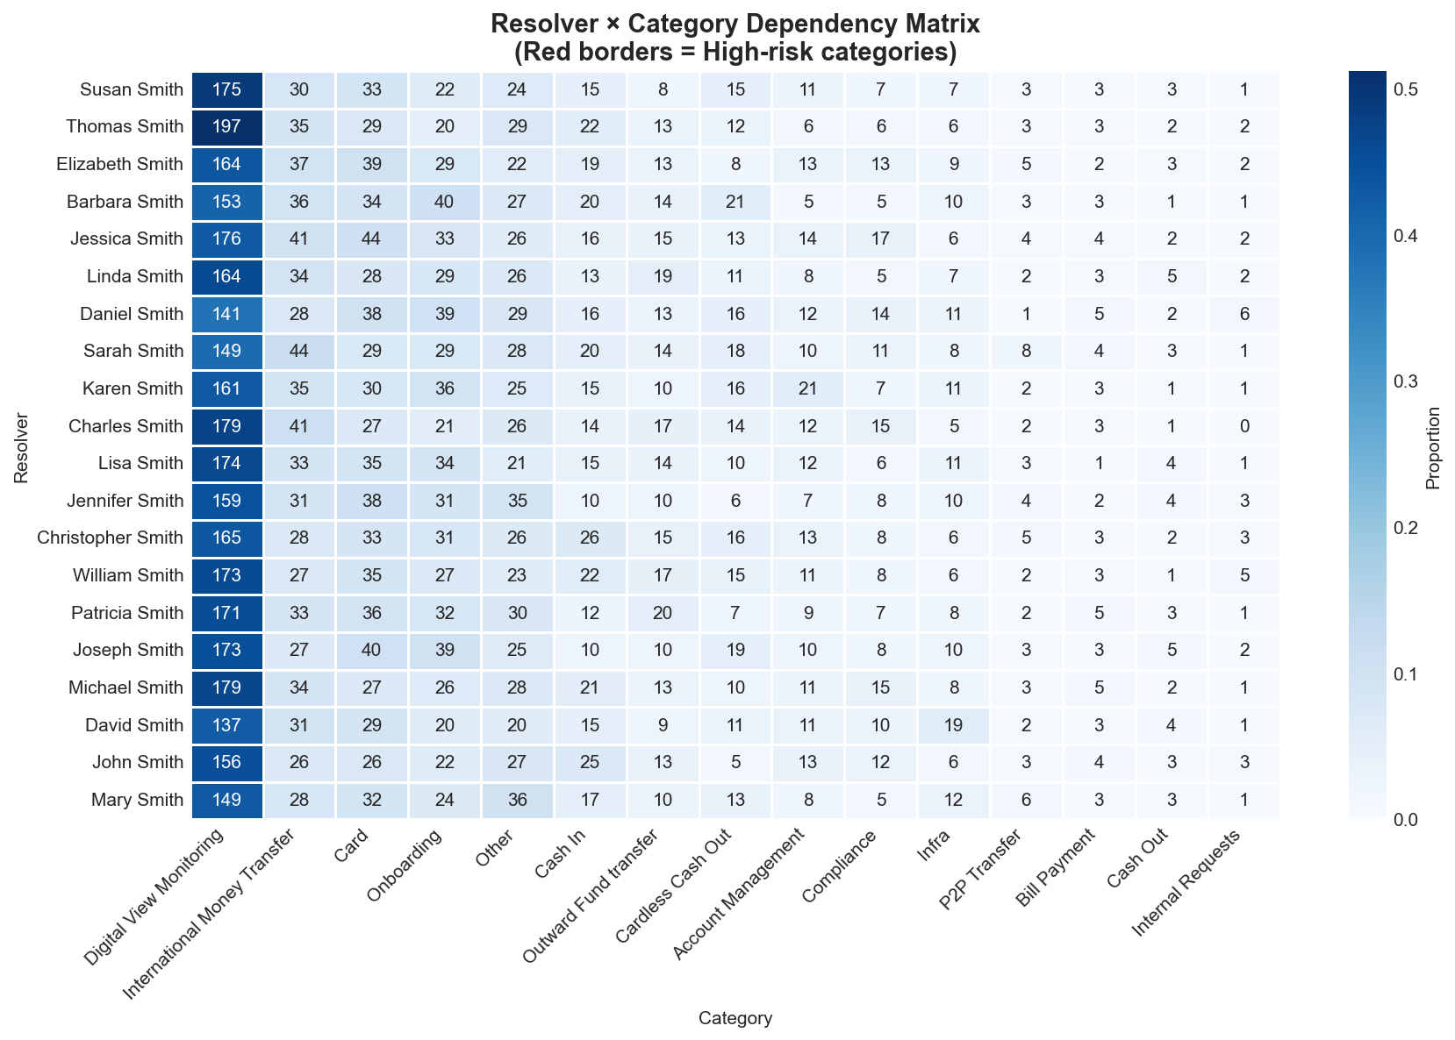
No data available

AI Insights:
Based on the provided data, here is the analysis and recommended action plan.

### **1. Risk Assessment and Potential Impact**

* **Current State:** The data indicates **no identified high-risk single-point dependencies or knowledge silos**. This is a positive finding, suggesting a well-distributed knowledge base and effective cross-training within the team or organization.
* **Potential Impact of Complacency:** The primary risk is not from a visible weakness but from **complacency**. Without active monitoring and maintenance, this healthy state can degrade. The potential impact of a future, undetected dependency forming could be severe, leading to operational disruption, project delays, or loss of critical institutional knowledge if a key person leaves unexpectedly.
* **Implicit Risk:** The absence of documented risks does not guarantee they do not exist; it may indicate that the current assessment methods or metrics are not capturing nuanced or emerging dependencies.

### **2. Knowledge Transfer Priority Recommendations**

Given the absence of critical silos, the priority shifts from firefighting to **proactive resilience building** and **validation**.

* **Implement a Proactive "Dependency Hunt" Review:** Schedule quarterly workshops where teams map core processes and systems to identify *potential* future single points of failure before they become critical.
* **Focus on Cross-Training for Breadth, Not Just Depth:** Prioritize knowledge transfer sessions on:
* **System Architecture & Integration Points:** Ensure multiple team members understand how major systems interconnect.
* **Vendor & Stakeholder Management:** Distribute key external relationship knowledge.
* **Decision Rationale & "Tribal Knowledge":** Capture the "why" behind key processes or architectural decisions that may not be fully documented.
* **Validate Existing Knowledge Distribution:** Conduct periodic, practical "fire drills" or scenario-based tests to verify that backup personnel can successfully perform critical tasks without the primary expert.

### **3. Documentation and Backup Personnel Training Plan**

The goal is to institutionalize knowledge and make the current resilient state sustainable.

* **Documentation Strategy:**
* **Mandate "Documentation as Part of Delivery":** For all key projects or system changes, require the creation or update of runbooks, decision logs, and architecture diagrams as a non-negotiable completion criterion.
* **Centralize and Audit Critical Documentation:** Maintain a single, easily accessible repository for all critical operational knowledge. Perform bi-annual audits to ensure documents are accurate and current.
* **Promote "Lightweight" Documentation:** Encourage the use of video recordings (screen shares), annotated diagrams, and wikis to lower the barrier to knowledge capture.

* **Backup Personnel Training Plan:**
* **Establish a Formal "Buddy & Shadow" System:** Pair primary and backup personnel for critical roles. Require backup personnel to shadow key tasks (e.g., deployments, critical issue resolution) on a regular, scheduled basis (e.g., once per quarter).
* **Create a "Readiness Checklist" for Key Roles:** For each critical function, develop a checklist of competencies. Backup personnel must demonstrate proficiency in these areas, verified by the primary and a manager.
* **Schedule Dedicated "Knowledge Transfer Sprints":** Periodically (e.g., twice a year), allocate dedicated time where primary experts run hands-on workshops for their backups, working through real-world scenarios and problem-solving.
* **Incorporate Backup Role Performance into Goals:** Include knowledge transfer contributions and the demonstrable readiness of one's backup as a component in performance evaluations for individuals in critical roles.

**Conclusion:** The current data presents an opportunity to build a best-in-class, proactive knowledge management culture. The recommended actions focus on leveraging this strong baseline to create systemic defenses against future risk, ensuring long-term operational stability and continuity.

Bottleneck Analysis
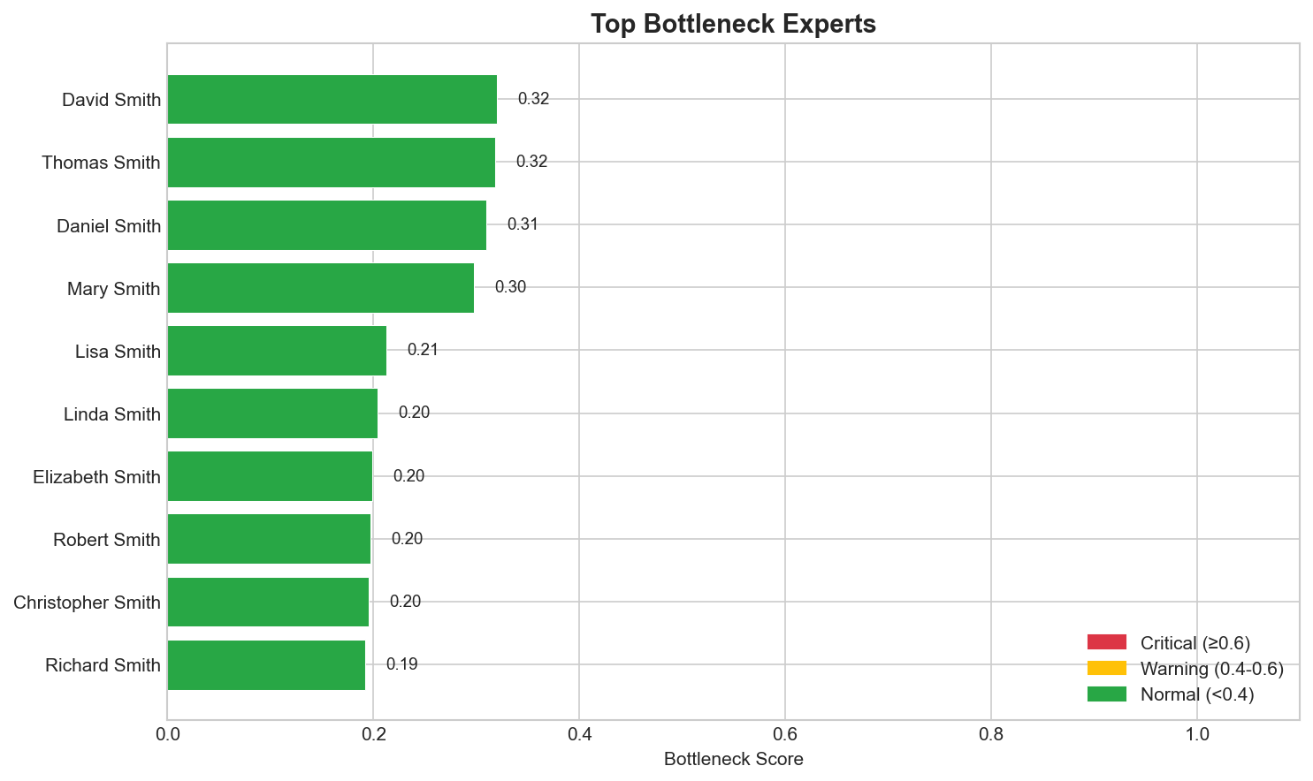
Rank | Resolver | Bottleneck Score | Current Backlog | SLA Compliance Rate | Root Cause
1 | David Smith | 0.32 | 0 | 65.0% | MTTR 54h exceeds threshold, SLA compliance 65%
2 | Thomas Smith | 0.32 | 0 | 63.5% | MTTR 53h exceeds threshold, SLA compliance 63%
3 | Daniel Smith | 0.31 | 0 | 63.2% | MTTR 51h exceeds threshold, SLA compliance 63%
4 | Mary Smith | 0.30 | 0 | 64.4% | MTTR 48h exceeds threshold, SLA compliance 64%
5 | Lisa Smith | 0.21 | 0 | 59.5% | MTTR 28h above target, SLA compliance 59%
6 | Linda Smith | 0.20 | 0 | 64.4% | MTTR 29h above target, SLA compliance 64%
7 | Elizabeth Smith | 0.20 | 0 | 60.9% | MTTR 26h above target, SLA compliance 61%
8 | Robert Smith | 0.20 | 0 | 63.0% | MTTR 26h above target, SLA compliance 63%
9 | Christopher Smith | 0.20 | 0 | 64.1% | MTTR 26h above target, SLA compliance 64%
10 | Richard Smith | 0.19 | 0 | 62.5% | MTTR 25h above target, SLA compliance 63%

AI Insights:
# **Bottleneck Analysis & Improvement Recommendations**

## **1. Root Cause Diagnosis**

The analysis reveals a critical systemic issue affecting team performance, characterized by:

* **Severe MTTR (Mean Time to Resolution) Exceedances:** Five out of six experts have MTTRs significantly above the global average (29.4h), with four experts exceeding 48 hours. This is the primary driver of the high bottleneck scores.
* **Consistently Low SLA Compliance:** All listed experts have SLA compliance rates between 59% and 65%, far below an acceptable operational standard (typically >95%). This directly correlates with the extended MTTR.
* **Pattern of Chronic Underperformance:** The issue is not isolated but affects the majority (83%) of the team, indicating a process, skill, or workload management failure rather than individual underperformance.
* **Absence of Backlog:** The zero backlog for all experts suggests the problem is not due to an overwhelming ticket volume but rather inefficiency in the **resolution process itself**.

**Primary Root Cause:** The data strongly points to **ineffective ticket resolution processes and/or significant skill gaps** within the team. Experts are taking too long to resolve issues they own, leading to chronic SLA breaches.

## **2. Short-Term Mitigation Measures (1-2 Weeks)**

Immediate actions to stabilize performance and protect SLAs:

* **Implement Tiered Escalation & Swarming:** For tickets approaching SLA breach (e.g., at 75% of SLA time), mandate immediate escalation to a team lead or initiate a "swarm" session with other experts to collaboratively resolve the issue.
* **Conduct Focused Ticket Audits:** The team lead should perform daily reviews of aging tickets (>24h) held by the top five bottleneck experts. The goal is to identify blockers and provide immediate guidance or reassignment.
* **Establish a Daily Stand-up for Aging Tickets:** Initiate a brief, focused 15-minute meeting each morning where experts briefly present any ticket older than 24 hours, stating the blocker. This promotes accountability and collective problem-solving.
* **Temporary Workload Rebalancing:** While backlogs are zero, proactively assign new, potentially complex tickets to the single non-bottleneck expert initially, to prevent further SLA degradation while root causes are addressed.

## **3. Medium & Long-Term Optimization Suggestions**

Sustainable solutions to address the core process and skill deficiencies:

* **Medium-Term (Next 1-2 Months):**
* **Deep-Dive Process Analysis:** Map the current ticket resolution workflow for each bottleneck expert. Identify common delay points (e.g., awaiting information, complex troubleshooting steps, knowledge gaps).
* **Develop & Enforce Standard Operating Procedures (SOPs):** Create clear, step-by-step playbooks for the top 20% most common and time-consuming ticket types. Mandate their use.
* **Launch a Targeted Training Program:** Based on the process analysis, design training modules on specific troubleshooting methodologies, tool usage, or domain knowledge where gaps are identified.
* **Revise and Communicate Clear MTTR & SLA Targets:** Ensure all team members understand the expected targets (e.g., MTTR < 24h, SLA > 95%) and the monitoring process.

* **Long-Term (Quarterly & Beyond):**
* **Implement a Knowledge Management System:** Build a centralized, easily searchable repository of resolved tickets, solutions, and workarounds to reduce redundant research and troubleshooting time.
* **Introduce Advanced Analytics:** Deploy tools to predict ticket complexity and assign them based on expert proficiency, optimizing first-touch resolution.
* **Establish a Continuous Improvement Culture:** Institute regular retrospectives to review SLA misses, not as blame sessions, but as learning opportunities to refine processes and training.
* **Review Compensation & Recognition Metrics:** Align performance incentives with MTTR efficiency and SLA compliance to reinforce desired behaviors.

Workload Balance Analysis
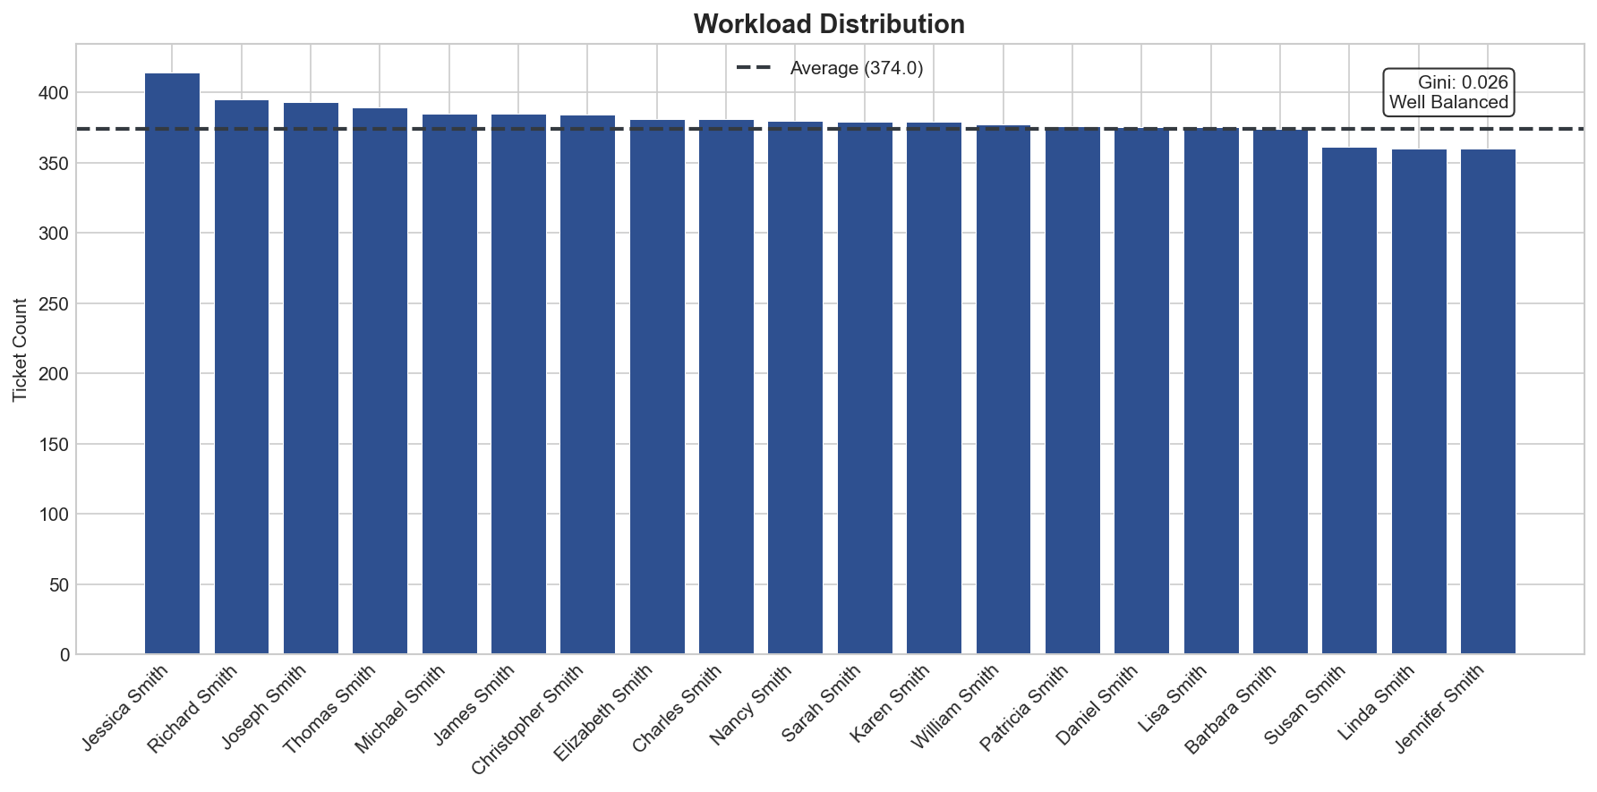
Gini Coefficient: 0.026
Interpretation: Well Balanced

AI Insights:
## Workload Distribution Health Assessment

**Current Status: Excellent Balance**
- **Gini Coefficient (0.026):** Indicates near-perfect workload distribution across the team
- **Standard Deviation (18.1 tickets):** Minimal variation from the average of 374 tickets
- **No Overloaded/Underloaded Experts:** All team members are operating within optimal capacity ranges
- **Overall Assessment:** The current distribution demonstrates exceptional operational efficiency with no immediate redistribution needs

## Specific Reallocation Suggestions

**No Immediate Reallocation Required**
Given the current balanced state, avoid unnecessary ticket transfers that could disrupt workflow. Instead:
- **Maintain Current Allocation:** Continue existing assignment protocols
- **Monitor New Ticket Intake:** Ensure new tickets are distributed using the same balanced methodology
- **Cross-Training Opportunities:** Use the balanced state to facilitate knowledge sharing without disrupting workloads

## Long-Term Load Balancing Strategy

**Proactive Maintenance Framework**
1. **Early Warning System Implementation**
- Set alerts for Gini Coefficient > 0.05 or Standard Deviation > 25 tickets
- Establish threshold triggers at 10% above/below average workload

2. **Dynamic Adjustment Protocol**
- Implement automated routing rules that consider both ticket count and complexity
- Develop skill-based weighting system for more nuanced workload measurement
- Create surge capacity plans for seasonal or unexpected volume increases

3. **Capacity Planning Enhancements**
- Conduct quarterly workload trend analysis to predict future imbalances
- Establish clear escalation paths for when individual experts approach 15% above average
- Implement rotational "float" assignments to maintain balance during vacations/absences

4. **Performance Benchmarking**
- Track balance metrics alongside quality and resolution time KPIs
- Use current balanced state as baseline for future comparisons
- Document current distribution methodology as best practice standard

**Key Recommendation:** Focus on sustaining current excellence through monitoring and preventive measures rather than corrective actions. The primary risk is complacency—maintain vigilance to preserve this optimal state as team composition and ticket volumes evolve.

Knowledge Silo Detection
No data available

Expert Profiles
