Fig1:

Recall rate of **velocity** method with different threshold **on nose:**

X: recall rate (number of detected annotation / total number of annotation)

y: degree of threshold

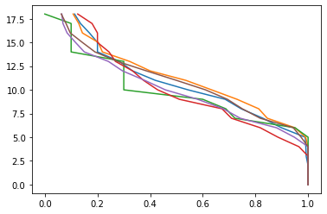

Fig2:

Precision rate of **velocity** method with different threshold **on nose:**

x: precision rate (number of correct detection / total number of detection)

y: degree of threshold

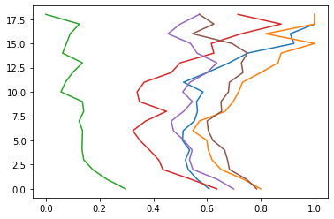

Fig3:

AUC of Precision vs recall **on nose**(**velocity**):

X: recall rate (number of detected annotation / total number of annotation)

Y: precision rate (number of correct detection / total number of detection)

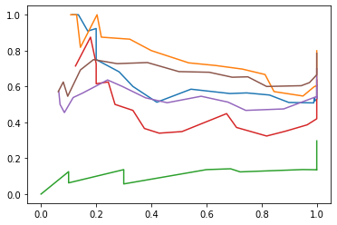

Fig4:

Recall rate of **velocity using five-point stencil** method with different threshold **on nose:**

X: recall rate (number of detected annotation / total number of annotation)

y: degree of threshold

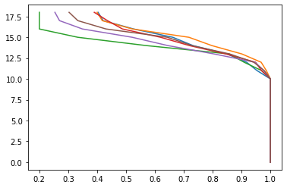

Fig5:

Precision rate of **velocity** **using five-point stencil** method with different threshold **on nose:**

x: precision rate (number of correct detection / total number of detection)

y: degree of threshold

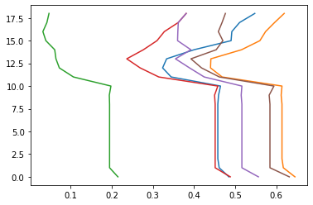

Fig6:

AUC of Precision vs recall **on nose**(**velocity using five-point stencil**):

X: recall rate (number of detected annotation / total number of annotation)

Y: precision rate (number of correct detection / total number of detection)

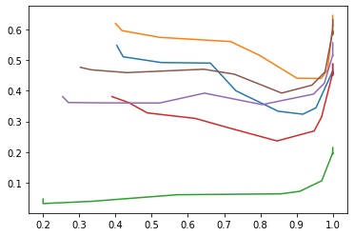

Fig7:

Recall rate of **Magnitude** method with different threshold **on nose:**

X: recall rate (number of detected annotation / total number of annotation)

y: degree of threshold

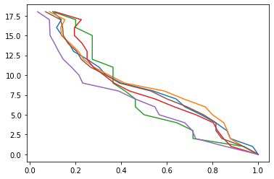

Fig8:

Precision rate of **Magnitude** method with different threshold **on nose:**

X: precision rate (number of correct detection / total number of detection)

y: degree of threshold

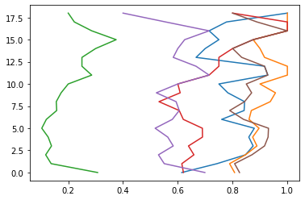

Fig 9:

AUC of Precision vs recall **on nose** (**Magnitude**):

X: recall rate (number of detected annotation / total number of annotation)

Y: precision rate (number of correct detection / total number of detection)

