**https://www.cnblogs.com/juan-wang/p/4123037.html**

**[使用IP欺骗Loadrunner并发测试小结](https://www.cnblogs.com/juan-wang/p/4123037.html)**

**测试要求：**

在本次测试中，我需要并发50个User，每一个User占用一个独立的IP，并且只执行一次脚本。脚本中发起两个请求，其中第一次请求返回200后才执行第二个请求。使用win7 OS。

**前置及Generator设置：**

我的Run-time Settings这样设定：

Run Logic: Number of Iterations: 1 (保证只执行一次脚本)

Log: Enable Log. Always send messages.(不是只在出错时发送log。我需要通过log来验证我的测试要求是否达到)

Think Time: Ignore think time (我不要思考时间，我想第二个请求紧跟第一个请求后执行)

其他不变。

为了在同一台机器上跑50个IP，我使用IP Spoofing

在开始菜单，找到Loadruner所在文件夹，进去找到Tools,里面有一个IP Wizard（IP欺骗）

在创建新的IP之前，可以CMD查看ipconfig, 查看自己所在IP区间。使用IP欺骗时，需要使用空闲IP，为确保不影响公司网络，建议使用一个路由器搭建独立的IP区间。

我使用的IP区间为：

LAN Subnet : 192.168.32.0 / 23 (空闲IP区段：192.168.32.4 ~ 192.168.33.254)

Gateway : 192.168.32.1

到增加IP地址对话框时，注意配置是否正确。我的配置如下图。

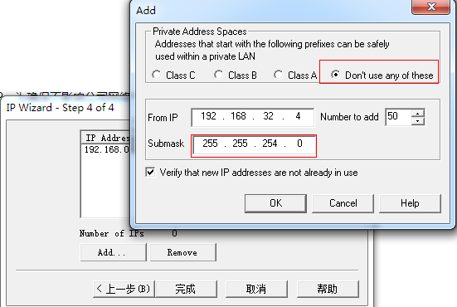

完成之后可以将刚才的IP地址保存为“IP Address File(*.ips)”文件。（这一操作我没有做，还好Loadrunner已经非常智能，在Load Generators只增加localhost就可以搞定）

好了，在CMD查看ipconfig /all 是不是多了50个IP。

注意，IP Wizard不支持DHCP，需要本机配置为固定IP地址。

接下来写脚本。

我的脚本如下：

[复制代码](javascript:void(0);)

1 Action()

2 {

3

4 int status;

5 int HttpRetCode;

6 char *ip;

7 ip = lr_get_vuser_ip();

8 //检查Loadrunner Controller有没有Enable IP Spoofing

9 if(ip)

10 lr_output_message("The IP address is %s", ip);

11 else

12 lr_output_message("IP spoofing disabled");

13 //设置集合点，让50个vuser一起发起第一个请求

14 lr_rendezvous("letusgo");

15 //开始第一个事务（请求）

16 lr_start_transaction("1stReq");

17

18 web_url("RCS_Initial_HTTP_Req",

19 //这里有一个参数化，我要每一次传递给该参数一个唯一的msisdn号码，并且只执行一次。

20 //我在参数属性对话框里设置：Select next row -> Unique

21 // Update value on -> Once

22 "URL= http://xxx.yyy.com/self?x-forwarding-msisdn={NewParam}",

23 "TargetFrame=Main",

24 "Resource=0",

25 "RecContentType=text/html",

26 "Mode=http",

27 LAST );

28 //打印第一个请求的返回码

29 HttpRetCode = web_get_int_property(HTTP_INFO_RETURN_CODE);

30 lr_output_message("Response code:%d",HttpRetCode);

31 //检查返回码是否是200

32 if(HttpRetCode == 200){

33 lr_end_transaction("1stReq", LR_PASS);

34 sleep(2000);

35 //开始第二个事务（请求）

36 lr_start_transaction("2ndReq");

37 web_url("RCS_Initial_HTTP_Req",

38 "URL= https://xxx.yyy.com/self?vers=1&IMSI=1&rcs_version=1&rcs_profile=1&client_vendor=1&client_version=1&terminal_vendor=1&terminal_model=1&terminal_sw_version=1&IMEI=1&mock_scheme=HTTPS",

39 "TargetFrame=Main",

40 "Resource=0",

41 "RecContentType=text/html",

42 "Mode=http",

43 LAST );

44 //打印第二个请求的返回码

45 HttpRetCode = web_get_int_property(HTTP_INFO_RETURN_CODE);

46 lr_output_message("Response code:%d",HttpRetCode);

47 //检查返回码是否是200

48 //结束第二个事务（请求）

49 if(HttpRetCode == 200){

50 lr_end_transaction("2ndReq", LR_PASS);

51 }else{

52 lr_end_transaction("2ndReq", LR_FAIL);

53 }

54

55 return 0; }else{

56 //结束第一个事务（请求）

57 lr_end_transaction("1stReq", LR_FAIL);

58 return 0;

59 }

60 }

61

[复制代码](javascript:void(0);)

**场景设置：**

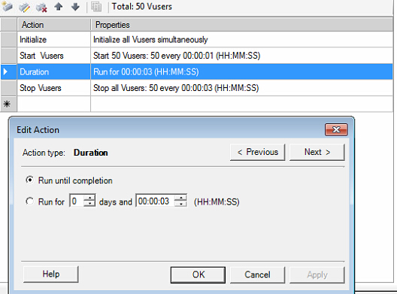

添加Load Generator

Name: localhost

Platform: windows

添加这一条就可以了。

然后将状态开启为Ready

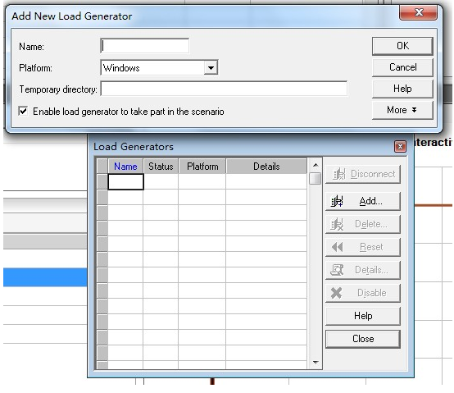

一定要注意每一个Vuser的IP是否是唯一的。双击下图Scenario Groups里面的Group Name行可以打开每一个Vuser对应的Generator,查看其IP。

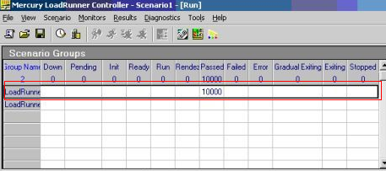

要监控一些服务器资源的资源如cpu,memory,disk，需要在controller里加入增加监控Unix Resources, 加入服务器地址。可以一次添加多个服务器。

前提：

需要关闭防火墙

需要在要监控的服务器上安装rstatd组件

[[root@](mailto:root@GR_API) ~]# service rstatd

Usage: /etc/init.d/rstatd {start|stop|status|restart|reload|force-reload}   
[[root@](mailto:root@GR_API)~]# service rstatd status   
rpc.rstatd (pid 2650) is running...   
[[root@](mailto:root@GR_API)~]#

可能报的错：

lr UNIX Resources. Cannot initialize the monitoring -47190

无法连接该服务器，请找公司OPS部门解决。我在测试中需要连接公司VPN服务器，在没有连接之前就会报这个错。

开始Run之前，别忘了log保存位置放到指定位置。在Results下面设置。

**关于Result :**

Graphs 右键 Add new items -> Add New Graph增加想要的图表结果

Reports -> HTML Report.. 生成html报告

小心Scale陷阱

要乘以前面的Scale值，才是真实结果。

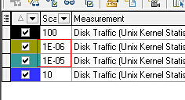

结果分析参考：

|  |  |  |
| --- | --- | --- |
| **UNIX counter** | **Windows Counter** | **Description** |
| Average Load* | N/A | The sum of the number of processes waiting in the run queue plus the number currently executing. |
| Collision rate | N/A | The total number of network collisions/sec |
| Context switch rate | System – Context Switches/sec | The rate at which processors switch from executing one thread to another. High switch rates can indicate performance problems as servers juggle multiple running applications. |
| CPU utilisation | %Processor Time | The percentage of elapsed time that the process spends executing non-idle threads. |
| Disk traffic | %Disk time | The percentage of elapsed time that the disk(s) are  busy servicing read or write requests. |
| Incoming packets error rate | Packets received errors | The number of packets received containing errors that precvent them from being delivered to a higher OSI layer protocol. |
| Incoming packets rate | Packets received/sec | The number of packets received on the network interface |
| Interrupt rate | Interrupts/sec | Average rate at which the processor receives and services hardware interrupts. Processes generate an interrupt when they finish a task and need to report that fact to the CPU. |
| Outgoing packets error rate | Packets outbound errors | The number of packets that can’t be transmitted due to errors |
| Outgoing packets rate | Packets sent / sec | The rate at which packets are sent on the network interface |
| Page-in rate | Pages Input/sec | The rate at which pages are read from disk to resolve hard page faults. Hard page faults occur when a process refers to a page in virtual memory which is not in it’s working set or available elsewhere in physical memory and has to be read from disk. |
| Page-out rate | Pages Output/sec | The rate at which memory pages are written to disk to free up space in physical memory. |
| Paging rate | Paging rate | The rate at which pages are read from disk or written to disk.  This is the sum of Pages Input/sec and Pages Output/sec. |
| Swap-in rate | N/A | The number of pages read into memory per second |
| Swap-out rate | N/A | The number of pages written out of memory per second |
| System mode CPU utilization | Processor – %Priviledged time | The percentage of elapsed time that the processor spends executing user threads (i.e. running applications) |
| User mode CPU utilization | Processor – %User time | The percentage or elapsed time that the processor spends executing priviledged or system mode threads. |

分类: [Testing road](https://www.cnblogs.com/juan-wang/category/654523.html)

标签: [Loadrunner](https://www.cnblogs.com/juan-wang/tag/Loadrunner/), [IP欺骗](https://www.cnblogs.com/juan-wang/tag/IP%E6%AC%BA%E9%AA%97/), [性能测试](https://www.cnblogs.com/juan-wang/tag/%E6%80%A7%E8%83%BD%E6%B5%8B%E8%AF%95/)