使用maven配置log4j

时间 2014-07-28 14:58:35  [IT部落格](http://www.tuicool.com/sites/yYrIbu)

原文  [http://www.itbuluoge.com/?p=786](http://www.itbuluoge.com/?p=786&utm_source=tuicool&utm_medium=referral)

主题 [Log4J](http://www.tuicool.com/topics/11070090)[Maven](http://www.tuicool.com/topics/11070054)

1 、 maven 的 log4j 坐标

|  |
| --- |
|  |

<dependency>

<groupId>log4j</groupId>

<artifactId>log4j</artifactId>

<version>1.2.9</version>

</dependency>

2 、配置文件内容及位置

|  |
| --- |
|  |

*# 所有Log信息输出到标准输出(System.out)和在下面指定的一个文件*

*# WARN是默认的logging级别*

log4j.rootCategory = DEBUG, STDOUT, FILE

*# 应用程序的logging级别是DEBUG*

log4j.logger.com.discursive = DEBUG

*# 配置标准输出Appender*

log4j.appender.STDOUT = org.apache.log4j.ConsoleAppender

log4j.appender.STDOUT.layout = org.apache.log4j.PatternLayout

log4j.appender.STDOUT.layout.ConversionPattern = %5p (%F:%L) %m%n

*# 配置输出文件Appender*

log4j.appender.FILE = org.apache.log4j.RollingFileAppender

log4j.appender.FILE.File = output.log

log4j.appender.FILE.MaxFileSize = 2000KB

log4j.appender.FILE.MaxBackupIndex = 5

log4j.appender.FILE.layout = org.apache.log4j.PatternLayout

log4j.appender.FILE.layout.ConversionPattern = %d %-5p %c - %m%n

3 、位置及使用

|  |
| --- |
|  |

**package** com.test.pro.MyPro;

**import** org.apache.log4j.Logger;

**import** org.apache.log4j.PropertyConfigurator;

*/\*\**

*\* Hello world!*

*\**

*\*/*

**public** **class App**

**{**

**public** **static** Logger m_log = **null**;

**public** **static** **void** main( [***String***](http://www.google.com/search?hl=en&q=allinurl%3Astring+java.sun.com&btnI=I%27m%20Feeling%20Lucky)[] args )

{

PropertyConfigurator.configure("E://work//workspace//MyPro//log4j.properties");

m_log = Logger.getLogger(App.class);

m_log.debug("debug test...........");

[***System***](http://www.google.com/search?hl=en&q=allinurl%3Asystem+java.sun.com&btnI=I%27m%20Feeling%20Lucky).out.println( "OK" );

}

}

默认可以放在 class 路径下，我这里是直接加载位置

4 、输出结果

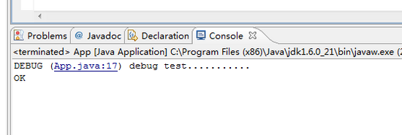

关键词：maven log4j