https://www.cnblogs.com/wangqianqiannb/p/7238481.html

**[vwware虚拟机无法连接外网](https://www.cnblogs.com/wangqianqiannb/p/7238481.html)**

1、问题：动态IP时连接外网没有问题，但是将IP改为静态IP时发现没有办法连接外网

查看文件/etc/resolv.conf，里面的内容全部都被注释

[root@jenkins network-scripts]# more /etc/resolv.conf   
# Generated by NetworkManager  
  
  
# No nameservers found; try putting DNS servers into your  
# ifcfg files in /etc/sysconfig/network-scripts like so:  
#  
# DNS1=xxx.xxx.xxx.xxx  
# DNS2=xxx.xxx.xxx.xxx  
# DOMAIN=lab.foo.com bar.foo.com

在eth0文件中增加一行语句  
[root@jenkins network-scripts]# vi ifcfg-eth0    
  
DEVICE=eth0  
BOOTPROTO=none  
#BOOTPROTO=dhcp  
IPADDR=192.168.0.173  
IPV6INIT=no  
NM_CONTROLLED=yes  
ONBOOT=yes  
TYPE=Ethernet  
UUID="9086dd6f-6c00-49be-ad52-28ab87f2dcb7"  
NAME="System eth0"  
HWADDR=00:0c:29:c2:96:4a  
  
NETMASK=255.255.255.0  
GATEWAY=192.168.0.1  
USERCTL=no  
DNS1=192.168.0.1

重启network  
[root@jenkins network-scripts]# service network restart   
Shutting down interface eth0:  Device state: 3 (disconnected)  
                                                           [  OK  ]  
Shutting down loopback interface:                          [  OK  ]  
Bringing up loopback interface:                            [  OK  ]  
Bringing up interface eth0:  Active connection state: activated  
Active connection path: /org/freedesktop/NetworkManager/ActiveConnection/5  
                                                           [  OK  ]

可以连接外网  
[root@jenkins network-scripts]# ping www.baidu.com  
PING www.a.shifen.com (61.135.169.121) 56(84) bytes of data.  
64 bytes from 61.135.169.121: icmp_seq=1 ttl=54 time=2.51 ms

再次查看/etc/resolv.conf文件  
[root@jenkins network-scripts]# more /etc/resolv.conf   
# Generated by NetworkManager  
nameserver 192.168.0.1

此处提供一个 ifcfg-eth0的静态ip又可以连接外网的配置

|  |
| --- |
| DEVICE=eth0  IPADDR=192.168.0.109  NETMASK=255.255.255.0  NETWORK=192.168.0.1  # If you're having problems with gated making 127.0.0.0/8 a martian,  # # you can change this to something else (255.255.255.255, for example)  BROADCAST=255.255.255.255  ONBOOT=yes  # BOOTPROTO=dhcp 是动态ip,而BOOTPROTO=static 是静态ip  BOOTPROTO=static  #BOOTPROTO=dhcp  #DNS1=114.114.114.114  HWADDR=00:0c:29:e2:0b:ad  GATEWAY=192.168.0.1  IPV6INIT=yes  IPV6_AUTOCONF=yes  TYPE=Ethernet  ZONE=public  #要连接 外网下面这个配置非常重要  DNS1=192.168.0.1 |

2、问题

虚拟机关闭的状态下进行了win10的更新，虚拟机打开之后处于没网状态，无法连接到桥接模式

首先将虚拟机挂起或者关闭

点击编辑-->虚拟网络编辑器

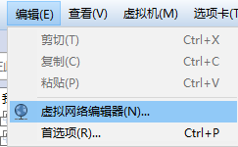

还原默认设置

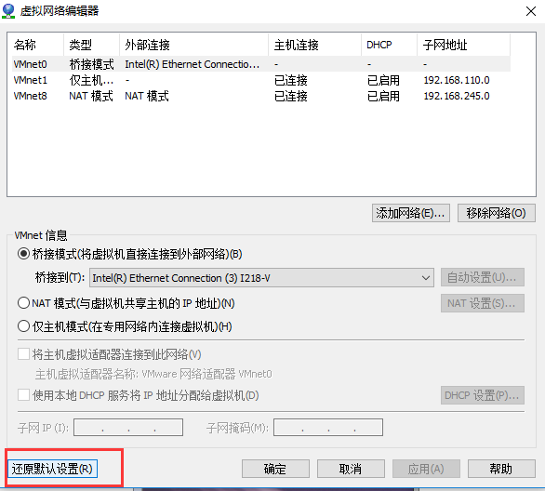

之后点击VMnet0

桥接到本地网卡即可

打开虚拟机，设置为桥接模式

分类: [VmWare](https://www.cnblogs.com/wangqianqiannb/category/1042586.html),[网络](https://www.cnblogs.com/wangqianqiannb/category/778277.html)

标签: [vmware](https://www.cnblogs.com/wangqianqiannb/tag/vmware/), [liux](https://www.cnblogs.com/wangqianqiannb/tag/liux/)