Suppose we have a parent having two children. When the parent sends data onto the pipe, only one of the two children will receive that data. The other child will receive an empty pipe with no data. In order to prove above statement we have developed a C program in which a parent will be able to communicate with its children as shown in figure 2 below.

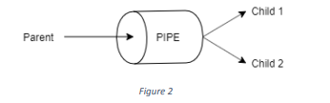

Parent sends message over the pipe and both the children are reading that data. One child is receiving parent’s message and will print it. Other will receive nothing and will print nothing.