Credit test - Database systems (NDBI025)
2019/2020
Name and Surname (legibly): Aydin Ahmadli
Login: 85031206 (illegible text will be automatically seen as wrong)

Solve this assignment independently. A solution same or suspiciously similar to another, already submitted, may not be accepted. I reserve the right to request additions or explanations to the submitted solution, either by email or via online communication.

1. CONCEPTUAL MODELING (total 30 points, min. 15)
- Describe in words an own simple assignment of an information system with the following restrictions: At least 3 classes, at least one M:N relationship, at least one 1:N relationship. Create a conceptual UML model for the described information model. (10 points)
- Convert the UML model you created to a logical relational model, including referential integrity.
List relations in the form R1(...), R2(...), ... (10 points)
- Convert the logical relational model you created to the physical one using the CREATE TABLE statements. (10 points)

2. QUERYING IN SQL (total 40 points, min. 20)

On above created tables, formulate 4 reasonable queries in natural language with the following restrictions, and write them using the SQL query. (one SELECT statement per query). It is of course possible to use nested queries, if you want, you can define at most two views using CREATE VIEW statement to simplify queries:

Query1. Using a join of two or more tables with a non-empty WHERE condition and ordering by at least two columns (10 points)
Query 2. Using the NOT EXISTS operator or similar (10 points) (10 points)
Query 3. Searching for objects from a group of them with an extreme value in a column (eg employees from the given department with the highest salary, express trains to Dallas with the lowest price, ...) (10 points)
Query 4. Search for groups of objects with a certain property (eg departments with an average salary of employees exceeding CZK 25.000, customers with a total volume of purchases not exceeding CZK 1.000, ...) (10 points)

3. DDL SQL & EMBEDDED SQL (total 30 points, min. 15)

- In the relational schema you created, create a procedure that inserts a new instance of the selected class, including a link to a specific existing instance with which an M: N association exists. All the necessary data the procedure gets passed through its parameters. (15 points)
- Formulate in natural language either a suitable function or integrity constraint over your schema, and create a corresponding function or trigger using T-SQL language. (15 points)
SOLUTION

Link to Source Code: https://rextester.com/GFHZM33455

- CONCEPTUAL MODELING

1.1 Database Description

For describing our database in natural language, lets imagine that we are some survey company which keeps track of some information. We want to store information about people and vehicles. To be more specific, we will also store information about vehicle manufacturer and vehicle distributor. More on relationships between them below:

Firstly, we will want to identify if specific vehicle is owned by person, or any person owns any vehicle. For the sake of our exercise, we impose some restrictions on our relationship between Vehicle – Person, by stating that, any vehicle can either be owned by single person, or not owned by anyone at all. On the other hand, we also state that any person can own equal or more than 1 vehicle (yes, it is weird that each person must have at least 1 vehicle, but just for the sake of our exercise, let’s say it is real :) ) This relationship is captured by Owns() in Logical Relational Model.

Secondly, we will want to identify relationship between Vehicle – Manufacture. So, we impose restriction such that, any vehicle must be made by single manufacture, on the other hand, any manufacture can make one or more vehicles (one-to-many or 1:N).

Thirdly, we will want to identify relationship between Vehicle – Distributor. So, we impose restriction such that, any vehicle can be spread by more 1 distributor, and any distributor can spread more than 1 vehicle (many-to-many or M:N). This relationship is captured by Spread() in Logical Relational Model.

1.1 UML Model

So, let’s start with Conceptual database modeling - UML. As described in description above, we will have 4 entities – Person, Vehicle, Manufacture, Distributor.

To specify each entity, we add attributes to them:
Person – lastname, firstname, address, age
Vehicle – model, year_made, price
Manufacture – name, country, city, average_yearly_capacity
Distributor – name, average_monthly_distribution_count

Based on the relationships between entities, we create UML as below:

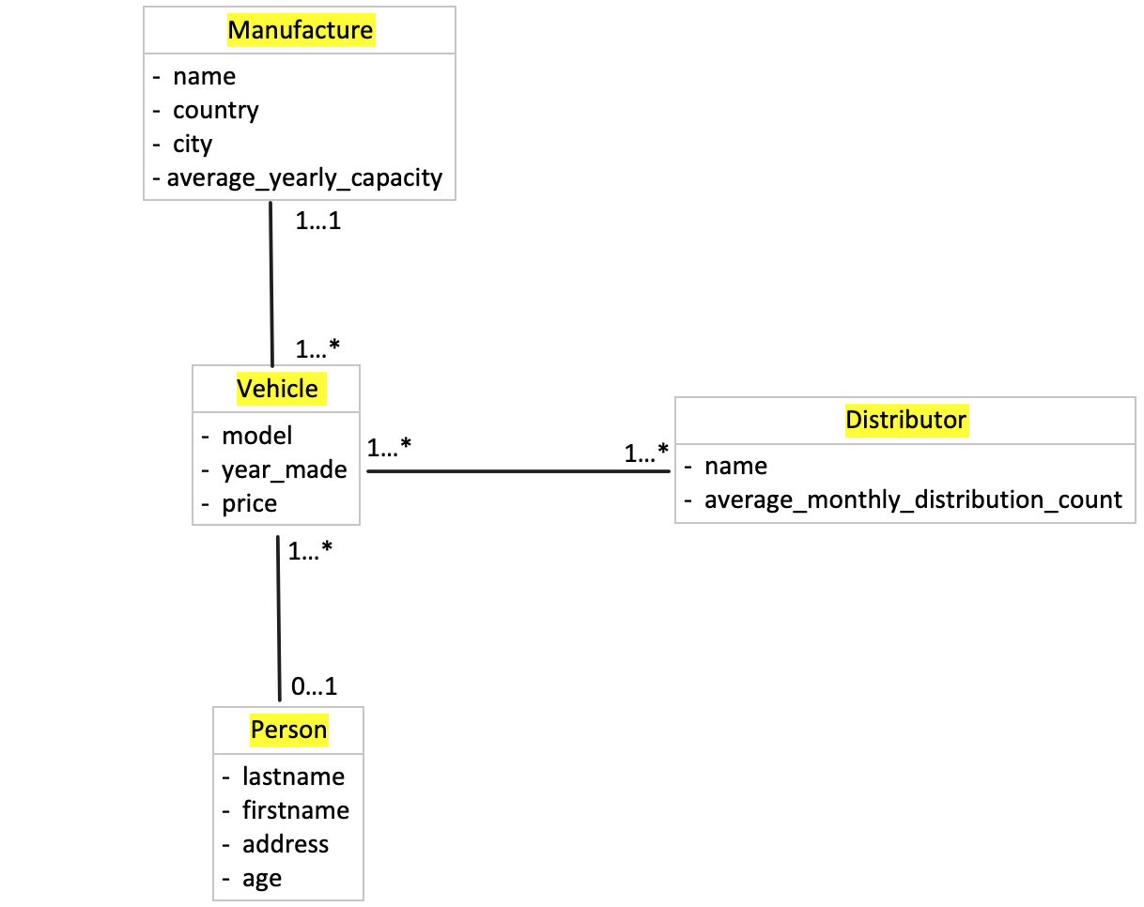

1.2 Logical Relational Model

- Person(personID, lastname, firstname, address, age)
- Manufacture(manufactureID, name, country, city, average_yearly_capacity)
- Vehicle(vehicleID, model, year_made, price, manufactureID), manufactureID ⊆ Manufacture.manufactureID
- Distributor(distributorID, name, average_monthly_distribution_count)
- Owns(personID, vehicleID), personID ⊆ Person.personID, vehicleID ⊆ Vehicle.vehicleID
- Spread(distributorID, vehicleID), distributorID ⊆ Distributor.distributorID, vehicleID ⊆ Vehicle.vehicleID

1.3 Create Table

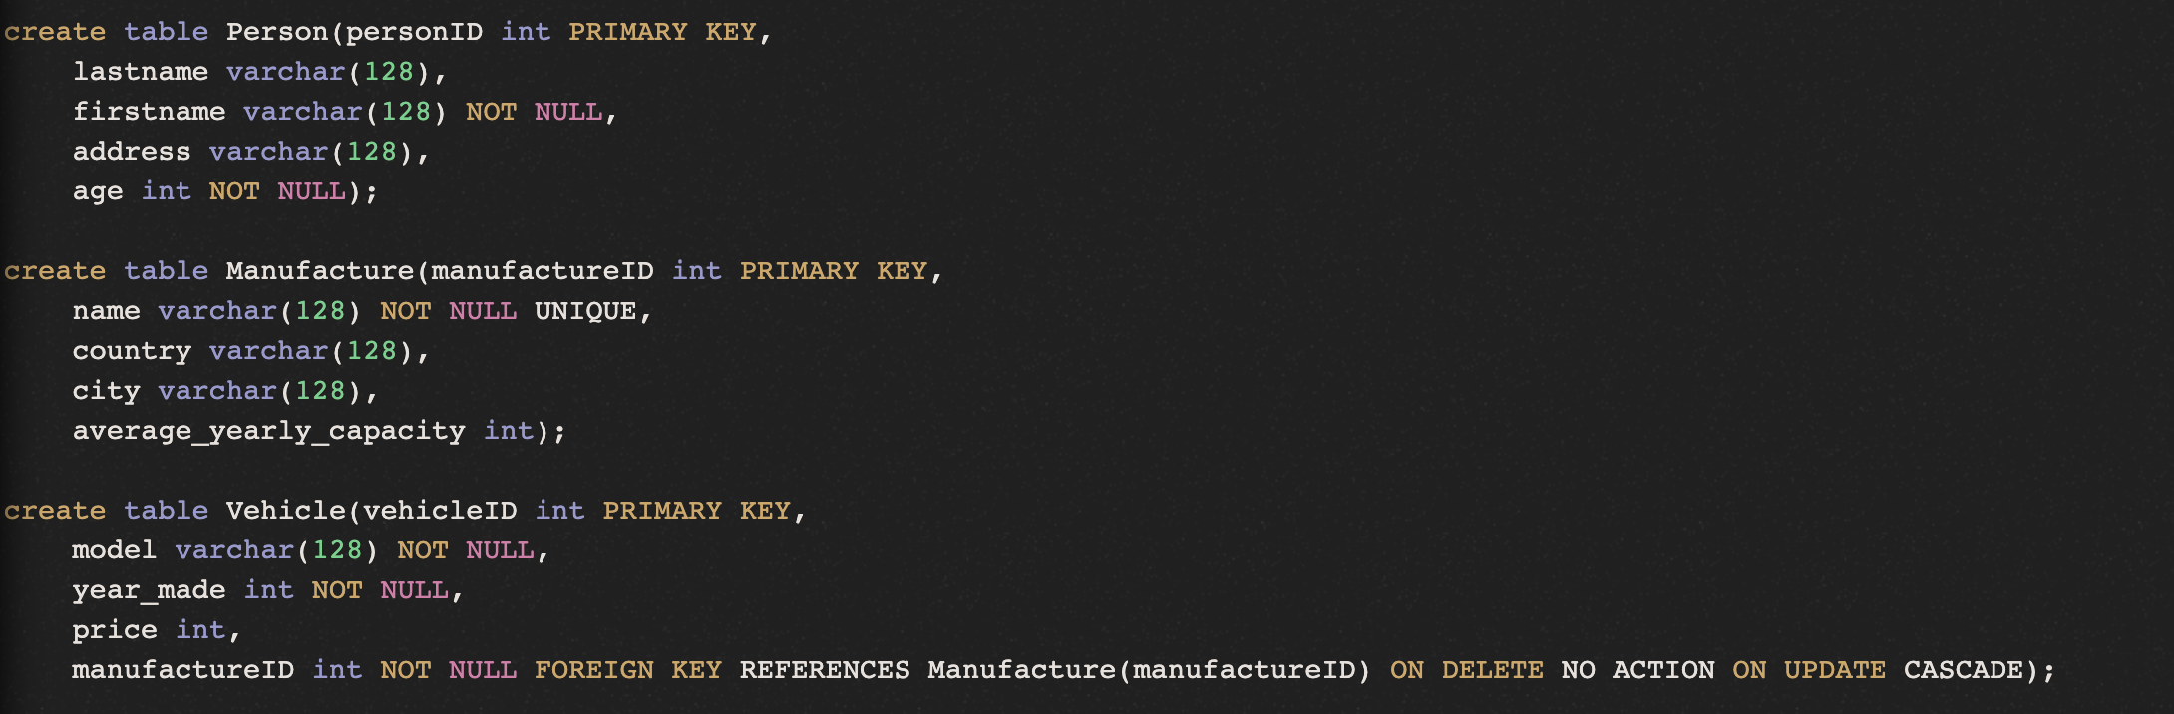
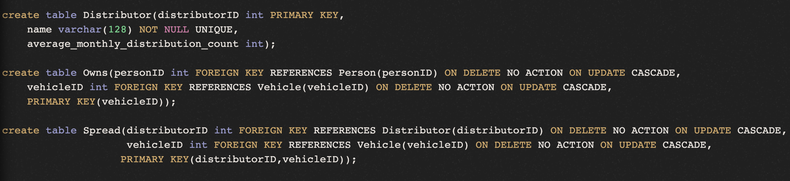

  - Insert into tables

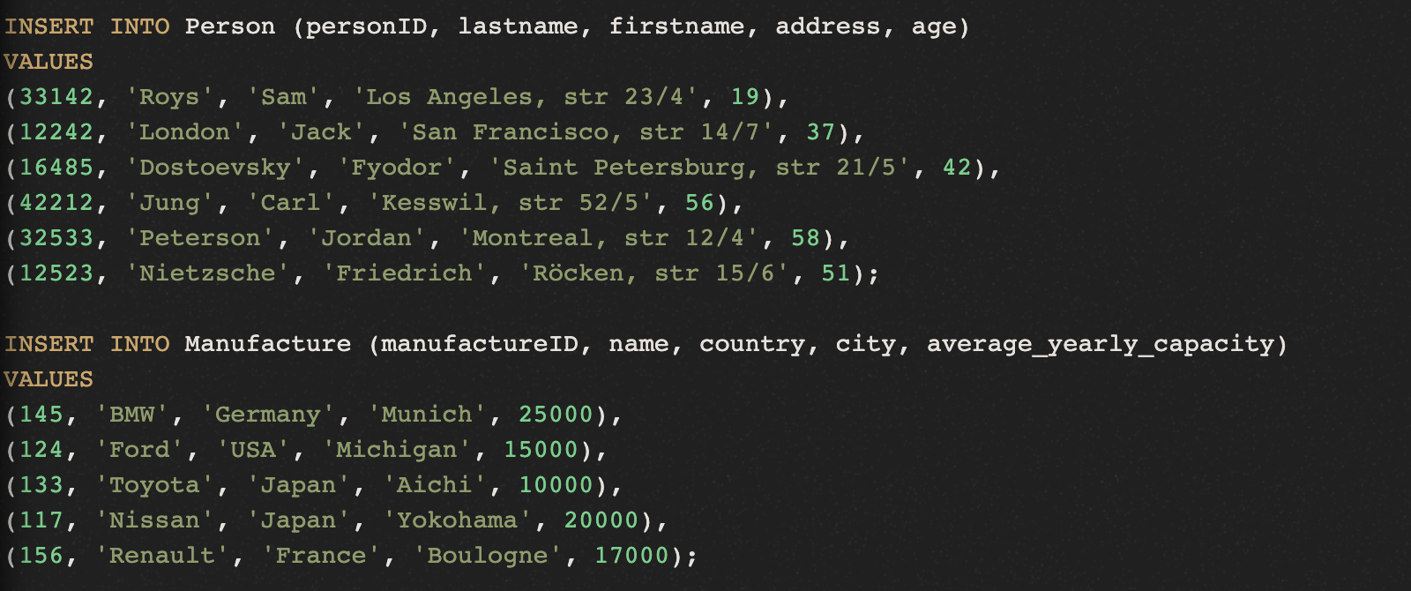
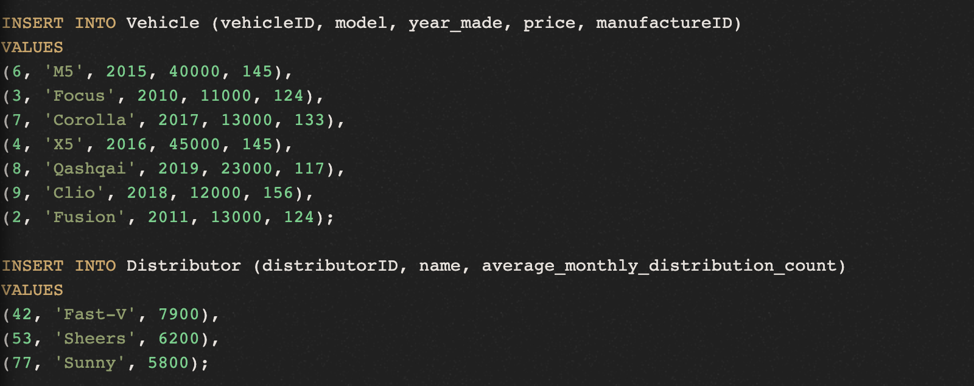
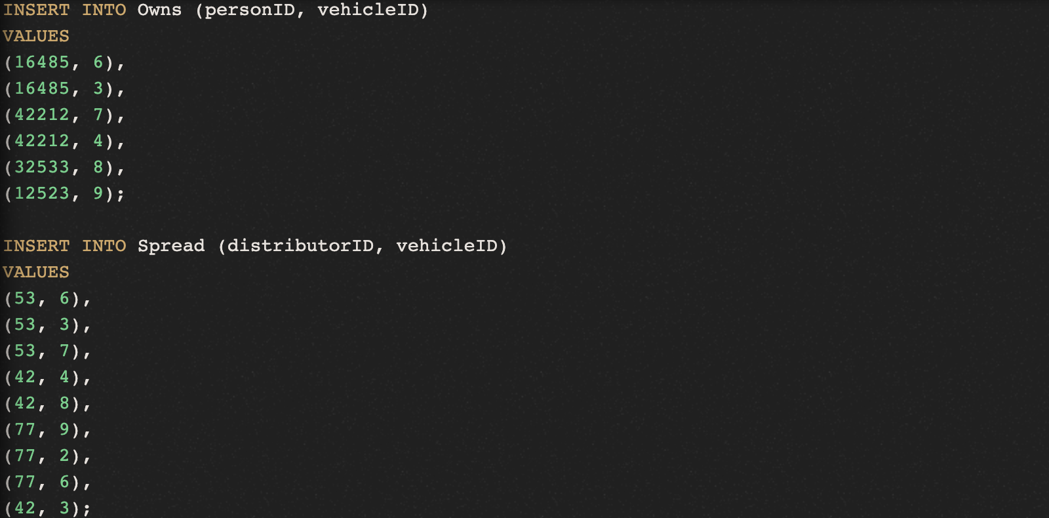

2. QUERYING IN SQL

Query 1
Our aim is to find out Vehicle models priced below 20,000$ together with their Manufacturer names. Plus, we want the result to be sorted first by price from highest to lowest, then by Manufacturer name. Below is query with its result:
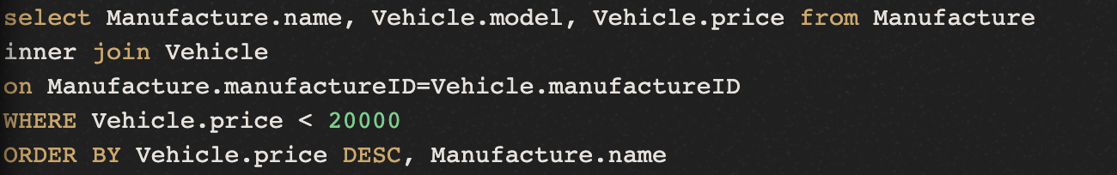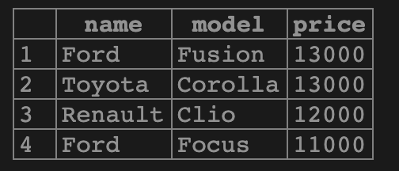

Query 2
Find manufacture year of vehicles which are not owned by some person.
NOTE: After some research on web, I came to conclusion that it is not possible to use "NOT EXISTS" without Subquery. That's why, I am tempted to include second "SELECT" statement in Subquery.
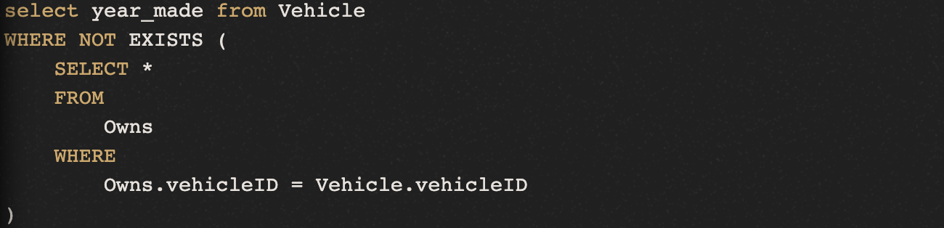

Query 3
Find cheapest model of BMW along with its price:
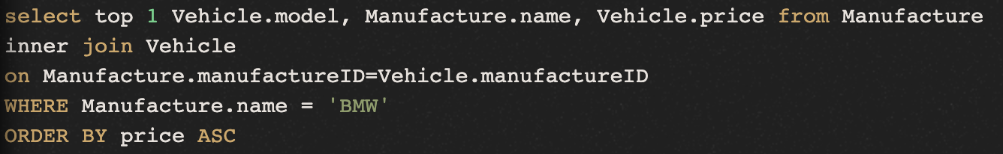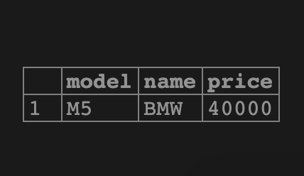

Query 4
Find out ages of people who own cars having total price higher than 20,000$. Return ages along with total price spent on cars.
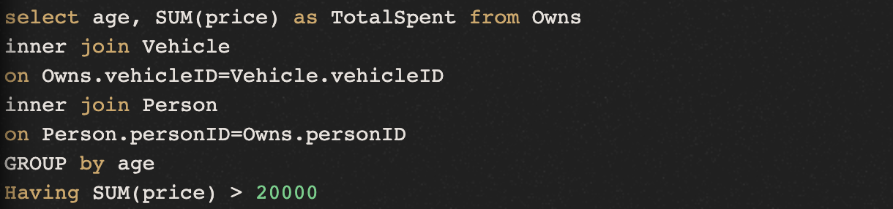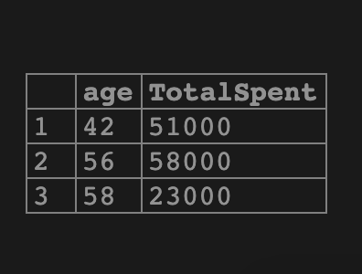

3. DDL SQL & EMBEDDED SQL

3.1 Create Procedure

Creating procedure which takes three arguments corresponding to columns of Distributor table, and then adds new instance/row to Distributor table:
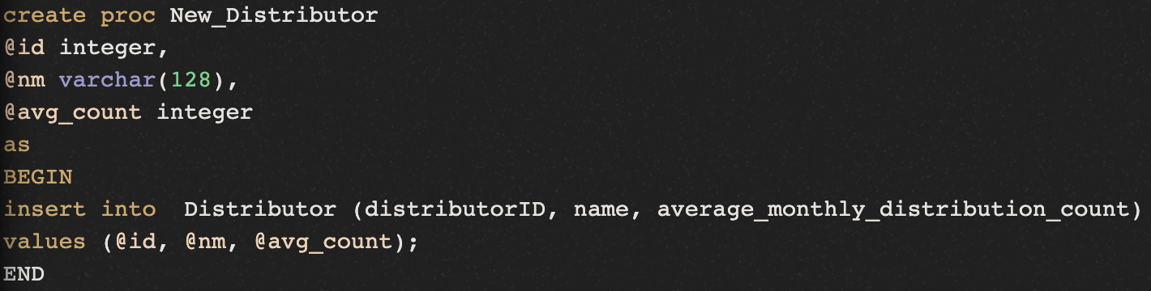

3.2 Create Function

Creating a function on Distributor table which takes two string arguments as distributor name and outputs sum of average_monthly_distribution_count values corresponding to both distributor names:
