**Tiles HW**

**Subtask 1 Results**

For subtask 1, we reconstruct the image by trained network and get;

.

.

We see from reconstructed image that, it kind of resembles original Santa image, but still lacks some specific parts. Although, we could achieve to have profit over $10,000 as seen from screenshots of results above. As a result, we had $10,600 net profit with 48 unique tiles and Total Price of reconstruction being $49,400.

For checking outputs explicitly, please check produced output file called 1st-sub-outputs.txt

**Subtask 2 Results**

For subtask 2, we reconstruct the image by trained network and get;

**Original Produced Rotateds colored**

.

.

.

As seen from reconstructed image above, this time training on rotation of tiles helped us to reconstruct and produce better Santa image by the help of network. Eyes, nose, mouth of Santa are better visible when compared to subtask 1. Also, on far right image, we colored the rotated tiles with red so that they are distinguishable among others.

When it comes to costs, we could have Total Price of $47,400 and Net Profit of $12,600 which is better than subtask 1 results because we used 46 unique tiles and 36 rotated tiles.

For checking outputs explicitly, please check produced output file called 2nd-sub-outputs.txt

**Subtask 3 Results**

For subtask 3, we reconstruct the image by trained network and get;

**

**Original Produced Prefabs colored**

As we see from produced image above, we most importantly used prefabricated tiles for Santa’s left eye, and forehead sections.

As mentioned on **document_configuration**, we used prefabricated tiles in 2 cases.

1. When some input tile is similar to some custom tile.
2. When some tile produced by network is almost similar to some custom tile.

**from first case from second case**

.

.

.

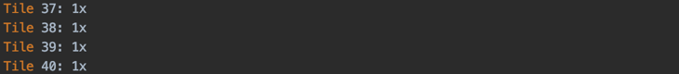

After replacing some tiles with prefabricated ones, we get Net Profit of $18,600 with Total Price of reconstruction being $41,400.

For checking outputs explicitly, please check produced output file called 3rd-sub-outputs.txt