**Results**

After training and testing the network, we get results as below:

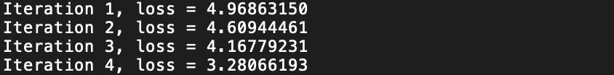

.

.

.

.

As we see, network stopped training after 180 iterations because loss did not improve more than given threshold for 10 consecutive epochs. All screenshots are taken from **outputs.txt** file which was produced by source code.

**Testing Network**

1. We test network on 7 original positive words. And we that network recognizes all 7/7 correctly. **It had 100% accuracy**
2. We test network on test data which contains 5000 words where approximately 10% is positive words and 90% is negative words. Our network couldn’t recognize only 1 word out of 5000 words which seems fine. **It had 99.98% accuracy**