**Buzzi Bodies AGM**

**Tuesday, 21st March 2017 at the Crown and Cushion, Great Gransden**

1. **Present**

Sarah Bonnett (Chair); Catherine White (Secretary); Kyla Castle; Anne Race; Laura White; Faith Bickerdike; Stephanie Reardon; Jean Rowbotham; Danielle Noe.

Apologies: Dean Sibley (Treasurer), Wiz Ducker, Sally Martin

**2. Minutes of the last AGM and Matters Arising**

Minutes from the last AGM were approved, most action points have been addressed.

Pottery was discussed and agreed that the company 'Glazed and Amused' was a success and the session well attended. Should we have pottery twice in the year? **Agreed to have pottery in June as well for Father's Day.**

Should we move the baby area further back from the tea and coffee as there have been concerns about spilling drinks on babies? **Agreed to move back**.

Birthdays need to be noted each week. **Whoever is doing the singing on the rota is to check birthdays**.

The website needs to be completed. **Sarah Bonnett to meet with Jason White to instruct exactly what needs to go on.**

**3. Chair's Report**

Attendances - After a dip in numbers last year they are now on the rise again. More activities and better publicity has helped this.

A new registration/consent form has been created. A simple website should be live soon.

Fundraising- £200 from the Gransden Ball, hopefully will have opportunity to apply for funds from the Gransden Air Show.

Toys/Equipment - Thanks to Kyla and Laura for the clear and clean up of the toy cupboard. Also for setting up the tidying system which has greatly helped.

Investment in various new toys. Changed room layout and established a book corner.

Events -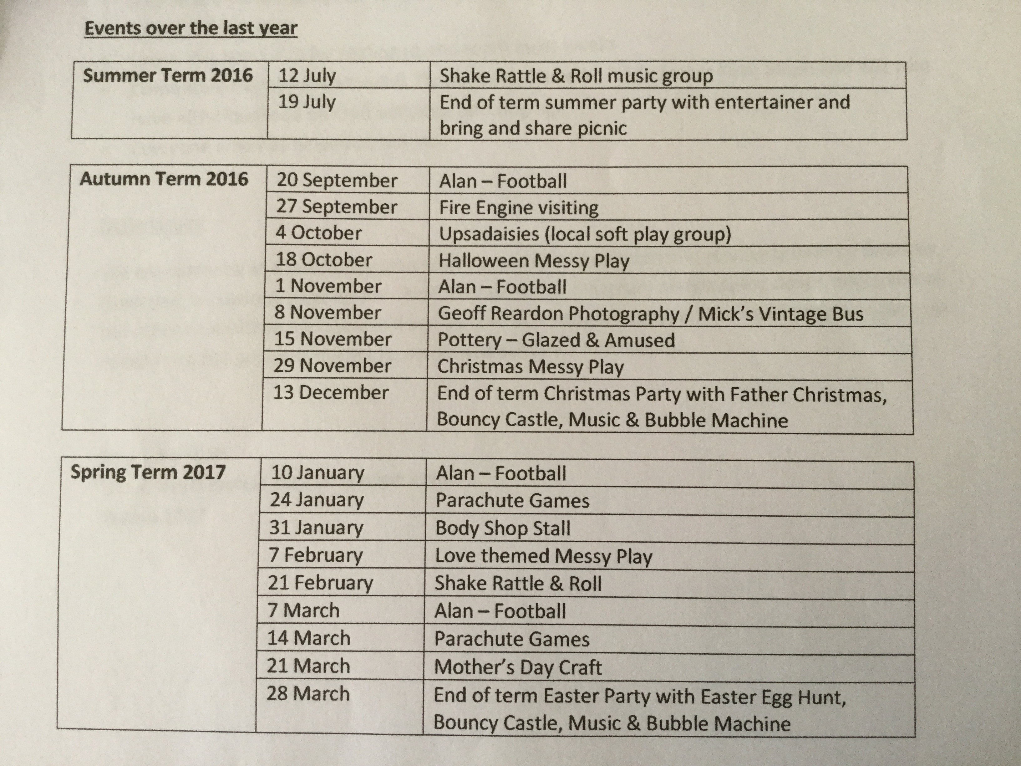

Volunteers and support - Huge thank you again to Jean Rowbotham and Margaret Dearing for their continued help with refreshments. Gill Taylor has also joined the team and a huge thanks to her for this.

Thank you also to all of the committee members for their various roles and efforts and to Alan Rowbotham for running the football and Mick Ward for bringing his vintage bus and being a great Father Christmas.

Main issues- currently a strong position with increasing attendances and relatively healthy finances. Various committee members are stepping down from roles therefore, we need people to step up to help run the group to ensure it enjoys continued success next year.

**4. Treasurer's report**

Current account balance - £1,125.81

Savings account balance - £1,006.57

Total in bank - **£2,132.38**

We are just about covering our weekly costs (£28 plus refreshment/craft costs)

Numbers attending vary. We need to be aiming for mid 20's every week to stay comfortable and allow us funds to invest in equipment or paying for additional activities.

As a comparison, our current account bank balance at 18th March 2016 was £1,149.17 and in March 2015 the balance was £943.30.

I would suggest holding a couple of fundraising events to maintain the current bank balance.

Newly elected officers need to be added to the signatories on the account.

**5. Election of committee**

|  |  |  |
| --- | --- | --- |
|  | **Current Committee**  **(Jul 16 to Jul 17)** | **New Committee**  **(Jul 17 to Jul 18)** |
| **Chair** | Sarah Bonnett | Laura White |
| **Treasurer** | Dean Sibley | Dean Sibley |
| **Secretary** | Catherine White | Anne Race |
|  |  |  |
| **General Committee** | Anne Race | Catherine White |
|  | Danielle Noe | Danielle Noe |
|  | Faith Bickerdike | Jean Rowbotham |
|  | Jean Rowbotham | Michyla Castle |
|  | Laura White | Sarah Bonnett |
|  | Michyla Castle | Steph Reardon |
|  | Steph Reardon |  |
|  | Wiz Ducker |  |

Early warning noted that Dean Sibley, Anne Race, Michyla Castle and Sarah Bonnett will all leave at the end of July 2018 as they will no longer have children attending Buzzi Bodies. New members need to be recruited.

**6. Any other business**

1. End of term party. Bouncy castle, music, bubbles, parachute and Easter egg hunt to be included.

Similar format for future parties. Agreed that an entertainer is too expensive at present.

b. Fees. Agreed to maintain these at £2 per child and 50p for additional siblings. Finances are currently stable.

c. Toy clean. Encourage people to take boxes/items home over the Easter break. **Ensure that toy cleans happen regularly.**

d. Rota. Almost completed. Need to encourage more to fill the spaces at the Easter party week. Agreed that the rota was still necessary.

e. First Aid course. This was agreed that this was not necessary as we are not a child care provider. This is not our responsibility.

f. Slide. Various issues with storage and an accident. Agreed to sell this on and reinvest in another scuttle bug.

g. Anecdotally, some people are still not paying. **To be monitored to ascertain the severity of the issue.**

**Meeting closed at 9.20pm. Next meeting will be a planning meeting Monday 24th April 2017.**