**Лабораторная работа №2**

Вариант 4

В данной лабораторной работе код разбит на две части – расчеты на С++, результаты которых выводятся в файл, и код на python, который строит графики, считывая данные из файла.

Код calculations.cpp:

#include <iostream>

#include <fstream>

#include <random>

#include <vector>

const int GRID_SIZE = 31;

const int NUM_STEPS_1 = 1000;

const int NUM_STEPS_2 = 10000;

const int LAUNCHES_NUM = 3;

const int START_POS = 15;

void randomWalk(int steps, std::vector<std::vector<int>>& trajectory){

std::random_device rd;

std::mt19937 gen(rd());

std::uniform_int_distribution<> dist(0, 5);

int x = START_POS, y = START_POS, z = START_POS;

trajectory.push_back({x, y, z});

for(int i = 0; i < steps; ++i){

int dir = dist(gen);

switch (dir) {

case 0: x = (x + 1) % GRID_SIZE; break; // вправо

case 1: x = (x - 1 + GRID_SIZE) % GRID_SIZE; break; // влево

case 2: y = (y + 1) % GRID_SIZE; break; // вверх

case 3: y = (y - 1 + GRID_SIZE) % GRID_SIZE; break; // вниз

case 4: z = (z + 1) % GRID_SIZE; break; // вперед

case 5: z = (z - 1 + GRID_SIZE) % GRID_SIZE; break; // назад

}

trajectory.push_back({x, y, z});

}

}

void saveToFile(const std::vector<std::vector<std::vector<int>>>& trajectories, const std::string& filename) {

std::ofstream output(filename);

if (!output.is_open()){

std::cerr << "Error in opening file " << filename << '\n';

exit(1);

}

for(const auto& trajectory : trajectories) {

for(const auto& i : trajectory) {

output << i[0] << ',' << i[1] << ',' << i[2] << '\n';

}

output << '\n';

}

output.close();

}

int main(){

std::vector<std::vector<std::vector<int>>> trajectories_1;

std::vector<std::vector<std::vector<int>>> trajectories_2;

for(int i = 0; i < LAUNCHES_NUM; ++i) {

std::vector<std::vector<int>> trajectory;

randomWalk(NUM_STEPS_1, trajectory);

trajectories_1.push_back(trajectory);

}

for(int i = 0; i < LAUNCHES_NUM; ++i) {

std::vector<std::vector<int>> trajectory;

randomWalk(NUM_STEPS_2, trajectory);

trajectories_2.push_back(trajectory);

}

saveToFile(trajectories_1, "trajectories_1000.txt");

saveToFile(trajectories_2, "trajectories_10000.txt");

std::cout << "Data has been saved!\n";

return 0;

}

Код readfile.py:

import matplotlib.pyplot as plt

def read_file(filename):

trajectories = []

with open(filename, 'r') as file:

trajectory = []

for line in file:

line = line.strip()

if line:

x, y, z = map(int, line.split(','))

trajectory.append((x, y, z))

else:

if trajectory:

trajectories.append(trajectory)

trajectory = []

if trajectory:

trajectories.append(trajectory)

return trajectories

trajectories_1000 = read_file("/home/buzzismaloy/University_shit/6th-term/monte-karlo/second-lab/trajectories_1000.txt")

fig = plt.figure(figsize=(12, 6))

ax = fig.add_subplot(121, projection='3d')

for traj in trajectories_1000:

x, y, z = zip(*traj)

ax.plot(x, y, z, marker='o')

ax.set_title('Random Walks (1000 Steps)')

ax.set_xlabel('X')

ax.set_ylabel('Y')

ax.set_zlabel('Z')

trajectories_10000 = read_file(

"/home/buzzismaloy/University_shit/6th-term/monte-karlo/second-lab/trajectories_10000.txt")

ax = fig.add_subplot(122, projection='3d')

for traj in trajectories_10000:

x, y, z = zip(*traj)

ax.plot(x, y, z, marker='o')

ax.set_title('Random Walks (10000 Steps)')

ax.set_xlabel('X')

ax.set_ylabel('Y')

ax.set_zlabel('Z')

#plt.savefig('trajectory_plot.png') # Сохранить график в файл

#plt.close() # Закрыть график

plt.show()

График:

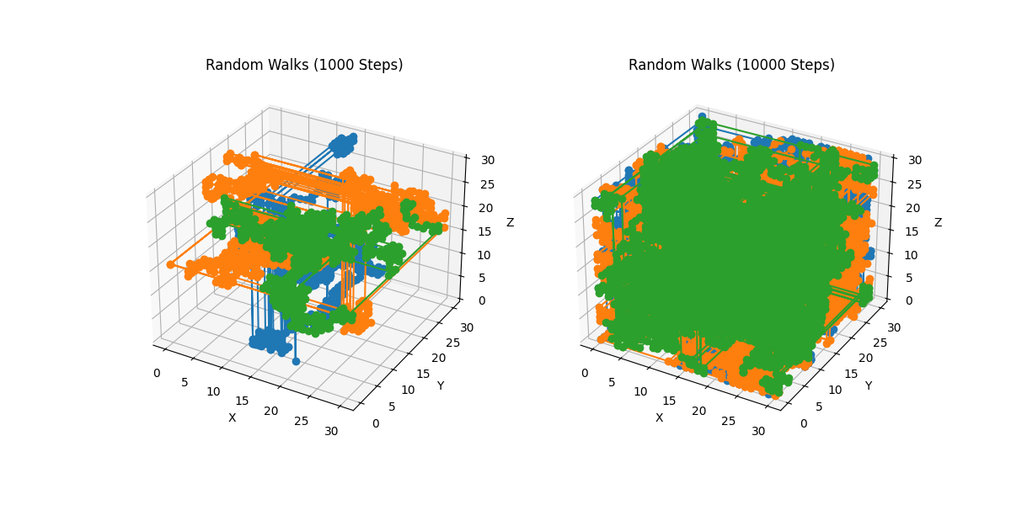

Теория:

