How to retrieve copies of your photos from Google Takeout

Note: Google Takeout does not delete or change your data in the Google storage space.

1. Open [Google Takeout](https://takeout.google.com).
2. Click "Deselect all" to uncheck all Google products.

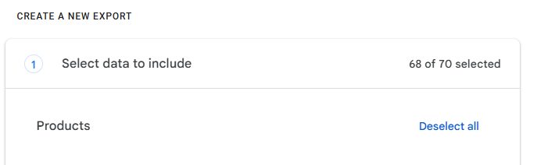

1. Scroll down and check the "Google Photos" checkbox. Generally, leave the "Multiple formats" and "All photo albums included" options as they are.

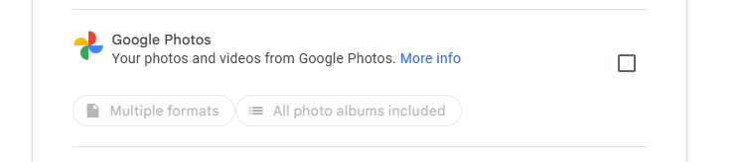

1. At the bottom of the page, click "Next step”.

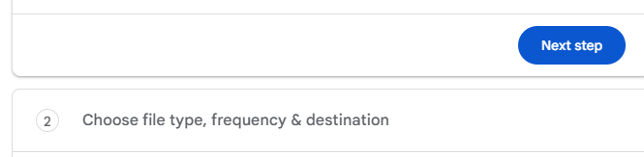

1. Keep the default options: "Transfer to: Send download via email", "Frequency: Export once", "File type: .zip", "File size: 2 GB". Click "Create export".

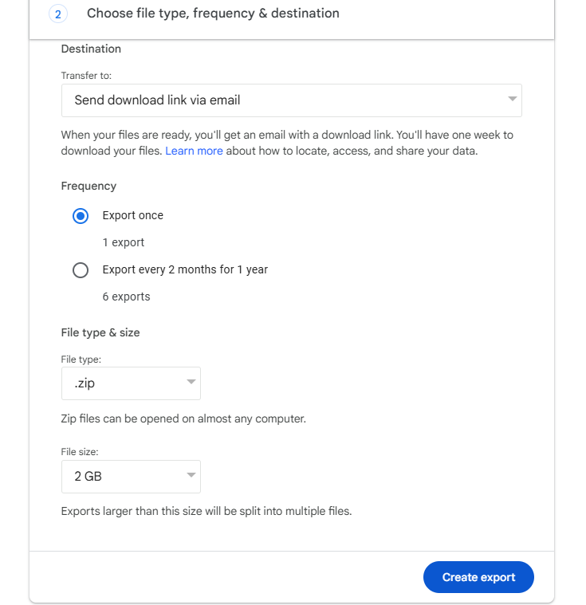

1. When you receive the email from Google Takeout, download each file to your "Downloads" folder or a folder of your choice. This may take some time and there may be many downloads.

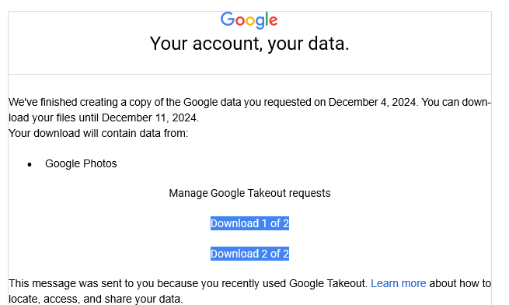

1. Use TakeoutWrangler to process the Google Takeout .zip files from your download folder to your local computer.
2. After verifying your local content, you can delete the Google Takeout .zip files from your download folder.
3. Never delete files from your Google Photos storage until you’ve verified you have them locally.
4. Clean up old photos from Google Photos to recover space in your Google storage.