1. SELECT medecin.NumMedec, medecin.Nom from medecin, specialite, specialiser WHERE specialiser.NumSpec=specialite.NumSpec AND specialiser.NumMedec= medecin.NumMedec AND specialite.Libelle= "S1" ;

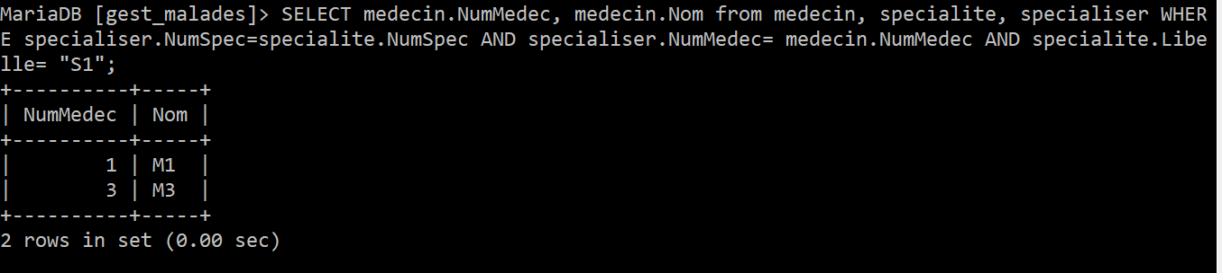

1. select * from specialite;

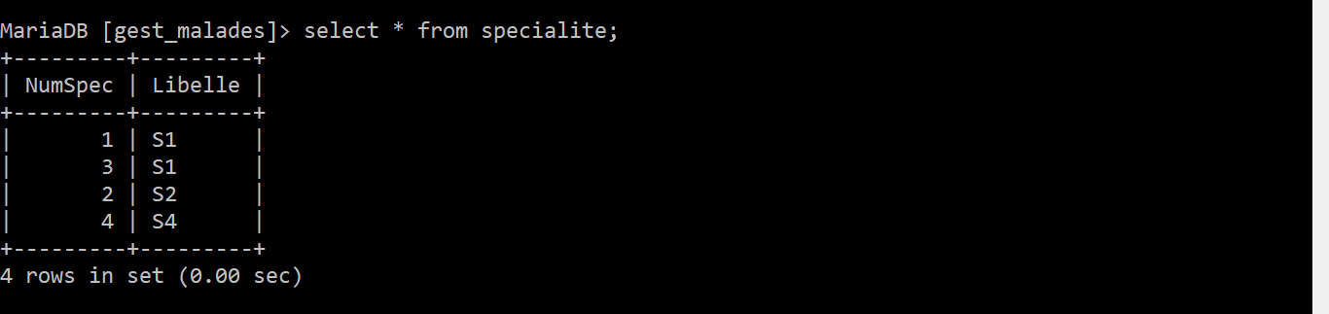

1. select NumMalade, Nom, DatNaiss from malade where Sexe = "M";

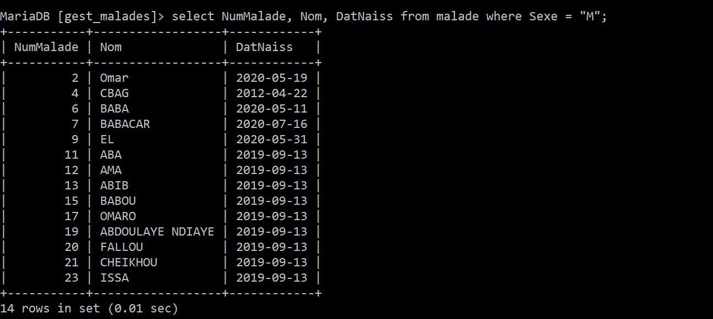

1. select NumMalade, Nom, DatNaiss from malade where Sexe = "F" AND Adresse LIKE "%P%";

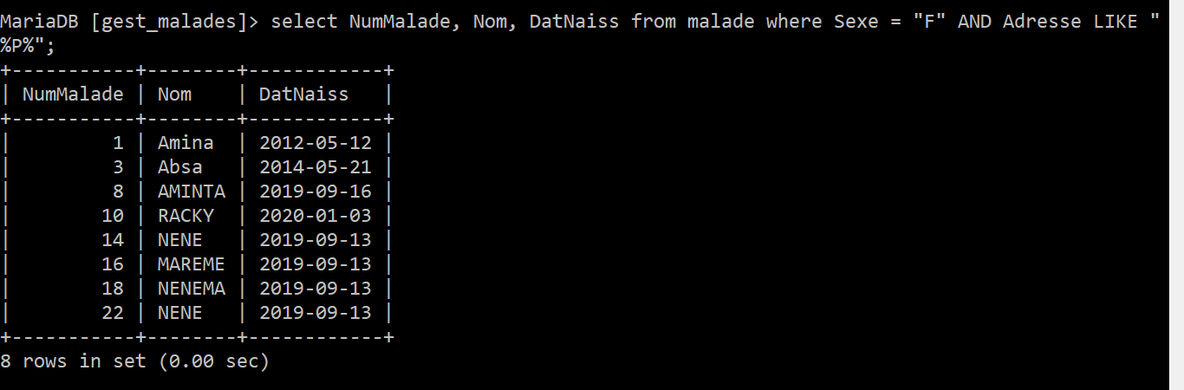

1. select malade.NumMalade, malade.Nom, malade.DatNaiss, chambre.NumChambre, chambre.Categorie, chambre.Type from malade, chambre, lit where malade.NumMalade= lit.NumLit and lit.NumChambre=chambre.NumChambre;

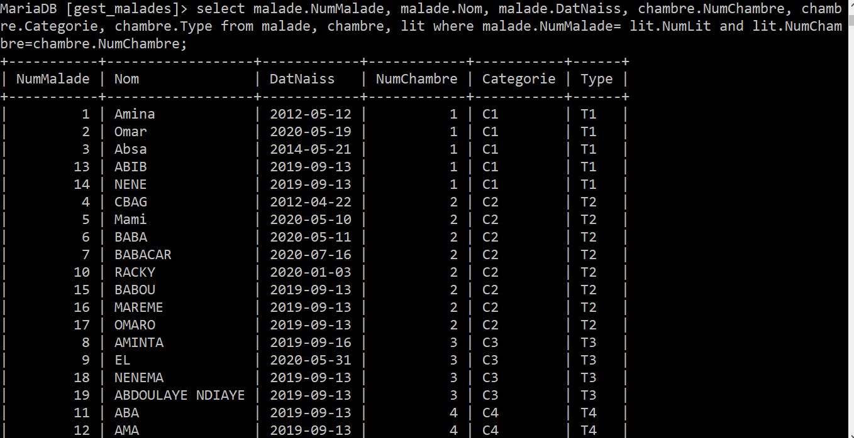

1. select malade.NumMalade, malade.Nom, malade.DatNaiss, deptmedical.NumDept, deptmedical.Nom from malade, deptmedical, interner where interner.NumDept=deptmedical.NumDept and malade.NumMalad= interner.NumMalade and malade.DatNaiss= "2012-04-22";

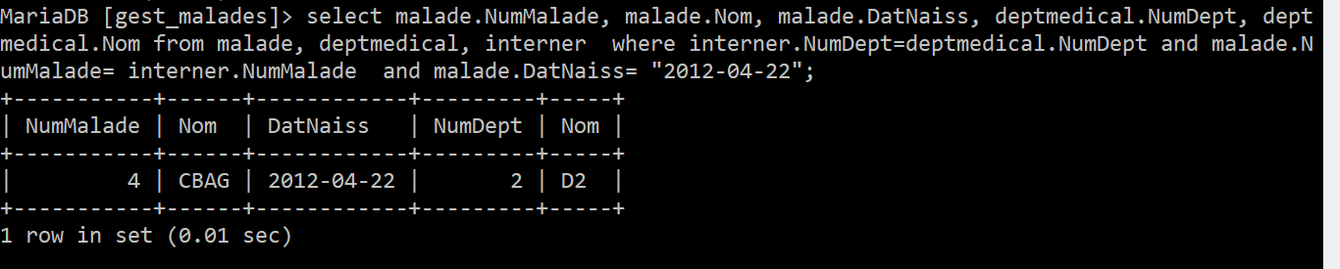

1. select malade.NumMalade, malade.Nom, malade.DatNaiss from malade, medecin, suivre where suivre.NumMalade= malade.NumMalade and suivre.NumMedec= medecin.NumMedec and medecin.Nom= "M3";

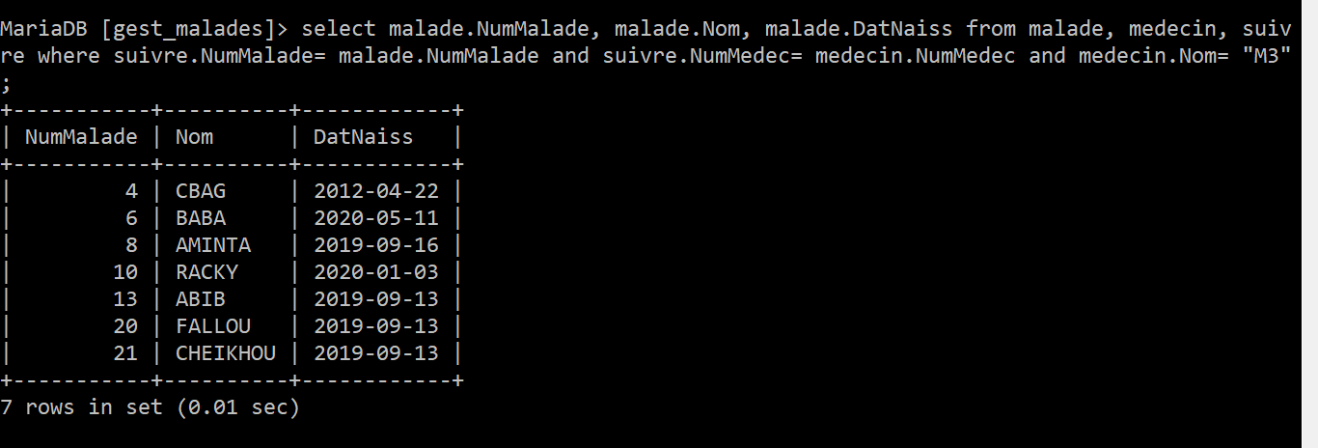

1. select malade.NumMalade, malade.Nom, malade.DatNaiss from malade, medecin, suivre, occuper where suivre.NumMalade= malade.NumMalade and suivre.NumMedec= medecin.NumMedec and medecin.Nom= "M3" and occuper.NumLit= 21;

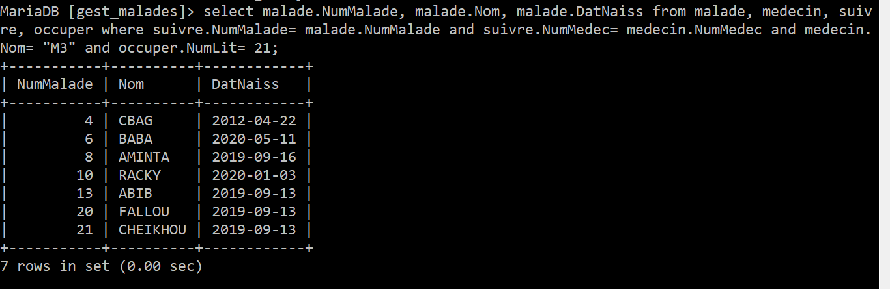

1. select distinct malade.NumMalade, malade.Nom, malade.DatNaiss from malade, occuper, lit where occuper.NumLit= 21 and occuper.NumMalade= malade.NumMalade;

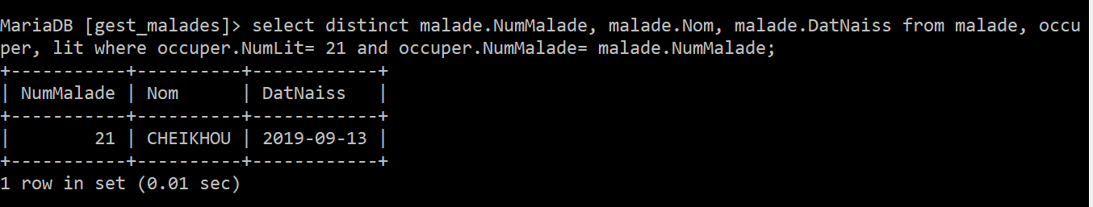

1. select malade.NumMalade, malade.Nom, malade.DatNaiss , feuille_devolution.NumFeuille, feuille_devolution.Date from malade, feuille_devolution where malade.NumMalade=11 and feuille_devolution.NumMalade= malade.NumMalade;

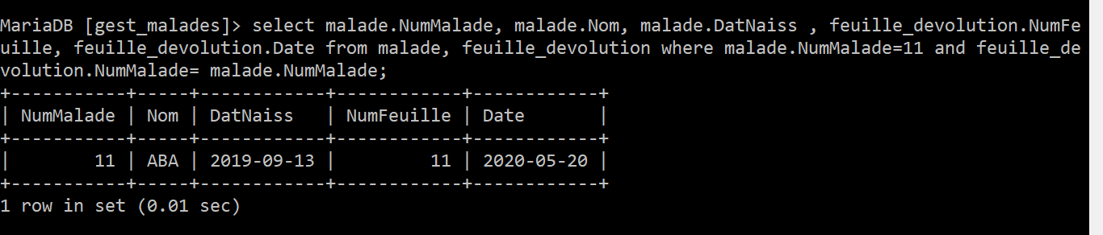

1. select COUNT(malade.NumMalade) as Nombre_malades, deptmedical.Nom from malade, deptmedical, interner where interner.NumDept= deptmedical.NumDept and interner.NumMalade= malade.NumMalade GROUP BY deptmedical.Nom;

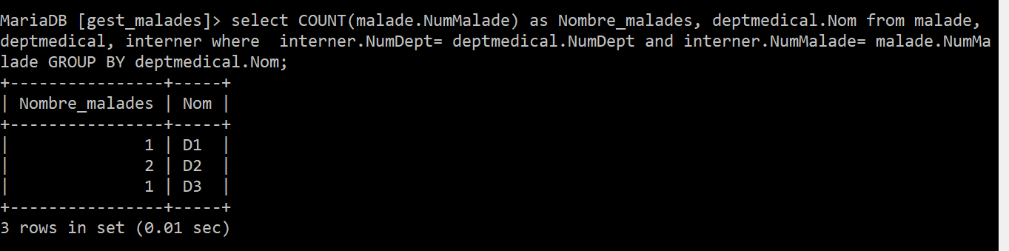

1. select distinct malade.NumMalade, malade.Nom, malade.Adresse, medecin.Nom as Nom_Medecin from malade, medecin, suivre, deptmedical, intervenir where suivre.NumMalade= malade.NumMalade and suivre.NumMedec= medecin.NumMedec and intervenir.NumMedec= medecin.NumMedec and intervenir.NumDept= 2;

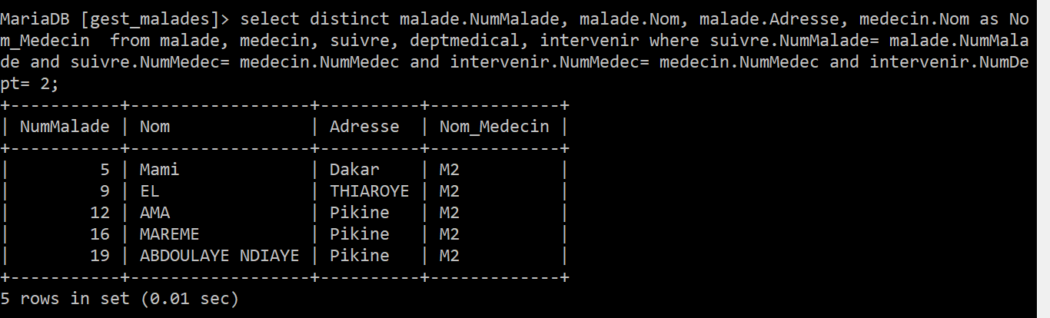

1. select malade.NumMalade, malade.Nom, malade.Adresse, interner.Date as date_internee from malade, interner where malade.NumMalade= interner.NumMalade and (MONTH(interner.Date)=12 or MONTH(interner.Date)=03);

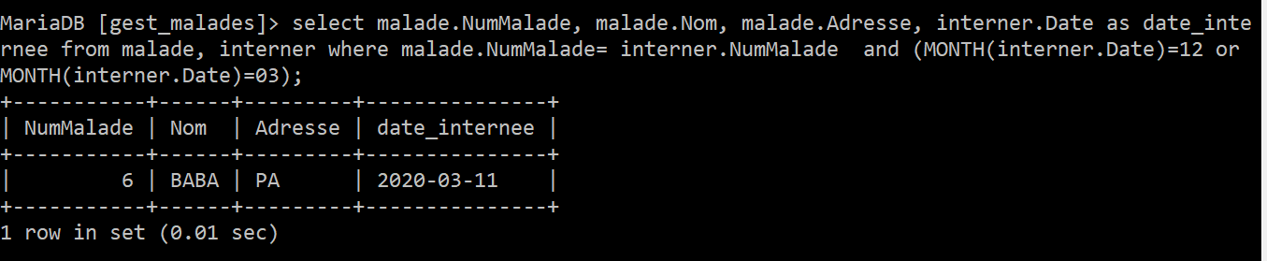

1ere methode:

select chambre.*, COUNT(occuper.NumMalade)as plus_malade from lit join chambre on lit.NumChambre=chambre.NumChambre join occuper on occuper.NumLit =lit.NumLit group by lit.NumChambre order by plus_malade Desc limit 1;

2e methode:

select chambre.*, COUNT(occuper.NumMalade) as nbr_malades from chambre, lit, malade, occuper where occuper.NumLit= lit.NumLit and occuper.NumMalade= malade.NumMalade and lit.NumChambre= chambre.NumChambre group by lit.NumChambre order by nbr_malades desc limit 1;

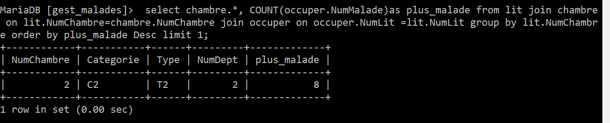

15-

1ere methode:

select deptmedical.*, COUNT(occuper.NumMalade) as nbr_malades from occuper join lit on occuper.NumLit= lit.NumLit join malade on occuper.NumMalade= malade.NumMalade join chambre on lit.NumChambre= chambre.NumChambre join deptmedical on chambre.NumChambre=deptmedical.NumDept group by chambre.NumDept order by nbr_malades desc limit 1;

2e methode:

select deptmedical.*, COUNT(occuper.NumMalade) as nbr_malades from chambre, lit, malade, occuper, deptmedical where occuper.NumLit= lit.NumLit and occuper.NumMalade= malade.NumMalade and lit.NumChambre= chambre.NumChambre AND chambre.NumChambre=deptmedical.NumDept group by chambre.NumDept order by nbr_malades desc limit 1;

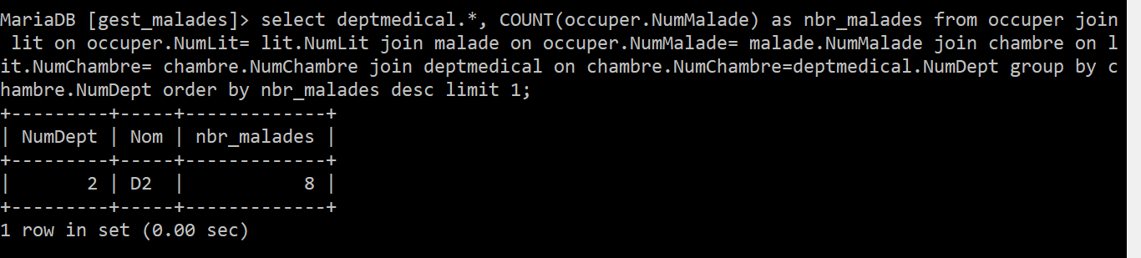

1. select chambre.*, COUNT(occuper.NumMalade)as plus_malade from lit join chambre on lit.NumChambre=chambre.NumChambre join occuper on occuper.NumLit =lit.NumLit group by lit.NumChambre order by plus_malade Desc limit 1;

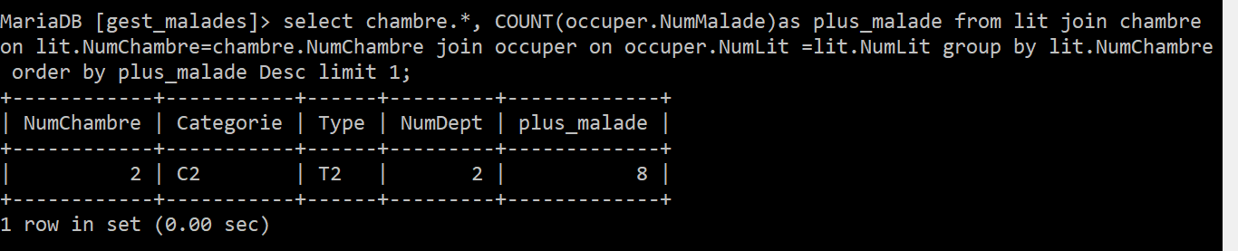

1. select medecin.*, COUNT(suivre.NumMalade) as nbr_malades_suivis from suivre join malade on suivre.NumMalade= malade.NumMalade join medecin on suivre.NumMedec= medecin.NumMedec group by medecin.NumMedec order by nbr_malades_suivis desc limit 1;

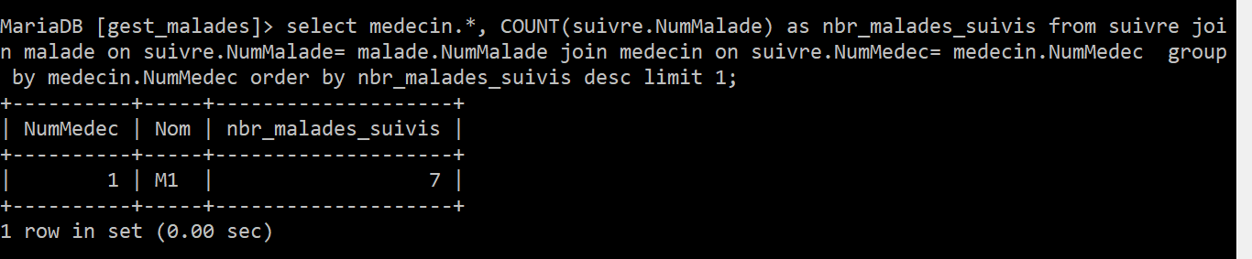

1. select malade.NumMalade, malade.Nom, malade.DatNaiss , chambre.NumChambre, lit.NumLit from occuper JOIN malade ON occuper.NumMalade= malade.NumMalade JOIN lit ON occuper.NumLit= lit.NumLit JOIN chambre ON lit.NumChambre=chambre.NumChambre JOIN suivre ON suivre.NumMalade= malade.NumMalade JOIN medecin ON suivre.NumMedec= medecin.NumMedec JOIN specialiser ON specialiser.NumMedec= medecin.NumMedec JOIN specialite ON specialiser.NumSpec= specialite.NumSpec WHERE specialite.Libelle="S2" GROUP BY malade.NumMalade ;

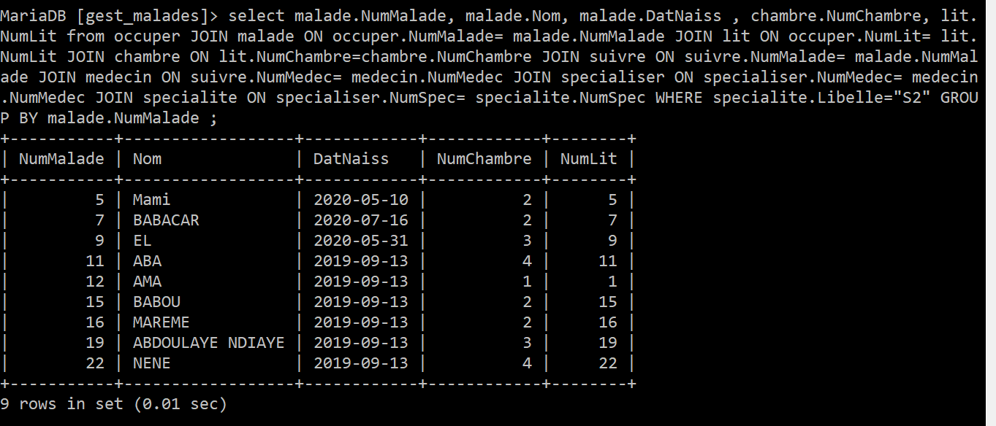

1. SELECT feuille_devolution.Etat FROM feuille_devolution JOIN malade ON feuille_devolution.NumMalade= malade.NumMalade JOIN interner ON interner.NumMalade = malade.NumMalade JOIN deptmedical ON interner.NumDept= deptmedical.NumDept WHERE deptmedical.Nom="D2" AND MONTH(interner.Date)=6 AND YEAR(interner.Date)=2020 ORDER by interner.Date ;

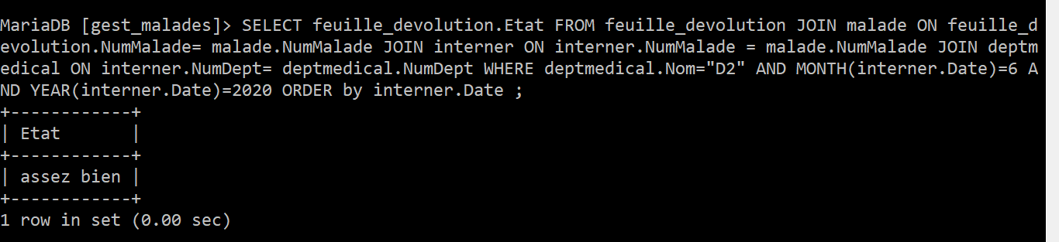

1. SELECT lit.NumLit, occuper.Date_doccupation AS date_prise FROM lit JOIN occuper ON occuper.NumLit = lit.NumLit JOIN malade ON occuper.NumMalade = malade.NumMalade WHERE MONTH(occuper.Date_doccupation) <> 03 ;

