Generates a grid with the given number and size of blocks. Additional an upper and lower help line can be added.

The frame of every block is in green (0x00ff00) color. Note that the frame is 1 pixel larger. So, if the block has a size of 16x16 pixel, the frame will have 17x17

The help lines are in red color (0x0ff0000)
DistLowerLine: Distance in pixel from bottom position of the block
DistUpperLine: Distance in pixel from top position of the block
This lines can be used as help lines for fonts. If not needed, just set it to 0, e.g. for sprites or icons.

Parameter:
[BlockCntY] [BlockSizeX] [BlockSizeY] [DistLowerLine] [DistUpperLine] [DestBitmap]

e.g.
GenGrid 16 16 16 16 2 10 Grid16x16x02x10.Bmp

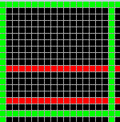
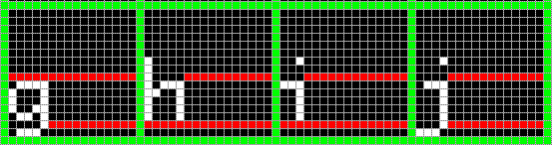

\
|
|
| 10 Pixel
|
/

_ 2 Pixel
/

Green Frame has 17x17
Black Block has 16x16

