Generates a cvs file (text file can be read by Excel) out of the given bitmap file. (.bmp is just replaced by .cvs). It scans each given blocks and tries to find the smallest fitting box. Therefore is scanns only for white(0xffffff) and grey(0x7f7f7f) colour. Output is only generate for non-empty blocks. This programm is only useable for black and white sprites/fonts.

Parameter:
[BlockCntX] [BlockCntY] [BlockSizeX] [BlockSizeY] [OffsetY] [SourceBitmap]

OffsetY: OffsetY in pixel from the bottom of the box.

e.g.
RasterScan 16 16 16 16 2 Raster1.Bmp
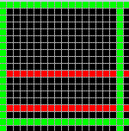
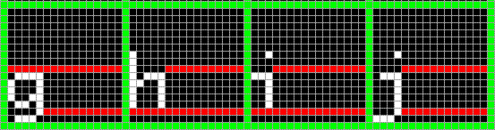
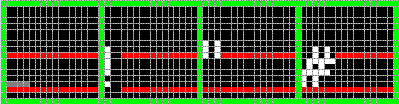
Output:

_ 2 Pixel
/ Offset

[Idx] [Format] [OftX] [OftY] [X] [Y] [W] [H] [BPP] [Type] [Idx2ASCII]
32 SpriteWH 0 0 1 48 4 1 1BPP RAW ' '
33 SpriteWH 0 0 18 42 1 7 1BPP RAW '!'
34 SpriteWH 0 5 35 41 3 3 1BPP RAW '"'
35 SpriteWH 0 0 52 42 6 7 1BPP RAW '#'
...
103 SpriteWH 0 -2 120 112 5 7 1BPP RAW 'g'
104 SpriteWH 0 0 137 109 5 8 1BPP RAW 'h'
105 SpriteWH 0 0 154 109 3 8 1BPP RAW 'i'
106 SpriteWH 0 -2 171 109 4 10 1BPP RAW 'j'

[X],[Y],[W],[H]: Position and size of the smallest fitting box
[OftX]: Distance the left side of the block minus [OffsetY]
[OftY]: Distance the bottom of the block minus [OffsetY]

