xPack OpenOCD x86_64 Open On-Chip Debugger 0.11.0+dev (2022-03-25-17:32)
Licensed under GNU GPL v2
For bug reports, read
http://openocd.org/doc/doxygen/bugs.html
Info : auto-selecting first available session transport "dapdirect_swd". To override use 'trans
port select <transport>'.
Info : STLINK V2J38S7 (API v2) VID:PID 0483:3748
Info : Target voltage: 3.288469
Info : Unable to match requested speed 400 kHz, using 240 kHz
Info : Unable to match requested speed 400 kHz, using 240 kHz
Info : clock speed 240 kHz
Info : stlink_dap_op_connect(connect)
Info : SWD DPIDR 0x0bc11477
Info : [at91samd.cpu] Cortex-M0+ r0p1 processor detected
Info : [at91samd.cpu] target has 4 breakpoints, 2 watchpoints
Error: [at91samd.cpu] clearing lockup after double fault
Polling target at91samd.cpu failed, trying to reexamine
Info : [at91samd.cpu] Cortex-M0+ r0p1 processor detected
Info : [at91samd.cpu] target has 4 breakpoints, 2 watchpoints
Info : starting gdb server for at91samd.cpu on 3333
Info : Listening on port 3333 for gdb connections
target halted due to debug-request, current mode: Thread
xPSR: 0x31000000 pc: 0xfffffffe msp: 0xfffffffc
** Programming Started **
Info : SAMD MCU: SAMD10D14AMU (16KB Flash, 4KB RAM)
Error: SAMD: NVM lock error
Error: Failed to erase row containing 00000000
Error: SAMD: failed to erase sector 0 at 0x00000000
Error: failed erasing sectors 0 to 4
** Programming Failed **
shutdown command invoked

OpenOCD shown following error, when trying to download SW. This is because, the first pages were reserved for the bootloader.
Reset the bootloader settings to default.

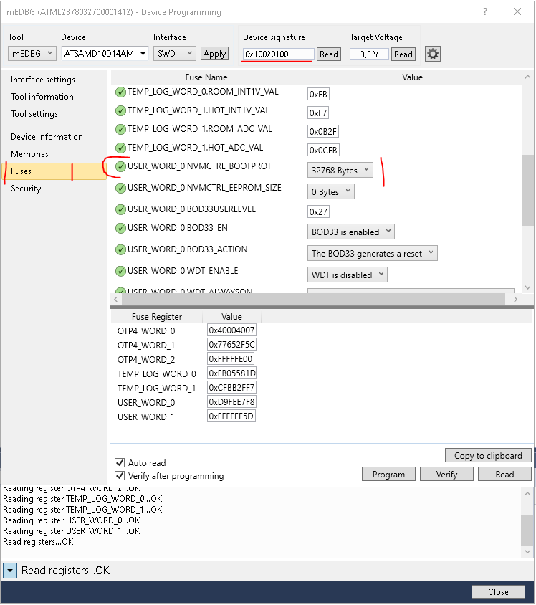

Programm the value to „0“

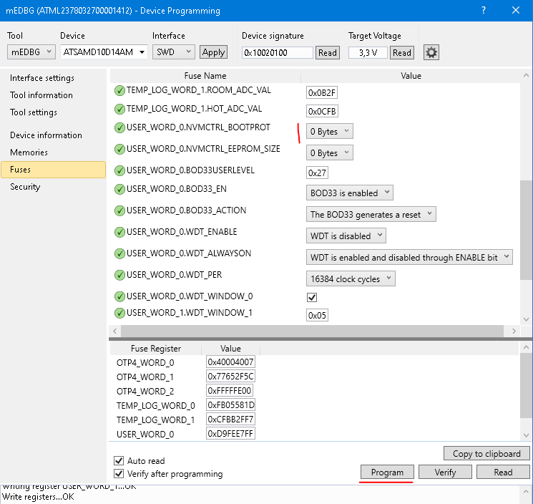
xPack OpenOCD x86_64 Open On-Chip Debugger 0.11.0+dev (2022-03-25-17:32)
Licensed under GNU GPL v2
For bug reports, read
http://openocd.org/doc/doxygen/bugs.html
Info : auto-selecting first available session transport "dapdirect_swd". To override use 'trans
port select <transport>'.
Info : STLINK V2J38S7 (API v2) VID:PID 0483:3748
Info : Target voltage: 3.289069
Info : Unable to match requested speed 400 kHz, using 240 kHz
Info : Unable to match requested speed 400 kHz, using 240 kHz
Info : clock speed 240 kHz
Info : stlink_dap_op_connect(connect)
Info : SWD DPIDR 0x0bc11477
Info : [at91samd.cpu] Cortex-M0+ r0p1 processor detected
Info : [at91samd.cpu] target has 4 breakpoints, 2 watchpoints
Error: [at91samd.cpu] clearing lockup after double fault
Polling target at91samd.cpu failed, trying to reexamine
Info : [at91samd.cpu] Cortex-M0+ r0p1 processor detected
Info : [at91samd.cpu] target has 4 breakpoints, 2 watchpoints
Info : starting gdb server for at91samd.cpu on 3333
Info : Listening on port 3333 for gdb connections
target halted due to debug-request, current mode: Thread
xPSR: 0x31000000 pc: 0xfffffffe msp: 0xfffffffc
** Programming Started **
Info : SAMD MCU: SAMD10D14AMU (16KB Flash, 4KB RAM)
** Programming Finished **
** Verify Started **
** Verified OK **
** Resetting Target **
shutdown command invoked

