**Components:-**

* Thread emulating UI component
* Mobile Server for routing requests to/from the server
* MYSQL DB for storing chat transcripts and other business logic related tables

**SEQUENCE-FLOW:-**

* Load page on localhost or on server post deploying the application.Page loads as this:-

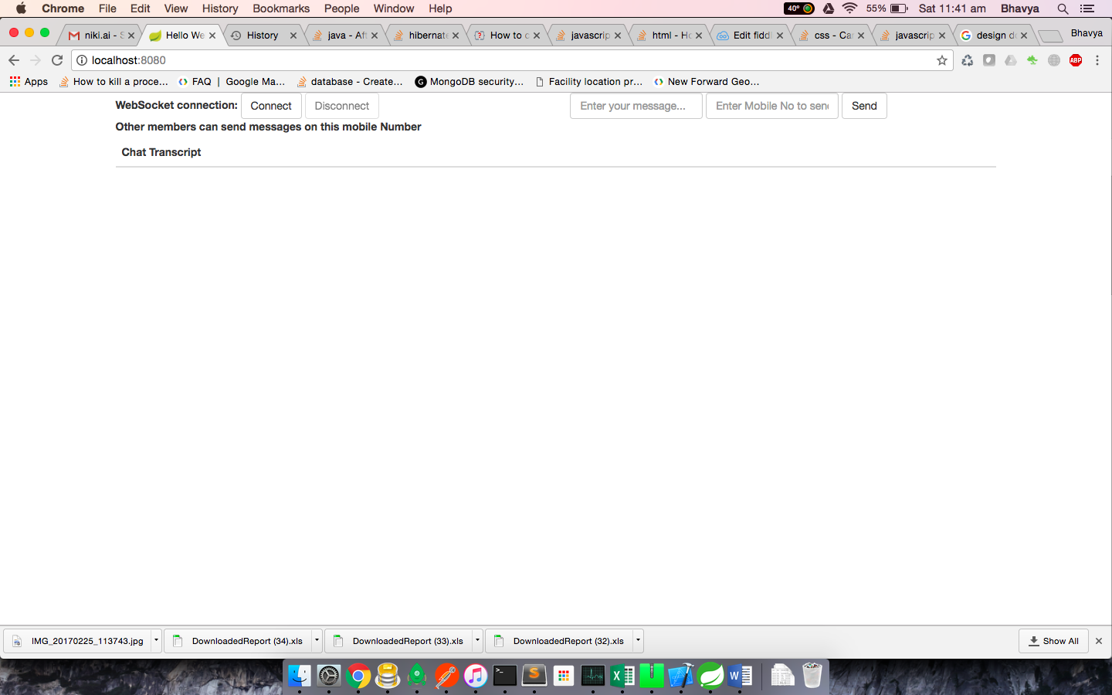

* Click on connect to assign a persistent socket connection and a mobile number to the mobile device emulating UI

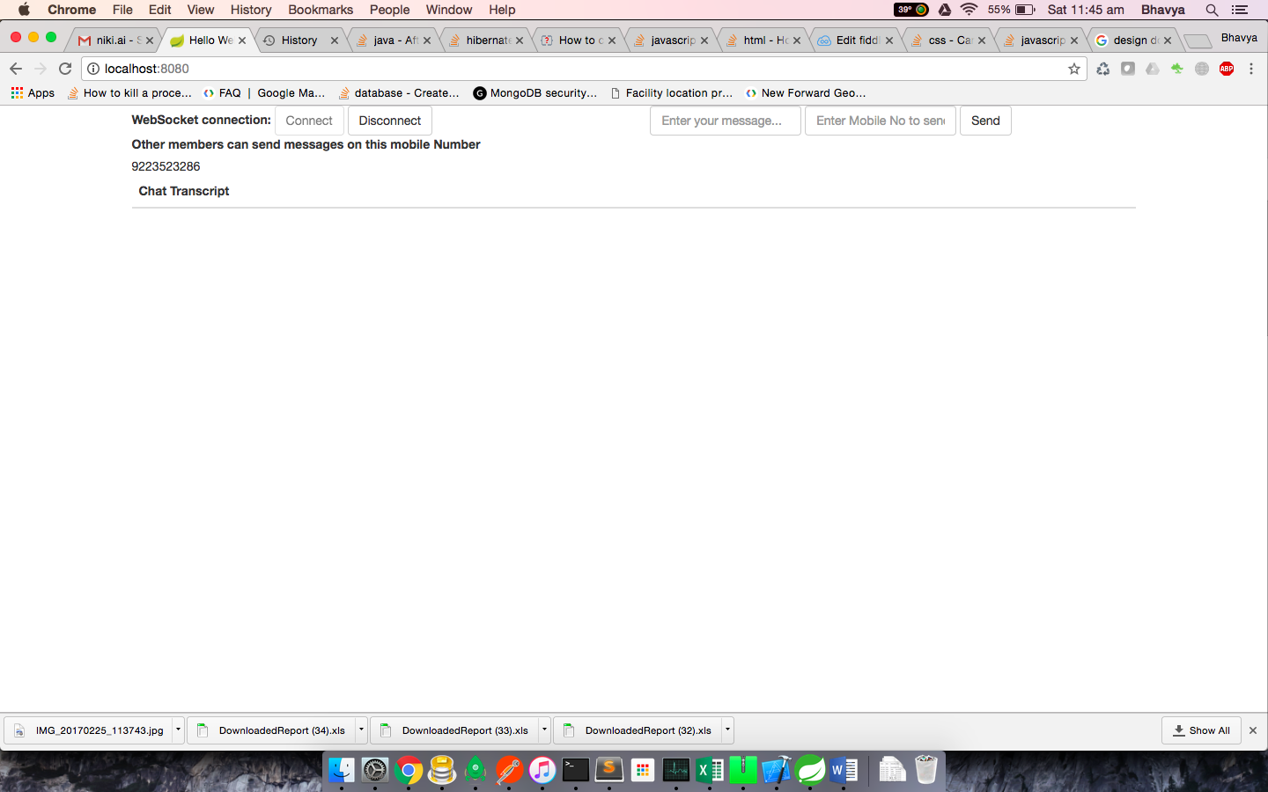

* Click on disconnect to revoke the socket assigned to this thread

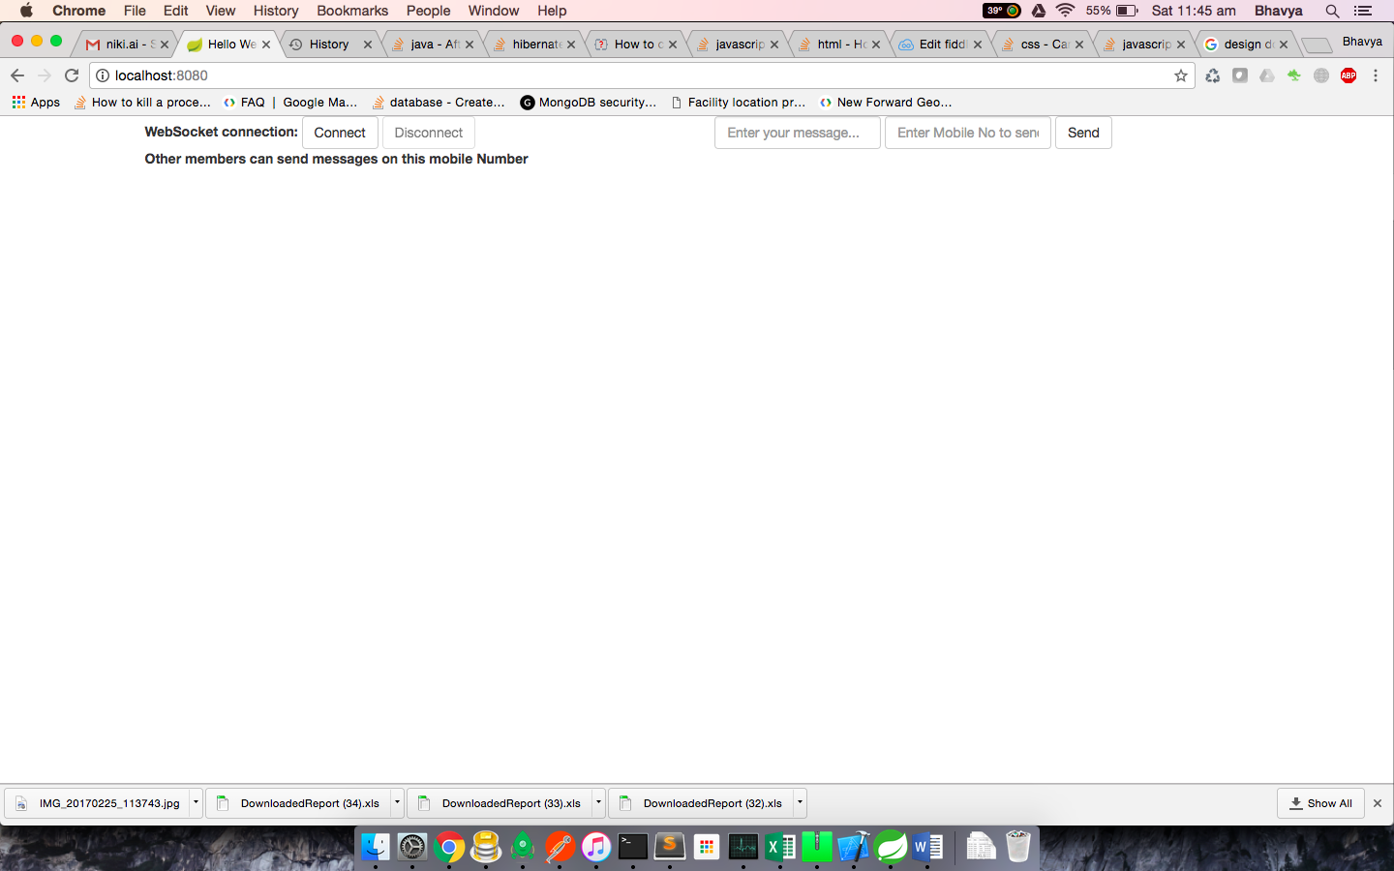

* Assign another mobile device a socket privilege alongside to send/receive messages from

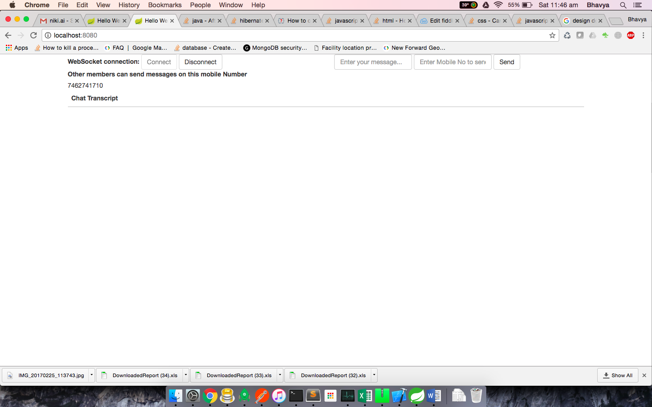

* Send a message from one mobile device to other using the two text areas which takes an input of the message and the mobile number to send text message to



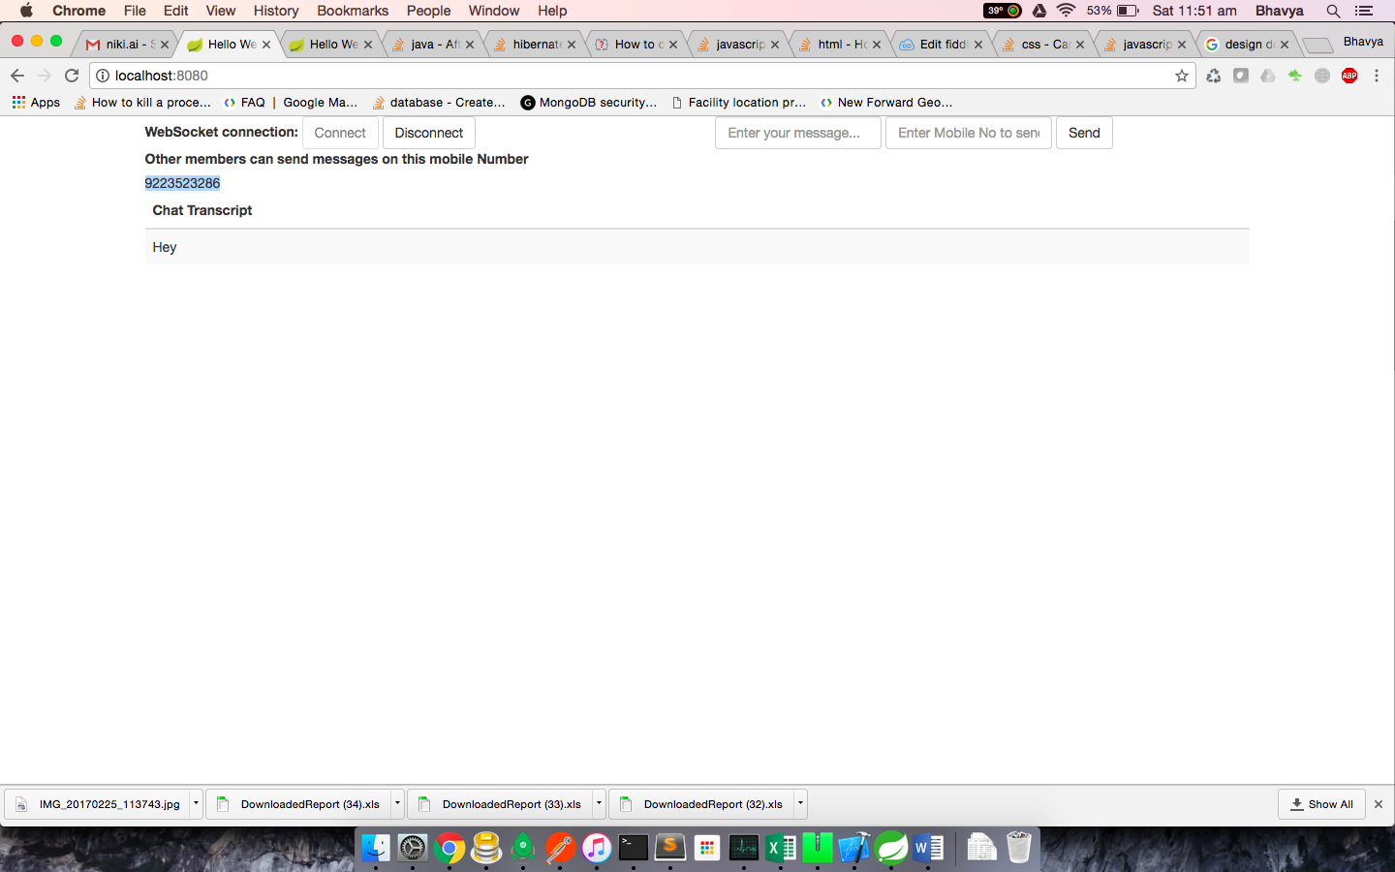

**Data Storage Pieces:-**

MYSQL DB has been used to store data.

Two tables **credentials** and **messagelog** have been used primarily to keep an account of the transactions occurring on the server.

The **credentials** table keeps a mapping of the destinationIds offered to each mobile device alongwith it’s mobile Number

The **messagelog** table keeps a log of the messages being transmitted to different destinationIds and keeps a check on not sending across duplicate Messages within an interval of 5 secs.

Component Diagram:-

