Task 1:
Python installation & setup
To install python and VS code successfully and run the first python program.

Software required:-
*python
*visual Studio Code(vs code)

installation steps:-
1.Downloaded python from the official python website.
2.Installed Python on the laptop.
3.Downloaded and installed visual studio code.
4.Installed the python extension in VS code.
5.Created the first python program.
6.Ran the program successfully.
Python program:-
print(”Hello,World”)

Output:-
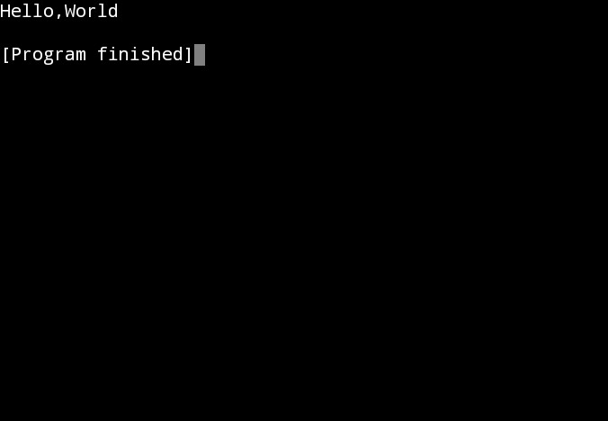

Screenshots:-
1) VS Code installation:-
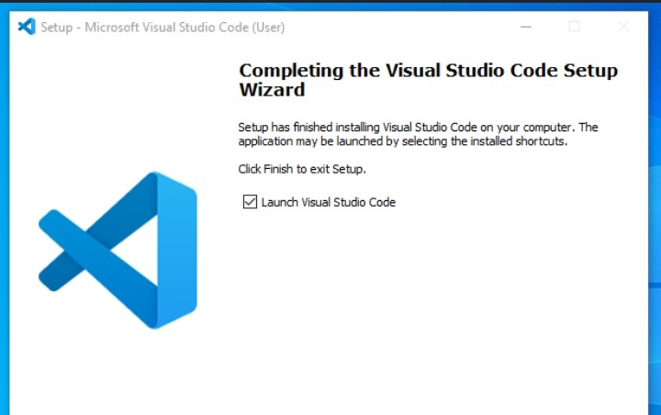

2)Python installation:-
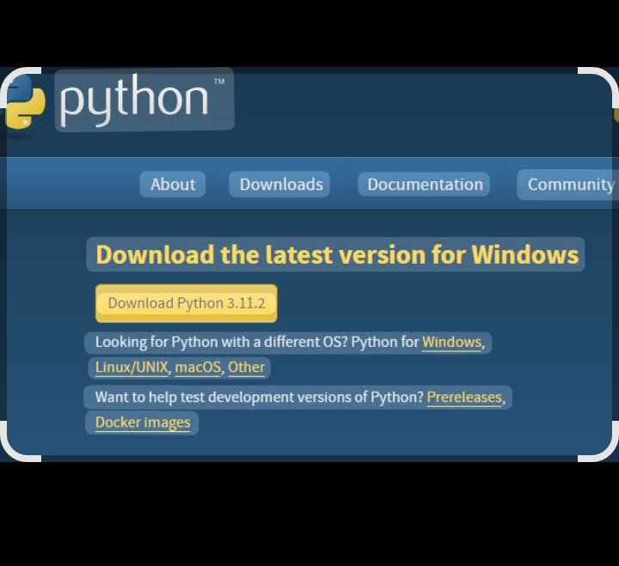

Explanation:-
Python is a programming language used for developing software and solving problems. VS Code is used to write and run python programs. The program print(“Hello, World!”) displays the message Hello, World! On the screen.
RESULT:-
Python and VS Code were installed successfully, and the python program was executed successfully.

Task 2:-
Variables & Data Types:-
Objective:-
To learn how to declare variables of different data types and display their values using the type()function.
Program:-
name=”Amrutha”
age= 19
height= 5.3
student= True
print(“name=”,name)
print(“Data Type =” , type(name))
print(“Age=”,age)
print(“Data Type=”,type(age))
print(“Height =” ,height)
print(“Data Type =”,type(height))
print(“Student=”,student)
print(“Data Type=”,type(student))

Output:-
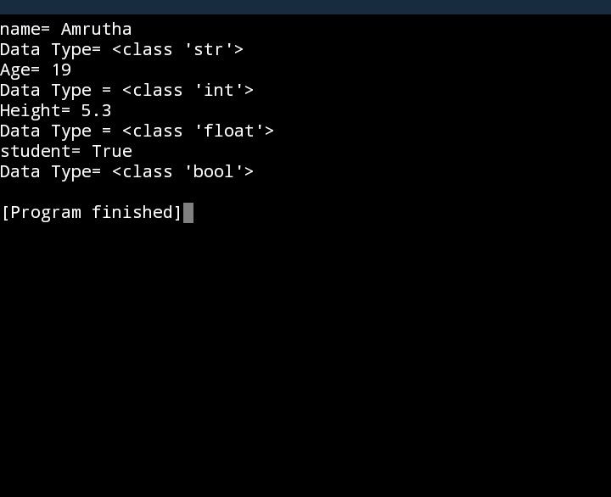

Explanation:-
.name-->String(str)
.age-->Integer(int)
.height-->Float(float)
.student-->Boolean(bool)

RESULT:-
The program was executed successfully. Different variables and their data types were displayed using the type() function.

Task 3:-
Input, output & Type Casting:-
Objective:-
To learn how to take input from the user and use type casting in Python.
Program:-
name = input(“Enter your name: “)
age = int(input(“Enter your age:”))
city = input(“Enter your city: “)
print(“\n_____Student Details____”)
print(“Name:”,name)
print(“Age:”,age)
print(“City:”,city)

Output:-
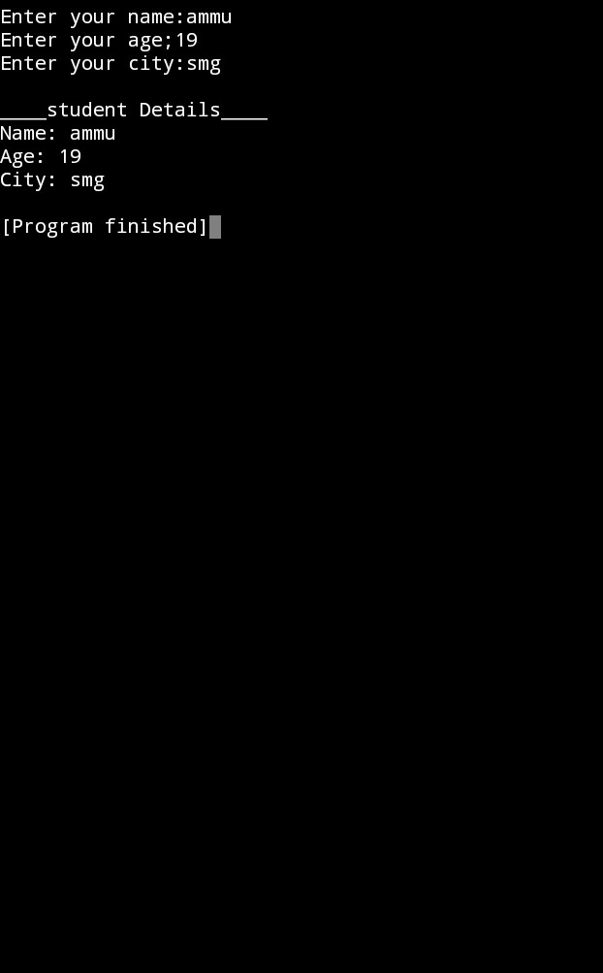

Explanation:-
*The input()function is used to get information from the user.
*int() is used to convert String input into an integer(Type Casting).
*print()displays the information given by the user on the screen.

Result:-
The program successfully accepted user input, converted the age into an integer using type casting, and displayed the entered details correctly.

TASK 4:-

OPERATORS
Objective:-
To perform arithmetic operations using python operators.
Program:-
num1 = int(input(“Enter first number:”)
num2 = int(input(“Enter second number : “))
print(“Addition =”,num1+num2)
print(“Subtraction =”,num1-num2)
print(“Multiplication =”,num1 * num2)
print(“Division =”,num1 / num2)
print(“Moduls =”, num1 % num2)
print(“Exponent =”,num1 ** num2)

Output:-
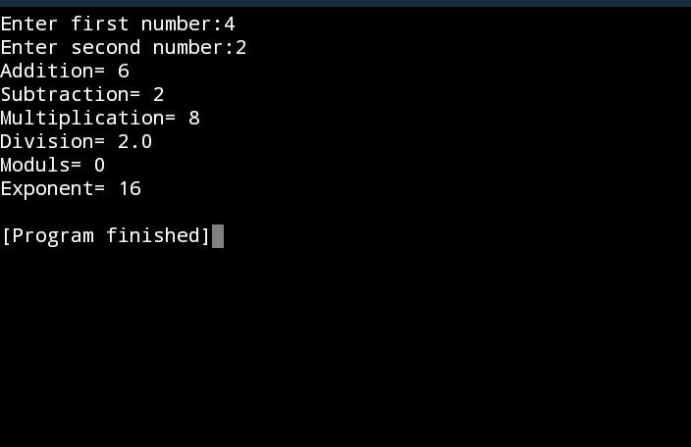

RESULT:-
The program successfully performed arithmetic operations using python operators and displayed the results correctly.

TASK 5:-
Objective:-
To create a simple python program that accepts student details and displays them on the screen.

PROGRAM:-
name = input(“Enter student Name:”)
usn = input(“Enter usn: “)
course = input(“Enter course: “)
college = input(“Enter college name: “)
print(“\n_____student information_____”)
print(“Student Name: “,name)
print(“usn:”,usn)
print(“course:”,course)
print(“college name:”, college)

Output:-

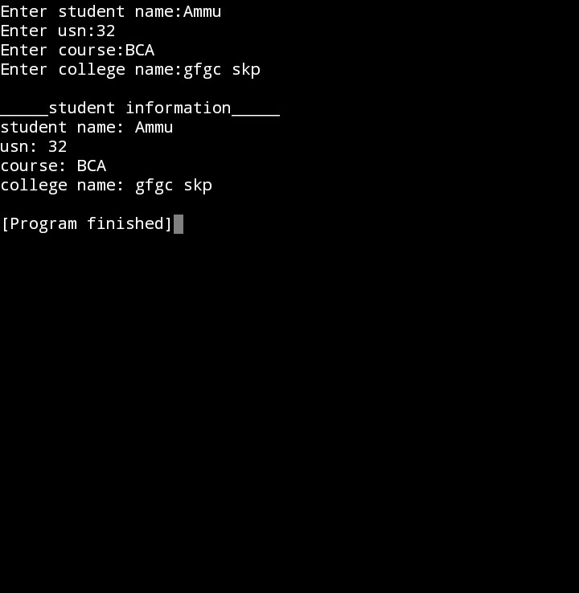

Explanation:-
* input() function: takes students name, usn, course, and college.

*print() function: displays all the collected information on screen.

*mini project goal: teaches how user input and output work.

Result:-
The student information system was created successfully. the program accepted the students details and displayed them correctly.

CONCLUSION:-
In this internship, I learned the basics of python programming. i understood python installation, variables, data types, input/output, type casting, operators, and developed a simple mini project. this assignment improved my programming knowledge and practical coding skills.

