Interpretable QSAR machine-learning model for passive intestinal permeability prediction using PAMPA data and virtual screening of DrugBank compounds
Benjamin Andres Vasquez Perez; Juan Alberto Castillo-Garit
Facultad de Ciencias Naturales, Matematicas y del Medio Ambiente, Universidad Tecnologica Metropolitana, Santiago, Chile

Abstract
Background: Passive intestinal permeability is a key determinant of oral drug absorption and remains a frequent attrition factor during early drug discovery. PAMPA provides a reproducible in vitro approximation of passive diffusion and is suitable for ligand-based computational modeling.
Methods: A curated PAMPA dataset was divided into training, internal test and external validation sets. Molecular descriptors and fingerprints were reduced using variance filtering, recursive feature elimination and a WEKA-based consensus selection strategy. A Random Forest classifier was trained using 11 final descriptors and evaluated by cross-validation, internal and external validation, applicability-domain analysis, a five-molecule prospective pre-screening set and virtual screening of DrugBank compounds.
Results: The final model achieved accuracies of 0.863, 0.751 and 0.887 for the training, internal test and external validation sets, respectively. The corresponding AUC values were 0.940, 0.830 and 0.678, and the external validation F1-score was 0.938. DrugBank screening yielded 863 high-probability candidates, 850 of which were within the applicability domain and 778 of which satisfied the implemented Lipinski filter.
Conclusion: The workflow provides a reproducible and interpretable QSAR model for prioritizing compounds with favorable passive intestinal permeability and can be integrated into early-stage virtual screening pipelines.
Keywords: PAMPA; QSAR; passive permeability; Random Forest; ADME; virtual screening; DrugBank; applicability domain.

1. Introduction
Low oral bioavailability remains one of the central causes of failure in drug discovery, because therapeutic activity depends not only on potency but also on the ability of a compound to reach the systemic circulation at suitable concentrations. ADME properties are therefore increasingly evaluated during early design rather than late development. Intestinal permeability is especially relevant for orally administered drugs, and the distinction between passive diffusion and transporter-mediated processes is important when selecting experimental and computational endpoints.
The parallel artificial membrane permeability assay (PAMPA) is a high-throughput experimental method designed to estimate passive membrane permeation using an artificial lipid barrier. Compared with cellular systems such as Caco-2 or MDCK, PAMPA does not include active transporters, metabolic enzymes or paracellular complexity. However, this narrower biological scope can be advantageous for machine-learning benchmarking, because the endpoint is more directly related to physicochemical and structural features of the molecule.
QSAR models are based on the premise that molecular structure encodes information needed to estimate physicochemical or biological behavior. Modern machine-learning algorithms extend classical linear QSAR by capturing nonlinear patterns and interactions among descriptors. Random Forests are useful in this setting because they are robust to descriptor interactions, provide internal measures of variable importance and can be combined with interpretability analyses. The present work develops a reproducible, interpretable Random Forest classifier for PAMPA permeability prediction and applies it to prospective and DrugBank screening.

2. Materials and Methods

2.1 Dataset curation and endpoint definition
The modeling dataset was compiled from compounds with experimentally reported PAMPA permeability classes. The curated data were organized into three sets: a training set of 4357 compounds, an internal test set of 1090 compounds and an independent external validation set of 486 compounds. The binary endpoint was encoded as permeable (Act1) or non-permeable (Act-1).
Dataset | Total compounds | Permeable | Non-permeable
Training | 4357 | 2332 | 2025
Internal test | 1090 | 583 | 507
External validation | 486 | 443 | 43

2.2 Molecular representation and descriptor reduction
Compounds were represented using molecular descriptors and structural fingerprints. The initial descriptor space was reduced by removing constant and non-informative variables, followed by Random-Forest-based recursive feature elimination. This procedure retained a compact intermediate set of 50 descriptors before consensus feature selection.

2.3 WEKA-based consensus feature selection
A Python automation layer was used to run WEKA attribute-selection procedures. Ten selector combinations were generated by pairing two classifiers, J48 and IBk, with five search strategies: BestFirst, GeneticSearch, LinearForwardSelection, RankSearch and SubsetSizeForwardSelection. Descriptor votes were obtained from the selected-attribute logs. A preliminary vote threshold of 40% identified candidate variables, and a parsimony step retained the 11 descriptors that maximized predictive performance without reducing model stability.

2.4 Model training and validation
The final model was a scikit-learn RandomForestClassifier with 500 trees, maximum depth of 10, minimum leaf size of 4, square-root feature sampling, class weights of 1.5 for the non-permeable class and 1.0 for the permeable class, and random_state=42. Performance was assessed using cross-validation, the original training set, the internal test set and the external validation set. Accuracy, sensitivity, specificity, AUC, MCC and F1-score were calculated. Applicability domain was estimated by leverage using h* = 3(p+1)/n.

2.5 Prospective and DrugBank screening
The model was challenged with five molecules not used for training as a small prospective pre-screening control. A larger virtual screening workflow was then applied to DrugBank-derived compounds. The complete DrugBank source contained more than 10000 entries before descriptor availability, curation and filtering. Final candidate tables were filtered according to predicted permeability probability, applicability-domain status and Lipinski-like criteria.

3. Results and Discussion

3.1 Consensus-selected descriptors
The final 11-descriptor panel is chemically coherent for passive permeability because it combines lipophilicity, aromatic/heteroatom fingerprints, topology, polarizability, donor surface terms and descriptors related to electronic distribution.
Descriptor | Family | Mechanistic interpretation
LOGPcons | Physicochemical | Consensus lipophilicity; controls affinity for the lipid-like membrane phase.
MACCSFP125 | Structural fingerprint | Heteroatom-containing aromatic pattern associated with two-dimensional pharmacophoric features.
PCR | Topological | Captures molecular complexity and branching.
Psi_e_A | Electrotopological | Reflects electronic accessibility weighted by electronegativity.
P_VSA_ppp_D | Surface/pharmacophore | Donor-associated surface related to desolvation cost.
Mp | Atomic property | Mean atomic polarizability and dispersion interactions.
SpMin1_Bh(p) | Burden matrix | Polarizability-weighted topological regions.
SHED_AL | Shannon entropy | Balance between acceptor and lipophilic regions.
SM12_AEA(ri) | Spectral moment | Conjugation and aromaticity.
P_VSA_s_3 | Surface descriptor | Surface contribution associated with physicochemical bins.
MATS5m | 2D autocorrelation | Mass distribution along molecular topology.

3.2 Cross-validation and final predictive performance
K | Accuracy | Sensitivity | Specificity | AUC | F1-score
5 | 0.738 | 0.729 | 0.746 | 0.823 | 0.735
10 | 0.738 | 0.730 | 0.745 | 0.823 | 0.735

Dataset | Accuracy | Sensitivity | Specificity | AUC | MCC | F1-score
Training | 0.863 | 0.852 | 0.877 | 0.940 | 0.727 | 0.870
Internal test | 0.751 | 0.760 | 0.742 | 0.830 | 0.501 | 0.766
External validation | 0.887 | 0.939 | 0.349 | 0.678 | 0.291 | 0.938

The training AUC of 0.940 and test AUC of 0.830 indicate good discrimination within the main chemical space. In the external validation set, the model maintained high accuracy and sensitivity, with an F1-score of 0.938. The lower external AUC should be interpreted in the context of strong class imbalance in the external set.
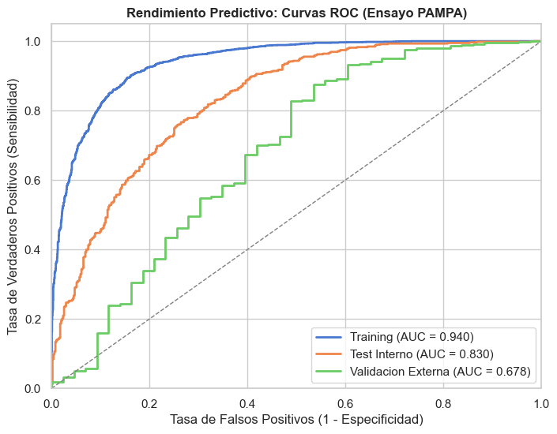
Figure 1. ROC curves for the final PAMPA permeability model.
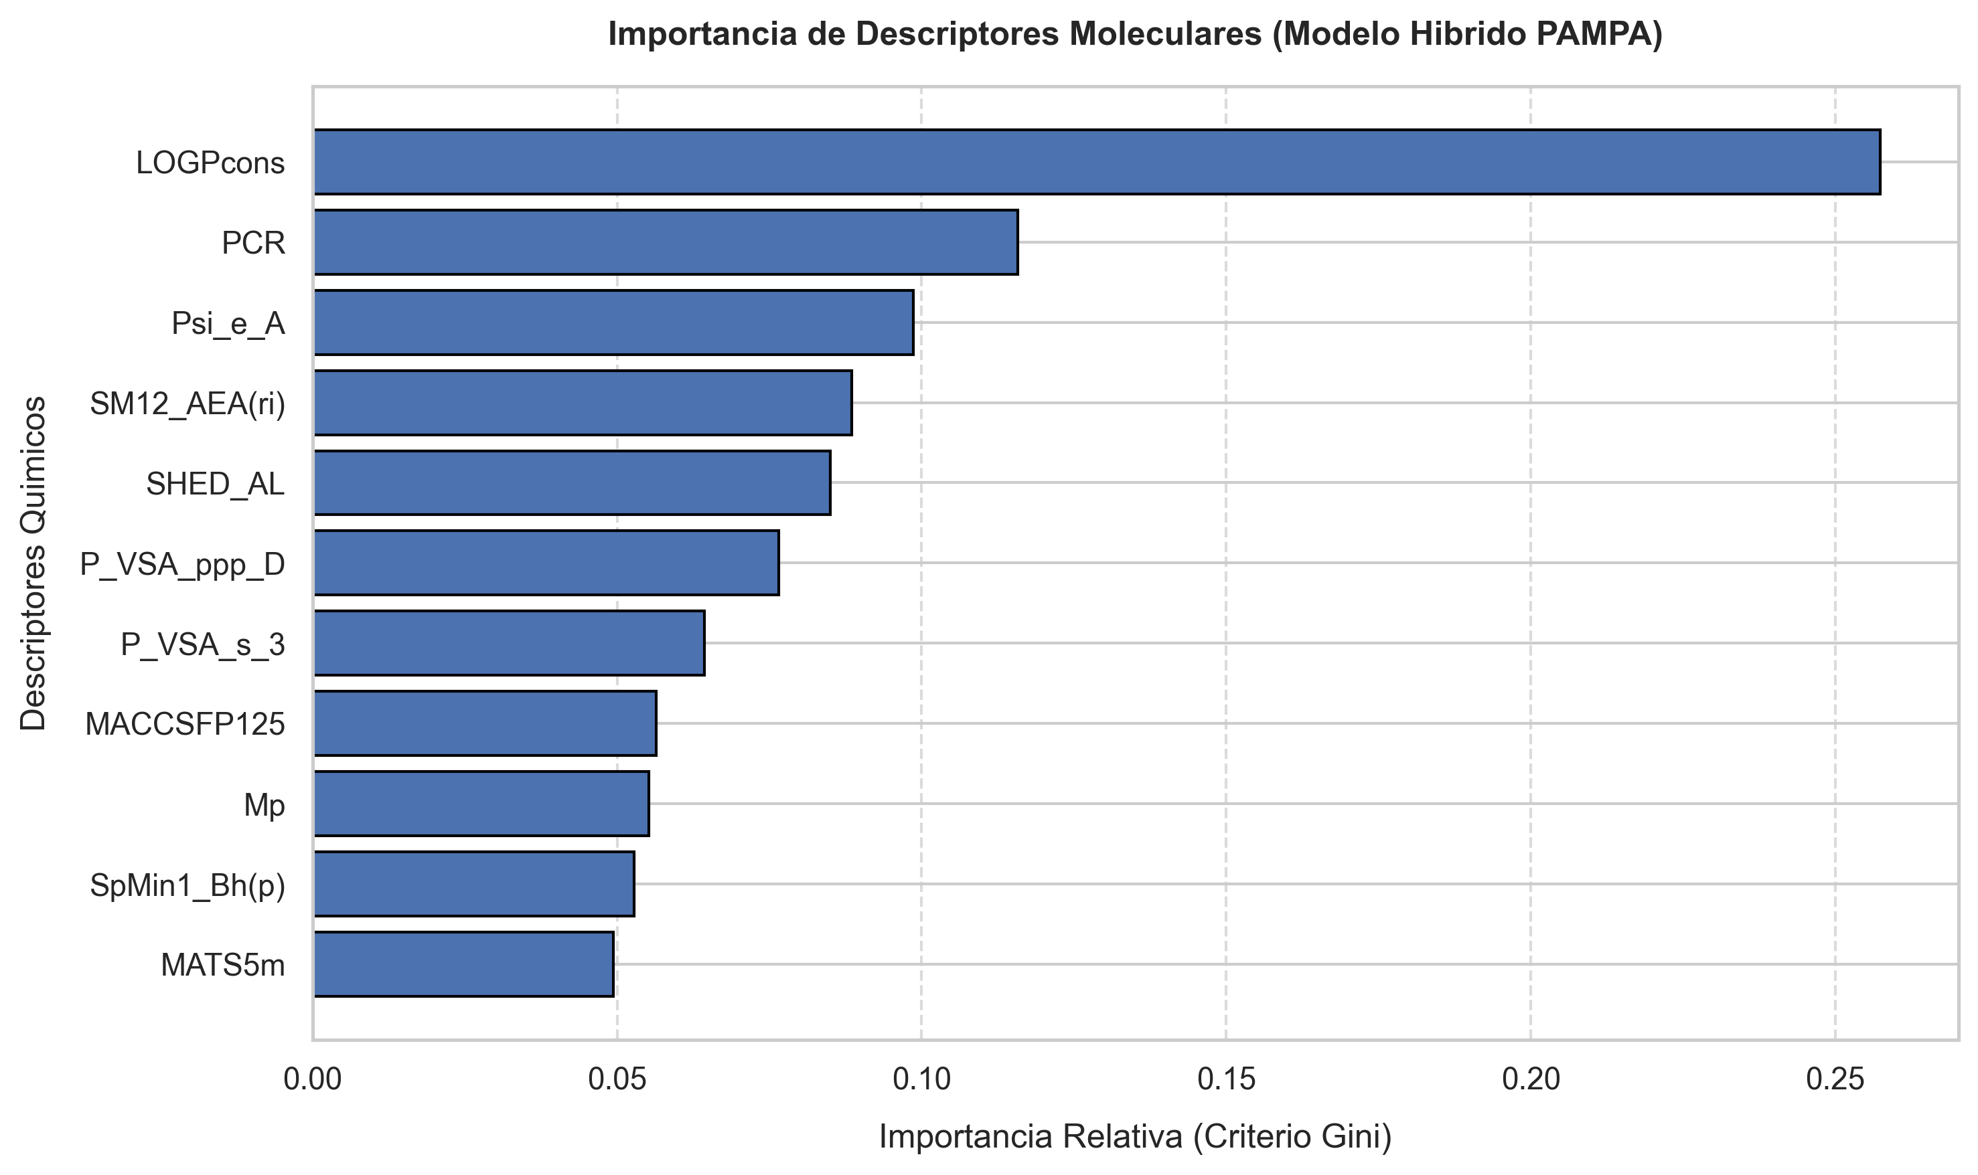
Figure 2. Variable-importance profile of the selected Random Forest model.

3.3 Prospective pre-screening and DrugBank virtual screening
Molecule | Predicted probability | Model call
Molecule3 | 0.696 | Permeable
Molecule2 | 0.695 | Permeable
Molecule4 | 0.659 | Permeable
Molecule1 | 0.648 | Permeable
Molecule5 | 0.045 | Non-permeable

DrugBank screening produced 863 high-probability candidate entries. The probability distribution ranged from 0.600 to 0.990, with a median of 0.760. Applicability-domain analysis classified 850 candidates as inside the model domain, while 13 were outside. Lipinski filtering identified 778 candidates as viable, 57 as non-viable and 28 as not evaluable.
DrugBank ID | Probability | Leverage | MW | LogP
DB00404 | 0.990 | 0.000941 | 308.77 | 3.58
DB03786 | 0.980 | 0.001027 | 316.38 | 3.72
DB04854 | 0.980 | 0.001027 | 316.38 | 3.72
DB03899 | 0.970 | 0.000737 | 311.39 | 2.81
DB04920 | 0.970 | 0.001777 | 456.32 | 4.25

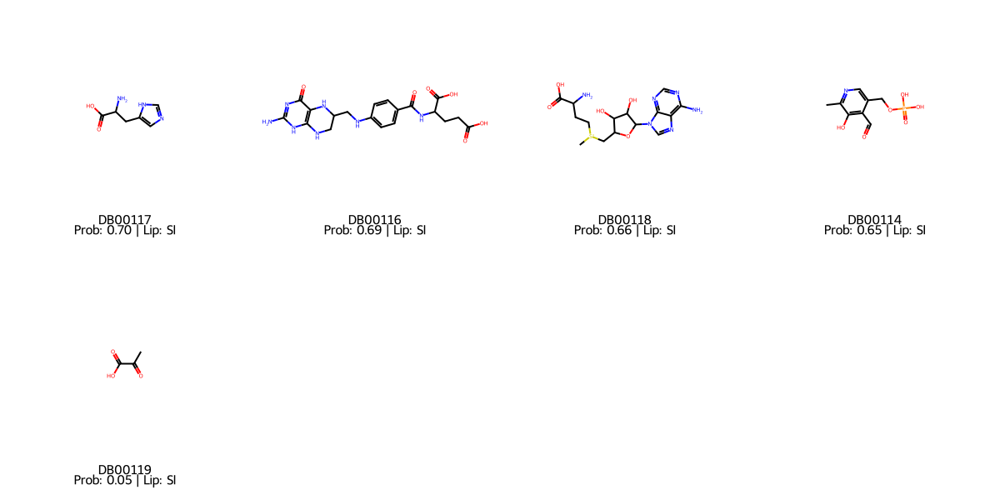
Figure 3. Representative structures from the prospective pre-screening/Lipinski workflow.

4. Conclusions
An interpretable Random Forest QSAR model was developed for passive intestinal permeability prediction using curated PAMPA data. The final 11-descriptor model reproduced the thesis metrics, achieving strong performance in training and internal testing and high sensitivity in an independent external validation set. The descriptor panel is chemically meaningful and reflects the interplay between lipophilicity, polar surface contributions, polarizability, topology and structural fingerprints. The workflow also provides applicability-domain filtering and virtual screening output, enabling practical prioritization of compounds with favorable passive permeability profiles.
The model is most appropriate as an early-stage decision-support tool for passive permeability prioritization. Future work should expand the external non-permeable class, calibrate probability outputs, compare additional algorithms using nested validation and experimentally validate selected DrugBank candidates in standardized PAMPA assays.

Data and code availability
The curated datasets, trained model, validation scripts, notebooks and screening outputs are available at https://github.com/bvasquezp/Permeability-PAMPA-ML. Final metrics can be reproduced with python src/check_final_metrics.py, and core file integrity can be checked with python src/validate_project.py.

Author contributions
Benjamin Andres Vasquez Perez: conceptualization, data curation, modeling, validation, visualization and writing original draft. Juan Alberto Castillo-Garit: supervision, methodology, scientific guidance and manuscript review. Author roles should be confirmed before submission.

Funding
Funding information should be added before journal submission.

Conflicts of interest
The authors declare no conflicts of interest. This statement should be confirmed before submission.

References
[1] DiMasi JA, Grabowski HG, Hansen RW. Innovation in the pharmaceutical industry: New estimates of R&D costs. Journal of Health Economics. 2016;47:20-33.
[2] Kola I, Landis J. Can the pharmaceutical industry reduce attrition rates? Nature Reviews Drug Discovery. 2004;3:711-715.
[3] Lipinski CA et al. Experimental and computational approaches to estimate solubility and permeability in drug discovery and development settings. Advanced Drug Delivery Reviews. 2001;46:3-26.
[4] Kansy M, Senner F, Gubernator K. Physicochemical high throughput screening: PAMPA in passive absorption processes. Journal of Medicinal Chemistry. 1998;41:1007-1010.
[5] Sun H et al. Highly predictive and interpretable models for PAMPA permeability. Bioorganic & Medicinal Chemistry. 2017;25:1266-1276.
[6] Breiman L. Random Forests. Machine Learning. 2001;45:5-32.
[7] OECD. Guidance document on the validation of (Q)SAR models. 2007.
[8] Pedregosa F et al. Scikit-learn: machine learning in Python. Journal of Machine Learning Research. 2011;12:2825-2830.
[9] Wishart DS et al. DrugBank 5.0: a major update to the DrugBank database for 2018. Nucleic Acids Research. 2018;46:D1074-D1082.
[10] Casanola-Martin GM et al. Atom based linear index descriptors in QSAR-machine learning classifiers. Medicinal Chemistry Research. 2018;27:695-704.
[11] Barigye SJ et al. Evolutionary algorithm-based generation of optimum peptide sequences with dengue virus inhibitory activity. Future Medicinal Chemistry. 2021;13:993-1000.
[12] Canizares-Carmenate Y et al. Machine learning approach to discovery of small molecules with potential inhibitory action against vasoactive metalloproteases. Molecular Diversity. 2022;26:1383-1397.

Python-generated reproducibility tables and figures
The following tables and figures were generated directly from the repository datasets, model and result files using manuscript/generate_python_assets.py.

Expanded methods and interpretation added to the LaTeX manuscript
The updated manuscript now describes the alvaDesc v.2.0.10 calculation from SMILES, limited to 0D-2D descriptors plus MACCS/ECFP fingerprints. Constant, near-constant and highly correlated descriptors were removed in alvaDesc, leaving 783 variables.
The EDA stage is described as an explicit dimensionality-reduction step: integrity checks, class-balance inspection, variance filtering, Mann-Whitney and correlation analyses, and Random-Forest RFE reduced the descriptor space to 50 variables before WEKA consensus voting selected the final 11 descriptors.
The results section also includes SHAP interpretation, named prospective pre-screening controls, and a DrugBank funnel from more than 10000 source entries to 863 high-probability candidates and 770 final candidates that are both inside the applicability domain and Lipinski viable.

Generated Table S1. Dataset composition
Dataset | Total | Permeable | Non-permeable | Permeable (%)
Training | 4357 | 2332 | 2025 | 53.5
Internal test | 1090 | 583 | 507 | 53.5
External validation | 486 | 443 | 43 | 91.2

Generated Table S2. Cross-validation metrics
K | Accuracy | Sensitivity | Specificity | AUC | F1-score
5.0 | 0.738 | 0.729 | 0.746 | 0.823 | 0.735
10.0 | 0.738 | 0.73 | 0.745 | 0.823 | 0.735

Generated Table S3. Final model metrics
Dataset | Accuracy | Sensibilidad | Especificidad | AUC | MCC | F1-Score
Training (Original) | 0.863 | 0.852 | 0.877 | 0.94 | 0.727 | 0.87
Test Interno | 0.751 | 0.76 | 0.742 | 0.83 | 0.501 | 0.766
Validacion Externa | 0.887 | 0.939 | 0.349 | 0.678 | 0.291 | 0.938

Generated Table S4. Named pre-screening results
Internal ID | Compound/control | Role | Probability | Model call | Experimental PAMPA
Molecule3 | Compound 7 | Waheed derivative | 0.696 | Permeable | 11.7 +/- 0.51
Molecule2 | Compound 3 | Waheed derivative | 0.695 | Permeable | 12.1 +/- 0.27
Molecule4 | Donepezil | Positive PAMPA control | 0.659 | Permeable | 22.4 +/- 0.49
Molecule1 | Compound 2 | Waheed derivative | 0.648 | Permeable | 11.1 +/- 0.43
Molecule5 | Norfloxacin | Negative PAMPA control | 0.045 | Non-permeable | 1.43 +/- 0.08

Generated Table S5. DrugBank filtering flow
Stage | Compounds | Criterion
Complete DrugBank source | >10000 | Starting screening library before descriptor availability and curation
High-probability candidates | 863 | Predicted permeable probability >= 0.60
Inside applicability domain | 850 | Leverage h <= 0.0083
Final prioritized candidates | 770 | Inside AD and Lipinski viable

Generated Table S6. DrugBank screening summary
Metric | Value
Final candidates | 863.0
Inside applicability domain | 850.0
Outside applicability domain | 13.0
Lipinski viable | 778.0
Lipinski non-viable | 57.0
Not evaluable by Lipinski | 28.0
Inside AD and Lipinski viable | 770.0
Median probability | 0.76
Maximum probability | 0.99

Generated Table S7. Top DrugBank candidates with names
DrugBank ID | Generic name | Probability | Leverage | MW | LogP | Lipinski
DB00404 | Alprazolam | 0.99 | 0.001 | 308.77 | 3.58 | Yes
DB03786 | 2-(3-Cyano-4-Isobutoxy-Phenyl)-4-Methyl-5-Thiazole-Carboxylic Acid | 0.98 | 0.001 | 316.38 | 3.72 | Yes
DB04854 | Febuxostat | 0.98 | 0.001 | 316.38 | 3.72 | Yes
DB03899 | 9-Butyl-8-(4-Methoxybenzyl)-9h-Purin-6-Amine | 0.97 | 0.001 | 311.39 | 2.81 | Yes
DB04920 | Clevidipine | 0.97 | 0.002 | 456.32 | 4.25 | Yes
DB00496 | Darifenacin | 0.96 | 0.001 | 426.56 | 3.96 | Yes
DB00561 | Doxapram | 0.96 | 0.002 | 378.52 | 3.17 | Yes
DB04715 | IMIDAZOPYRIDAZIN 1 | 0.96 | 0.001 | 306.37 | 3.42 | Yes
DB05838 | OPC-51803 | 0.96 | 0.001 | 454.01 | 5.38 | Yes
DB00656 | Trazodone | 0.953 | 0.002 | 371.87 | 2.36 | Yes

Generated Table S8. Thesis-reported DrugBank top 10 audit
DrugBank ID | Thesis-reported name | SDF-verified name | Thesis probability | Current probability | Name audit
DB06209 | Prasugrel | prasugrel | 0.98 | 0.946 | Match
DB01656 | Vatalanib | Roflumilast | 0.978 | 0.89 | Check ID/name
DB00838 | Clopidogrel | Clocortolone | 0.976 | 0.92 | Check ID/name
DB02300 | Calcipotriol | Calcipotriol | 0.97 | 0.92 | Match
DB00317 | Gefitinib | Gefitinib | 0.97 | 0.91 | Match
DB00401 | Propranolol | Nisoldipine | 0.97 | 0.94 | Check ID/name
DB00559 | Verapamil | Bosentan | 0.97 | 0.93 | Check ID/name
DB04967 | Lucanthone | Lucanthone | 0.97 | 0.93 | Match
DB04715 | Imidazopyridazine | IMIDAZOPYRIDAZIN 1 | 0.97 | 0.96 | Check ID/name
DB00269 | Chlorpromazine | Chlorotrianisene | 0.96 | 0.93 | Check ID/name

Generated Figure S1. Dataset class distribution
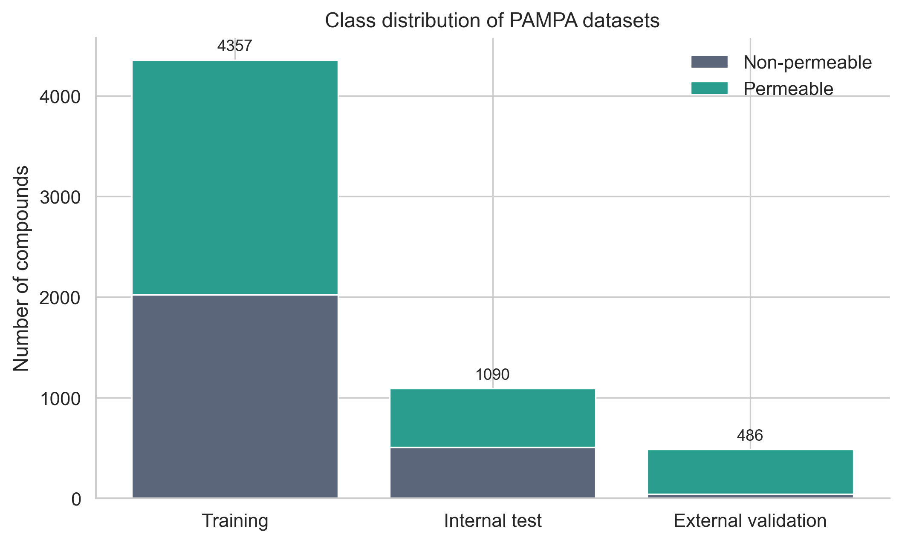

Generated Figure S2. Final metrics heatmap
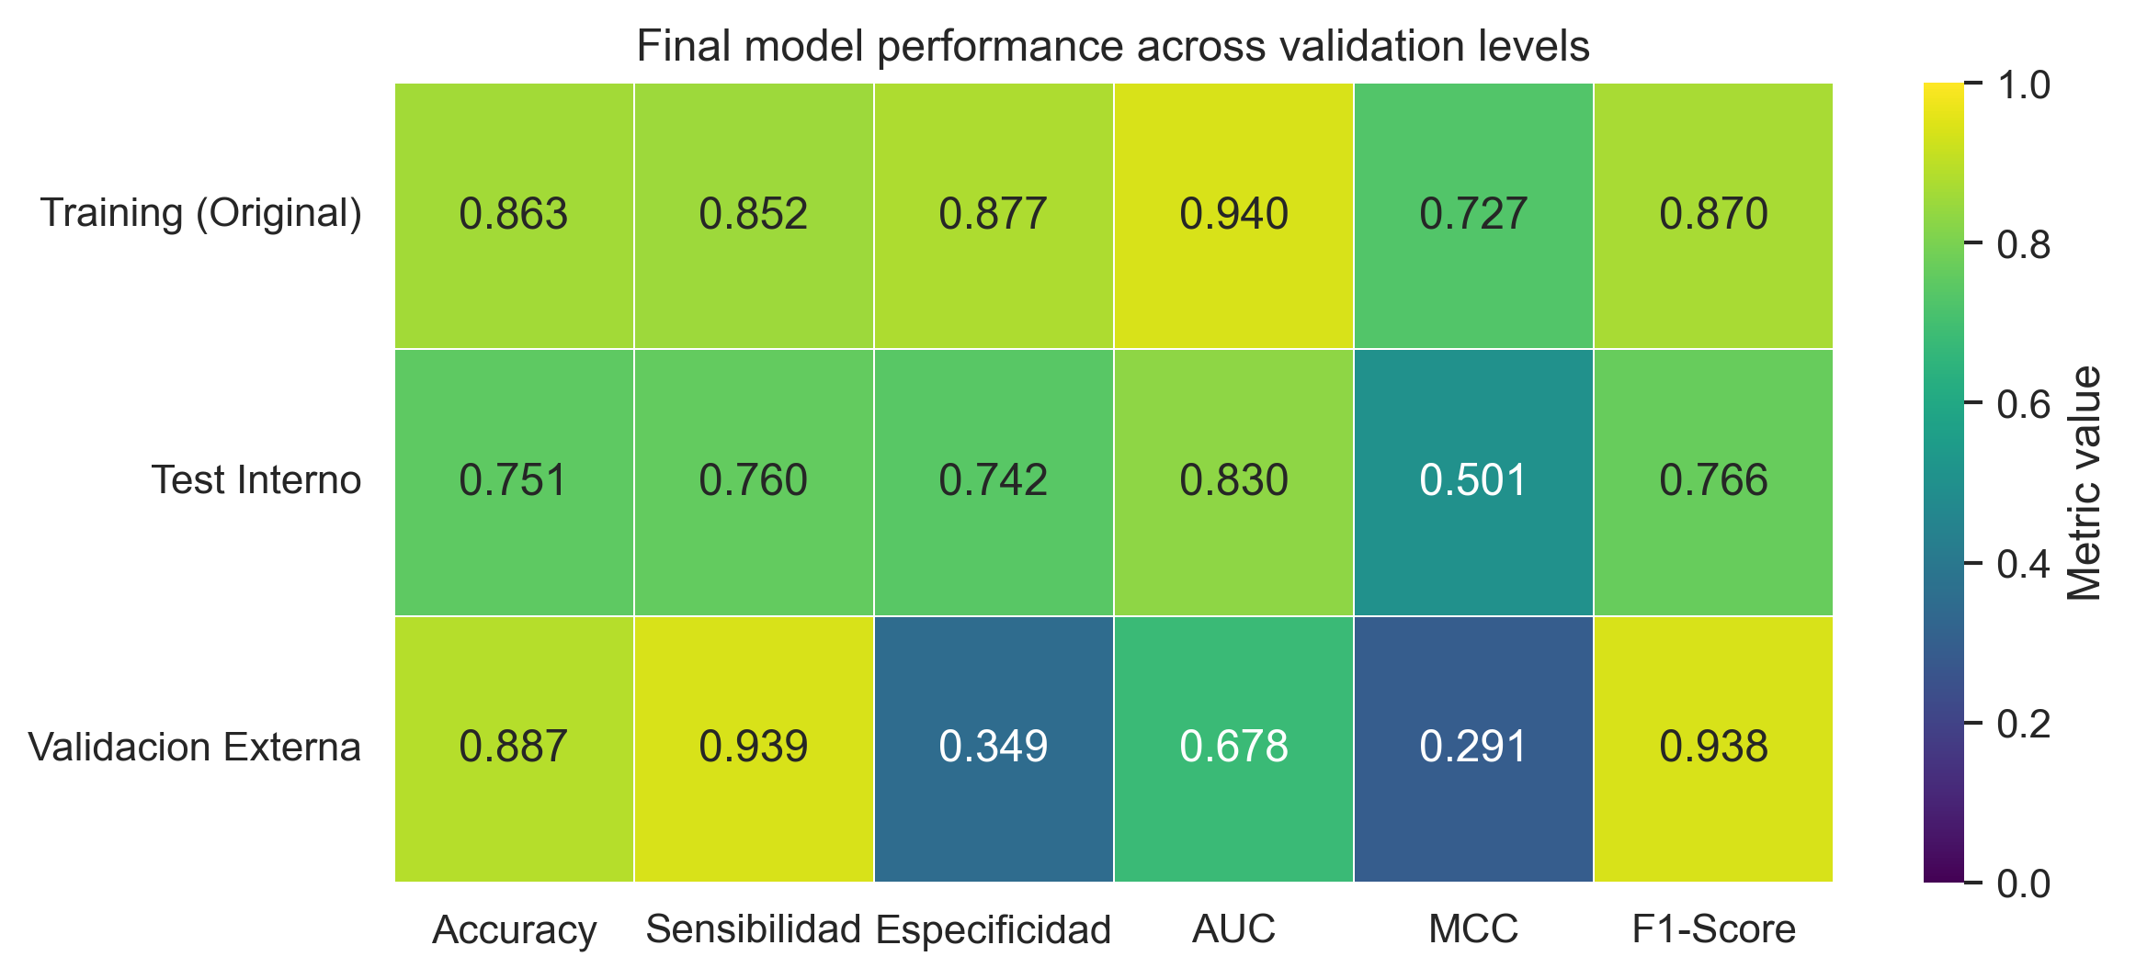

Generated Figure S3. Confusion matrices
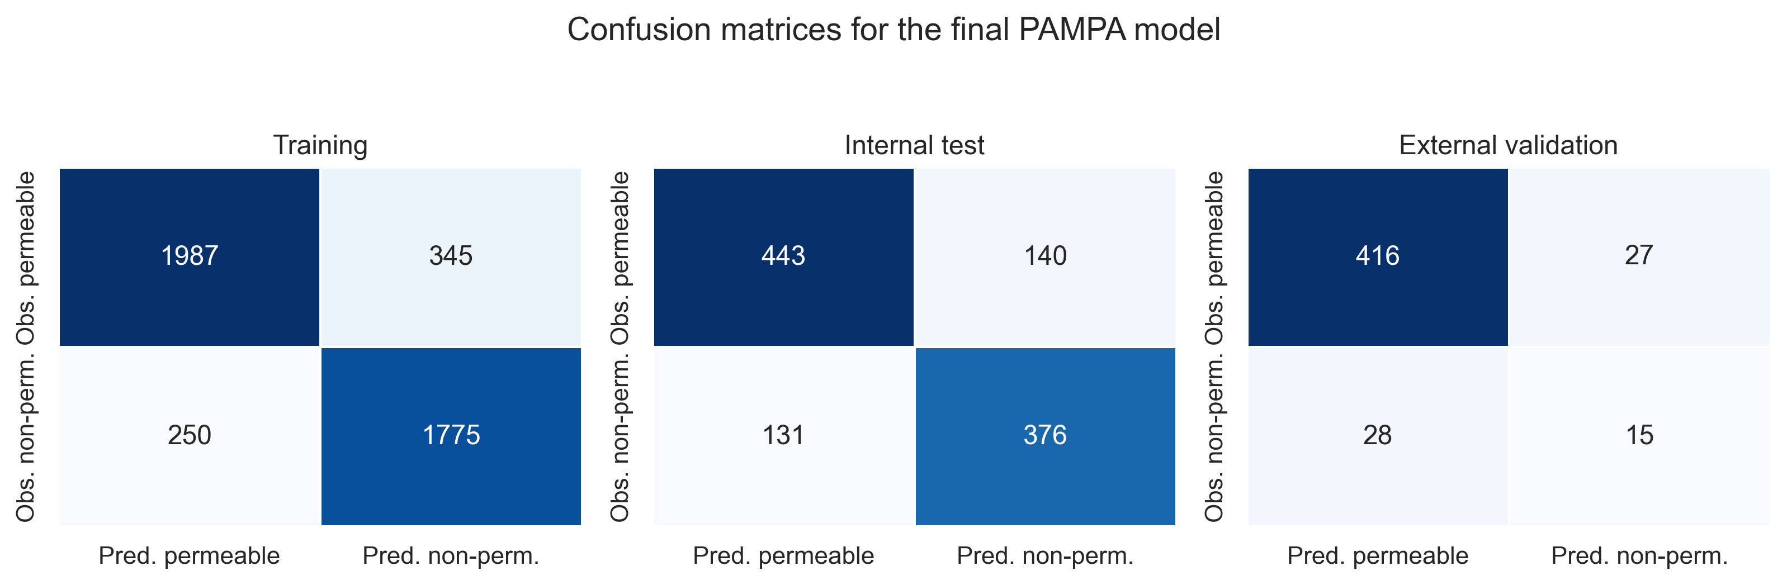

Generated Figure S4. SHAP global importance
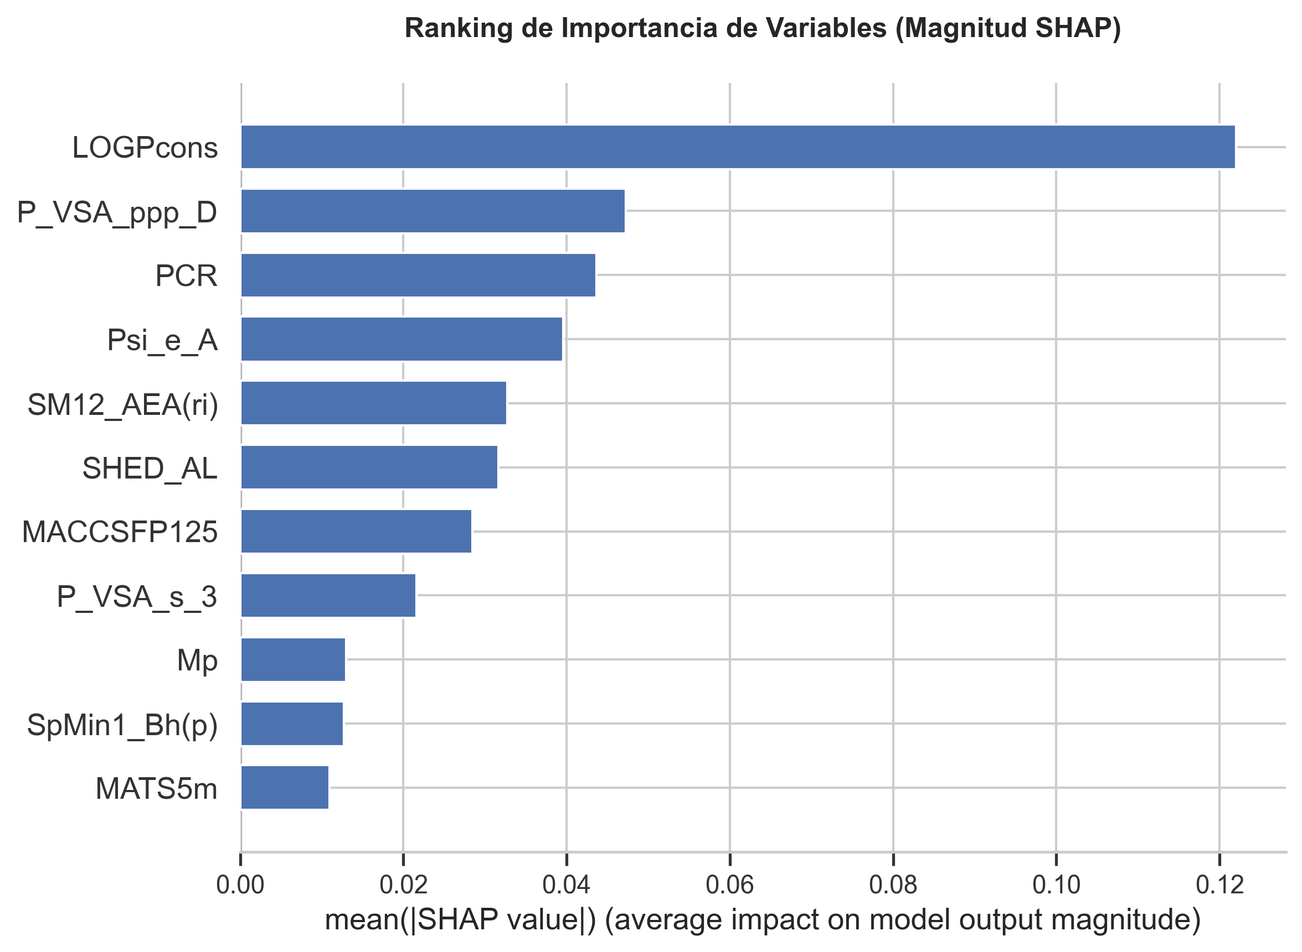

Generated Figure S5. SHAP beeswarm interpretation
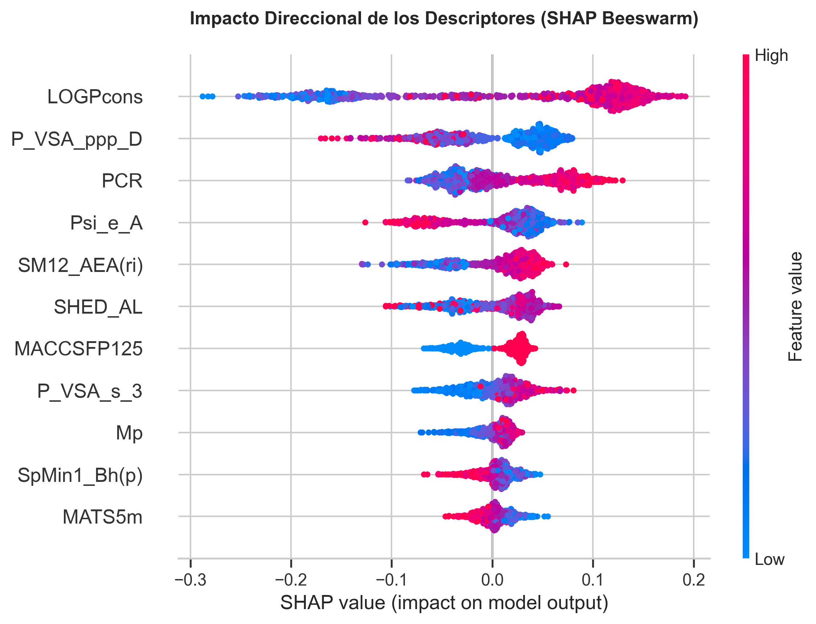

Generated Figure S6. Pre-screening structures and controls
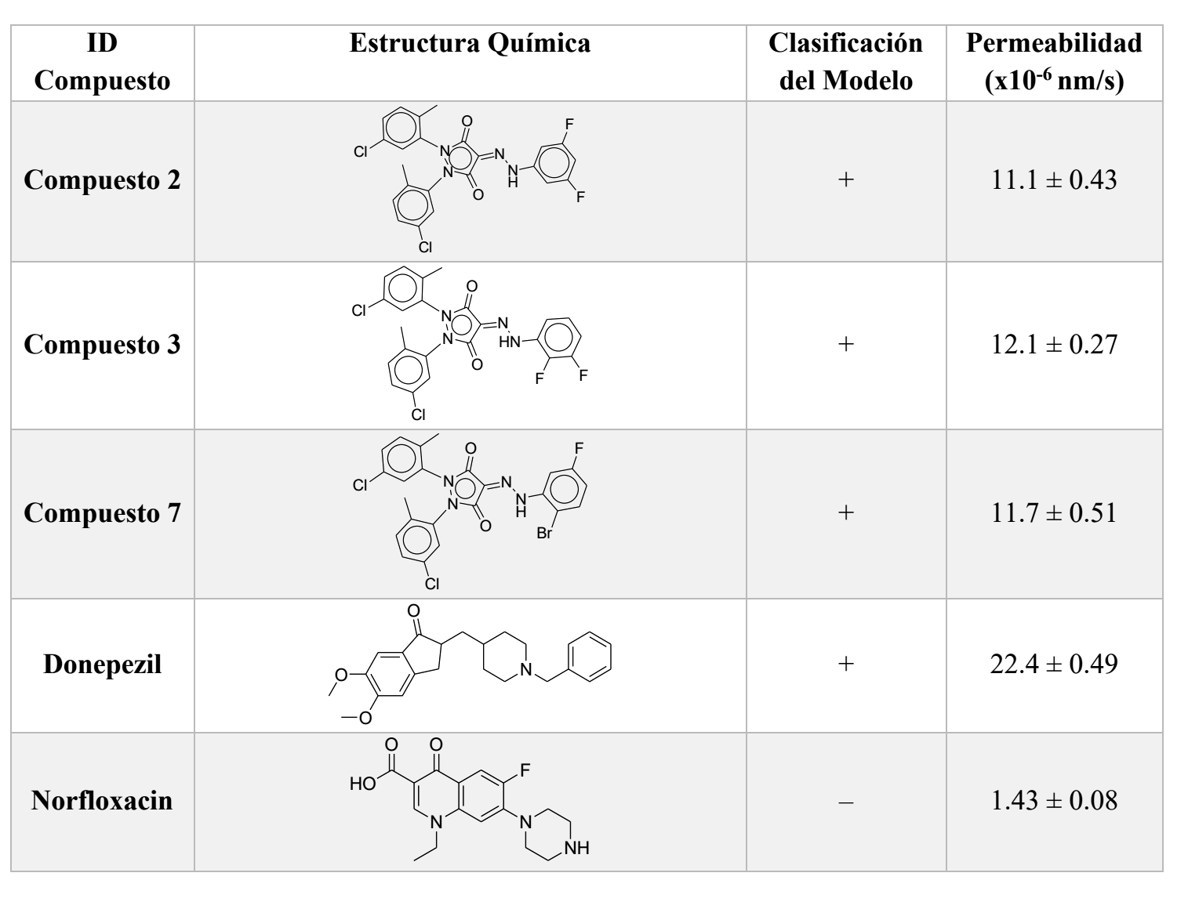

Generated Figure S7. Pre-screening probabilities
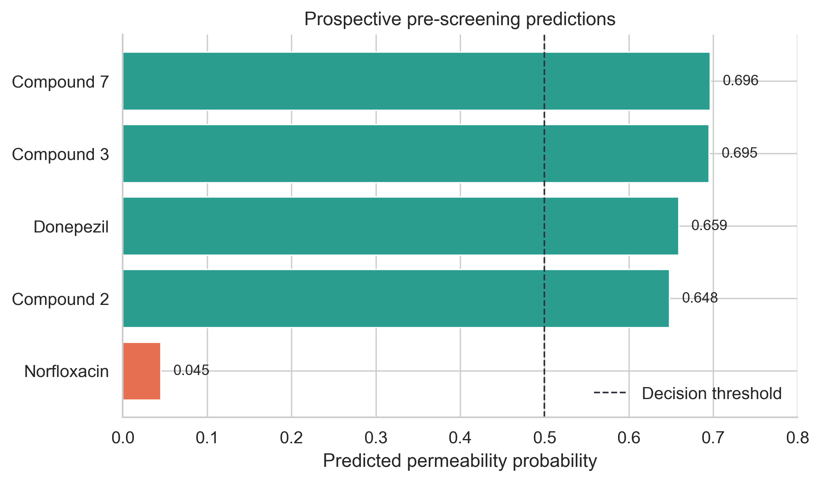

Generated Figure S8. DrugBank filtering funnel
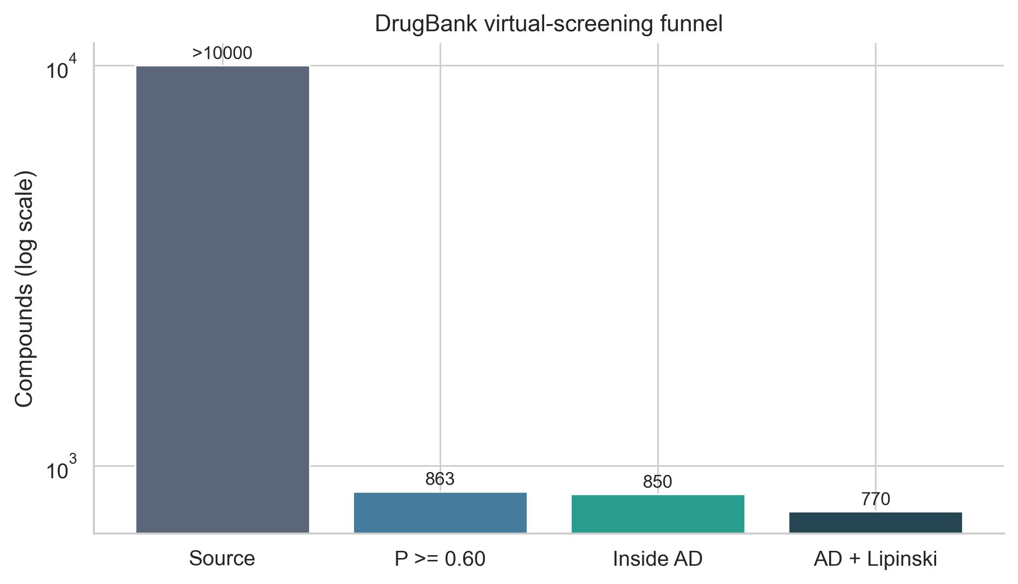

Generated Figure S9. DrugBank probability distribution
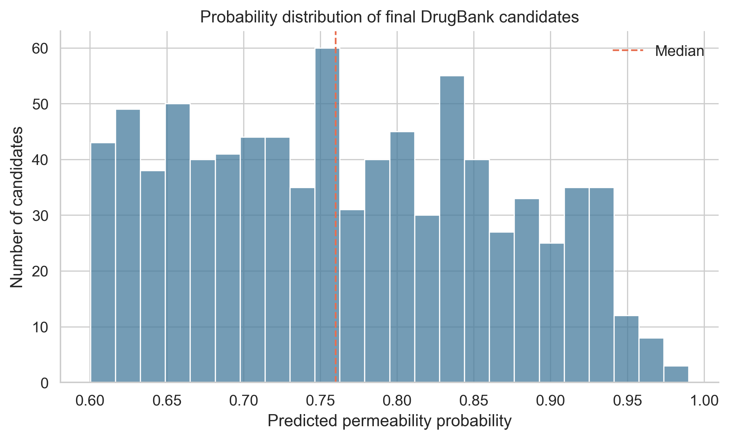

Generated Figure S10. DrugBank leverage profile
