Project Design
Eddie Chongtham • Zoubera Issaka

1. Tasks:
Create sub tasks and assign them to each member. And list the sub tasks below.

Team member name: Eddie Chongtham
Tasks:
- Set up ASP.NET MVC project structure, EF Core, and SQL Server database
- Design and implement all database models (Vehicle, Customer, Reservation, Bill, User)
- Build Repositories layer (IVehicleRepository, ICustomerRepository, IReservationRepository, IBillRepository, IUserRepository)
- Implement user authentication (Register, Login, Logout) with SHA-256 password hashing
- Develop Vehicle Management module (CRUD: Add, Edit, Delete, List vehicles)
- Develop Customer Management module (CRUD: Add, Edit, Delete, List customers)
- Develop Reservation Management module (Create, view, status management)
- Add interactive pickup location map using Leaflet.js + OpenStreetMap for reservation creation (bonus feature)
- Develop Billing module (auto-calculate rental cost, tax, additional charges, mark paid)
- Integrate Stripe Checkout payment gateway for secure online billing (bonus feature)
- Develop Reports module (reservation history, revenue summary, available vehicles)
- Write database migrations and seed initial data (admin user + sample vehicles/customers)
- Configure Azure deployment: App Service, Azure SQL, connection strings
- Create ER Diagram and UI Wireframes for project design document

Team member name: Zoubera Issaka
Tasks:
- Design and implement all Razor Views (Login, Register, Dashboard, Vehicles, Customers, Reservations, Billing, Reports)
- Apply consistent Bootstrap 5 responsive layout and styling across all pages
- Implement navigation bar with role-aware links and active-state highlighting
- Build Home/Dashboard view with summary cards (total vehicles, customers, reservations, revenue)
- Create form validation UI (client-side messages, error summaries)
- Implement flash/TempData notification banners (success, error alerts)
- UI testing: verify all pages render correctly and forms submit as expected
- Cross-browser and mobile responsiveness testing
- Assist with GitHub repository setup and branch management
- Review and proofread project design document

2. UI design
Wireframes were created in draw.io. The design covers 8 pages: Login, Register, Dashboard, Vehicles, Customers, Reservations, Billing, and Reports. The wireframes have been updated to include the interactive Leaflet.js pickup location map on the Create Reservation page, and the Stripe Checkout payment button on the Billing Details page.

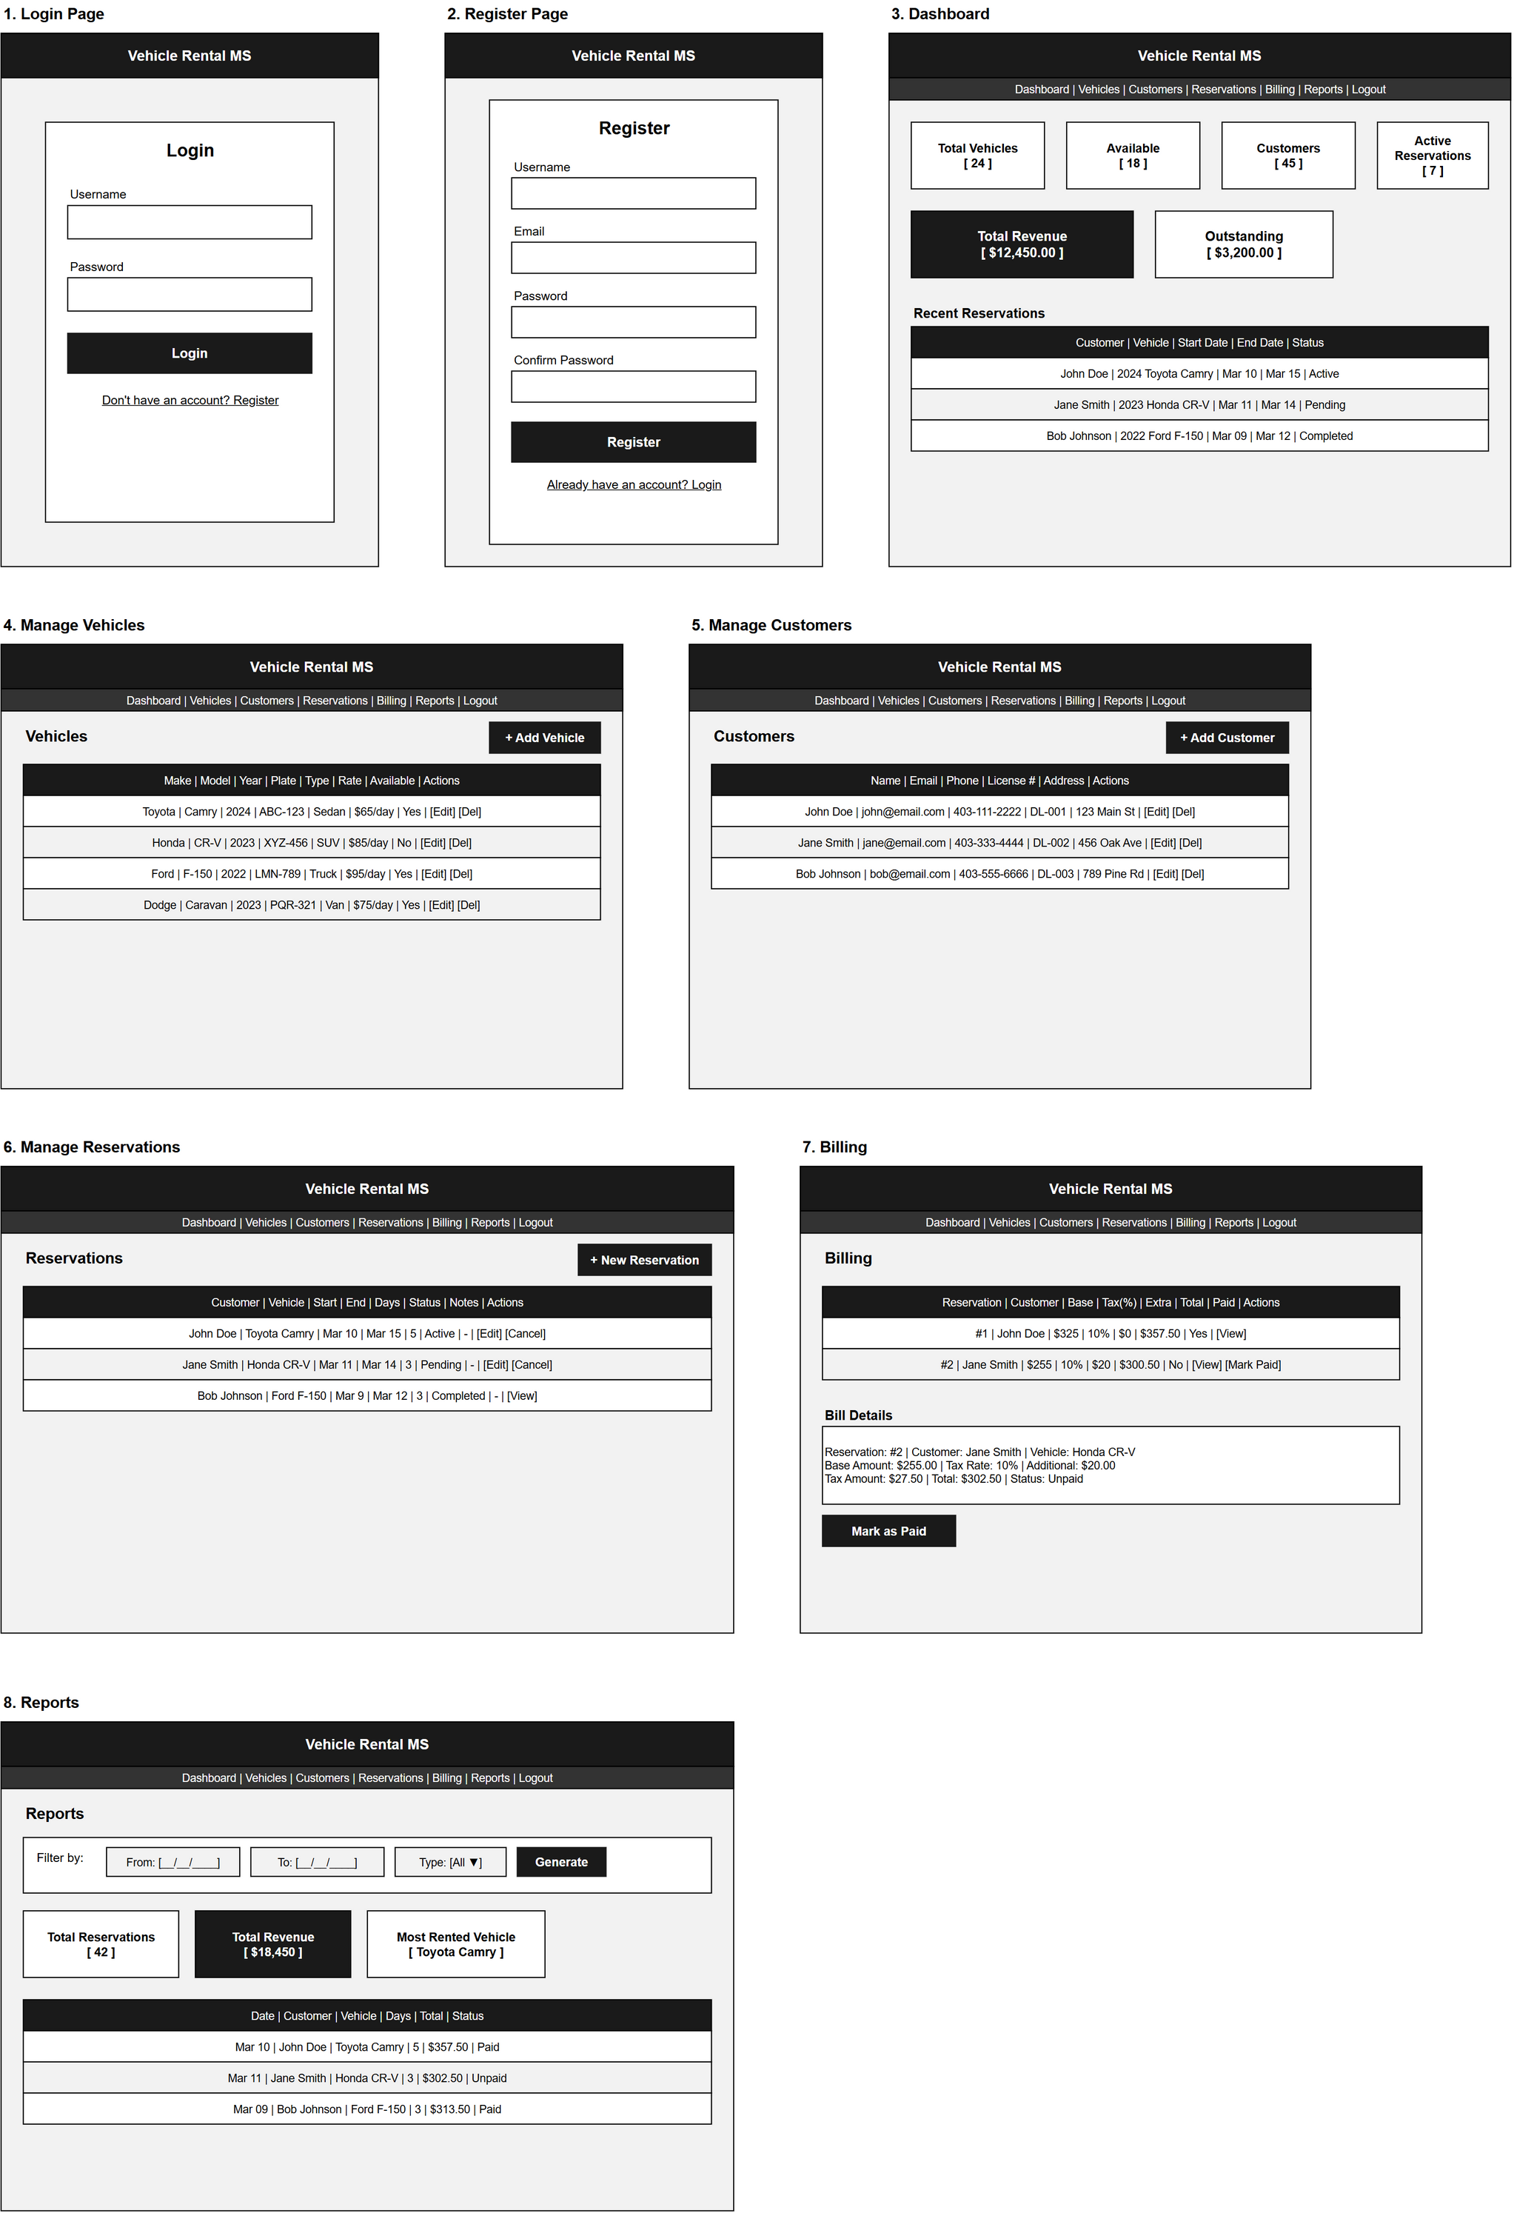
Figure 1 – UI Wireframes (draw.io)

3. Database design
The database consists of 5 tables with the following relationships:
• Users (1) ──< Reservations (many) — one user (admin) manages many reservations
• Customers (1) ──< Reservations (many) — one customer can have many reservations
• Vehicles (1) ──< Reservations (many) — one vehicle can appear in many reservations
• Reservations (1) ──< Bills (1) — each reservation has exactly one bill

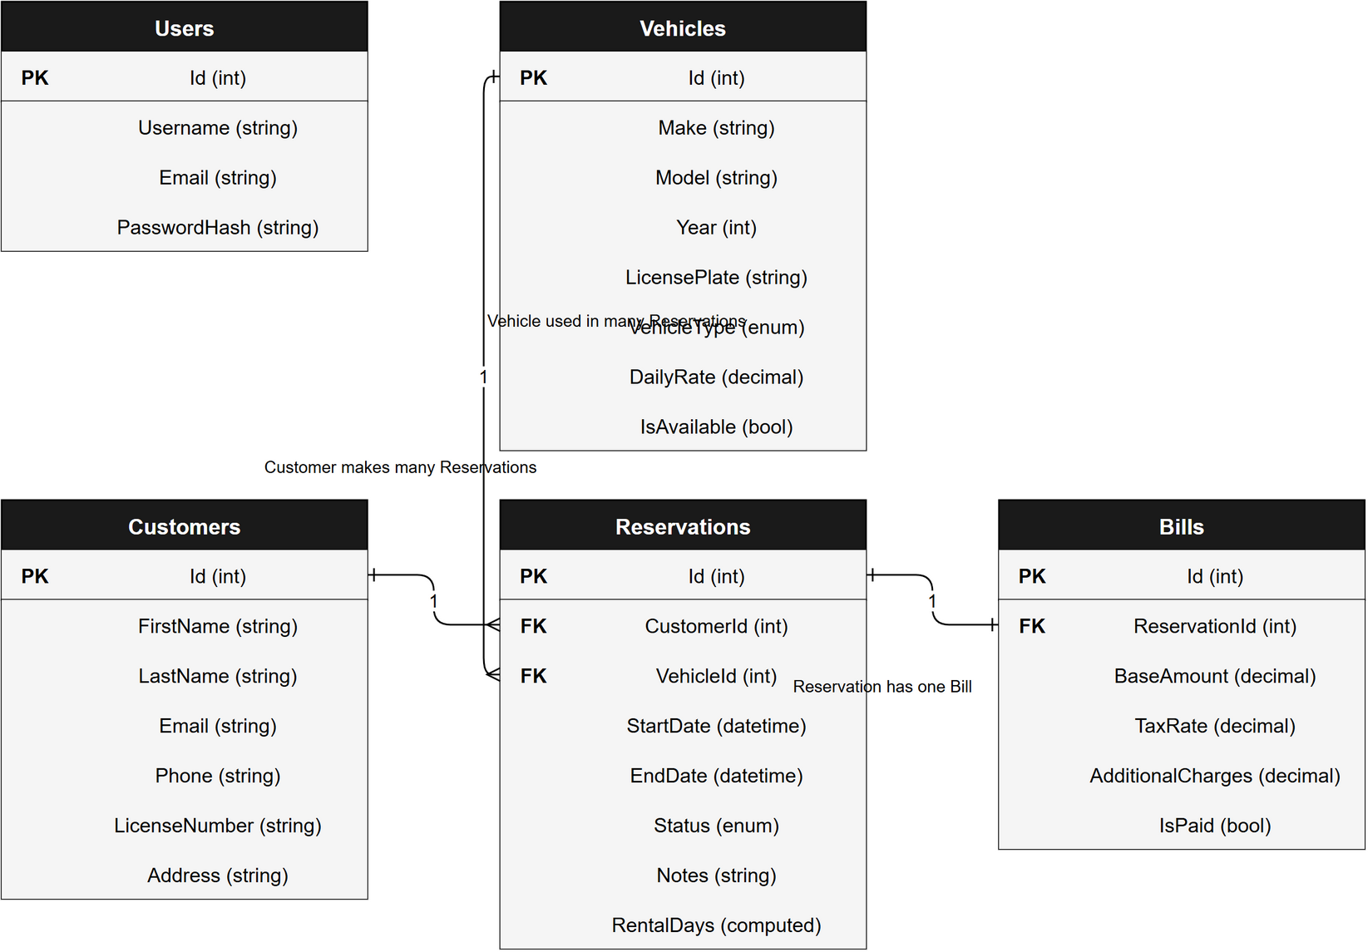
Figure 2 – ER Diagram (draw.io)

