Car price prediction using
Neural Networks

By

Lina AL-Hayani
24000024

Ahmad AL-Mustafa
24000022

Ali AL-Hasan
24000014

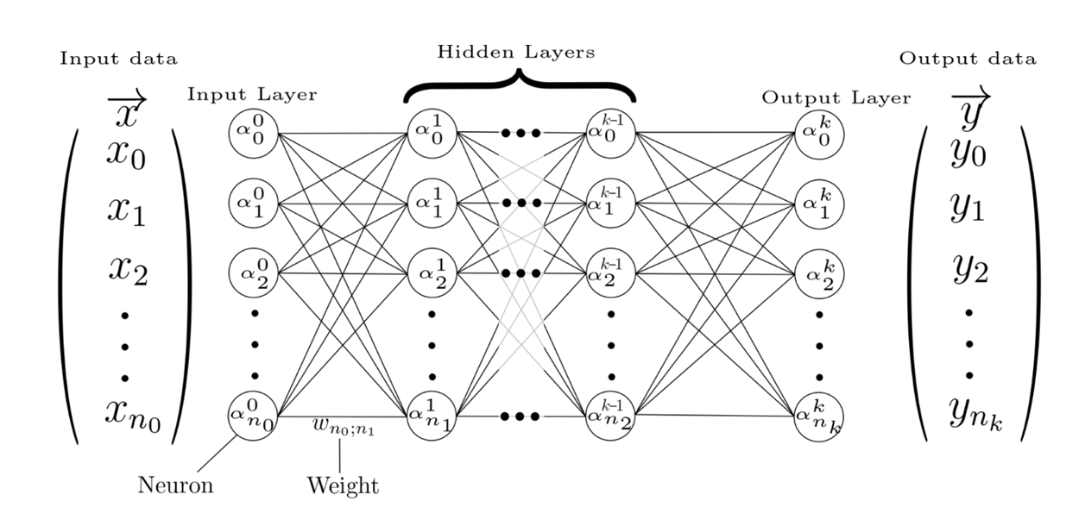
Table of Contents

1-st Section: EDA
1-st Section: Exploratory Data Analysis (EDA) & Data Preprocessing
1.1 Dataset Loading
The first step consisted of importing the required Python libraries used for data manipulation, visualization, preprocessing, and dataset splitting.
Code
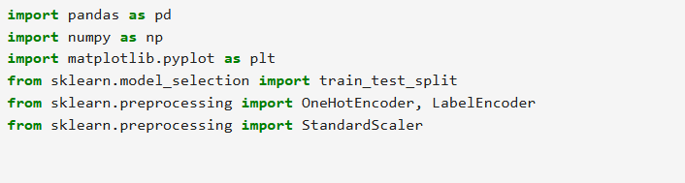
import pandas as pd
import numpy as np
import matplotlib.pyplot as plt

from sklearn.model_selection import train_test_split
from sklearn.preprocessing import OneHotEncoder, LabelEncoder
from sklearn.preprocessing import StandardScaler

Explanation
Several libraries were imported to support different stages of preprocessing:
- Pandas for data loading and manipulation.
- NumPy for numerical operations.
- Matplotlib for data visualization.
- Scikit-Learn utilities for encoding, scaling, and splitting the dataset.
The dataset was then loaded from a CSV file:
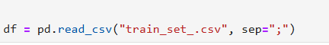
df = pd.read_csv("train_set_.csv", sep=";")

The separator was specified as semicolon (;) because the dataset was stored using semicolon-separated values rather than comma-separated values.

1.2 Feature Extraction
In this step, a feature engineering function is defined to extract useful information from the raw dataset in order to improve model performance.
The function extract_features(df) processes the original Name column and derives three new features:
- Brand: extracted as the first word in the car name, representing the manufacturer.
- Model: extracted from the remaining parts of the name to represent the specific car model.
- Has_Turbo: a binary feature indicating whether the car name contains the word “Turbo” (1 if present, 0 otherwise).
After extracting these features, the original Name column is removed from the dataset since it is no longer needed.
Finally, the function is applied to the dataset, resulting in an enriched feature set that provides more structured and meaningful input for the neural network model.
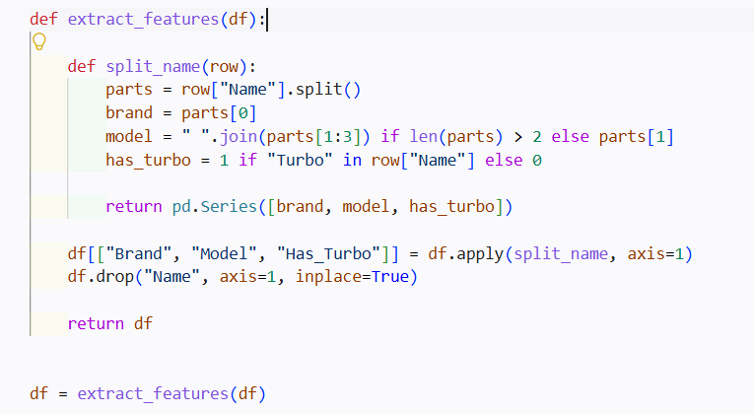

def extract_features(df):

def split_name(row):
parts = row["Name"].split()
brand = parts[0]
model = " ".join(parts[1:3]) if len(parts) > 2 else parts[1]
has_turbo = 1 if "Turbo" in row["Name"] else 0

return pd.Series([brand, model, has_turbo])

df[["Brand", "Model", "Has_Turbo"]] = df.apply(split_name, axis=1)
df.drop("Name", axis=1, inplace=True)

return df

df = extract_features(df)

1.3 Data Cleaning and Type Conversion
In this step, the dataset is cleaned by removing non-numeric characters from important numerical features and converting them into proper numeric types suitable for model training.
The following transformations are applied:
- Mileage: The unit strings (" kmpl" and " km/kg") are removed, and the column is converted to numeric values. Any invalid entries are handled using coercion, converting them into missing values if necessary.
- Engine: The " CC" unit is removed, and the values are converted into numeric format.
- Power: The " bhp" unit is removed, and the column is converted into numeric values as well.
These steps ensure that all features are in a consistent numerical format, which is essential for machine learning models that cannot process string-based data. This cleaning process also helps reduce noise and improves the reliability of the dataset before further preprocessing and training.
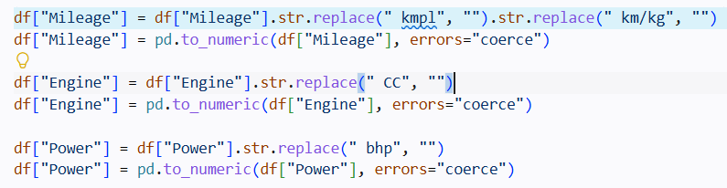
df["Mileage"] = df["Mileage"].str.replace(" kmpl", "").str.replace(" km/kg", "")
df["Mileage"] = pd.to_numeric(df["Mileage"], errors="coerce")

df["Engine"] = df["Engine"].str.replace(" CC", "")
df["Engine"] = pd.to_numeric(df["Engine"], errors="coerce")

df["Power"] = df["Power"].str.replace(" bhp", "")
df["Power"] = pd.to_numeric(df["Power"], errors="coerce")

1.4 Handling Missing and Invalid Values
In this step, data quality is improved by identifying and correcting invalid or missing values in key numerical features.
First, unrealistic values are treated as missing data:
- Mileage values equal to 0 are replaced with missing values (NaN).
- Seats values equal to 0 are also replaced with NaN.
- Engine values below 500 are considered invalid and replaced with NaN.
After that, missing values are handled using appropriate imputation strategies:
- Mileage and Engine missing values are filled using the median, which is robust against outliers.
- Seats missing values are filled using the mode, since seat count is a discrete categorical-like feature.
- Power missing values are first filled based on the median within each Engine group, and any remaining missing values are filled using the overall median.
These steps ensure that the dataset is consistent, free of invalid entries, and ready for reliable model training without bias introduced by missing data.
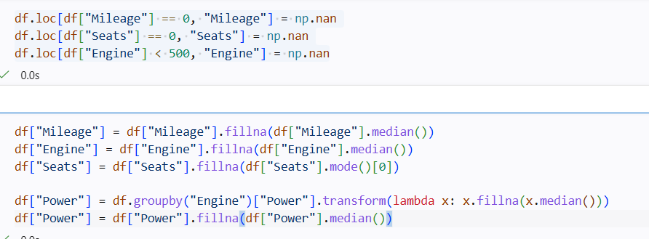
df.loc[df["Mileage"] == 0, "Mileage"] = np.nan
df.loc[df["Seats"] == 0, "Seats"] = np.nan
df.loc[df["Engine"] < 500, "Engine"] = np.nan

df["Mileage"] = df["Mileage"].fillna(df["Mileage"].median())
df["Engine"] = df["Engine"].fillna(df["Engine"].median())
df["Seats"] = df["Seats"].fillna(df["Seats"].mode()[0])

df["Power"] = df.groupby("Engine")["Power"].transform(lambda x: x.fillna(x.median()))
df["Power"] = df["Power"].fillna(df["Power"].median())

1.5 Feature Encoding
In this step, categorical variables are transformed into numerical representations to make them suitable for machine learning models.
First, Frequency Encoding is applied to the Model feature. Each model is replaced by its frequency (number of occurrences) in the dataset. This helps the model capture how common each car model is without increasing dimensionality.
Next, One-Hot Encoding is applied to the remaining categorical features:
- Brand
- Location
- Fuel_Type
- Transmission
- Owner_Type
This process creates binary columns for each category, where each column indicates the presence (1) or absence (0) of a specific category. The parameter drop_first=True is used to avoid multicollinearity by removing the first category in each encoded feature.
These transformations convert all categorical data into a fully numerical format, which is required for training the neural network effectively.
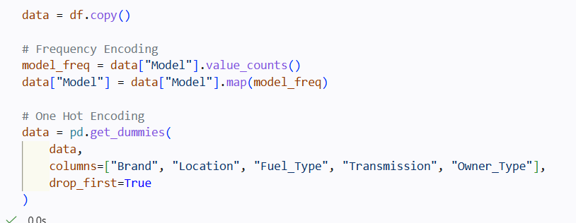
ata = df.copy()

# Frequency Encoding
model_freq = data["Model"].value_counts()
data["Model"] = data["Model"].map(model_freq)

# One Hot Encoding
data = pd.get_dummies(
data,
columns=["Brand", "Location", "Fuel_Type", "Transmission", "Owner_Type"],
drop_first=True
)

1.6 Train-Test Split
In this step, the dataset is prepared for model training by separating the input features from the target variable and splitting the data into training and validation sets.
- X (Features): All independent variables are selected by dropping the target column Price.
- y (Target): The dependent variable representing the car price is assigned to y.
After that, the dataset is split using train_test_split:
- 80% of the data is used for training the model.
- 20% is reserved for validation/testing.
The parameter random_state=42 is used to ensure reproducibility of results, meaning that the same split can be obtained every time the code is executed.
This step is essential to evaluate the model's ability to generalize to unseen data and avoid overfitting.
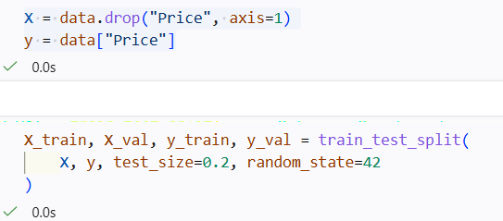
X = data.drop("Price", axis=1)
y = data["Price"]

X_train, X_val, y_train, y_val = train_test_split(
X, y, test_size=0.2, random_state=42
)

1.7 Saving Preprocessing Objects
In this step, important preprocessing components and metadata are saved to disk to ensure consistency during future predictions.
- The scaler is saved using joblib.dump, allowing the same feature scaling to be applied later on new input data.
- The frequency encoding mapping (model_freq) is also saved so that the Model feature can be encoded in the same way during inference.
- The feature columns (X_columns) are stored to maintain the exact structure and order of input features required by the trained model.
Saving these objects ensures that the prediction pipeline remains consistent between training and deployment, preventing mismatches in feature processing and improving the reliability of the model in real-world usage.
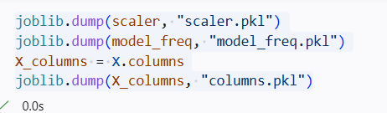
joblib.dump(scaler, "scaler.pkl")
joblib.dump(model_freq, "model_freq.pkl")
X_columns = X.columns
joblib.dump(X_columns, "columns.pkl")

1.8 Preparing and Saving Final Training and Validation Datasets
In this step, the processed and scaled data is organized into final datasets that will be used for model training and evaluation.
First, the scaled feature arrays are converted back into DataFrame format:
- train_final is created from X_train_scaled and includes the corresponding feature column names.
- The target variable Price is appended to the training dataset.
- The same process is applied to create val_final using X_val_scaled.
After constructing the final datasets, both are saved as CSV files:
- train_ready.csv for model training.
- val_ready.csv for validation/testing.
This step ensures that both training and validation datasets are fully preprocessed, structured, and ready for direct use in the neural network model, while also enabling reproducibility and easier experimentation in future stages.
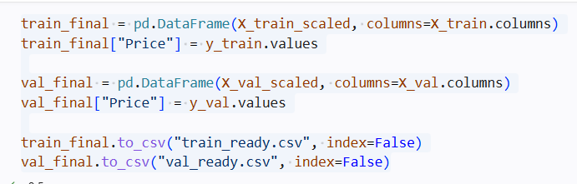

train_final = pd.DataFrame(X_train_scaled, columns=X_train.columns)
train_final["Price"] = y_train.values

val_final = pd.DataFrame(X_val_scaled, columns=X_val.columns)
val_final["Price"] = y_val.values

train_final.to_csv("train_ready.csv", index=False)
val_final.to_csv("val_ready.csv", index=False)

2.1 Loading Preprocessing Objects and Test Data
In this step, the previously saved preprocessing components are reloaded to ensure consistency between training and inference stages.
- The scaler is loaded using joblib.load to apply the same feature scaling that was used during training.
- The frequency encoding mapping (model_freq) is also loaded to correctly transform the Model feature in the test data.
- The feature columns (X_columns) are restored to guarantee that the test data follows the exact same structure and column order as the training data.
After that, the test dataset is loaded from a CSV file using pandas.read_csv. This dataset does not contain labels (prices) and will be used for final predictions.
This step is essential to ensure that the model receives input data in the same format as it was trained on, which is critical for producing accurate and reliable predictions.
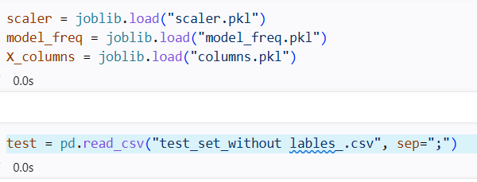
joblib.dump(scaler, "scaler.pkl")
joblib.dump(model_freq, "model_freq.pkl")
X_columns = X.columns
joblib.dump(X_columns, "columns.pkl")

test = pd.read_csv("test_set_without lables_.csv", sep=";")

2.2 Test Data Preprocessing and Alignment
In this step, the test dataset is fully preprocessed to match the exact structure and transformations applied to the training data, ensuring consistency during prediction.
First, the same data cleaning operations are applied:
- Units are removed from Mileage, Engine, and Power columns.
- These columns are then converted into numeric format using pd.to_numeric, handling invalid values as missing data where necessary.
Next, categorical and engineered features are processed:
- The Model feature is encoded using the previously saved frequency mapping (model_freq), and missing values are replaced with 0.
- Categorical variables such as Brand, Location, Fuel_Type, Transmission, and Owner_Type are transformed using One-Hot Encoding with drop_first=True.
To ensure compatibility with the training dataset, the test set is then aligned using:
- reindex(columns=X_columns, fill_value=0)
This guarantees that the test data has exactly the same feature columns as the training data, filling any missing columns with zeros.
Finally, the dataset is standardized using the previously fitted scaler, producing test_scaled, which ensures that all features are on the same scale as during model training.
Note: The repeated One-Hot Encoding lines in the code are redundant and do not affect the final result but should be cleaned for better code efficiency.
This step ensures that the test data is fully consistent with the training pipeline, which is critical for generating reliable predictions.
def extract_features(df):

def split_name(row):
parts = row["Name"].split()
brand = parts[0]
model = " ".join(parts[1:3]) if len(parts) > 2 else parts[1]
has_turbo = 1 if "Turbo" in row["Name"] else 0

return pd.Series([brand, model, has_turbo])

df[["Brand", "Model", "Has_Turbo"]] = df.apply(split_name, axis=1)
df.drop("Name", axis=1, inplace=True)

return df

test = extract_features(test)

test = test.reindex(columns=X_columns, fill_value=0)
test_scaled = scaler.transform(test)

2-nd Section:
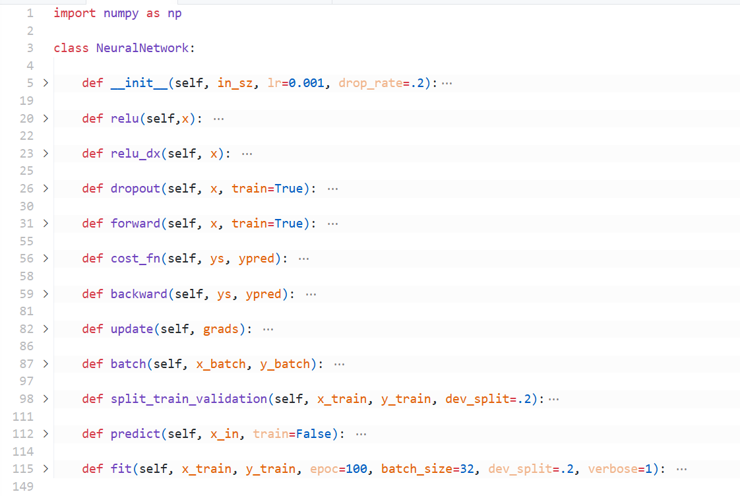
Building the Neural network:
Figure 2.1: the back-bone or the Neural Network implementation.
2.1 Class Initialization:
def __init__(self, in_sz, lr=0.001, drop_rate=.2):
self.lr = lr
self.drop_rate = drop_rate
self.ws = []
self.bs = []
self.Zs = {}
self.dropout_msks = {}
for i in range(len(in_sz) - 1):
kaim_he_factor = np.sqrt(2/in_sz[i])
w = np.random.randn(in_sz[i],in_sz[i+1]) * kaim_he_factor
b = np.zeros((1, in_sz[i+1]))
self.ws.append(w)
self.bs.append(b)

Establishes the network architecture with properly scaled initial parameters to prevent vanishing/exploding gradients.
Parameters:
- in_sz: A list specifying the number of neurons in each layer [input, hidden1, hidden2, ..., output].
- lr: Learning rate.
- drop_rate: Dropout probability for regularization.
Initialization Process:
- Sets the learning rate and dropout rate as instance variables and initializes empty lists for weights (ws) and biases (bs) Creates dictionaries to store intermediate values (Zs) and dropout masks (dropout_msks).
- For each pair of hidden layers we used the kaiming/He initialization to initializes weights with random values from a normal distribution scaled by the He factor to prevent vanishing/exploding gradients:
$$He=\sqrt{\frac{2}{n_{in}}}$$
Where $n_{in}$ The number of inputs to the layer.
- Initialize biases with zeros.
2.2 Activation Functions:
def relu(self,x):
return np.maximum(0,x)

def relu_dx(self, x):
return (x > 0).astype(float)

Implements the Rectified Linear Unit activation (Relu) function and it’s derivative.
Parameters:
- x: the weighted sum of inputs plus the bias for a specific neuron before it is activated.
Mechanism:
- relu: returns the input value for positive values and 0 for negative values.
- relu_dx: returns 1 for positive values and 0 for negative values.

2.3 Dropout Regularization:
def dropout(self, x, train=True):
msk = np.random.rand(*x.shape) > self.drop_rate
msk_scaled = x * msk / (1 - self.drop_rate)
return msk_scaled if train else x
This function is used to prevents overfitting by randomly deactivating neurons during training.
Parameters:
- x: the weighted sum of inputs plus the bias for a specific neuron before it is activated.
- train: to specify that this function is only applied during training process.
Mechanism:
- it creates a binary mask where each neuron has drop_rate probability of being set to $0$, then it scales remaining activations by $\frac{1}{1-DropRate}$ to maintain the expected value.

2.4 Forward Pass Calculation:
def forward(self, x, train=True):
self.Zs = {}
curr_in = x
self.Zs['a0'] = x
for i in range(len(self.ws) - 1):
z = np.dot(curr_in, self.ws[i]) + self.bs[i]
self.Zs[f'z{i+1}'] = z
a = self.relu(z)
self.Zs[f'a{i+1}'] = a
if train and i < len(self.ws) - 2:
a = self.dropout(a, train)
self.Zs[f'droput_msk{i+1}'] = self.dropout_msks.get(f'dropout_msk{i+1}', None)
curr_in = a
# Move this outside the for loop - THIS IS THE FIX
last_idx = len(self.ws) - 1
z_out = np.dot(curr_in, self.ws[last_idx]) + self.bs[last_idx]
self.Zs[f'z{len(self.ws)-1}'] = z_out
return z_out

This function performs the forward pass through the network to compute predictions.

Parameters:
- x: the weighted sum of inputs plus the bias for a specific neuron before it is activated.
- train: to specify if we are during training or not.
Mechanism:
- stores input as activation layer 0: $a^{\left[0\right]}$.
- for each hidden layer (except the output layer):
  - computes: $z=w*a+b$.
  - applies Relu activation: $a=relu(z)$.
  - stores those values after activation and applies dropout (if training).
- for the output layer it computes the value $z$ without activation.

2.5 Cost Functions:
def cost_fn(self, ys, ypred):
return np.mean((ypred - ys)**2)
This function implements Mean Squared Error (MSE) as the loss function.
Parameters:
- ys: the true value we are trying to predict.
- ypred: the predicted value by the network.
Mechanism:
- Computes the average squared difference between predictions and actual values.

2.6 Backward Propagation:
def backward(self, ys, ypred):
m = ys.shape[0]
grads_w = []
grads_b = []

dz = ypred - ys
dz = dz * (2/m)

for i in range(len(self.ws)-1, -1, -1):
a_prev = self.Zs[f'a{i}'] if i > 0 else self.Zs['a0']
dw = np.dot(a_prev.T, dz)
db = np.sum(dz, axis=0, keepdims=True)

grads_w.insert(0, dw)
grads_b.insert(0,db)

if i > 0:
da = np.dot(dz, self.ws[i].T)
z_prev = self.Zs[f'z{i}']
dz = da * self.relu_dx(z_prev)

return grads_w, grads_b
This function implements the backpropagation algorithm with the chain rule, propagating error gradients from output to input (Computes gradients of the loss with respect to all parameters using the chain rule).
Parameters:
- ys: the true value we are trying to predict.
- ypred: the predicted value by the network.
Mechanism:
- output layer gradient: $dz=\frac{1}{m}(ypred-ys)$ the derivative of MSE.
- Iterate backwards through layers:
  - Compute weigh gradients: $dw=a_{prev}*dz$.
  - Compute bias gradients: $db=∑dz$.
  - Propagate gradients backward: $da=dz*w$.
  - Compute activation derivative: $dz=da*relu(z_{prev})$.
- Returns lists of gradients for both ws and bs.

2.7 Parameters Update:
def update(self, grads):
for i in range(len(self.ws)):
self.ws[i] -= self.lr * grads[0][i]
self.bs[i] -= self.lr * grads[1][i]
This function gradient descent update on all parameters with the learning rate lr.
Parameters:
- grads: a list of gradients for both ws and bs.
Mechanism:
- for each layer:
  - $w=w-lr*dw$.
  - $b=b-lr*db$.

2.8 Mini-Batch Processing:
def batch(self, x_batch, y_batch):
ypred = self.forward(x_batch, train=True)
loss = self.cost_fn(y_batch, ypred)
grads = list(self.backward(y_batch, ypred))
self.update(grads)
return loss
This function performs one forward & backward pass on a mini-batch.
Parameters:
- x_batch: the input data.
- x_batch: the target value.
Mechanism:
- it and computes the loss and executes backward propagation and update parameter using the gradients.

2.9 Data Splitting:
def split_train_validation(self, x_train, y_train, dev_split=.2):
n = x_train.shape[0]
val_sz = int(n*dev_split)
indices = np.random.permutation(n)
train = indices[val_sz:]
val = indices[:val_sz]

x_train_split = x_train[train]
y_train_split = y_train[train]
x_val = x_train[val]
y_val = y_train[val]

return x_train_split, y_train_split, x_val, y_val
This function performs random stratified splitting of training data using sklearn.
Parameters:
- x_train: the input data.
- y_train: the target value.
- dev_sz: the size of the validation set.

2.10 Prediction:
def predict(self, x_in, train=False):
return self.forward(x_in, False)
This function performs forward propagation for inference & and set the dropout to False (this is not training).
Parameters:
- x_in: the input data.

2.11 Training Loop:
def fit(self, x_train, y_train, epoc=100, batch_size=32, dev_split=.2, verbose=1):
x_train_split, y_train_split, x_val, y_val = self.split_train_validation(x_train, y_train, dev_split=dev_split)
n = x_train_split.shape[0]
records = {
'loss': [],
'val_loss': [],
'mae': [],
'val_mae': []
}

for epoch in range(epoc):
# Shuffle data each epoch
indices = np.random.permutation(n)
x_shuffled = x_train_split[indices]
y_shuffled = y_train_split[indices]

epoch_losses = []

for i in range(0, n, batch_size):
x_batch = x_shuffled[i:i+batch_size]
y_batch = y_shuffled[i:i+batch_size]
loss = self.batch(x_batch, y_batch)
epoch_losses.append(loss)

# Record metrics every epoch
train_pred = self.predict(x_train_split)
train_loss = self.cost_fn(train_pred, y_train_split)
train_mae = np.mean(np.abs(train_pred - y_train_split))

val_pred = self.predict(x_val)
val_loss = self.cost_fn(val_pred, y_val)
val_mae = np.mean(np.abs(val_pred - y_val))

records['loss'].append(train_loss)
records['mae'].append(train_mae)
records['val_loss'].append(val_loss)
records['val_mae'].append(val_mae)

if verbose and epoch % 10 == 0:
print(f"Epoch {epoch}: Train Loss={train_loss:.4f}, Val Loss={val_loss:.4f}")

return records
This function performs the complete training process.
Parameters:
- x_train: the input data.
- y_train: the target value.
- epoc: the number of training loop.
- batch_size: the number of training samples processed by the network before it update its parameters.
- dev_split: the validation split size.
- verbose: control the amount of information the model prints during training.
Mechanism:
- Data Preparation: Splits data into training/validation sets.
- Mini-Batch processing:
  - Shuffles data each epoch
  - Process data in batches and updates parameters after each batch.
- Loss Tracking:
  - Records training & validation loss, MAE.

Neural Network Architecture:
- Relu activation for hidden layers.
- No activation for the output layer.
- kaiming/He initialization for stable gradients.
- Dropout regularization to prevent overfitting.
- Mini-batch gradient decent for efficiency.

