Click on yellow marked tab on daily check window :

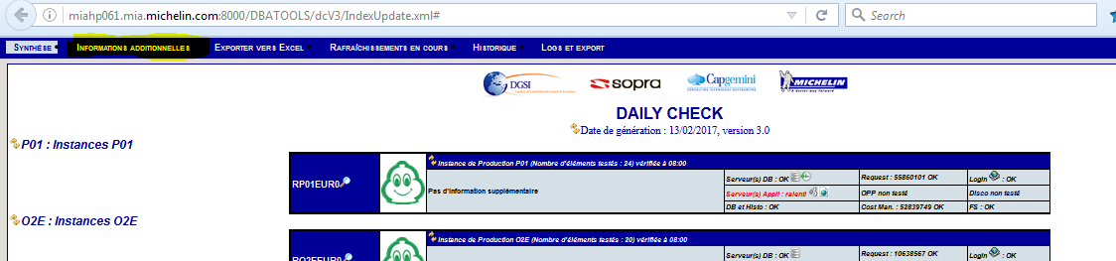

It will open below page:

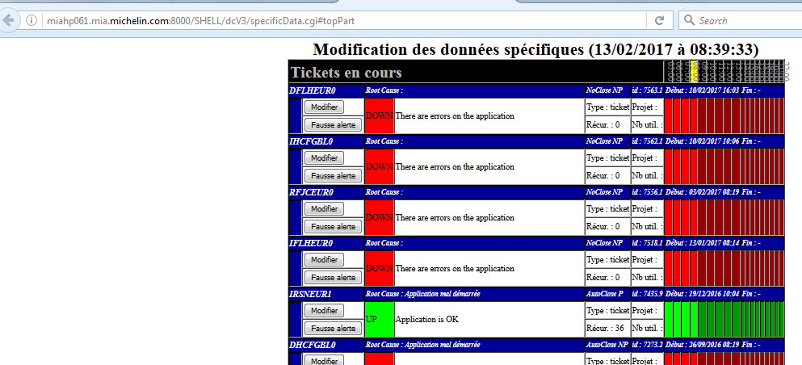

Select application (click on “Modifier”)

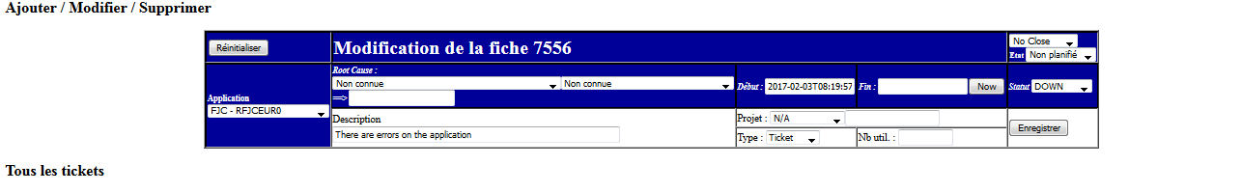

Do the changes as per below:

Root Cause: RFJCEUR0 – Application mal demarree >> Application mal demarree

Description : Application is OK (OR any other reason)

Then change to “Auto Close” as per below screenshot and click on “Enregistrer” button.

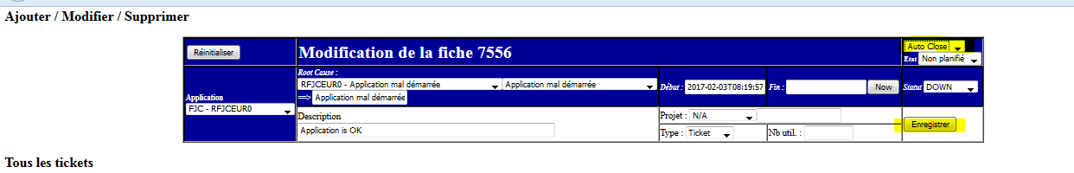

**After completing this process to reflect this changes in front end daily check do the below:**

**Click on >> **

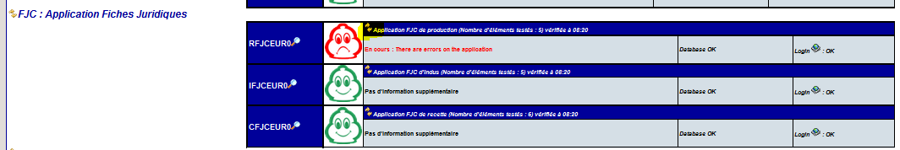

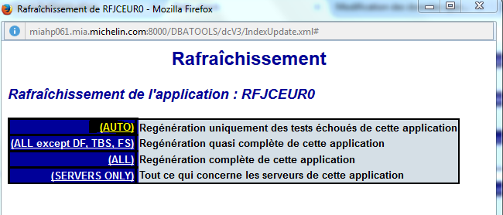

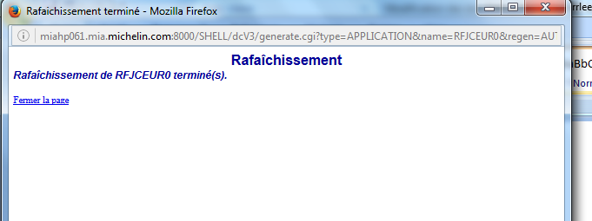

**Then wait for 2-3 min till refresh is completed.**

**After completing this whole process refresh daily check url … then Red smiley symbol changes to green.**

**Before >> **

**After >> **