Michelin Architechture

INTRODUCTION

GOAL OF THE DOCUMENT

The objective of this Document is to describe the
- Architecture
- Environment Strategy & Michelin environments
- Releases

ARCHITECHTURE

PLATFORM ARCHITECHTURE

O2E eBiz application are hosted on IBM AIX 5.3.10 64 bit Platform.

RSN and FLH eBiz application are hosted on IBM AIX 6.1 64 bit Platform.

Michelin has opted for the Virtual Server architecture. All the instances are hosted on Virtual Servers

Environment Strategy & MICHELIN ENVIRONMENT

Currently there are 4 different projects which are in Place details as below

O2E- Europe –
11.5.10.2 / 10g, 2 languages installed – Romania, Russia
FLASH- Flash Accounting
12.1.1 / 11g, language- US
Resine- Resine
11.5.10.2/9i , language – US

All the above mentioned projects have different strategy.

O2E - 3 node architecture

DB is hosted on <SID>VDB owner- <starting 2 letters of SID>rao2e<instnce number> e.g.rorao2e0

GTS is hosted on <SID>VA owner- <starting 4 letters of SID>era<instance number> e.g. ro2eera0

WEB on <SID>VW1 owner- <starting 4 letters of SID>erw<instance number> e.g. ro2eerw0

FLASH – Single Node architecture

DB, GTS, WEB are hosted on one virtual server <SID>vw1 ,

GTS and WEB/FORMS server owner <starting letter of SID> flheura e.g. dflheura

DB owner - starting letter of SID>oraflh<instnace number> e.g.doraflh0

RESINE- 2 nodes architecture

Environment Strategy & MICHELIN ENVIRONMENT

Please see the attached files

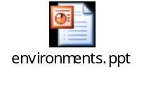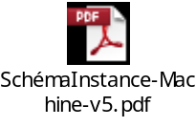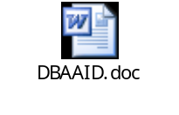

RELEASES

O2E

- The Major Release contained the Russian Localization Implementation (RLP) and CPU patches

- Another Major Release contained the implementation of SSL.

- Another Major Release contained the replacement of JInitiator by JRE.

FLASH
- We observed Flash being implemented as a fresh project – Initial Install was carried out by FO dba team
- BO-Team then involved for further development and support. There were some minor patches after the Implementation as well as many ad-hoc issues were resolved as a part of support

RESINE

- For Resine we have not undertaken any development work but we have provided support for some issues. Like Instance check and Performance issues

- The Major Release contained the replacement of JInitiator by JRE.

