Beginning Andes

To begin Andes, navigate to the installation folder (the default on installation is C:\Program Files\Andes) and double click the Andes Physics Workbench icon. After a brief pause, you will then see a dialog asking you to login. Enter your login name and click Okay. Andes will then open up a dialog where you may choose a problem set. Choose “Getting Started”. A new dialog will appear that will allow you to choose a problem. At first all the problems have a “—“ following their name. Later you will see “(Partial)”, indicating you have started solving but not completed the problem and “DONE” showing that you have successfully solved that problem. Select the problem GS00 and click “Begin Solution”. A group of windows should appear, and the upper left window should display the following physics problem: “We have been traveling on the road for 5 hours at 28 m/s. How many meters have we traveled?”

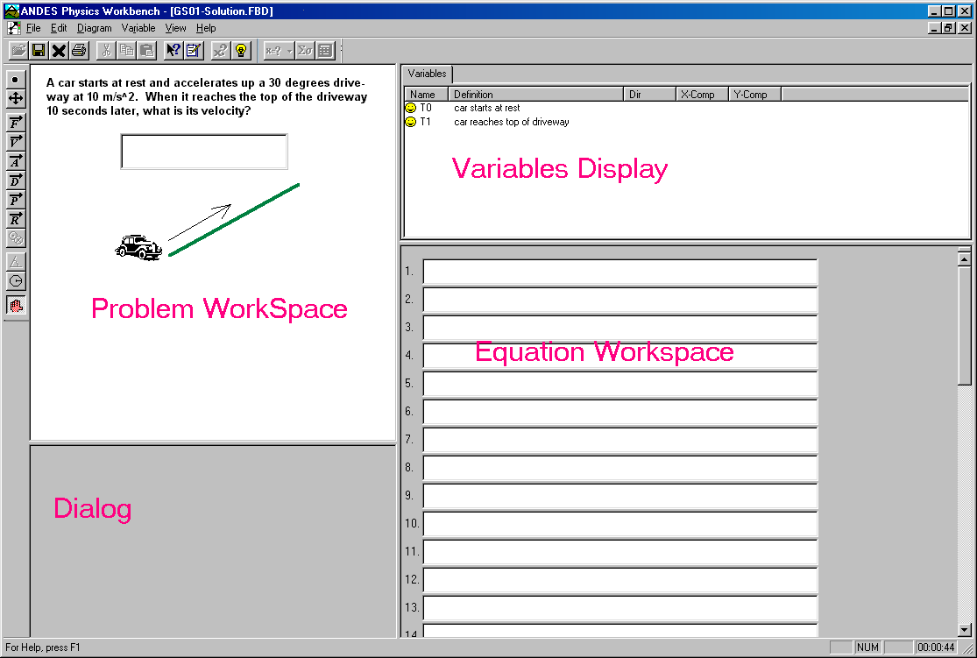

Defining bodies

One of the first steps to solving physics problems often involves defining the body(ies) you will be working with. Many of the Andes problems require only one body to be defined.

To define the body, click on the Body tool (the black circle button at top of the tool bar at the left of display). You will see the mouse cursor change to an arrow with a black dot. Clicking in the problem workspace (upper-left quadrant) will place a black filled circle and open a dialog box. The dialog box has you fill in three slots:
- In the selection box at top of the dialog there will be several bodies to choose from. One click will select a body and highlight it; a second click will de-select it.
- In a drop-down box labeled “At Time” there are options for specifying the duration that we want to analyze the body for. There are two yellow smiley faces in the variables display (upper-right quadrant of display) labeled “T0 start of trip” and “T1 end of trip.” These variables correspond to the choices given you in the drop-down boxes. Since we are interested in the time of the whole trip, from start to finish, you should select the option “T0 to T1” in the slot.
- In the third slot labeled “Variable Name”, type in the name to call this body. Choose a name that reflects the use of the body.

When you have filled all three slots, click on Okay. You will see that a new entry has been added to the variables display (upper-right quadrant). This is the name you chose with the letter “m” as the first character. This variable refers to the body’s mass. Although you won’t need that variable in this problem, it is useful in many other problems.

The entry has a green check mark to indicate that you defined the body correctly. If you had entered it incorrectly there would have been a red X instead. Also the circle in the problem workspace is green. If the body specified were incorrect the circle would be filled red instead. (If you are red-green color-blind, please contact us so we can tell you how to change the colors that Andes uses to indicate correctness.)

Making mistakes and correcting them

Sometimes you will discover that you have created a body (or other entry) that you don’t want. Selecting the entry and then pressing the Delete key will remove it and any variables that were created with it.

Let’s see what happens when one makes a mistake. First delete the body you have created. Let’s define another body but deliberately make an error. Start by clicking on the Body tool (back circle button), then clicking on the upper-left quadrant. When the dialog box comes up, fill in the slots as follows:
- Select “earth” as the body. (This is not correct)
- Select “T0 to T1” as the time. (This is correct)
- Type in a name for the body. (This is correct)

When you click Okay, the circle in the problem workspace and the variable that is defined are both marked red.

If you don’t know or cannot figure out why an entry is wrong you can ask Andes for help. Let’s practice that. Begin by right clicking (click on right mouse button) on the red circle and selecting the “What’s wrong with that?” option from the menu that pops up. Andes will respond with a message in the discussion display (lower-left quadrant). After you’ve read it, you will need to click OK in order to take any further actions.

To modify the body; right-click on it and then choose properties. The creation dialog will appear and you can change the values. In this case change the body to “car” and click Okay.

When you have fixed the error, the body will be drawn green and the variables display will have a green check next to the variable created.

You can also modify variables by right clicking on the variable and choosing Modify Variable.

Defining variables

Before you can enter an equation, you must always define the variables that will be used in the equation. There are different ways to define variables depending on the type of the variable desired. We have already seen one way to create a mass variable by defining the body. Keeping with our car trip problem above, we will practice defining variables that are not magnitudes or components of vectors.

We know that the car trip problem may be solved using the equation speed = distance / time; but before we can enter this equation we need to define three variables, for speed, distance, and time. Let’s do time first.

Select the Variable menu and then choose the Add New Variable sub-menu. Among the options given you can see selections for speed, time, and distance traveled.

Choose the Time option. A dialog box appears that requires you to fill in 3 slots:
- In the slot labeled “From”, select T0 because we want the duration of the time interval that starts with T0.
- In the slot labeled “To,” select T1, because that is when the time interval we want ends.
- Now enter the name for your time variable in the slot labeled “variable name” (NOTE: whatever you type it will be prefixed with the letter ‘t’.)

When you have filled all three slots, click Okay. If you now look at the variables display you will see a new entry. This is your duration variable. It has a green check mark to indicate that you defined a variable that is used in the solution and that you defined it correctly. If you had entered it incorrectly or had defined a variable not used in the solution there would have been a red X instead.

Let’s define the variable for speed. Pull down the Variable menu at the top of the screen, choose Add New Variable, and choose Speed. The dialog box that appears this time has 4 slots that need to be filled:
- Select the car as the body, because it is the car whose speed we are interested in.
- Select “average” instead of “instantaneous,” because we want the variable to refer to the car’s speed over the whole time interval, and not at just one instant.
- Select “T0 to T1” as the time, because that’s the time interval we want the speed variable to refer to.
- Fill in a name for your speed variable. Your name will be prefixed with “v”.

After you fill in these slots and click Okay, the variables display will have the new speed variable listed.

Now, define a variable for distance. Choose Variable, then Add New Variable, then Distance traveled. In the dialog box choose the body (car) the time (T0 to T1) and a name. Click Okay. The variables display shows that you have now defined three variables.

You’ve now learned how to define a scalar variable. Later we will discuss how to define variables that involve vectors.

Entering Equations

Now you can enter the equations needed to solve the problem. In our car trip problem we will need the equation speed = distance / time. Write your equation in the first available equation slot (lower-right quadrant of display). Use the variable names as shown in the variables display. Also make sure that you have hit the enter key after writing the equation and before you do anything else. For example: If you had variables named tTrip (time taken), sLong (distance traveled), vFast (average Speed) you would write the equation vFast = sLong / tTrip (followed by a return/enter key).

You also need to write equations for any given values the problem may have. In this case you need an equation that states the time taken and an equation stating the speed. Continuing, write the equation vFast = 28 m/s (use your variable names in place of vFast, tTrip and sLong). Note that vFast = 28 is not correct. In Andes you must specify units for all numbers that have units. Now, write the equation for tTrip. Andes will do some conversions for you and will allow some flexibility in the entering of values in equations. For example: tTrip = 4 hr + 60 min is an acceptable entry. Go ahead and write an equation that enters the given value for your time variable.

You now have written all the equation needed to solve the problem. Right-click anywhere in the equation display and select Solve For and then choose the variable you want solved. In this case select sLong (or whatever your distance variable is named). Andes will write a new equation in the equation window that gives the value of that variable.
Once you have an answer in the equation window, you need to transfer it to theanswer box that appears beneath the statement of the car trip problem. You can do that easily using cut and paste. Left click at beginning of the number you want and drag-highlight to the end of the number and its units. Hit the control-C key. Now click in the answer box and hit control-V followed by return. Voila! You just solved your first Andes problem.

Close the problem. You will now see the problem dialog again, only now the problem GS00 is marked “DONE” and the next problem (GS01) is highlighted, ready for you to begin solving your next task.

When you don’t know what to do

If you need reminders or more information in order to use the Andes interface, use the Help menu. There are several “How To” guides as well as “Help Topics”. Take some time now to explore the help by finding out what help is available on Physics Equations.

There may come a moment when you have no idea what to do next. If this happens you may ask Andes for help. The quickest way is to select the light-bulb icon (located in tool bar below menu … about four icons from the right). Andes will start a tutoring conversation and attempt to guide you to a solution.

We will practice using Andes help in the next problem as well as using a few more of the tools that Andes provides.

Problem GS01

After you close the car trip problem, Andes displays the list of problems in the “Getting Started” problem set. Click on “GS01” and Begin Solution. The upper left quadrant should display the following problem: “A car starts at rest and accelerates up a 30 degrees driveway at 10 m/s^2. When it reaches the top of the driveway 10 seconds later, what is its velocity?”

The first step is to define the body. Define the body to be the car over the duration T0 to T1. We won’t use the mass variable this time either.

Now define a variable for the time from T0 to T1.

Using Help

This time let’s use Andes Help to help determine our next step. Click the light-bulb tool. Andes responds by asking “What quantity is the problem seeking?” and provides a menu that we can use to specify our answer. Choose ‘Magnitude of’ and then ‘Velocity’. Another dialog appears. Choose the body we want to know the velocity of. Then set the type and the time. Since we are seeking the velocity of the car when it is at the top of the driveway the type will be instantaneous and the moment will be T1. Click Okay. Andes responds by asking, “Which principle should you use to find it?” and bringing up a new dialog. This time choose “Kinematics” and then “constant acceleration”. If you are not sure what principle “constant acceleration” is you can get help by selecting the “Help on Principles” button at the top of this dialog. Try it now. When you are ready, click Okay.

Andes suggests “Try drawing a diagram showing all of the needed kinematics vectors of the car from T0 to T1 and coordinates axis”. Click Okay.

Defining Vectors

Now let’s draw the vectors. There are several tools for drawing vectors; each one is for defining a different type of vector. The vector tool icons have a letter with an arrow over the top of the letter. The letter is a clue to the type of vector that tool draws. If you move the mouse over an icon and wait a second a tool tip will appear telling you the nature of that icon.

First we’ll do the vector for the sought quantity. Find the Velocity tool and click on it. The mouse cursor will change to show the icon with the arrow.

Click in the problem workspace, don’t release yet, and drag the mouse until the vector drawn is the length and orientation you want for this case. Make the vector point upward and to the right at roughly 30 degrees (Don’t worry about getting it exact, we’ll get to that in a second.)

When you release the mouse a diagram appears with five slots:
- The body of the velocity we seek. Select the car because this is the body we are examining.
- Select instantaneous for the type because we want to know the velocity at a particular moment.
- Set the time to be T1 as this is the moment we are concerned with for this vector
- Enter 30 degrees. This is the direction the car is moving.
- Enter a name. Note that velocities always begin with ‘v’.
- Click okay. The vector will be redrawn so that it actually points at a 30-degree angle.

The variable display now shows two new variables: The name you gave the vector (let’s assume vEnd) and a variable called θvEnd (the name you chose preceded by θ). You can see that θvEnd has the value 30 degrees.

We’ll also need a vector for the velocity at time T0. This time we need a zero length vector because the car is at rest at T0. Choose the Velocity tool but this time click and then immediately release in the problem workspace. You will see a symbol that looks like an underscore followed by ‘=0’. A dialog box will appear similar to the one above except that the degrees box is disabled. Fill in the slots to specify an instantaneous velocity at T0 of the car and give it a name.

Again note the new variables shown in the variable display. We don’t get theta variables (θName) for zero-length vectors.

We will also need vectors for the acceleration and for the displacement. Using the acceleration tool draw the vector for the acceleration of the car from T0 to T1 at 30 degrees. Since this acceleration is constant use the type average.

Now draw the displacement vector of the car from T0 to T1 at 30 degrees.

Take a moment to observe the variables that are now available for your equations. You would like to be able to write an equation that states that the average acceleration over some duration is the difference between the initial velocity and the final velocity divided by the time taken. Since we are using vectors we need to be able to state our formulae in terms of the components of our vectors. Andes can give us the variables we need but only after we have drawn a coordinate system.

Defining Axes

When dealing with vectors you should almost always draw a coordinate system. You can draw the axes so that they are rotated: the x-axis does not have to be horizontal. A good choice for the rotation of the coordinate system can greatly simplify the solution.

Select the axes tool. (This is the tool just below the Body tool. It has the crossed arrows icon). Now click, but don’t release yet, in the problem workspace. Drag the mouse slowly up and to the right. You will see the x, y axes lengthen. Move the mouse around a little and observe how you can rotate the axes and expand/shrink the length of the axes. You will see that you can only draw axis with the x-axis in the first quadrant. For this problem, rotate the axes until the x-axis is aligned somewhat like the other vectors (roughly 30 degrees). Now release the mouse. A dialog box will appear with two slots:
- Make sure that the slot for Orientation specifies 30 degrees. This will allow us to have the x-axis aligned with many of our other vectors.
- If the problem uses more than one set of axes you would specify the body this axes is applied to. In this problem we have only one body so this slot is disabled.

As with all diagrams; you can select the axis and move it around so that you may place it in a manner that makes it easy to use.

Examining the variables display will reveal that Andes has now created component variables for all the vectors you have defined. For each vector there is a <name>_x and a <name>_y that you may use to refer to the x and y components (respectively).

Using Vector variables

Now you can start writing equations to solve the problem. Suppose you have named your vectors: ‘a’ (acceleration), ‘d’ (displacement), ‘vS’ (start velocity), and ‘vE’ (final velocity); and named the time variable ‘t’. The first equations we might write are: vE_x = vS_x + a_x * t (from definition of average acceleration) and vS_x = 0 (given). Enter these two equations, using your variables, into the equation workspace.

Using the Greek alphabet

We would now like to write the equations: vE_x = vE * cos (θvE - θx) and a_x = a * cos(θa - θx). How do we get a ‘θ’ character?

On the tool bar, below the file menu, to the left of the calculator icon is an icon with the symbols Σσ. Select this and choose the θ character. The θ character will be written in the currently active equation slot.
Optionally: Enter the equation as: vE_x = vE * cos ($qvE - $qx) and a_x = a * cos($qa - $qx). The $q can be used to represent the Greek letter ‘θ’. In fact you may get any Greek symbol from the Σσ menu by preceding the alt-letter with $letter.

Enter the equations as stated above.

Don’t forget to enter equations for the given quantities. In this case write the equations: t = 10 s; and a = 10 m/s^2.

Now use the solve tool to finish solving the equations and enter the answer in the answer box.

Although you need to enter equations for the given information about the magnitudes of the vectors (e.g., a=10 m/s^2) you don’t need to enter given information about the angles of vectors. Since the equations θx=…, θvE =… and θx=0 appear in the variable window, you don’t have to copy them into the equation window.

Congratulations, you have now completed your second Andes Physics problem. Good luck with the rest of the problems. Don’t forget to take advantage of Andes’ Help facilities especially the Hint (What now?) Light-Bulb and the What’s Wrong with This Help.

Using Andes Help To Get Started

Open problem Exkt1A in the Translational Kinematics Problem Set. Before doing anything else select the light-bulb help (Hint). Andes will ask you in the dialog display “What quantity is the problem seeking?” and will pop up a dialog where you can answer that question. Answer it incorrectly and choose time. Fill in the dialog that pops up with any values you like and say Okay. Andes will say “That quantity is not sought by the problem statement . Please try again.” And will bring up the dialog again. This time say Speed. When the dialog pops up put in values that you think are correct and say Okay.

Andes will respond with “Right indeed. Which principle should you use to find it?” A dialog box will appear and you should choose the principle you think is needed. Experiment a little. Choose a wrong answer. Andes will let you make a couple of wrong answers before making a suggestion to help you. If “Explain More” is at the bottom of a dialog you can click on it to get more information. Continuing to select “Explain More” will usually end telling you exactly what needs to be done.

Go ahead and finish the problem. You are on your way!

