GEOSPATIAL ANALYSIS AND ROUTE OPTIMIZATION PROJECT USING OSMNX

Submitted by

ANANA K P - 223270

ARYA M - 223272

GOWRI KRISHNA PRIYESH - 223275

PRACHOD D - 223278

VIVEK B KRISHNA - 223284

In partial fulfillment of the requirements for the award of Master of Science in Data Analytics with Specialization in Geoinformatics of



School of Digital Sciences Kerala University of Digital Sciences, Innovation, and Technology (Digital University Kerala) Technocity Campus, Thiruvananthapuram, Kerala – 695317

(JANUARY 2024)

**BONAFIDE CERTIFICATE**

This is to certify that the project report entitled “**GEOSPATIAL ANALYSIS AND ROUTE OPTIMIZATION PROJECT USING OSMNX** “ submitted by

ANANA K P - 223270

ARYA M - 223272

GOWRI KRISHNA PRIYESH - 223275

PRACHOD D - 223278

VIVEK B KRISHNA -223284

In partial fulfillment of the requirements for the award of Master of Science in Data Analytics with Specialization in Geoinformatics is a bona fide record of the work carried out at Kerala University of Digital Sciences, Innovation, and Technology under our supervision.



Head of Institution

Prof. SAJI GOPINATH

Vice Chancellor DUK

**DECLARATION**

We Anana K P, Arya M, Gowri Krishna Priyesh, Prachod D and Vivek B Krishna students of Master of Science in Data Analytics with a Specialization in Geoinformatics, hereby declare that this report is substantially the result of our own work, and has been carried out during the period of January 2024.

Place: Trivandrum Anana K P

Date: 07/02/2024 Arya M

Gowri Krishna Priyesh

Prachod D

Vivek B Krishna

**ACKNOWLEDGEMENT**

As a team, we extend our heartfelt gratitude to our esteemed guide, Prof.Radhakrishnan Assistant Professor at Digital University Kerala, Trivandrum. His unwavering guidance, invaluable advice, and unwavering support have been instrumental in our successful completion of this project.

We would also like to extend my thanks to Mr. Nikhil P. and Mr.Sarath Zacharia of the Geospatial Analytics Lab for their exceptional assistance and cooperation. Their expertise and willingness to share their knowledge significantly contributed to the successful completion of this project. Their enthusiasm and commitment to their work have been commendable, and I am grateful for their invaluable contributions.

Furthermore, we express our profound appreciation to Prof. Saji Gopinath for providing us with an exceptional learning environment, invaluable guidance, and access to educational resources that have significantly enriched our capabilities, enabling us to undertake and excel in a project of this magnitude. In addition, we take this opportunity to extend our warm thanks to our friends and beloved family members. Their unwavering assistance, constant encouragement, and steadfast support throughout the execution of this project have been invaluable and deeply appreciated. Together, we acknowledge and express our gratitude to these remarkable individuals and groups who have played pivotal roles in our journey toward project success.

Place: Trivandrum Anana K P

Date: 07/02/2024 Arya M

Gowri Krishna Priyesh

Prachod D

Vivek B Krishna

**ABSTRACT**

Geospatial Analysis And Route Optimization Project Using Osmnx leverages the capabilities of the OSMnx library to conduct a comprehensive analysis of urban transportation in Thiruvananthapuram, Kerala. The code integrates various functionalities to retrieve road networks, visualize them, and calculate optimized routes between specified locations. The methodology includes importing essential libraries, retrieving road networks for both pedestrian and vehicular traffic, visualizing the road networks, converting them into GeoDataFrames, and imputing edge speeds and travel times for efficient analysis.

The study tries to implement geocoding functions to convert addresses into geographical coordinates, facilitating the identification of the nearest graph nodes to specified origin and destination points. The project calculates the shortest path between these nodes based on travel time, utilizing the powerful capabilities of the NetworkX library.

The visualization aspect of the project is emphasized through the plotting of road networks and the display of the calculated shortest path on the map. This enables a clear representation of urban infrastructure and optimized routes, providing valuable insights for transportation planning.

The project's practical applications are highlighted by the ability to calculate route lengths and travel times, aiding urban planners and policymakers in making informed decisions about transportation infrastructure improvements. The modular structure of the code allows for scalability and adaptation to different urban areas, making it a versatile tool for geospatial analysis and route optimization.

In summary, this project offers a robust framework for analyzing urban transportation networks, calculating optimized routes, and visualizing results, with the potential to contribute to sustainable urban development and enhanced travel experiences.

CONTENTS

BONAFIDE……………………………………………………………………………... 2

DECLARATION………………………………………………………………………... 3

ACKNOWLEDGEMENT…………………………………………………………...…. 4

ABSTRACT………….………………………………………………………………… 5

CONTENTS ……………....……………………………………………………………. 6

INTRODUCTION….……………………………………………………………………7

LITERATURE REVIEW ……………………………………………….………………8

METHODOLOGY……………………………………………………………………...10

CONCLUSION AND FUTURE REFERENCES……………...………………………. 13

REFERENCES…....…………………………………………………………………….15

INTRODUCTION

In the dynamic landscape of urban environments, the efficient analysis of transportation networks and the optimization of travel routes are integral components for sustainable urban development and mobility. Recognizing the significance of geospatial analysis in enhancing transportation planning, this project employs the OpenStreetMap-based Python library, OSMnx, to delve into the intricacies of urban and tourist transportation in Thiruvananthapuram, Kerala.

The project sets out to address the complexities of urban mobility by leveraging OSMnx's capabilities to retrieve, visualize, and analyze road networks. By focusing on road networks, the project aims to provide a holistic understanding of the district's transportation infrastructure.

The choice of Thiruvananthapuram as a case study offers a unique perspective, given its diverse urban landscape and the challenges associated with managing transportation in a rapidly.The initial stages of the project involve retrieving road networks for the extraction of vehicular networks, providing a nuanced representation of the district's connectivity.

This project transcends the mere quest for the fastest route; it's about uncovering the hidden potential within road networks, empowering informed decision-making for urban planning, logistics and travel.. As we delve deeper, we'll not only master the tools but also gain valuable insights into the dynamic flow of people and goods within the intricate tapestry of our city.

In conclusion, this project uses OSMnx to serve as a versatile and scalable framework applicable to diverse road networks. By marrying advanced geospatial analysis techniques with practical route optimization, the project strives to be a catalyst for sustainable urban transportation planning and improved travel experiences.

LITERATURE REVIEW

The studies and research conducted related with this projects are

1. “OSMnx: New Methods for Acquiring, Constructing, Analyzing, and Visualizing Complex Street Networks" introduces a paradigm-shifting approach to urban transportation analysis. The paper, authored by Geoff Boeing, showcases the OSMnx library as a groundbreaking tool for geospatial researchers and urban planners. Boeing presents innovative methods for acquiring and constructing complex street networks, leveraging OpenStreetMap data to facilitate a detailed understanding of urban infrastructure.

Its comprehensive exploration of OSMnx's functionalities showcases its potential to redefine how we approach the study of urban transportation networks, offering a versatile and scalable solution for researchers and planners alike. The paper serves as a crucial reference for those seeking to harness the capabilities of OSMnx in advancing the understanding and optimization of complex street networks.

1. The research paper titled "Urban Road Transport Network Analysis: Machine Learning and Social Network Approaches" presents a compelling exploration of innovative methodologies in comprehending urban transportation networks. Integrating both machine learning and social network approaches, the study provides a nuanced perspective on the complexities of urban road systems. The fusion of machine learning techniques adds a predictive dimension, enabling the anticipation of traffic patterns and congestion, while the application of social network analysis sheds light on the intricate relationships between different components of the road network.

The paper underscores the significance of embracing advanced technologies to enhance the understanding of urban road transport dynamics. By employing machine learning algorithms, the authors demonstrate the capability to extract meaningful insights from vast datasets, aiding in the development of more efficient transportation strategies. Additionally, the social network perspective offers a holistic understanding of the interconnectivity among various elements within the urban road network, emphasizing the importance of considering socio-behavioral aspects in transportation planning.

1. "Road Transport for Tourism: Evaluating Policy Measures from Consumer Profiles" critically examines policy interventions in road transport impacting tourism. The review assesses the effectiveness of these measures through a lens of consumer profiles, aiming to discern their impact on travelers. By scrutinizing policies affecting road transport, the study delves into how they align with diverse consumer preferences and behaviors, providing valuable insights for policymakers in shaping transportation strategies that cater to the dynamic needs of tourists. The research contributes a nuanced perspective on the intersection of policy measures, road transport, and the evolving landscape of tourism preferences.

**METHODOLOGY**

1. Data Acquisition:

Input Data: Tourist data is sourced from a CSV file scraped from the internet containing information about various destinations, including name, location (latitude and longitude), and tourist ratings.Python library pandas is utilized to read and manipulate the CSV data.

2. Destination Filtering:

The dataset is filtered to include only top-rated destinations (ratings higher than 4.8). This step ensures that the optimization focuses on high-quality tourist spots. This deliberate filtration ensures that the ensuing optimization process centers on high-quality tourist spots, aligning with the preferences of discerning travelers.

3. Distance and Time Calculation:

Coordinates of the reference location (Kovalam beach) are extracted from the DataFrame.

The Haversine formula is applied to calculate distances between Kovalam beach and each of other major destinations in Trivandrum, providing a measure of road network distances.Travel times are estimated based on an assumed average speed of 30 km/h.Python libraries geopy for distance calculation, math for mathematical operations

4. Nearest Neighbor Algorithm for TSP:

A function is defined to calculate Haversine distance between two points.Latitude and longitude coordinates are converted to (x, y) coordinates to facilitate distance calculations.

Nearest Neighbor algorithm is implemented to solve the Traveling Salesman Problem (TSP) starting from a randomly chosen city and iteratively selecting the nearest unvisited city until all cities are visited.

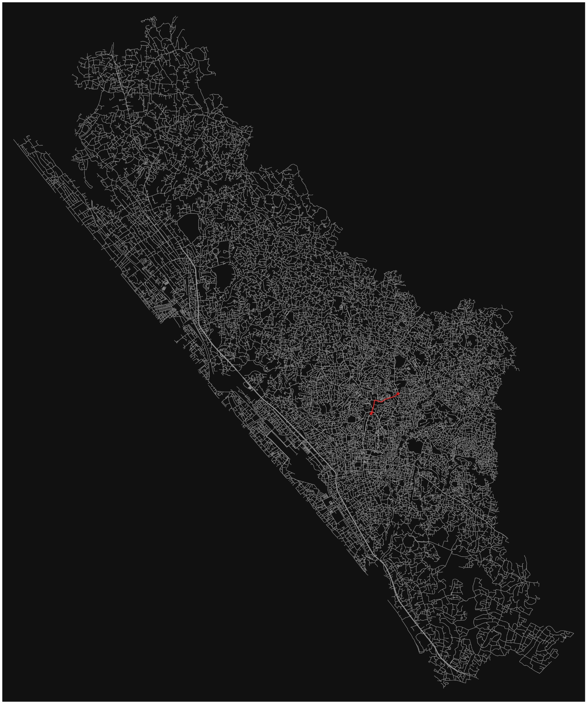

Fig.1 Road Network of Thiruvananthapuram District Kerala

5. . Results and Output:

The indices of the optimal tour route are printed, providing the sequence in which the destinations should be visited to minimize total distance.The total distance and estimated time taken for the tour are calculated and printed.A function is defined to print the names of places in the optimal tour sequence. The output obtained were the Indices of optimal tour, total distance, time taken, and names of places in the optimal tour.

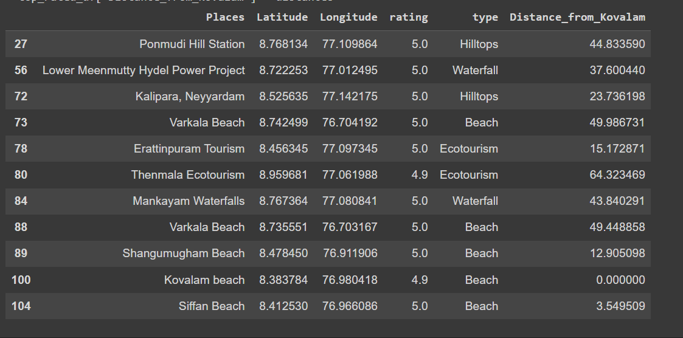

Fig.2 Obtained Result of Shortest Travel Distances from Kovalam Beach

6. Potential Enhancements:

Further development can include the creation of a user interface for inputting preferences and starting location. Integration with mapping APIs like Google Maps for visualization and real-time navigation.Exploration of more advanced optimization algorithms such as Genetic Algorithms or Ant Colony Optimization.Dynamic updates based on real-time traffic conditions or user feedback.Integration with accommodation and dining services for a comprehensive travel plan.

CONCLUSION AND FUTURE SCOPE

In conclusion, Geospatial Analysis And Route Optimization Project Using Osmnx project presents a systematic and innovative approach to enhancing the travel experience for tourists by intelligently optimizing routes through top-rated destinations. The methodology encompasses various stages, from data acquisition and filtering to geospatial analysis and algorithmic optimization using the Nearest Neighbor algorithm. The results provide a tangible and efficient tour sequence, minimizing the total distance and offering an estimated time for the journey. The project not only showcases the versatility of Python libraries like pandas, geopy, and math but also demonstrates the practical application of mathematical algorithms in solving real-world problems like the Traveling Salesman Problem.

The ability to generate an optimized tour route opens up avenues for further development and customization, aligning with diverse user preferences. The user-friendly approach, facilitated by the potential integration of a graphical user interface, promises a more interactive and personalized experience. Furthermore, the project's integration with mapping APIs like Google Maps can enhance visualization and enable real-time navigation, adding a dynamic layer to the optimization process. The exploration of advanced optimization algorithms, such as Genetic Algorithms or Ant Colony Optimization, presents an exciting avenue for improving the efficiency and accuracy of the tour sequence.

Future Scope:

The Road Trip Optimization project exhibits substantial potential for expansion and refinement. Future iterations could focus on the following areas

1. Graphical User Interface (GUI): The development of a user-friendly interface can enhance accessibility and broaden the project's utility. An intuitive GUI would allow users to input preferences, customize starting locations, and visualize optimized routes seamlessly.
2. Integration with Mapping APIs: Leveraging advanced mapping APIs like Google Maps or Mapbox could provide real-time visualization of the optimized tour route, enabling users to navigate efficiently and adapt to changing conditions during their journey.
3. Dynamic Updates: Incorporating real-time data sources for traffic conditions, road closures, or user feedback can enable dynamic updates to the tour route. This adaptability ensures the optimization remains relevant and efficient, even in the face of changing circumstances.
4. Comprehensive Travel Plans: Expanding the project to encompass not only route optimization but also integration with accommodation and dining services can provide users with a comprehensive travel plan. This holistic approach enhances the user experience by offering a complete itinerary.

**REFERENCES**

1. Extraction And Construction Algorithm Of Traffic Road Network Model Based On Osm File : Hangong Wang1, Jiakang Wang1, Peiyao Yu1, Xudong Chen1 And Ziyang Wang2
2. Road Transport In Tourism: Implementing Successfully Air Transport Practices : Manolis Christofakismanolis Christofakistheodoros Stavrinoudis Theodoros Stavrinoudis Spyridon Kapitsino
3. Analysis Of Traffic Characteristics Of Urban Roads Under The Influence Of Roadside Frictions : S. Salini A, R. Ashalatha B
4. Urban Road Transport Network Analysis:Machine Learning And Social Network Approaches Kuşkapan 1, M. Yasin Çodur 2, Ahmet Tortum 3, Giovanni Tesoriere 4, Tiziana Campisi
5. Gis And Transport Modeling—Strengthening The Spatial Perspective : Martin Loidlgudrun Wallentingudrun Wallentinrita Cyganskirita Cyganski