# Document 1

## Vertical images

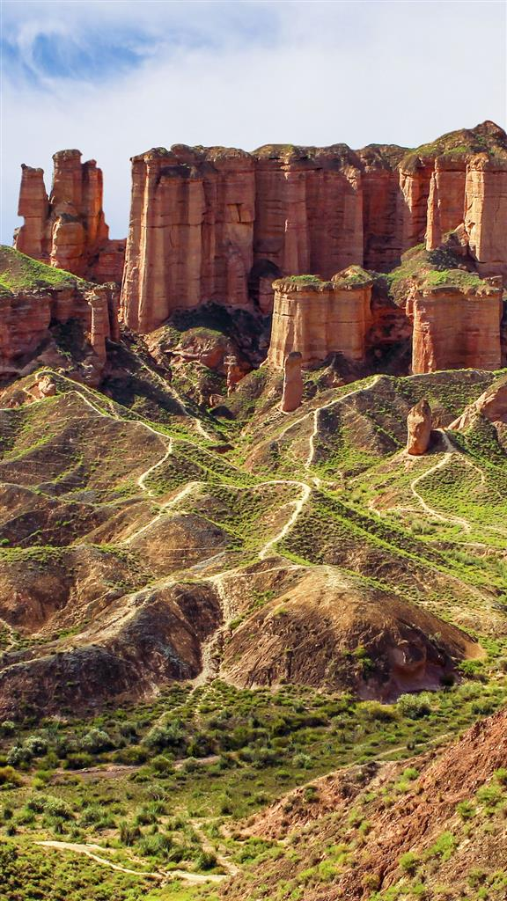

## Table

|  |  |  |  |
| --- | --- | --- | --- |
| **Id** | **Col #1** | **Col #2** | **Col #3** |
| 1 | Item 1.1 | Item 1.2 | Item 1.3 |
| 2 | Item 2.1 | Item 2.2 | Item 2.3 |
| 3 | Item 3.1 | Item 3.2 | Item 3.3 |