# Nested documents

<{doc1}>

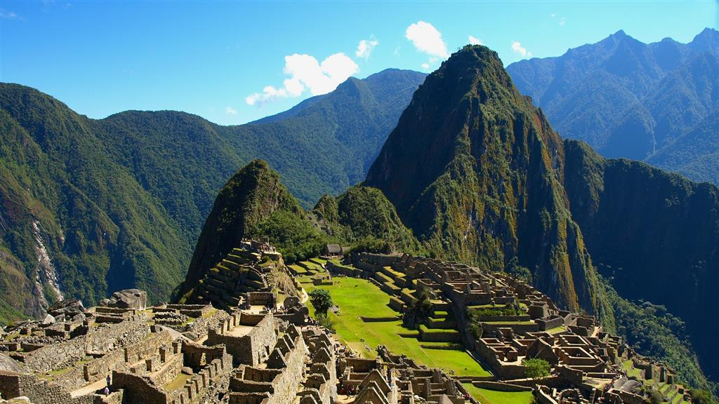

<{ doc2 }>

<{doc3}>

The end.