Covid-19’s Negative Impact on Students

Caitlyn Robinson

Benjamin Vest

Abstract

The Covid-19 pandemic has changed many aspects of our daily lives, but how has it impacted the education of high school students? This paper looks at various indicators of students’ performance including SAT scores, AP testing scores, ACT, and graduation percentage and compares performance to the years before the pandemic started.

Introduction

During the Covid-19 pandemic, several indicators of student performance declined including SAT scores, AP testing scores, and ACT scores decreased while graduation rates fluctuated. According to data collected nationally and from DC at the peak of the pandemic in March 2020, all test scores dropped, and graduation rates declined.

On March 13th, 2020, schools shut down for several weeks. The shutdown happens to align perfectly with the sudden decrease in all test scores. During this time, most students then went fully online, only attending classes through virtual meeting software like Zoom. According to an article posted by PsyPost[2], “Those who attended school remotely during the pandemic fared worse emotionally, academically, and socially than those who attended in person”. Students do not do as well academically in online classes as in person, so their performance on tests like the SAT, ACT, and on AP tests are likely to decrease as well.

SAT Results

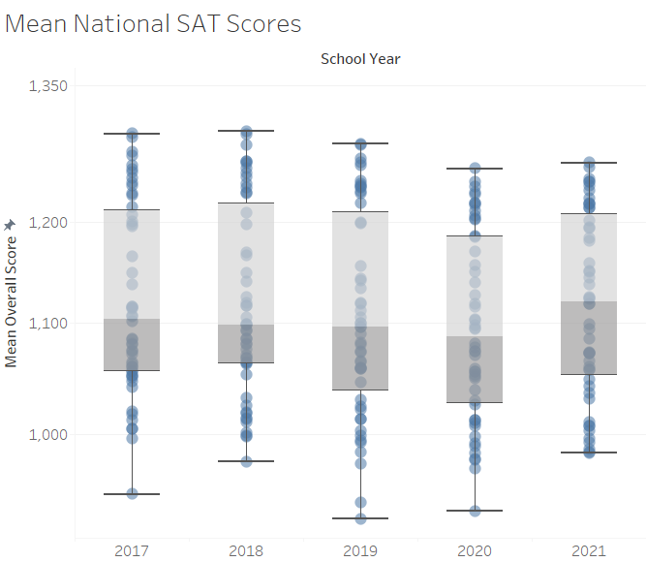

SAT scores decreased during the pandemic. According to national data, overall scores on the SAT decreased as the Covid-19 pandemic started. Overall scores are the scores that combine the total of the Math and Evidence Based Reading and Writing sections. This is consistent across the different sections of the SAT. Both the math and evidence-based reading and writing sections showed the same trend as the total score. Test scores declined as the pandemic started. Scores rose in 2021, when many schools returned to in-person classes.

SAT benchmarks are used to determine how prepared a student is for college or a career. For colleges the benchmark is used to determine the likelihood of success in any intro classes taken by the student during their first semester. A benchmark score indicates a 75% chance that a student will get at least a C in their first semester of college. Getting a score above the benchmark does not mean the student has a higher chance of getting a C or better. The math benchmark is associated with the chance that a student will get at least a C in their math courses and the Evidence-Based Reading and Writing benchmark indicates the chance a student will get at least a C in other courses like writing, history, or science classes in their first semester of college.

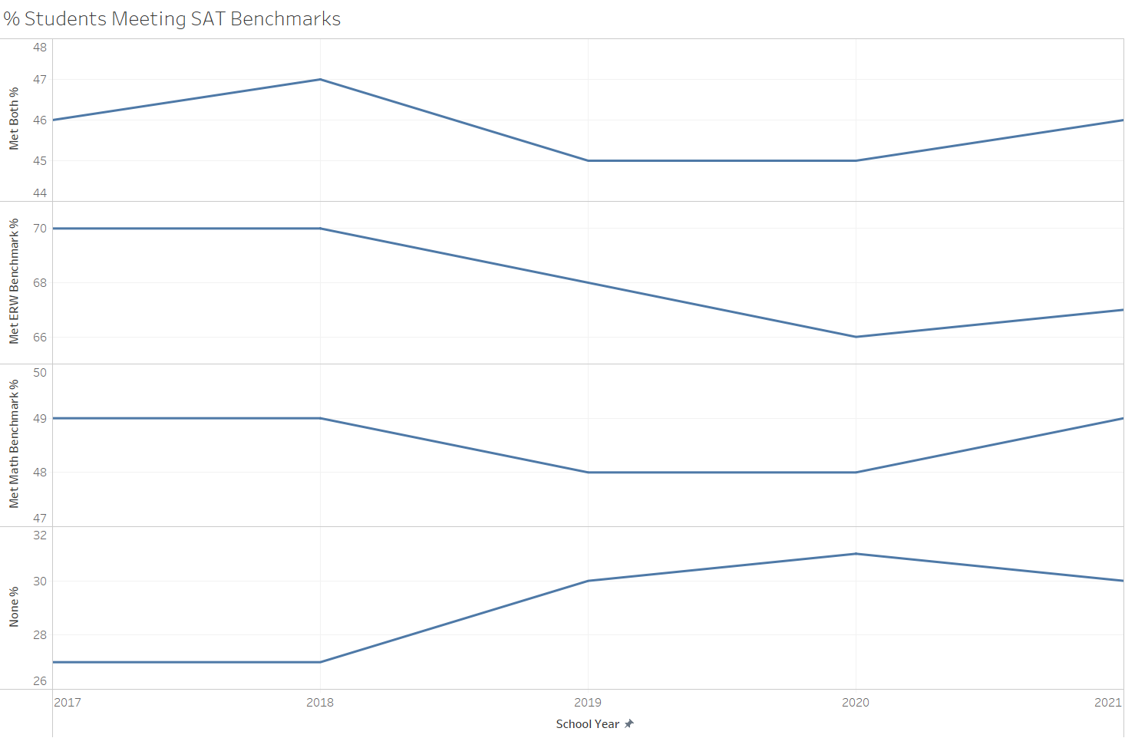

The percent of students who met or exceeded the SAT benchmarks has decreased for all sections of the SAT after the pandemic occurred. The visual above shows the percent of students who have met or exceeded the SAT’s benchmarks on a national level. Only the met math benchmark percent has returned to its pre-covid state.

This is especially significant when you look at the met ERW category and the both categories which have stopped decreasing but have not risen back to their pre-covid levels. The none category is the only category to have grown and is the category for test takers who did not meet either benchmark.

AP Scores

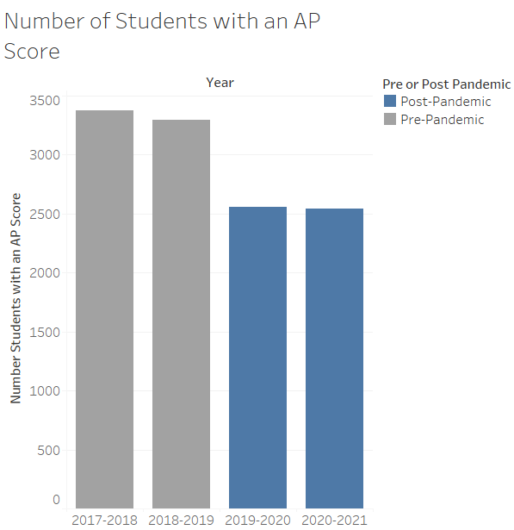

Fewer students passed AP tests during the pandemic according to data from DC schools. Students counted as having an AP score are any students who passed at least one AP exam that year. Sharing a trend with SAT scores, AP scores saw a decrease as schools started to go online during the pandemic in March of 2020. Even though the schools maintained a similar number of students enrolled, they had a decrease in the total number of students who had an AP score. AP scores did not rise after the return to in-person classes like SAT scores. They lowered by a small amount but did not change much between the 2019-2020 school year and the 2020-2021 school year.

ACT Results

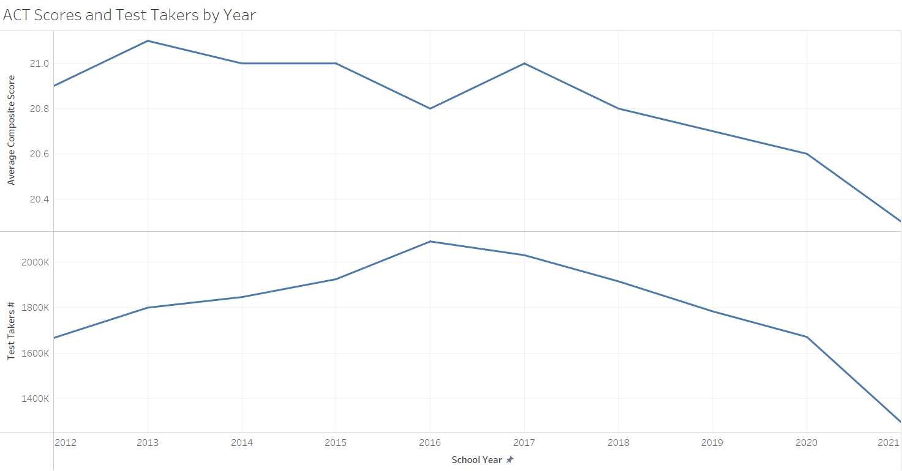

National ACT scores started to drop before the pandemic started in 2019. The drop is constant until the average score decreases by a larger amount. The number of test takers show a larger decrease during the pandemic. The number of test takers has been slowly declining, but in 2021 the largest drop in test takers can be seen.

The decrease in test takers could be because less colleges require the ACT to apply, not just because of Covid-19. According to a Forbes article[4], “More than three-quarters of all U.S. bachelor degree-granting institutions now practice test-optional or test-blind admissions, an all-time high.”. Many colleges do not consider test scores anymore when admitting new students, so these students do not take the tests. Students who decide to take the ACT are often those who need a high test score to improve already low grades. Students with high grades will not need the test scores. Students with low grades are less likely to have a high ACT score, thus affecting the overall average.

Graduation Rates

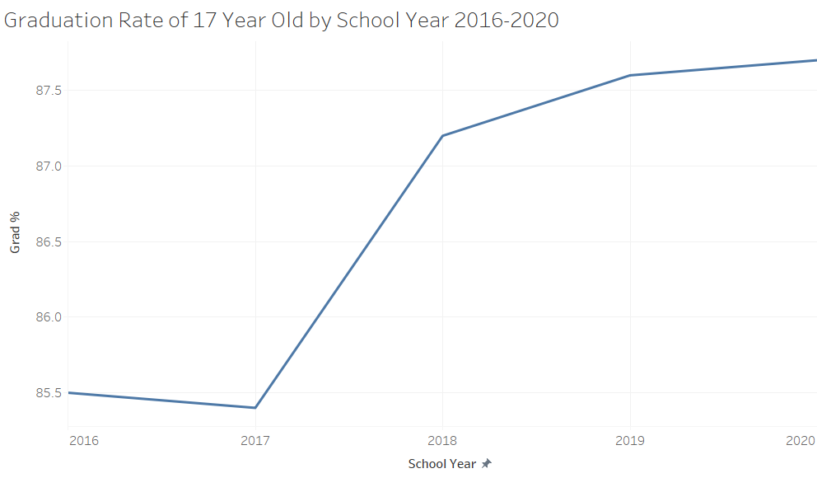

National graduation rates have continued to increase after the pandemic started in 2019. The increase is in contrast with SAT and ACT scores comes down the direct influence in the shift to online learning and the shifting of to being more online as a whole as well as the indirect factors such as the loosening of some state’s graduation requirements and the shift to online learning reducing how rigorous some school systems could be in maintaining quality of their education.

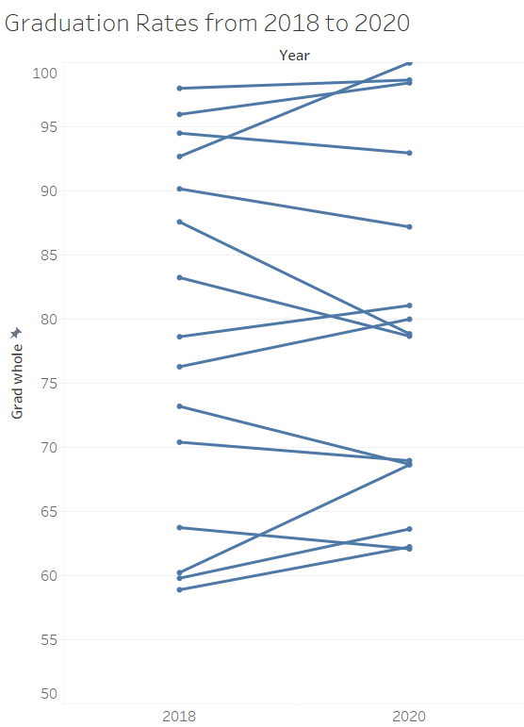

In the spring of 2020, seven of 15 Washington DC public schools saw graduation rates decrease. This decrease contrasts against the eight DC schools whose graduation rates increased, an outcome consistent with the overall national trend of increased graduation rates for the same period. 47% of schools’ graduation rates decreased while the total average graduation percentage for DC increased.

Each of these points may have more contributing factors than the Covid-19 pandemic alone. For example, graduation rates can be affected by school funding, the teachers employed by a school, or even each student’s personal life. It cannot be assumed that these changes were caused by Covid-19 alone.

Conclusion

High school students’ performance on the SAT, AP tests, and the ACT decreased during the Covid-19 pandemic. Average test scores for high schools decreased after the start of the pandemic, and test scores were not the only factor that showed a decrease in performance either. The percentage of high school seniors graduating also declined for many schools. The data suggest that high school seniors may find it more difficult to achieve the same scores as the seniors from years before the pandemic.

References

1.Hauck, G., &amp; Stanglin, D. (2020, March 14). *Coronavirus updates: Trump declares national emergency; schools in 12 states shut down; Cruise Lines halted*. USA Today. Retrieved April 22, 2022, from https://www.usatoday.com/story/news/health/2020/03/13/coronavirus-updates-us-testing-death-toll-stocks-school-closures/5032550002/

2.Ellwood, B. (2021, August 10). *High school students who attended school remotely during the pandemic report worse social, emotional, and academic well-being*. PsyPost. Retrieved April 22, 2022, from https://www.psypost.org/2021/08/high-school-students-who-attended-school-remotely-during-the-pandemic-report-worse-social-emotional-and-academic-well-being-61669

3.*SAT Suite of Assessments - Benchmarks. Benchmarks* – SAT Suite | College Board. (n.d.). Retrieved April 22, 2022, from https://satsuite.collegeboard.org/k12-educators/about/understand-scores-benchmarks/benchmarks

4.Nietzel, M. T. (2021, October 14). *The number of students taking the Act dropped 22% This Year.* Forbes. Retrieved April 22, 2022, from <https://www.forbes.com/sites/michaeltnietzel/2021/10/13/the-number-of-students-taking-the-act-dropped-22-this-year/?sh=399d0299c60a>

5. District of Columbia Public Schools. (n.d.). School Data. Retrieved April 22, 2022, from <https://dcps.dc.gov/service/school-data>

6. *Digest of Education Statistics*, 2020. National Center for Education Statistics (NCES) Home Page, a part of the U.S. Department of Education. (n.d.). Retrieved April 22, 2022, from https://nces.ed.gov/programs/digest/d20/tables/dt20_219.10.asp

7. Aldric, A. (n.d.). *Average act score for 2021, 2020, 2019, 2018, and earlier years*. PrepScholar. Retrieved April 22, 2022, from https://blog.prepscholar.com/average-act-score-by-year

8. *SAT scores*. SAT Scores – SAT Suite | College Board. (n.d.). Retrieved April 22, 2022, from https://satsuite.collegeboard.org/sat/scores