**DESIGN DOCUMENT (LLD)**

**For**

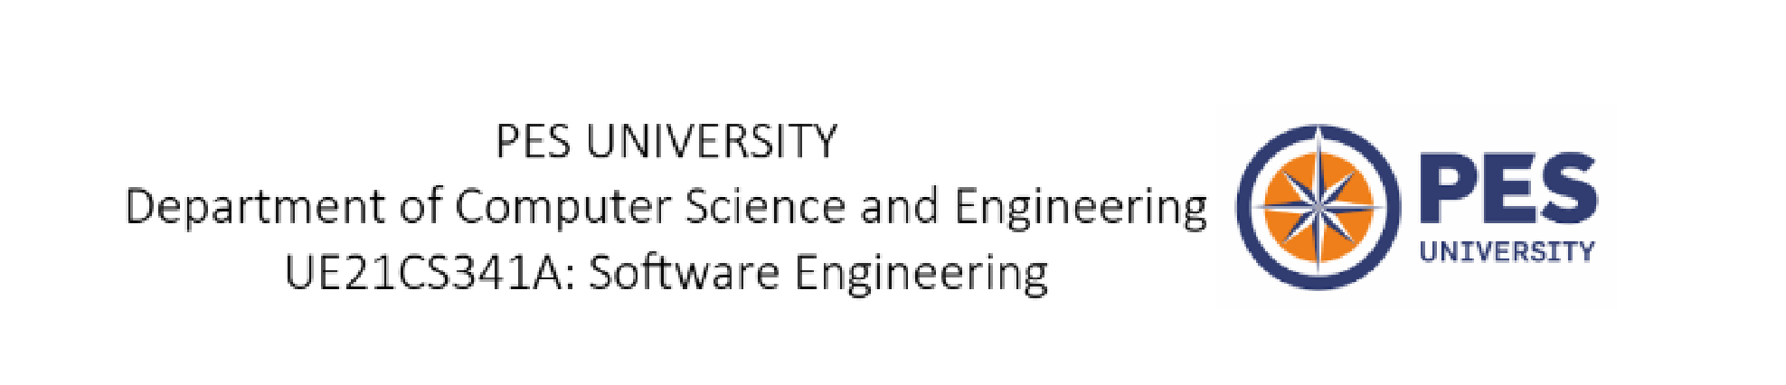 **COVITEAM Collaborative Virtual Teammate Network**

**Prepared by**

**PES2UG21CS175 | GAURAV B V**

**PES2UG21CS172 | GAGAN R**

**PES2UG21CS140 | CHARAN S GOWDA**

**INDEX**

**SL**

**NO.**

**TOPIC**

**PG**

**NO.**

**1.**

**CLASS**

**DIAGRAM**

**3**

**2.**

**DATA**

**FLOW**

**DIAGRAM**

**(**

**LEVEL**

**0)**

**4**

**3.**

**DATA**

**FLOW**

**DIAGRAM**

**(**

**LEVEL**

**1)**

**5**

**4.**

**ARCHITECTURE**

**DIAGRAM**

**6**

**5.**

**ARCHITECTURE**

**STYLE**

**7**



**1.CLASS DIAGRAM**

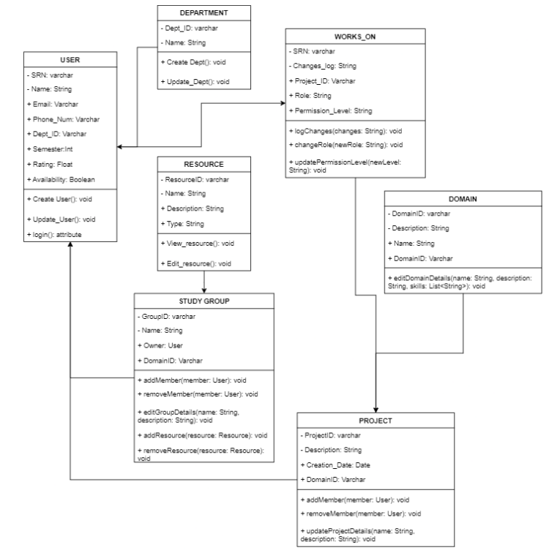

**2.DATA FLOW DIAGRAM (LEVEL 0)**

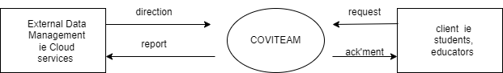

**3.DATA FLOW DIAGRAM (LEVEL 1)**

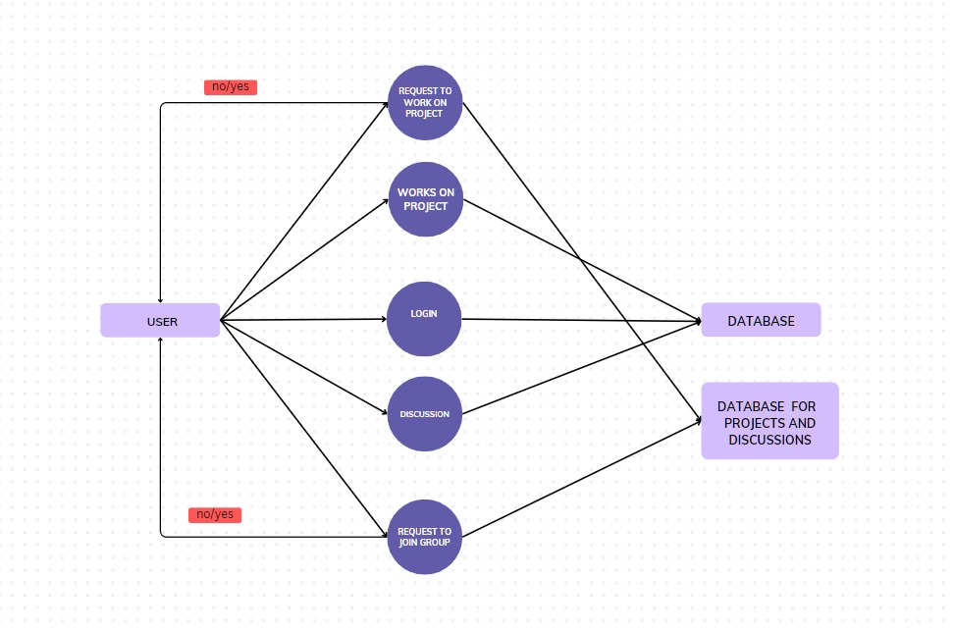

**4.ARCHITECTURE DIAGRAM**

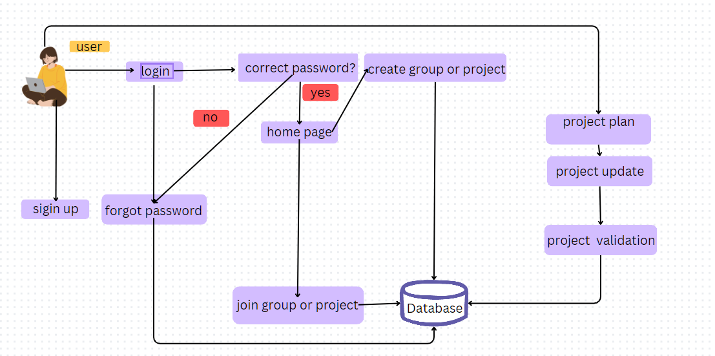

**4.ARCHITECTURE STYLE (client server)**

**Client-Server:** The client–server model is a distributed application structure that partitions tasks or workloads between the providers and service requesters.

**Justification:**

**Scalability:** Client-server architecture allows for horizontal scalability. You can scale the system by adding more servers to handle an increasing number of clients. This makes it suitable for applications that may experience variable or high loads, as you can distribute the load across multiple servers.

**Security Enforcement:** By centralizing authentication and authorization mechanisms on the server, you can control and enforce security policies more effectively.

**Centralized Data Management:** Storing data on a central server allows for consistent data management, backup, and recovery. This is crucial for applications that require data integrity and availability.

**Resource Sharing:** Client-server architecture allows multiple clients to share a common set of resources or services provided by the server, making it an effective choice for scenarios where resource sharing is required.