

***Mini project report on***

Disaster Data Management System

*Submitted in partial fulfilment of the requirements for the award of degree of*

**Bachelor of Technology**

**in**

**Computer Science & Engineering**

**UE21CS351 – DBMS Project**

***Submitted by:***

|  |  |
| --- | --- |
| **GAGAN R**  **DEVANJAN BANERJEE** | **PES2UG21CS172**  **PES2UG21CS159** |

*3*

Under the guidance of

**Prof. Nivedita Kasturi**

Assistant Professor

|  |
| --- |
| Designation  PES University |

**AUG - DEC 2023**

**DEPARTMENT OF COMPUTER SCIENCE AND ENGINEERING**

FACULTY OF ENGINEERING

**PES UNIVERSITY**

(Established under Karnataka Act No. 16 of 2013)

Electronic City, Hosur Road, Bengaluru – 560 100, Karnataka, India



**PES UNIVERSITY**

(Established under Karnataka Act No. 16 of 2013)

Electronic City, Hosur Road, Bengaluru – 560 100, Karnataka, India

**CERTIFICATE**

*This is to certify that the mini project entitled*

**TURF Management System**

*is a bonafide work carried out by*

|  |  |
| --- | --- |
| **GAGAN R**  **DEVANJAN BANERJEE** | **PES2UG21CS172**  **PES2UG21CS159** |

In partial fulfilment for the completion of fifth semester DBMS Project (UE20CSS301) in the Program of Study -Bachelor of Technology in Computer Science and Engineering under rules and regulations of PES University, Bengaluru during the period AUG. 2022 – DEC. 2022. It is certified that all corrections / suggestions indicated for internal assessment have been incorporated in the report. The project has been approved as it satisfies the 5th semester academic requirements in respect of project work.

|  |  |
| --- | --- |
| Signature  Prof. Nivedita Kasturi  Assistant Professor |  |

**DECLARATION**

We hereby declare that the DBMS Project entitled **Parking Management System** has been carried out by us under the guidance of **Prof. Nivedita Kasturi, Assistant Professor** and submitted in partial fulfilment of the course requirements for the award of degree of **Bachelor of Technology** in **Computer Science and Engineering** of **PES University, Bengaluru** during the academic semester AUG – DEC 2023.

|  |  |  |
| --- | --- | --- |
| **GAGAN R**  **DEVANJAN BANERJEE** | **PES2UG21CS172**  **PES2UG21CS159** |  |

**ACKNOWLEDGEMENT**

I would like to express my gratitude to Prof. Nivedita Kasturi, Department of Computer Science and Engineering, PES University, for her continuous guidance, assistance, and encouragement throughout the development of this UE21CS351 - DBMS Project.

I take this opportunity to thank Dr. Sandesh B J, C, Professor,ChairPerson, Department of Computer Science and Engineering, PES University, for all the knowledge and support I have received from the department.

I am deeply grateful to Dr. M. R. Doreswamy, Chancellor, PES University, Prof. Jawahar Doreswamy, Pro Chancellor – PES University, Dr. Suryaprasad J, Vice-Chancellor, PES University for providing to me various opportunities and enlightenment every step of the way. Finally, this DBMS Project could not have been completed without the continual support and encouragement I have received from my family and friends.

**ABSTRACT**

**Purpose:**

A Turf Management System is a software application designed to help manage and maintain sports turf, such as golf courses, athletic fields, and parks. It assists in various tasks including scheduling maintenance, tracking inventory, monitoring soil and weather conditions, and managing staff assignments

**Scope:**

The Turf Management System (TMS) will be a comprehensive software solution designed to streamline and enhance the management and maintenance of sports turf areas, such as golf courses, athletic fields, and parks. This system assists groundskeepers, managers, and maintenance teams in efficiently managing tasks, resources, and data associated with maintaining optimal turf conditions.

# 

# TABLE OF CONTENTS

|  |  |  |
| --- | --- | --- |
| **Chapter No.** | **Title** | **Page No.** |
|  | **INTRODUCTION** | **08** |
|  | **PROBLEM DEFINITION** | **09** |
|  | **ER MODEL** | **10** |
|  | **ER TO RELATIONAL MAPPING** | **11** |
|  | **DDL STATEMENTS** | **12** |
|  | **DML STATEMENTS** | **14** |
|  | **QUERIES (SIMPLE QUERY AND UPDATE AND DELETE OPERATION, CORRELATED QUERY AND NESTED QUERY)** | **16** |
|  | **STORED PROCEDURE, FUNCTIONS AND TRIGGERS** | **17** |
|  | **FRONT END DEVELOPMENT** | **18** |
|  | |  |

**INTRODUCTION**

A Turf Management System is a software application designed to help manage and maintain sports turf, such as golf courses, athletic fields, and parks. It assists in various tasks including scheduling maintenance, tracking inventory, monitoring soil and weather conditions, and managing staff assignments

**PROBLEM DEFINITION**

The management of turf, such as grassy lawns, athletic fields, and recreational spaces, involves various challenges related to maintenance, resource utilization, and environmental impact. Achieving an optimal balance between aesthetic appeal, resource efficiency, and environmental sustainability is crucial for the long-term health and usability of these green spaces.

**ER MODEL:**

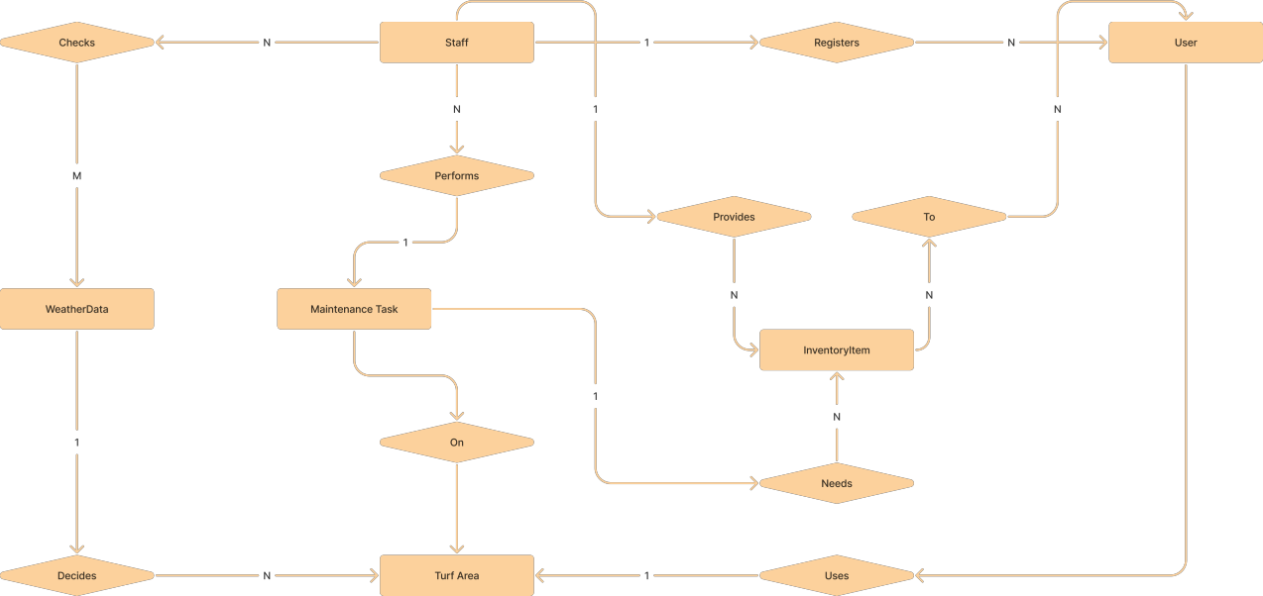

**ER TO RELATIONAL MAPPING:**

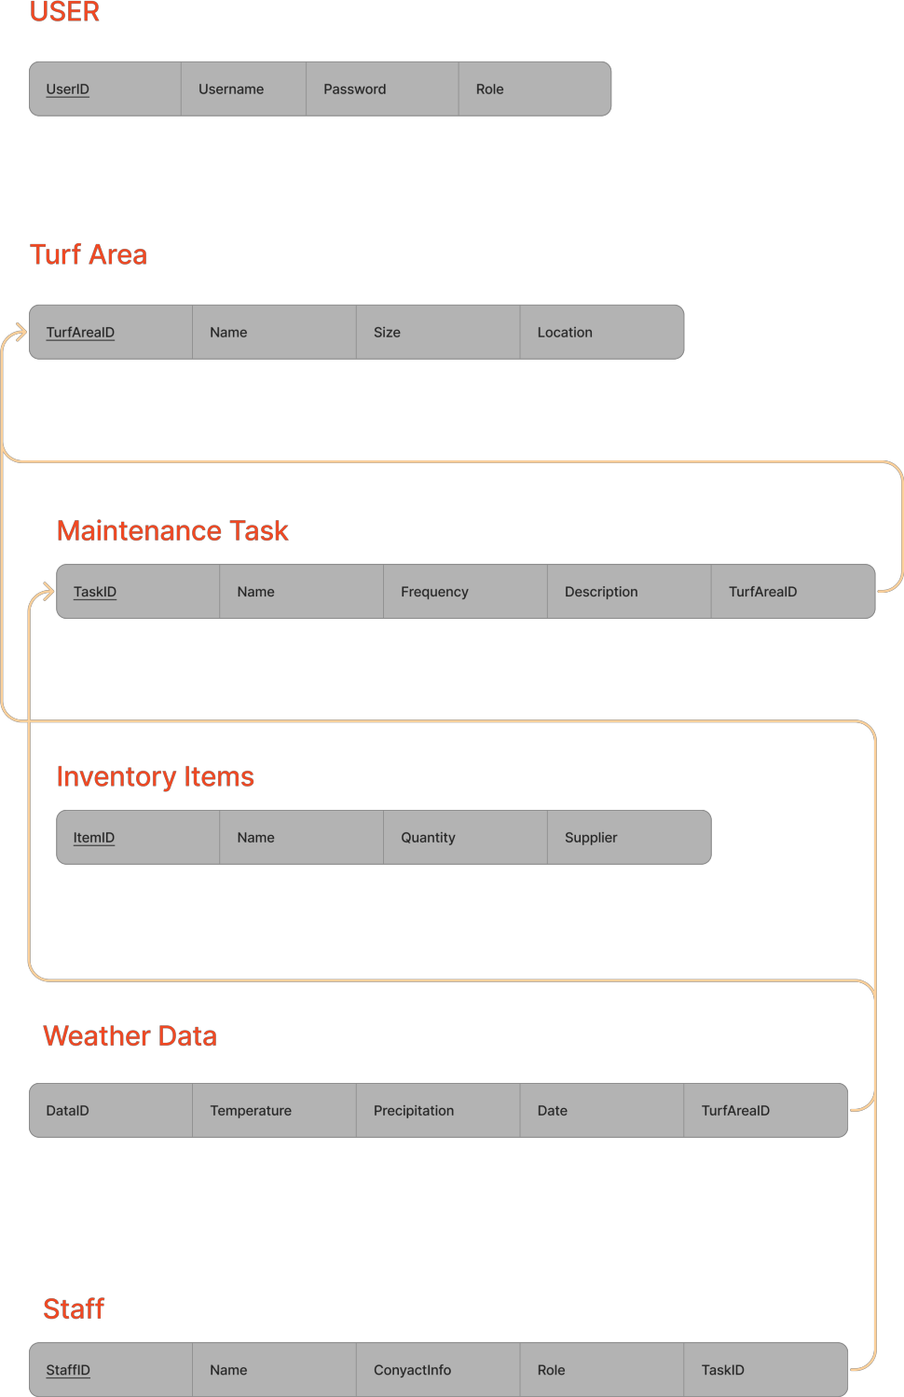

**DDL STATEMENTS**

 CREATE TABLE `booking_list` (

  `id` int(30) NOT NULL,

  `ref_code` varchar(100) NOT NULL,

  `client_id` int(30) NOT NULL,

  `facility_id` int(30) NOT NULL,

  `date_from` date NOT NULL,

  `date_to` date NOT NULL,

  `status` tinyint(2) NOT NULL DEFAULT 0 COMMENT '0 = Pending,\r\n1 = Confirmed,\r\n2 = Done,\r\n3 = Cancelled',

  `date_created` datetime NOT NULL DEFAULT current_timestamp(),

  `date_updated` datetime DEFAULT NULL ON UPDATE current_timestamp()

) ENGINE=InnoDB DEFAULT CHARSET=utf8mb4;

CREATE TABLE `category_list` (

  `id` int(30) NOT NULL,

  `name` text NOT NULL,

  `description` text NOT NULL,

  `delete_flag` tinyint(1) NOT NULL DEFAULT 0,

  `status` tinyint(1) NOT NULL DEFAULT 1,

  `date_created` datetime NOT NULL DEFAULT current_timestamp(),

  `date_updated` datetime DEFAULT NULL ON UPDATE current_timestamp()

) ENGINE=InnoDB DEFAULT CHARSET=utf8mb4;

CREATE TABLE `client_list` (

  `id` int(30) NOT NULL,

  `firstname` text NOT NULL,

  `middlename` text DEFAULT NULL,

  `lastname` text NOT NULL,

  `gender` text NOT NULL,

  `contact` text NOT NULL,

  `address` text NOT NULL,

  `email` text NOT NULL,

  `password` text NOT NULL,

  `image_path` text DEFAULT NULL,

  `status` tinyint(1) NOT NULL DEFAULT 1,

  `delete_flag` tinyint(1) NOT NULL DEFAULT 0,

  `date_created` datetime NOT NULL DEFAULT current_timestamp(),

  `date_added` datetime DEFAULT NULL ON UPDATE current_timestamp()

) ENGINE=InnoDB DEFAULT CHARSET=utf8mb4;

CREATE TABLE `facility_list` (

  `id` int(30) NOT NULL,

  `facility_code` varchar(100) NOT NULL,

  `category_id` int(30) NOT NULL,

  `image_path` text DEFAULT NULL,

  `status` tinyint(1) NOT NULL DEFAULT 1,

  `delete_flag` tinyint(1) NOT NULL DEFAULT 0,

  `date_created` datetime NOT NULL DEFAULT current_timestamp(),

  `date_updated` datetime DEFAULT NULL ON UPDATE current_timestamp(),

  `name` text NOT NULL,

  `description` text NOT NULL,

  `price` double(10,2) NOT NULL

) ENGINE=InnoDB DEFAULT CHARSET=utf8mb4;

CREATE TABLE `system_info` (

  `id` int(30) NOT NULL,

  `meta_field` text NOT NULL,

  `meta_value` text NOT NULL

) ENGINE=InnoDB DEFAULT CHARSET=utf8mb4;

CREATE TABLE `users` (

  `id` int(50) NOT NULL,

  `firstname` varchar(250) NOT NULL,

  `lastname` varchar(250) NOT NULL,

  `username` text NOT NULL,

  `password` text NOT NULL,

  `avatar` text DEFAULT NULL,

  `last_login` datetime DEFAULT NULL,

  `type` tinyint(1) NOT NULL DEFAULT 0,

  `date_added` datetime NOT NULL DEFAULT current_timestamp(),

  `date_updated` datetime DEFAULT NULL ON UPDATE current_timestamp()

) ENGINE=InnoDB DEFAULT CHARSET=utf8mb4;

ALTER TABLE `booking_list`

  ADD PRIMARY KEY (`id`),

  ADD KEY `cab_id` (`facility_id`),

  ADD KEY `client_id` (`client_id`);

--

-- Indexes for table `category_list`

--

ALTER TABLE `category_list`

  ADD PRIMARY KEY (`id`);

--

-- Indexes for table `client_list`

--

ALTER TABLE `client_list`

  ADD PRIMARY KEY (`id`),

  ADD UNIQUE KEY `email` (`email`) USING HASH;

--

-- Indexes for table `facility_list`

--

ALTER TABLE `facility_list`

  ADD PRIMARY KEY (`id`),

  ADD KEY `category_id` (`category_id`);

--

-- Indexes for table `system_info`

--

ALTER TABLE `system_info`

  ADD PRIMARY KEY (`id`);

--

-- Indexes for table `users`

--

ALTER TABLE `users`

  ADD PRIMARY KEY (`id`);

--

-- AUTO_INCREMENT for dumped tables

--

--

-- AUTO_INCREMENT for table `booking_list`

--

ALTER TABLE `booking_list`

  MODIFY `id` int(30) NOT NULL AUTO_INCREMENT, AUTO_INCREMENT=5;

--

-- AUTO_INCREMENT for table `category_list`

--

ALTER TABLE `category_list`

  MODIFY `id` int(30) NOT NULL AUTO_INCREMENT, AUTO_INCREMENT=9;

--

-- AUTO_INCREMENT for table `client_list`

--

ALTER TABLE `client_list`

  MODIFY `id` int(30) NOT NULL AUTO_INCREMENT, AUTO_INCREMENT=3;

--

-- AUTO_INCREMENT for table `facility_list`

--

ALTER TABLE `facility_list`

  MODIFY `id` int(30) NOT NULL AUTO_INCREMENT, AUTO_INCREMENT=6;

--

-- AUTO_INCREMENT for table `system_info`

--

ALTER TABLE `system_info`

  MODIFY `id` int(30) NOT NULL AUTO_INCREMENT, AUTO_INCREMENT=15;

--

-- AUTO_INCREMENT for table `users`

--

ALTER TABLE `users`

  MODIFY `id` int(50) NOT NULL AUTO_INCREMENT, AUTO_INCREMENT=11;

--

-- Constraints for dumped tables

--

--

-- Constraints for table `booking_list`

--

ALTER TABLE `booking_list`

  ADD CONSTRAINT `booking_list_ibfk_1` FOREIGN KEY (`facility_id`) REFERENCES `facility_list` (`id`) ON DELETE CASCADE,

  ADD CONSTRAINT `booking_list_ibfk_2` FOREIGN KEY (`client_id`) REFERENCES `client_list` (`id`) ON DELETE CASCADE;

--

-- Constraints for table `facility_list`

--

ALTER TABLE `facility_list`

  ADD CONSTRAINT `facility_list_ibfk_1` FOREIGN KEY (`category_id`) REFERENCES `category_list` (`id`) ON DELETE CASCADE;

COMMIT;

**DML STATEMENTS:**

INSERT INTO `booking_list` (`id`, `ref_code`, `client_id`, `facility_id`, `date_from`, `date_to`, `status`, `date_created`, `date_updated`) VALUES

(1, '202203-00001', 1, 1, '2022-03-24', '2022-03-24', 3, '2022-03-23 13:22:06', '2022-03-23 13:49:09'),

(2, '202203-00002', 1, 2, '2022-03-24', '2022-03-25', 1, '2022-03-23 13:30:40', '2022-03-23 13:49:11'),

(3, '202203-00003', 2, 4, '2022-03-24', '2022-03-25', 1, '2022-03-23 15:40:58', '2022-03-23 15:41:59'),

(4, '202203-00004', 2, 1, '2022-03-28', '2022-03-28', 3, '2022-03-23 15:41:17', '2022-03-23 15:41:26');

INSERT INTO `category_list` (`id`, `name`, `description`, `delete_flag`, `status`, `date_created`, `date_updated`) VALUES

(1, 'Basket Ball', 'Basket Ball Facility', 0, 1, '2022-03-23 10:34:53', NULL),

(2, 'Badminton', 'Badminton Court', 0, 1, '2022-03-23 10:35:12', NULL),

(3, 'Tennis Court', 'Tennis Court', 0, 1, '2022-03-23 10:35:32', NULL),

(4, 'Football', 'Football Field', 0, 1, '2022-03-23 10:35:46', NULL),

(5, 'Volleyball', 'Volleyball Court', 0, 1, '2022-03-23 10:36:08', NULL),

(6, 'Baseball', 'Baseball Field', 0, 1, '2022-03-23 10:36:42', NULL),

(7, 'Sample 101', 'This is a sample Facility Category Only', 0, 1, '2022-03-23 15:26:12', NULL),

(8, 'Sample 103', 'Test', 1, 0, '2022-03-23 15:26:42', '2022-03-23 15:26:54');

INSERT INTO `client_list` (`id`, `firstname`, `middlename`, `lastname`, `gender`, `contact`, `address`, `email`, `password`, `image_path`, `status`, `delete_flag`, `date_created`, `date_added`) VALUES

(1, 'Mark', 'D', 'Male', '', '09123456789', 'Sample Address', 'mcooper@sample.com', 'c7162ff89c647f444fcaa5c635dac8c3', 'uploads/clients/1.png?v=1648008107', 1, 0, '2022-03-23 12:01:47', '2022-03-23 12:01:47'),

(2, 'Samantha', 'C', 'Miller', 'Male', '09456789123', 'Sample Address only', 'sam23@gmail.com', '56fafa8964024efa410773781a5f9e93', 'uploads/clients/2.png?v=1648021231', 1, 0, '2022-03-23 15:40:31', '2022-03-23 15:44:07');

INSERT INTO `facility_list` (`id`, `facility_code`, `category_id`, `image_path`, `status`, `delete_flag`, `date_created`, `date_updated`, `name`, `description`, `price`) VALUES

(1, '202203-00001', 1, 'uploads/facility/1.png?v=1648020784', 1, 0, '2022-03-23 11:07:02', '2022-03-23 15:33:04', 'Indoor Basketball Court', '<p style=\"margin-right: 0px; margin-bottom: 15px; margin-left: 0px; padding: 0px; text-align: justify; color: rgb(0, 0, 0); font-family: \"Open Sans\", Arial, sans-serif; font-size: 14px;\">

(5, '202203-00005', 6, NULL, 1, 1, '2022-03-23 15:33:48', '2022-03-23 15:33:55', 'test', '<p>test</p>', 123.00);

INSERT INTO `system_info` (`id`, `meta_field`, `meta_value`) VALUES

(1, 'name', 'Sports Complex Booking System'),

(6, 'short_name', 'SCBS - PHP'),

(11, 'logo', 'uploads/system-logo.png?v=1648002319'),

(13, 'user_avatar', 'uploads/user_avatar.jpg'),

(14, 'cover', 'uploads/system-cover.png?v=1648002561');

INSERT INTO `users` (`id`, `firstname`, `lastname`, `username`, `password`, `avatar`, `last_login`, `type`, `date_added`, `date_updated`) VALUES

(1, 'Adminstrator', 'Admin', 'admin', '0192023a7bbd73250516f069df18b500', 'uploads/1624240500_avatar.png', NULL, 1, '2021-01-20 14:02:37', '2021-06-21 09:55:07'),

(10, 'Claire', 'Blake', 'cblake', '542d2760db6928e65bd10de7c16bb82c', 'uploads/avatar-10.png?v=1648021481', NULL, 2, '2022-03-23 15:44:41', '2022-03-23 15:44:41');

**QUERIES**

**Simple:**

("SELECT * from `category_list` where delete_flag = 0 order by `name` asc ");

                        while($row = $qry->fetch_assoc()):

query("SELECT * from `category_list` where id = '{$_GET['id']}' ");

query("SELECT * from `category_list` where id = '{$_GET['id']}' "); query

**Nested:**

query("SELECT *,concat(lastname, ', ', firstname,' ',middlename) as fullname from `client_list` where delete_flag= 0 order by concat(lastname, ', ', firstname,' ',middlename) asc ");

**Corelated:**

query("SELECT b.*,concat(c.lastname,', ', c.firstname,' ',COALESCE(c.middlename,'')) as client, f.name as facility,cc.name as category FROM `booking_list` b inner join client_list c on b.client_id = c.id inner join facility_list f on b.facility_id = f.id inner join category_list cc on f.category_id = cc.id order by unix_timestamp(b.date_created) desc ");

                    while($row = $bookings->fetch_assoc()):

**STORED PROCEDURES, FUCNTIONS AND TRIGGERS**

**Procedure (get clientbookings ):**

DELIMITER //

CREATE PROCEDURE GetClientBookings(IN p_client_id INT)

BEGIN

    SELECT * FROM booking_list WHERE client_id = p_client_id;

END //

DELIMITER ;

**Logs :**

CREATE TABLE logs (

    id INT PRIMARY KEY AUTO_INCREMENT,

    action_type VARCHAR(50),

    table_name VARCHAR(50),

    record_id INT,

    user_id INT,

    action_time TIMESTAMP DEFAULT CURRENT_TIMESTAMP,

    details TEXT

);

**Function (average and total cost ):**

DELIMITER //

CREATE FUNCTION TotalCost() RETURNS DECIMAL(10,2)

BEGIN

    DECLARE total_cost DECIMAL(10,2);

    SELECT SUM(cost) INTO total_cost FROM coarts;

    RETURN total_cost;

END //

DELIMITER ;

DELIMITER //

CREATE FUNCTION AverageCost() RETURNS DECIMAL(10,2)

BEGIN

    DECLARE average_cost DECIMAL(10,2);

    SELECT AVG(cost) INTO average_cost FROM coarts;

    RETURN average_cost;

END //

DELIMITER ; `

**Trigger (for updating logs):**

CREATE TRIGGER users_after_insert AFTER INSERT ON users

FOR EACH ROW

INSERT INTO logs (action_type, table_name, record_id, user_id, details)

VALUES ('INSERT', 'users', NEW.id, NEW.id, CONCAT('Inserted user with ID ', NEW.id));

**FRONT END DEVELOPMENT:**

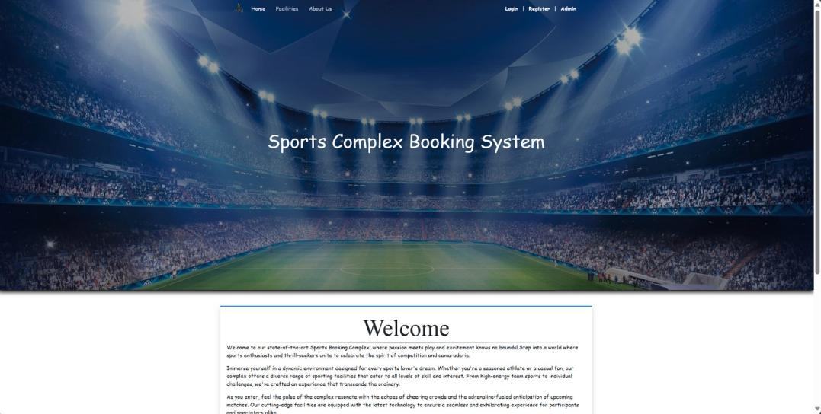

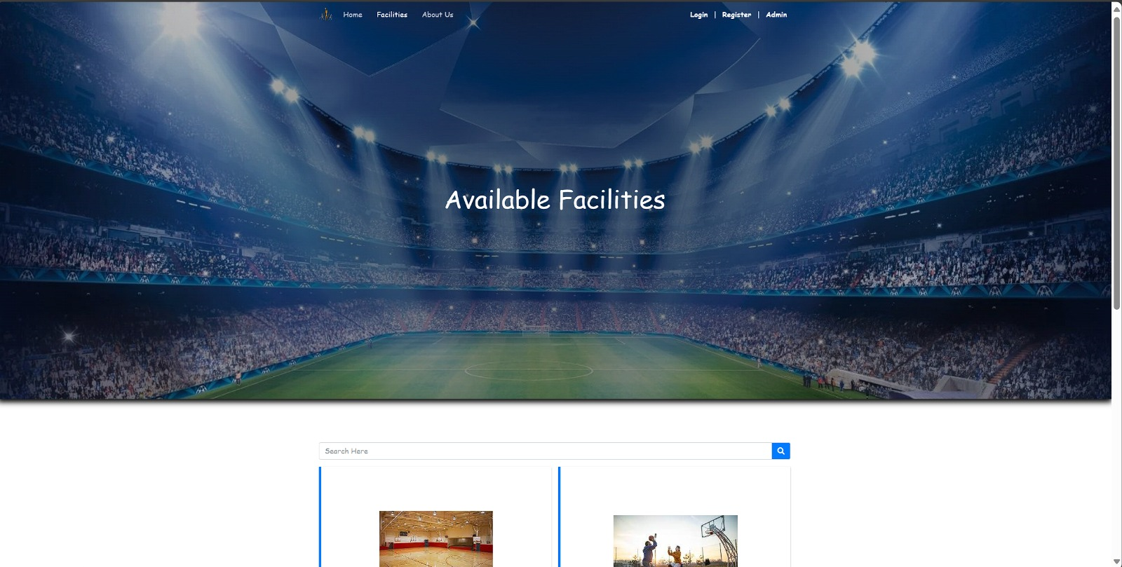

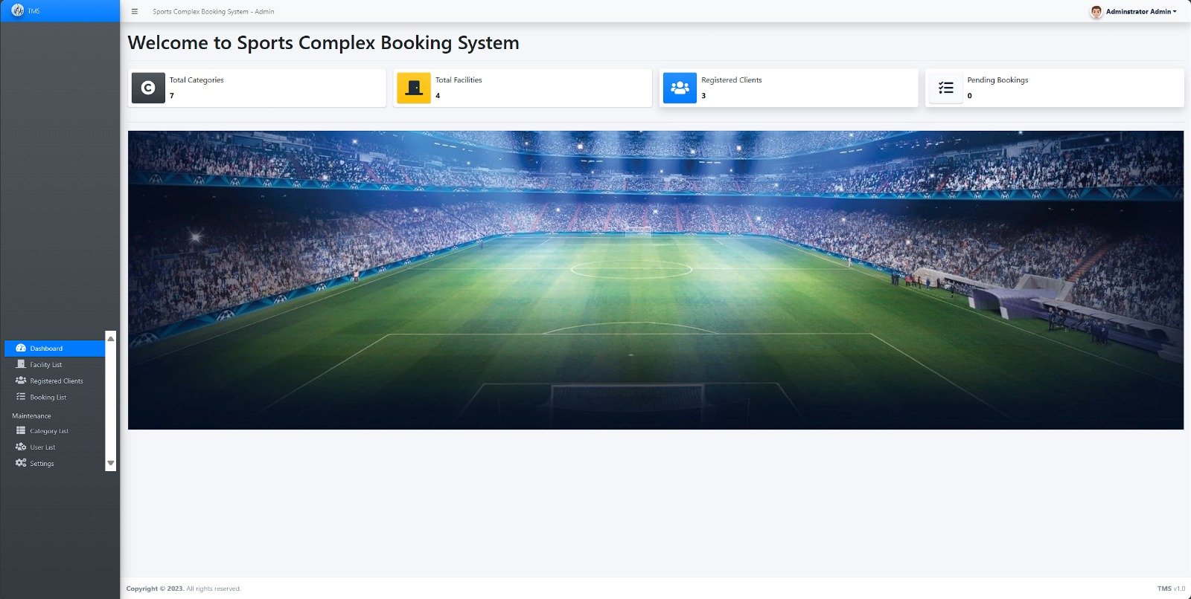

### Client Booking List

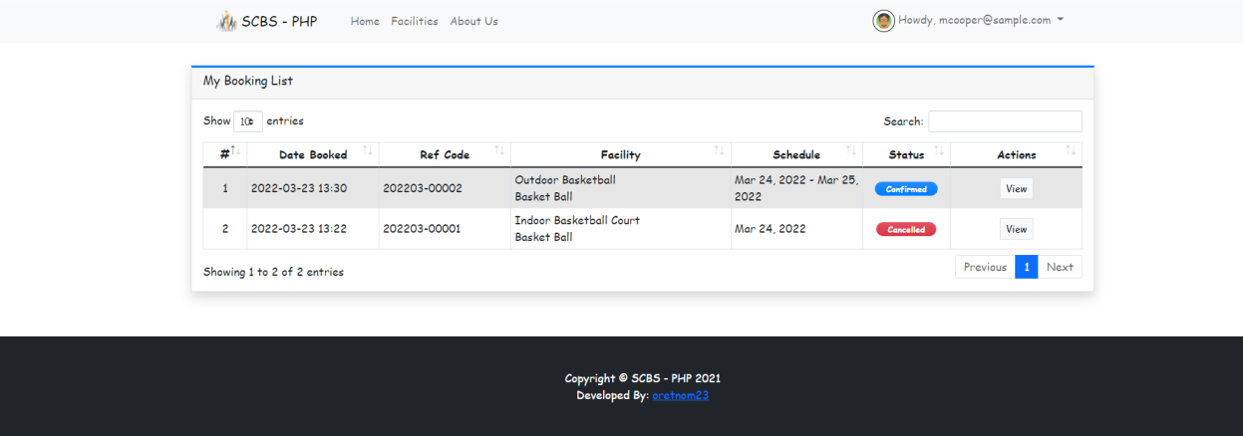

### Booked Facility Details Modal (Client)

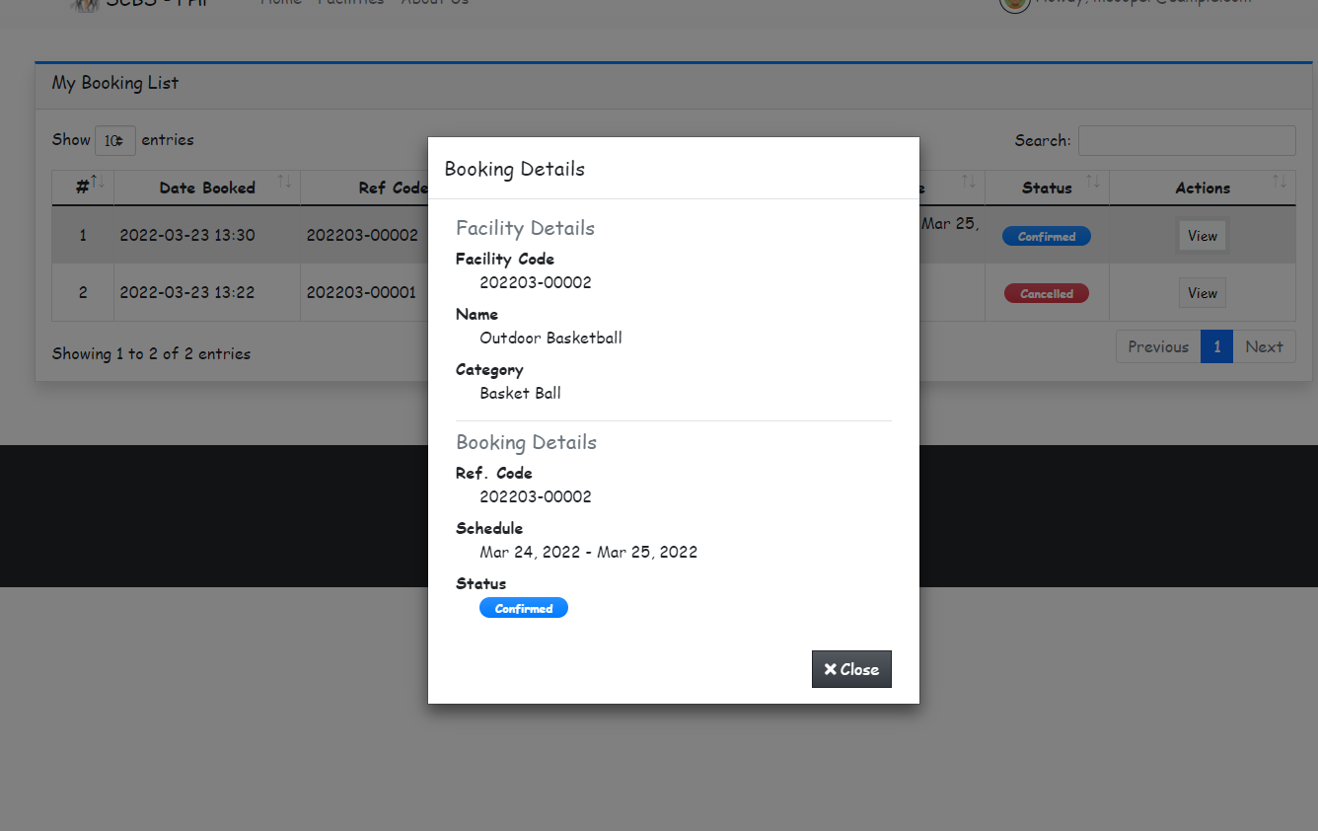

### Admin Panel

