Product Detail Support page
Functional requirements of the Product Detail Support page

Author: Peter Ruiter
Version: 0.8h
Status: Draft
Date: 2009-04-07

History 5
References 5
Acronyms 6
1 General 7
2 Environment 7
2.1 Application Area’s 8
2.2 Text elements 8
2.3 External Parties 9
2.4 Basic concepts 10
2.4.1 Language code conversion 10
2.4.2 Restricted content 11
2.4.3 Document set for a product 11
2.4.3.1 OLEE documents in the documents table 13
2.4.4 Session-ID 13
2.4.5 Releasing documents for public usage 14
2.4.6 Related doctype concept 14
3 Functional Requirements 15
3.1 Style 15
3.2 Startup 15
3.3 Header 15
3.4 Footer 20
3.5 Search 22
3.5.1 Product Search box 22
3.5.2 In-document-Search box 23
3.5.3 Pre-emptive search box 23
3.5.4 Interface with Autonomy for In-document-Search 25
3.6 Navigation 26
3.6.1 Navigation configuration 26
3.6.2 Menu creation 29
3.6.3 Link generation and Target settings for navigation links 31
3.6.4 Rendering the menu’s 34
3.7 Product Header 37
3.8 Content 39
3.8.1 Content header 39
3.8.2 Content Pane 40
3.8.2.1 Select module for content 41
3.8.2.2 Landing page 41
3.8.2.3 Listing 44
3.8.2.4 Download Page 52
3.8.2.5 OLEE 53
3.8.2.6 Contact 53
3.8.2.7 I-frame 55
3.8.2.8 Product image 55
3.8.2.9 Philips Cube 55
3.8.2.10 Related CTN’s 56
3.8.3 Display new window for download with readme file (cpcontent.pl) 56
3.8.4 EULA script 57
3.9 OLEE documents 57
3.9.1 Deployment of OLEE’s 57
3.9.2 Presentation of OLEE 58
3.9.2.1 Templates 58
3.9.2.2 OLEE List 58
3.9.2.3 OLEE view 66
3.10 Feedback script 72
4 Interfaces 72
4.1 Interface nr. 3: Content deployment 73
4.2 Interface nr. 23: MetrixLab integration 73
4.3 Interface nr. 3: Reporting data 73
5 Appendix 74
5.1 Data model 74
5.2 Links to P4C 76
5.2.1 Siebel 76
5.2.1.1 Siebel data 76
5.2.2 Call Centers China, and India 76
6 Reporting 76

Figure 1: P4C Product Support page layout 7
Figure 2: Header and its items 16
Figure 3: Normal Header image 18
Figure 4: SubBrand header image Norelco 18
Figure 5: Servicer Header Image 18
Figure 6: Footer 20
Figure 7: Search boxes on the P4C-Philips page 22
Figure 8: CTN Search box 22
Figure 9: In-doc-search box 23
Figure 10: Pre-emptive search box 23
Figure 11: Search results for pre-emptive search 24
Figure 12: Navigation menus’ position 26
Figure 13: Left navigation menu box 35
Figure 14: Contact menu 35
Figure 15: Register Product box - 1 36
Figure 16: Register Product box - 2 36
Figure 17: Middle navigation box 37
Figure 18: Product Header 37
Figure 19: Product image popup 38
Figure 20: Ticker tape 38
Figure 21: Page content 39
Figure 22: Landing page title 39
Figure 23: Menu link title 40
Figure 24: Download button 40
Figure 25: MP3/4 landing page 43
Figure 26: Content Box 44
Figure 27: Document Type box for AA2 - Public 47
Figure 28: Document Type box for AA2 - Restricted 48
Figure 29: Document Type box for AA5 - Public 49
Figure 30: Document Type box for AA10 - Public 50
Figure 31: Document Type box - Version number 50
Figure 32: Document Type box - Long doctype description 51
Figure 33: Document Type box - Related document type 51
Figure 34: Standard list template for document types in AA11 (sorted on Category) 60
Figure 35: Standard list template for document types in AA11 (sorted on Date) 61
Figure 36: Standard list template for document types in AA11 (sorted on Reference number) 61
Figure 37: Call Center Script template (based on document type CCS) - Colllapsed 62
Figure 38: Call Center Script template (based on document type CCS) - Expanded 62
Figure 39: Appl Area 12 doctype - Standard list template – Topic view 63
Figure 40: Appl Area 12 doctype - Standard list template - Popularity view 64
Figure 41: Appl Area 13 doctype - Standard list template 65
Figure 42: Language pick list template 65
Figure 43: AA11 doctype - Standard view template 68
Figure 44: AA12 doctype - Standard view template 69
Figure 45: Attachment box with no Attachment message 70
Figure 46: Attachment box with attachments 70
Figure 47: Feedback on teh FAQ page 71

History
Date | Version | Description | Author
2008-03-07 | 0.1 | Initial version | Duyet The Vo
2008-09-17 | 0.2 | Rework | Peter Ruiter
2008-09-23 | 0.3 | Additions | Peter Ruiter
2008-09-25 | 0.4 | Additions | Peter Ruiter
2008-09-29 | 0.5 | Additions | Peter Ruiter
2008-10-03 | 0.6 | Additions | Peter Ruiter
2009-01-16 | 0.8b | Additions | Peter Ruiter
2009-01-29 | 0.8c | Additions, added updated version 0.94d of data model | Peter Ruiter
2009-02-09 | 0.8d | Reshuffling of paragraphs  Extending and refining doctypebox | Peter Ruiter
2009-02-18 | 0.8e | Added captions to all the images  Additions to paragraph on Content, Navigation and appendix | Peter Ruiter
2009-02-24 | 0.8g | Additions to doctype boxes, etc. Changed the document set. | Peter Ruiter

References

- More technical information on the implementation van be found in V:\Customer_Service\Application Management\Perl\P4C\System documentation\ p4c_systemoverview-code.doc
- The interfaces document can be found in PCE IO ePlatform Sharepoint at http://pww.emea.sharepoint.philips.com/sites/gs71/Shared%20Documents/Forms/AllItems.aspx?RootFolder=%2fsites%2fgs71%2fShared%20Documents%2fService%20Area%20%2d%20Online%2fProjects%2f2008%5fConsumerCare%5fMigration%5fto%5fATG&FolderCTID=0x012000DC379EDC487EFB4188CA041D61CB4769&View=%7b62EC6D5E%2d9887%2d48F0%2dA6D0%2d8EE4072360E2%7d under the name Total list of interfaces systems Migration P4C-ATG.doc

Acronyms
Acronym | Description
AA | Application Area
CCR | Central Content Repository
CDLS | Contact Data Look up Service (web service in MRS)
CSV | Comma Separated Values
CTN | Commercial Type Number
DB | Data Base
DCT | DoCument Type
DMT | Data Management Toolkit (list of Apex applications used to maintenance and configuration, also for P4C)
doctype | Document type, eg. DFU, TUT, FAQ
EULA | End User License Agreement
FAQ | Frequently Asked Question
HTML | Hyper Text Markup Language (and file extension)
MID | Menu Identification
MRS | Mail Relay System
OLEE | On Line Editing & Entry tool (used for creation/maintenance fo FAQ-type of content.
OLEE doctypes | Document types from AA11, AA12 and AA13
P4C | Philips for Consumers
SCD | Symptom Cure Document doctype (is an OLEE)
scy | selected country
slg | selected language
sympcure | Symptom Cure (SCD)
TXT | Text file extension
URL | Uniform Resource Locator

ToDo:
- Reporting requirements (e.g. the FAQ + Feedback)
- Describe the Public/Restricted mechanism and details
  - the link with get-script (restricted)
  - the link with the symbolic link (public)
- Describe the text for the link in the content pane
- Template on Brand
- Synchronize deployment also with search indexing
- Describe algorithm around showing language version of document
- URL interface (also with searchtxt), used in documents and software
- Eula script and EULA data and OFN for restricted files
- General settings configuration
- Functionality to deliver data for Autonomy (docroot/autonomy and feed_autoniomy in cgi-bin)
- Describe the Mail de-activate function (show alert on clicking Send eMail)
- OLEE, take ENG if AEN not available

Other applications
- Get-script
- Product selection P4S
- P4C-SMS
- Web-Configurator (DMT)

Requirement template
☞ | <RD-P4C-XYZ-####>  </ RD-P4C- XYZ-####>

General
The P4C Product Support page has the following layout:

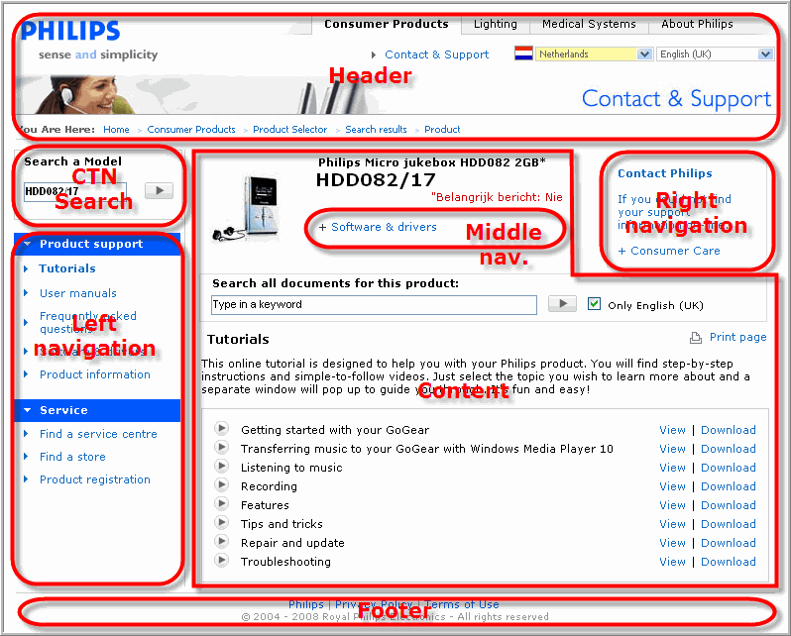
Figure 1: P4C Product Support page layout
The layout of the page is defined in the templates. The navigation is defined in the navigation configuration. Links will show based on the available content for a selected product and based on the selected country (for country related content).
The DB files and configuration files are described in another document (DB and Configuration files.doc).

Environment
The program to generate the Product Support pages
This program is to display product information, and part of this information is a set of documents that are available as files on the web servers file system. These documents are uploaded to the CCR by the business and deployed to the data center, Each document has a 3-letter document type code which is used to identify the document. These document types are grouped in Application Area’s that defines the meta data that is available for the document. The program to deliver the Product Support page is build on top of this.

Application Area’s
We have documents for the following Application Area’s (AA) in the CCR that are published to P4C:
- AA2 - product related, 3-letter language code
e.g. manual or Leaflet (public)
or Service Manual (restricted)
- AA5 - product related, 2-letter country code
e.g. Warranty Booklet (public)
(we currently have no restricted document type for this AA)
- AA10 - product related (no further meta data)
e.g Product Images
- AA11 - product related, OLEE, restricted
e.g. Symptom Cures
- AA12 - product related, OLEE, public
e.g. FAQ’s
- AA13 - product related, OLEE, Flash or Flash-Video, public
e.g. Tutorials

We want to have non product related documents available on P4C from the following Application Area’s:
- AA8 - Tree related, no country, no language
- AA9 - Tree related, language related (3-letter language code)

The missing number in the Application Area’s are not in use at the moment because they are either sleeping, or the type of content has disappeared. The last category can be re-used in the future.

The following Application Area’s are sleeping:
- AA1 - Product related, 2-letter country code and 3-letter language code

Furthermore there is a need expressed for Tree related content that has a country. For this Application Area 7 can be reused in the future.

Text elements
All text elements in the Product support pages are accessed by their respective label. The text for a label is generated in English (usually British English). For each label a translation must be created for all languages the web site is available for.
There are a number of different labels:
- CCR elements (maintained in the CCR or the CMC)
  - Support categorization elements (CCR receives them from Pikachu) (these descriptions are currently used in the old product selector)
  - Product descriptions (CCR receives them from Pikachu)
  - Document type descriptions
    - Short description (CCR)
    - Long description (CCR)
  - Country descriptions (CCR)
  - Language descriptions (CCR)
- Text elements (CCR)
The labels are replaced with the text in the selected language.

External Parties
A number of non-Philips parties are delivering functionality that is incorporated in the Product support site.
These parties are:
- Metrixlab > NPS surveys
Metrixlab delivered some JavaScript that makes parameters on language and country and categorization available to them to decide when to offer a survey.
- Omniture > Reporting
For Omniture a set of meta-tags in the HTML-Head must be created for proper reporting, and some JavaScript is incorporated. (see also requirement RD-P4C-HEADER-0080)
- Creative virtual > Autochat (pilot)
A link is created in the navigation configuration, and a special box is created (See navigation configuration look&feel). Some JavaScript must be added to the head of the page.
- eStara > Live chat (pilot)
A placeholder is created and some JavaScript is incorporated to let it function.

- Live.com > Live chat
A link is created in the navigation configuration, and a special box is created (See navigation configuration look&feel). Besides the link in the box an extra piece of HTML (JavaScript, references) is to added at the bottom of the page.

Basic concepts
Before starting to define functional specifications the reader should be aware of a few basic concepts.

Language code conversion
Within the CCR and in P4C the language is coded in 3-letters since a 2-letter code is not sufficient. Portuguese in Portugal is a different language then Portuguese spoken in Brazil, but both have the 2-letter code ‘pt’. The same goes for Engish.
The Product Support site can be called to with a 2-letter language code. Together with te country code the correct 3-letter language code will be retrieved and used in subsequent requests.
When a country code is missing only the 2-letter language code is used to searchfor the corresponding 3-letter language code. The first 3-letter code found will be used.
If the language is not defined or a corresponding 3-letter language code cannot be found the language is set to British English (ENG)

☞ | <RD_P4C_BASICCONCEPTS_0010  section=”BasicConcepts”  title=”Language Code setting”  >  If the Product Support or selector page is called the language parameter must be tested and or processed according the following rules  Y  Y  Y  Y  Get value of parameter SLG  empty?  Found matches?  Use value ‘ENG’  3-letter code?  Valid code?  Use original value  Use first match  Combine with value for SCY  Search for match  </RD_P4C_BASICCONCEPTS_0010>

☞ | <RD-P4C-BASICCONCEPTS-0020 section=”BasicConcepts”  title=”Language Labels”  >  All text on the page will be in the selected language. If there is no translation available for an item, this will be printed in the default language: English (UK).  </RD-P4C-BASICCONCEPTS-0020>

Restricted content
Retrieve secure cookie(s) and determine type of user based on (list of) cookie(s), extend list of doctypes for (all) secure cookie(s).
Based on the type of user some different sub templates are used, and for some usertypes ( ‘servicer’) an extra menu is added (Service Menu), also when no info is available for this menu (saying: No documentation available).
User types and cookies are configured (and maintained) in the CCR.

☞ | <RD_P4S_USERTYPE_0100 section=”BasicConcepts”  title=”Language Labels”  >  Defining the user type is an algorithm:  - If one of the secure cookies is of type ‘servicer’ then the usertype is ‘servicer’.  - If one of the secure cookies is of type ‘callcenter’, and there is no cookie with user type ‘servicer’, then the usertype is ‘callcenter’  - In all other situations the usertype is same as the cookie defines.  </RD_P4S_USERTYPE_0100>

Document set for a product
The product support page is created based on the available content. This is in fact the document set for the product (in this case the term ‘document’ includes the files and the OLEE’s). Next to the public documentation there is also the restricted documentation. When the user has a cookie for restricted documentation also the restricted documents for the product are retrieved and the found document records are filtered for the document types that are configured for the cookie. In this way a complete document set is created before the page creation is started.

In the new design the restricted documents for web users need to be shown also when the user does not have the secure cookie and is not running HTTPS. This can be accomplished by not only retrieving the public documents for a product, but also the restricted documents, and filter this list of restricted documents with all the doctypes configured for the cookies of type ‘webuser’. The found documents are added to the document set. When the document type box is created the logic must check if the doctype is a restricted doctype and if yes check if the user is authorized (has the secure cookie with this document type) and create the links accordingly (if authorized use the sget-link to the document, if not show the message and link to Club Philips login, together with the sget link so the user can download as soon as he/she is successfully logged in.

The document set for a product is a list of public and restricted documents available for the product. This list is created out of all documents that are available for a product based on a set of rules.

☞ | <RD_P4C_BASICCONCEPTS_0020  section=”BasicConcepts”  title=”documentSet”  >  The set of documents available for a product is created by using the following rules:  - Get a list of all public and restricted documents for the CTN,  - If a second CTN (ctn2) is available in the query list and the user-type is ‘servicer’, then also get all public and restricted documents for CTN2,  - Create a cookie-doctypelist of unique doctypes for all cookies with type ‘webuser’, (the webuser-doctypes, from all web-user cookies in the cookie configuration list),  - Create a list of unique list document types from the secure cookies a user has in his browser (secure-doctypes list),  - Combine the webuser- and the secure-doctypes list and remove doubles (creating the allowed-doctypes list)  - Filter all restricted documents with the allowed-doctypes list (all documents with a doctype in the allowed-doctypes list will pass into the document set),  - Filter the resulting document set:  - Filter all documents with doctype in AA5 on the selected country (documents will pass into the document set when the selected country code (scy) occurs in the list of country codes for that document),  - For all documents with an OLEE doctype, check if a country is set for the document:  - If there is no country set, then the document will pass into the final document set  - If a country is set (can only be one) the document will only pass into the final document set if the country is the same as the selected country (scy).  The result of this flow is a final document set with all documents that are available for the support page (public and restricted). This final document set is then used when generating the navigation and, if necessary, building the content pane.  </RD_P4C_BASICCONCEPTS_0020>

☞ | <RD-P4C-BASICCONCEPTS-0030  section=”BasicConcepts”  title=”documentSubSet”  >  A Document-Subset can be created from the Document-Set (as described in RD-P4C-BASICCONCEPTS-0020).  A Document Subset is created when the content pane must show documents for a menu link. With this Document-Subset the content pane HTML can be created.  This is a separation of concerns. The logic to decide what documents need to be shown (and go in the Document-Subset) is separated from the presentation.  </RD-P4C-BASICCONCEPTS-0030>

OLEE documents in the documents table
The document-prods table basically only holds file based documents. When a product has OLEE’s for a certain document type one record is available in the document-prods table for the OLEE-doctype to indicate the availability of the OLEE’s (and the hyperlink in this record will create the list of OLEE’s for this document type). In this way only the document-prods table has to be queried for the document set.

Session-ID
For the FAQ-reporting a session-ID is necessary. This session-ID should be preserved when the user clicks around on the product support page and must be used for the FAQ-list and for the individual FAQ’s.
The session-ID is parameter ‘session’ in the URL, where is is retrieved for reporting.

☞ | <RD_P4C_Session_0000 section=”Startup”  title=”SessionID”  Subtitle=”Set”  >  If  - parameter session is present  and  - the value has format:  {[0-9]}14_{[0-9]}3\.{[0-9]}3\.{[0-9]}3\.{[0-9]}3  (yyyymmddhhmmss_IP-address)  Then  - pass it on.  Else  - create a sessionID (see RD_P4C_Session_0010 RD_P4C_Session_0010for the format), and pass that on  </RD_P4C_Session_0000>

☞ | <RD_P4C_Session_0010 section=”Stratup”  title=”SessionID”  Subtitle=”Format”  >  A session ID format is:  - [yyyymmddhhmmss]_[user-ip-address]  Example of session-ID is:  - 20090217152213_166.49.210.110  </RD_P4C_Session_0010>

Releasing documents for public usage
The content on the P4C server is maintained in one directory, which is the same as on the CCR. The P4C server is a mirror of the CCR and therefore contains the same content data as the CCR. New content data is uploaded to the CCR and with each deploy all this new data is spooled to the P4C server disks. The directory (mprdata) where the content resides is a directory under the document root of www.p4c.philips.com, but this directory is only available under the web server for Philips IP-address ranges (access list is maintained in an .htaccess file in the main content directory). To make files publicly accessible a symbolic link is created in a directory that is publically available. This process to create these symbolic links is part of the deployment process.
To be continued…

Related doctype concept
The related doctype concept is mostly used to show a readme file together with a software asset. For an example see the Firmware Upgrade Software for the HDD070/00.
If a doctype is a related doctype is not a property of the doctype itself, but is a setting in the web navigation configuration.

The links for the Product Support page are configured in the Web-Navigation application (APEX application on Oracle, the data is in the CCR-Schema). When a link is configured one or more document types are attached to the link and when the product page is created the application will check if there are documents present for one of the document types for this link, and when at least one document is found the link will be created.
When the content for the Product Support page is created for this link the documents are retrieved for all the document types that are configured for this link and per doctype a doctype box is created. The documents for a doctype are listed in the box and each document will have a link with the URL to the document.
When a related doctype is configured for this doctype for this link (and a document for this related document ype is available), then the link for the document will not be the URL of the document. Next step is to show a new page with the document for the original document type as a download (button) and to show the contents of the document for the related document type below the Download button. See requirement RD-P4C-CONTENT-LISTING-0170.

Functional Requirements

Style
General page style like background color, text color, font, font size, link color, etc.

☞ | <RD-P4C-STYLE-0010  section=””  title=””  >  In general the Philips Support styles will apply to P4C site.  </ RD-P4C-STYLE-0010>

☞ | <RD-P4C-STYLE-0020  section=””  title=””  >  Requirement description goes here …  Some textual explaination or image about the requirement if needed …  </ RD-P4C-STYLE-0020>

Startup
When a product support page is requested the following steps are taken before starting to build the page:
- Check if the country code is a valid code and the country is in the list of supported countries (if not, the country code is emptied and the site will be displayed in a Global Context – country list will say ‘Any country’).
- Check if the language is a valid 3-letter language code, if not set it (see RD_P4C_BASICCONCEPTS_0010 for language code setting)
- Check if the CTN in the query string is a valid CTN code (exact match, case insensitive, and get product data), if not redirect to product selector.
- Check for redirection to Magnavox (US) and redirect to correct domain.
- Get cookie and determine user-type (see RD_P4S_USERTYPE_0100)
- Get the document set for the product (see RD_P4C_BASICCONCEPTS_0020)
- If a session-ID exists, use that, if not generate one (see RD_P4C_Session_0010).
- Generate the page items
- Send page to user.

Header
The page header consists of the following items:

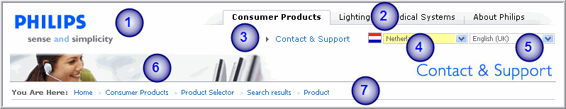
Figure 2: Header and its items

- Philips logo
- Navigation links to other Product Divisions
- A link to Philips Global Support site
- Dropdown box for countries
- Dropdown box for languages
- Header image
- Breadcrumb

☞ | <RD-P4C-HEADER-0010  section=”Header”  title=”Philips Logo”  >  The Philips logo should be taken from the Philips Global Support Site. It should be linked to www.philips.com  </ RD-P4C-HEADER-0010>

☞ | <RD-P4C-HEADER-0020  section=”Header”  title=”Links to other sectors”  >  The navigation links to other Product Division should be linked to:  These Tabs should not be visible for the servicers.  Note:  - At the Global Support site a dropdown menu will be shown. This is not available on P4C Product Support Page.  </ RD-P4C-HEADER-0020>
  - Consumer Product | www.consumer.philips.com
  - Lighting | www.lighting.philips.com
  - Medical Systems | www.medical.philips.com
  - About Philips | www. Philips.com/about

☞ | <RD-P4C-HEADER-0030  section=”header”  title=”Contact&Support link”  >  The ‘Contact & Support’ label should be linked to www.support.philips.com  First a test is done to check if the user has a locale cookie, and if yes this locale is used to target sms-support page. If not the country and language code from P4C are used.  This ‘Contact & Support’ should not be visible for the servicers.  </ RD-P4C-HEADER-0030>

☞ | <RD-P4C-HEADER-0040  section=”header”  title=”Create Country selection box”  >  The country dropdown box shows a list of countries. The list of countries is filtered with the country codes in the configuration file‘mail.conf’ (containing a list of country codes for supported countries). At the beginning of the list an entry is added for ‘Any country’, which is the default value. The selected country is set according to the value is parameter ‘scy’.  When the value is parameter ‘scy’ is not in the filtered list of countries the selected country is ‘Any country’ (effectively no option is set to ‘selected’ and the browser will show the top entry, which is (must be) ‘Any country’).  A flag for the selected country will be shown left of the country selection box  Notes:  - The country is present in the URL with the parameter ‘scy’. The value is a 2-letter country code (ISO 3166).  - When ‘Any country’ is used, ‘scy’ is empty and can be omitted from the URL.  </ RD-P4C-HEADER-0040>

☞ | <RD-P4C-HEADER-0041  section=”header”  title=”Selecting a Country”  >  When a country is selected in the country selection box that is different then the current country, the page will be reloaded with the selected country. There is no special button to confirm the change.  </ RD-P4C-HEADER-0041>

☞ | <RD-P4C-HEADER-0050  section=”header”  title=”Create Language selection box”  >  The language dropdown box shows a list of languages. The list of languages is filtered with the language codes in the configuration file‘lang_live_eda.conf’ (containing a list of 3-letter language codes supported on the product support page).  Notes:  - The language is present in the URL with the following parameter:  slg=<3-letter-code language code> (ISO 639-2 with some exceptions)  - There is no relation between selected country and selected language.  </ RD-P4C-HEADER-0050>

☞ | <RD-P4C-HEADER-0060  section=”header”  title=”Header Image”  >  The header image (Contact & Support) should be shown with the text in the selected language. The text is part of the image.  In case of no image available for a selected language the default English image will be shown.  Figure 3: Normal Header image  The following exceptions apply to the header image:  Sub-brand: depending on the sub-brand a different image can be shown. The sub-brands and its images are defined in the configuration file ‘subbrand_img.conf’. If the product sub-brand occurs in the sub-brand configuration file the corresponding image will be used.  Figure 4: SubBrand header image Norelco  For a servicer there is only one image for all language (no sub-brands):  Figure 5: Servicer Header Image  </ RD-P4C-HEADER-0060>

☞ | <RD-P4C-HEADER-0070  section=”header”  title=”Breadcrumb trail”  >  The breadcrumb is used to give users a way to keep track of their location within the P4C site.  The following will be shown if user access the P4C Product Support page via the search result from the Product Selector:  The following will be shown if user access the P4C Product Support page directly, eg. via SMS page.  Note: If a locale is detected the link to the Contact&Support will be index_{locale}.html.  The following will be shown if user is a servicer:  </ RD-P4C-HEADER-0070>
  Home | www.philips.com
  Consumer Products | www.consumer.philips.com/consumer/catalog /catalog_selector.jsp
  Product Selector | www.p4c.philips.com/cgi-bin/dcbint/ cpproduct_selector.pl?...
  Search results | www.p4c.philips.com/cgi-bin/dcbint/ cpproduct_selector.pl?...
  Product | www.p4c.philips.com/cgi-bin/dcbint/ cpindex.pl?ctn=…
  Home | www.philips.com
  Consumer Products | www.consumer.philips.com/consumer/catalog /catalog_selector.jsp
  Contact & Support | www.support.philips.com/support/html/ index_global.html
  Product | www.p4c.philips.com/cgi-bin/dcbint/ cpindex.pl?ctn=…
  Product Selector | www.p4c.philips.com/cgi-bin/dcbint/ cpproduct_selector.pl?...
  Search results | www.p4c.philips.com/cgi-bin/dcbint/ cpproduct_selector.pl?...
  Product | www.p4c.philips.com/cgi-bin/dcbint/ cpindex.pl?ctn=…

☞ | <RD-P4C-HEADER-0080  section=”header”  title=”Tags”  subtitle=”Omniture”  >  Within the <header> tag, the Omniture metrics should be defined using the <meta> tag as following:  Values for the PAGENAME parameter. When the parameter is enclosed in square brackets the value is to be replaced by the value of the URL-paramater with that name. The value is literal when quoted:  All values should be in lower case except the division parameter value.  These Meta tags are used by a JavaScript called just before the </body> tag: check requirement RD-P4C-FOOTER-0020.  </ RD-P4C-HEADER-0080>
  name | Content
  DIVISION | SP
  SECTION | p4c
  PAGENAME | see table below
  HIERARCHY | CTN, ie. hdd082/17 or empty if unknown
  COUNTRY | 2-letter-code country or global for ‘Any country’, or empty if no country
  LANGUAGE | 2-letter-code language
  scriptname | Content
  cpproduct_selector.pl | Productselector
  cpindex.pl  cpcontent.pl | Is a concatenation of the following items separated with a colon-sign (“:”), or empty if not specified.  - ‘support’  - [MID]  - [DCT]  - [SLG]  Examples:  - content="support:link_software:fus:aen"  - content="support:link_FAQs"
  sclist.pl  tutlist.pl  faqlist.pl  scview.pl  tutview.pl  faqview.pl | Is a concatenation of the following items separated with a colon-sign (“:”), or empty if not specified.  - ‘sc’, ‘tut’, or ‘faq’  - ‘list’ or ‘view’  - [DCT]  - [SLG]  - [refdisplay] (only applicable for *view.pl)  Examples:  - content="faq:list:faq:aen"  - content="faq:view:qac:aen:0002699"
  eula.pl | Is a concatenation of the following items separated with a colon-sign (“:”), or empty if not specified.  - ‘support’  - ‘eula’  - [DCT]  - [SLG]  Examples:  - content="support:eula:fus:nld"
  feedback.pl | Is a concatenation of the following items separated with a colon-sign (“:”), or empty if not specified.  - ‘faq’  - ‘feedback’  - [DCT]  - [SLG]  - [refdisplay]  - value of selected radio button.  Examples:  - content="faq:feedback:qac:eng:pi_c48_phoenix_arizona_044:needtotry"

Footer
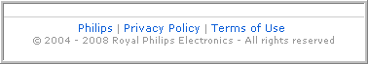
Figure 6: Footer

☞ | <RD-P4C-FOOTER-0005  section=”footer”  title=”Definition”  >  The footer will end the page and close the HTML. The footer will hold some links common to all Philips pages and also JavaScript that is necessary for certain functionalities on the Product Support pages.  </ RD-P4C-FOOTER-0005>

☞ | <RD-P4C-FOOTER-0010  section=”footer”  title=”links”  >  The footer contains links to some general pages about Philips, the Privacy Policy of Philips and the Terms of Use.  The links should pointed to the following locations:  Remark: Based on a locale the link should be pointing to version for the proper language for that locale.  </ RD-P4C-FOOTER-0010>
  Philips | www.philips.com/siteowner
  Privacy Policy | www.philips.com/privacypolicy
  Terms of Use | www.philips.com/terms

☞ | <RD-P4C-FOOTER-0020  section=”footer”  title=”JavaScript”  subtitle=”Omniture”  >  For Omniture metrics a javascript must be in the HTML just before the </body> tag:  <script type="text/javascript" src="http://www.crsc.philips.com/crsc/scripts/s_code_philipsglobal.js"></script>  See also Header section for the required meta-data tags.  </ RD-P4C-FOOTER-0020>

☞ | <RD-P4C-FOOTER-0020  section=”footer”  title=”JavaScript”  subtitle=”e-Stara”  >  </ RD-P4C-FOOTER-0020>

☞ | <RD-P4C-FOOTER-0020  section=”footer”  title=”JavaScript”  subtitle=”Live.com”  >  </ RD-P4C-FOOTER-0020>

Search
There are 2 search boxes on the P4C page:
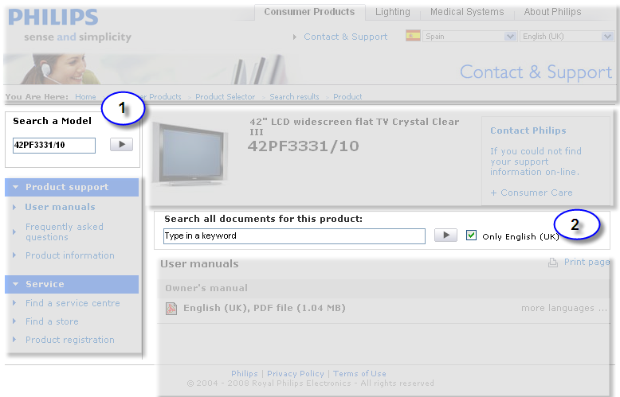
Figure 7: Search boxes on the P4C-Philips page

Product Search box
The product search box will not return in the newdesign, but the specification is here to have a reference to what is available in the P4C/P4C implementation.

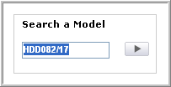
Figure 8: CTN Search box

☞ | <RD-P4C-SEARCH-0010>  Figure 8: CTN Search box  The CTN Search box will provide a means to search for a product. The search string can be one of the following and is case insensitive:  - a CTN: e.g. HDD082/17  - a textual string: e.g. TV  The result can be:  - one product: the P4C support page will show all data of the found product  - no product found: the P4C product selector page will use the search string and show the results of the search.  </ RD-P4C-SEARCH-0010>

☞ | <RD-P4C-SEARCH-0020>  When page is loaded, the CTN is put in the CTN search box. It is selected and has the focus.  </ RD-P4C- SEARCH-0020>

In-document-Search box
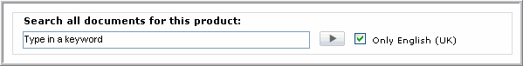
Figure 9: In-doc-search box

☞ | <RD-P4C-SEARCH-0020>  Figure 9: In-doc-search box.  The in-document-search box will provide users a means to search for a phrase within the available documentation for the selected product.  A search can be done in all documents for the selected language or in all available languages (Check box is always checked at page load and does not reflect the users choice).  The maximal string length is 100 characters.  Note:  - Autonomy search is called for this search functionality. An interface to Autonomy search implemented. Data is send and received in XML-format.  </RD-P4C-SEARCH-0020>

Pre-emptive search box
The pre-emptive search box will not return in the new design. In the P4C/P4C implementation this option is de-activated, but the functionality is still in the code.

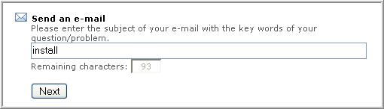
Figure 10: Pre-emptive search box

☞ | <RD-P4C-SEARCH-0030>  Figure 10: Pre-emptive search box  When selecting the e-mail form a search box will appear, inviting the user to formulate the subject of the mail. This pre-emptive search box will force users to do a search for a phrase with in the available documents for the given product in the selected language (no option available to search in all languages).  The maximal string length is 100 characters.  When clicking the Next-button the search will be done.  </RD-P4C-SEARCH-0030>
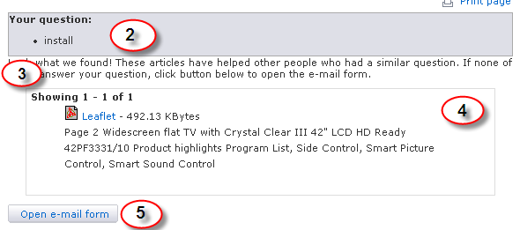
Figure 11: Search results for pre-emptive search

☞ | <RD-P4C-SEARCH-0040 section=”Search”  title=”ResultsPreEmptiveSearch”  >  - A section ‘Your question’ is created which returns the users question.  - An explanation is added to help the user understand what is happening  - If results are found here the results are listed  - A button is created to open the e-mail form  </RD-P4C-SEARCH-0040>

☞ | <RD-P4C-SEARCH-0045 section=”Search”  title=”Results”  title=”NoResults”  >  </RD-P4C-SEARCH-0045>

☞ | <RD-P4C-SEARCH-0050 section=”Search”  title=”Results”  title=”List”  >  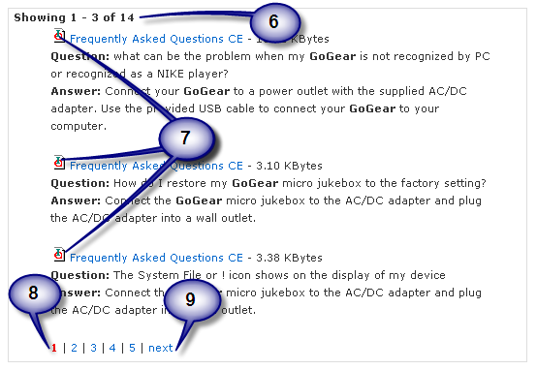Error: Reference source not found: Search results with pagination  When the search results for the pre-emptive search are more then 3 a pagination mechanism is used to present all search results in several pages. The first results are listed and pagination line is added.  - Show the number if hits and the series of hits that are shown  - Format the hits according to requirement <RD-P4C-SEARCH-0060>  - add a pagination line with the page numbers highlighted in red for the current page (no hyperlink) and the other pages in blue and hyperlinked to the proper set of hits.  - If the first page is on display a option ‘next’ is added to the end of the line. For detailed requirement of the pagination line please refer to requirement <RD-P4C-SEARCH-0070>  </RD-P4C-SEARCH-0050>

Interface with Autonomy for In-document-Search
The interface with Autonomy to deliver the In-Document-Search is twofold. One is the interface to request data for a search and format the results to show them to the end-user.
The other is the interface to deliver Autonomy the data to index for this search.

☞ | <RD-P4C-SEARCH-0060 section=”Search”  title=”Request”  subtitle=”definition”  >  ToDo: Describe search Request  </ RD-P4C-STYLE-0060>

☞ | <RD-P4C-SEARCH-0070 section=”Search”  title=”Respons”  subtitle=”definition”  >  ToDo: Describe search Response  </ RD-P4C-STYLE-0070>

☞ | <RD-P4C-SEARCH-0080 section=”Search”  title=”Response”  subtitle=”Formatting”  >  ToDo: Format of search result hits.  </ RD-P4C-STYLE-0080>

☞ | <RD-P4C-SEARCH-0090 section=”Search”  title=”Results”  subtitle=”Pagination”  >  ToDo: Requirements for the pagination line.  </ RD-P4C-STYLE-0090>

Navigation
The navigation links on the Product support page are highly dynamic and are configured in the DMT.
The navigation menu’s can be positioned in different slots on the P4C template.
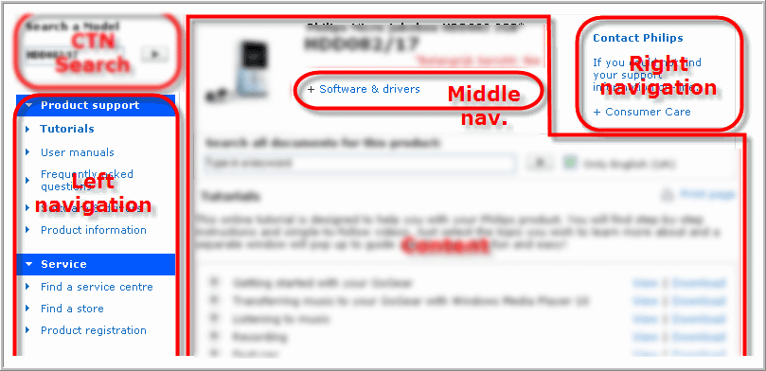
Figure 12: Navigation menus’ position

Navigation configuration
The configuration has a list of elements that can be changed through the Web Configurator in the DMT.

☞ | <RD-P4C-NAV-0010 section=”Navigation”  title=”Configuration”  subtitle=”recordFields”  >  The navigation menus are created according the definitions in navigation_p4c.conf file.  This configuration defines:  - Position of the menu (left, middle or right),  - The name of the menu (label),  - the order of the menus,  - the name of the links in the menu (label),  - the order of the links in the menu,  - A (list of) document type code(s) related to a link  - A second document type code related to one other document type for this link  - The parameter for the meta data element to target a single document for the document type.  - A link-target for the menu-link/document type combination (is overruled if it is in-page and the document is not TXT or HTM(L) format).  - Display option (defines if link must be displayed when no date is available; link will not contain a hyperlink)  Exception in usage. See RD-P4C-NAV-0021.  - External link (link to other web site)  - Link mapping (rewrite parameter names and convert 3-letter language code to 2-letter language code)  - List of inclusive or exclusive country codes  - List of inclusive or exclusive category codes  - I-frame indicator and height  - List of inclusive or exclusive brand codes  </ RD-P4C-NAV-0010>

☞ | <RD-P4C-NAV-0015 section=”Navigation”  title=”Link”  title=”Definition”  >  A link is defined by:  - A menu that holds the link.  - A link label (defines the string that will be displayed).  - A relation to one or more document types to the link.  - A definition of an external URL for the link and the link mapping for this link.  - A definition of the target  - Setting the display option  - Setting of the I-Frame option  - Setting the filters on:  - Country  - Category  - Brand  Both doctype(s) and external link:  In this case a document found for (one of) the document type(s) has precedence over the external link (see RD-P4C-NAV-0130).  </ RD-P4C-NAV-0015>

☞ | <RD-P4C-NAV-0020 section=”Navigation”  title=”Link”  subtitle=”DoctypeDefinition”  >  When a document type is defined for a link there are some extra options that must/can be defined:  - Related document type  A related document is another document type that is related to the document type for this link. Typically used for readme files fo software packages.  - Link Target  For each document type a link-target can be set. This link target will decide if the document is shown in the same browser or in a new browser (name or unnamed). Be aware that this link-target van be overruled by setting the target in the general settings configuration file for this document type.  - Document ID  Setting the Document ID means you are trying to target one instance of the document. The document ID can be set for a language or country related document  Constraints for configuring document type for a link:  - If one doctype is configured for a link this doctype can be in any Application Area  - If more than one doctype is defined for a link these document types can only be in Application Area’s 2 (language) and 5 (country).  This last constraint is not by choice, but we ended up in this state. When redoing the code it is better to create code where the doctypes can have mixed Appl. Area’s.  </ RD-P4C-NAV-0020>

☞ | <RD-P4C-NAV-0025 section=”Navigation”  title=”ExternalLink”  >  </ RD-P4C-NAV-0025>

☞ | <RD-P4C-NAV-0030 section=”Navigation”  title=”TargetDefinition”  >  </ RD-P4C-NAV-0030>

☞ | <RD-P4C-NAV-0035 section=”Navigation”  title=”DisplayOption”  >  Display option 0:  The link will only show when there is data available for the link, or an external link is defined.  Display option 1:  Show link always, also when there is no content. If there is no content (and no external link) the link label will show without a hyperlink (just as text)  Display option 2:  The link will use DB-file ‘product_chassis.txt’ to check if the specified CTN is present in the table. Based on the column where the CTN is found the script knows if the CTN is a Product or a Chassis.  Display option 3:  The link will use DB-file ‘product_refurbished.txt’ to check if the specified CTN is present in this table in the column for refurbished products. When the CTN occurs in this column the link is displayed.  </ RD-P4C-NAV-0035>

☞ | <RD-P4C-NAV-0040 section=”Navigation”  title=”I-FrameSetting”  >  </ RD-P4C-NAV-0040>

☞ | <RD-P4C-NAV-0045 section=”Navigation”  title=”CountryList”  >  </ RD-P4C-NAV-0045>

☞ | <RD-P4C-NAV-0050 section=”Navigation”  title=”BrandList”  >  </ RD-P4C-NAV-0050>

☞ | <RD-P4C-NAV-0055 section=”Navigation”  title=”CategoryList”  >  </ RD-P4C-NAV-0055>

Menu creation
The menu’s and its items are defined in the navigation configuration file (navigation_p4c.conf). A detailed description about each field can be found in the “p4c-systemoverview_framed.doc”.

☞ | <RD-P4C-NAV-0110 section=”Navigation”  title=”LinkFiltering”  >  Links are subject to the following filters:  - The Link can be configured for one or more countries, and a switch can be set to display the link in this set of countries, or to be displayed in all countries outside this set.  - The link can be configured for one or more categories, and a switch can be set to display the link in this set of categories, or to be displayed in all countries outside this set.  - The link can be configured for one or more brands, and the switch can be set to display the link for this (these) brand(s), or to be displayed in all brands outside this (these) brand(s).  </ RD-P4C-NAV-0110>

☞ | <RD-P4C-NAV-0130 section=”Navigation”  title=”linkDisplayRule”  >  A link is only created in the following situations:  - A link has one or more document types defined  and  for the product at least one document is available for one of these document types in the document set (document set is defined in ???).  Or  - A link has an external link (link to another web site) defined.  Or  - The link is a special link  </RD-P4C-NAV-0130>

☞ | <RD-P4C-NAV-0120 section=”Navigation”  title=”MenuDisplayRules”  >  The following rules are applied:  - A defined menu is only created when links in the menu have to be displayed (in other words; if there is any data for the menu items).  - Exceptions:  - The main menu is always displayed. When no information is available the menu is displayed with the message ‘No documentation available’.  - When a user is of type ‘servicer’ an extra Service-menu is created. When no information for this menu is available the menu is displayed with the message ‘No documentation available’.  - the country menu is suppressed when:  - the user has not selected a country  - The user is of type ‘servicer’.  - All other menus are always and only displayed when at least one link is present. See RD-P4C-NAV-0110 and RD-P4C-NAV-0130 for rules when links are filtered and when links are displayed.  </ RD-P4C-NAV-0120>

☞ | <RD-P4C-NAV-0140 section=”Navigation”  title=”Position”  >  The menu must be generated for the slot that is related to the value of column position.  </ RD-P4C-NAV-0140>

☞ | <RD-P4C-NAV-0150 section=”Navigation”  title=”Highlighting”  >  When a link is defined a highlighting can be set to any other available link.  </ RD-P4C-NAV-0150>

Link generation and Target settings for navigation links
When a link has data and must be generated the label is substituted for the translated string and an hyper- link is generated.

☞ | <RD-P4C-NAV-0210 section=”Navigation”  title=”LinkGeneration”  title=”Link”  >  The following links can be generated depending on the link-configuration:  - Link to a list of documents (can be one doctype):  The hyperlink points to P4C with all the parameters that where present in the URL and the Link-label as value of parameter ‘mid’.  - Link to single document (DID is defined according the Appl. Area of the document type (AA2=’slg’, AA5=’scy’, for AA10 no option):  If the document is in HTML- or TXT- format link back to the script with all the parameters that where present in the URL and the Link-label as value of parameter ‘mid’.  If the document is in any other format, or the doctype target is not set to ‘_self’ (in–page):  - Public: use the symbolic link from the document record as the URL.  - Restricted: Use the ‘Physical URL’ as a value for parameter ‘url’ and call the Get-script. Also add parameter ‘ofn’ and use for the value the “original Filename’ from the document record.  - Link to OLEE list:  If the configuration is to show in-page create a link back to the script with the all the parameters that where present in the URL and the Link-label as value of parameter ‘mid’.  If the configuration is to show a stand-alone list use the hyperlink found in the document record (this is a link to the list of OLEE’s).  If parameter ‘pars’ is present in the URL of the page add this to the hyperlink.  The sessionID (RD_P4C_Session_0010) must be added to the link  - Link to external web site:  Based on the I-frame-setting the following happens:  - No I-frame: The URL to the external web site is used for the hyperlink, parameters defined in the link mapping (RD-P4C-NAV-0021) are added first, and then all P4C parameters that were present in the URL to the page.  - I-frame is set: A link back to the page is generated with all the parameters that where present in the URL and the Link-label as value of parameter ‘mid’ (code creating the content area will read the link label, read the record from the navigation configuration for this label, and put the external link in the i-frame. See for more details the chapter on Content area).  - Special link:  The script currently identifies the special links based on the value in column DisplayOption.  We have 2 special links:  - Product/Chassis relations (DisplayOption=2):  In the Servicer menu this link will appear when the CTN is present in the Product-Chassis list. Clicking this link will open a page in the content area with a list of related Products (when the CTN is a Chassis) or Chassis (when the CTN is a product).  - Product/Refurbished relations (DisplayOption=3):  This link will appear in the Main menu when the CTN appears in the refurbished list. Clicking this link will open a page in the content area with a list of Products.  </ RD-P4C-NAV-0210>

☞ | <RD_P4C_NAV_0214 section=”Navigation”  title=”LinkGeneration”  subtitle=”SessionID”  >  The Session-ID that was set (RD_P4C_Session_0010) or received must be transported to the following page (if it is the product support page) so it can be used when opening an FAQ.  </RD-P4C-NAV-0214>

☞ | <RD-P4C-NAV-0216 section=”Navigation”  title=”LinkGeneration”  subtitle=”ParsVariable”  >  If the Pars-variable is present this variable and its value must be transported to the following page (if it is the product support page) so it can be used when opening an FAQ.  </RD-P4C-NAV-0216>

☞ | <RD-P4C-NAV-0220 section=”Navigation”  title=”TargetSetting”  >  The target settings for the document links for all doctypes except the OLEE doctypes (all Appl. Area’s <11) follow this flow:  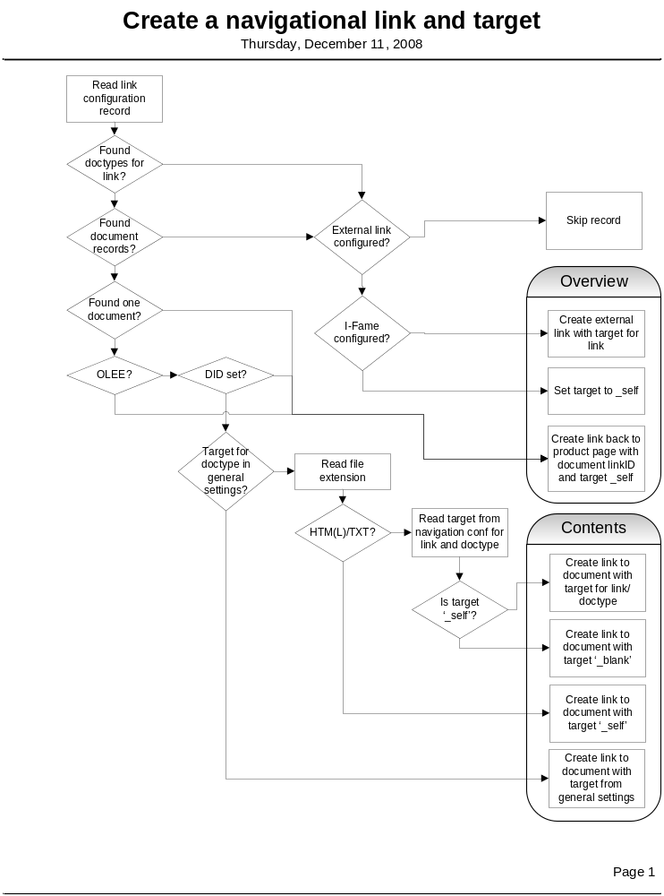  NB: If a link has an I-Frame defined in the link configuration the target si always set to _self.  </ RD-P4C-NAV-0220>

☞ | <RD-P4C-NAV-0230 section=”Navigation”  title=”LinkMapping”  >  Link mapping means to rewrite parameter names to deliver a parameter value with the proper name to an external web site; e.g. the country is defined as ‘scy’ in P4C, but as ‘country’ in the web sitet elink refers to.  Link mapping can be defined for an external link (this is a link to another web site). Link mapping also converts the 3-letter language code in the 2-letter ISO standard.  Example: within P4C the country is defined in parameter ‘scy’ (Selected CountrY), while in external web sites the country is often in parameter ‘country’ or some other abbreviation. To deliver the correct country to the external web site the parameter ‘scy’ must be rewritten into ‘country’, or whatever the external web site uses.  This process is called Linkmapping. When an external link is configured by CMST also the link mapping must be defined by CMST (both in the web configurator in the DMT).  </ RD-P4C-NAV-0230>

☞ | <RD-P4C-NAV-0240  section=”Navigation”  title=”IFrame”  >  If the I-Frame indicator is set, the link must be created to open the product page with an i-frame. The link must contain the parameter ‘mode’ with value ‘iframe’ and the link label as value for parameter ‘mid’.  Target altijd op _self!  </ RD-P4C-NAV-0240>

Rendering the menu’s
The links in the navigation configuration are grouped in menu’s. These menu’s and the links are subject to a certain Look&Feel. This Look&Feel a menu and it’s links must use is configured in the web configuration: see attribute Menu_Layout in table MenuConfig (package NavigationConfig) in the data model. This attribute refers to a template set that implements this look&feel.

☞ | <RD-P4C-NAV-0250 section=”Navigation”  title=”MenuOrder”  >  If there are multiple menu boxes defined the order in which the menus have to be displayed is the order in which they appear in the MenuConfig table.  In the left navigation slot the boxes should be shown from top to bottom  In the middle and right slots the menus are shown from left to right.  </ RD-P4C-NAV-0250>

☞ | <RD-P4C-NAV-0260 section=”Navigation”  title=”MenuLayout”  subtitle=”mainmenu”  >  The Menu_Layuout ‘mainmenu’ has the following requirements:  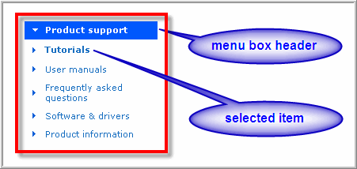  Figure 13: Left navigation menu box  - Menu box header will have a blue background and the text has a bold white font  - Selected menu item will have a bold blue font  - Other menu-items will have a normal blue font  When the text labels are too long for the width of the box they must wrap. The background must grow with the height of the box.  </ RD-P4C-NAV-0260>

☞ | <RD-P4C-NAV-0270 section=”Navigation”  title=”MenuLayout”  subtitle=”avatarmenu”  >  The menu_Layout ‘avatarmenu’ has the following requirements:  </ RD-P4C--NAV-0270>

☞ | <RD-P4C-NAV-0280 section=”Navigation”  title=”MenuLayout”  subtitle=”contact”  >  The menu_Layout ‘contact’ has the following requirements:  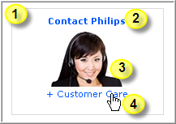  Figure 14: Contact menu  </ RD-P4C--NAV-0280>

☞ | <RD-P4C-NAV-0290 section=”Navigation”  title=”MenuLayout”  subtitle=”regprodmenu”  >  The menu_Layout ‘regprodmenu’ has the following requirements:  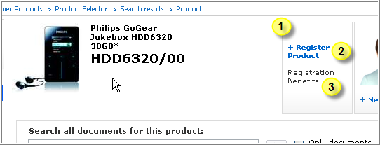  Figure 15: Register Product box - 1  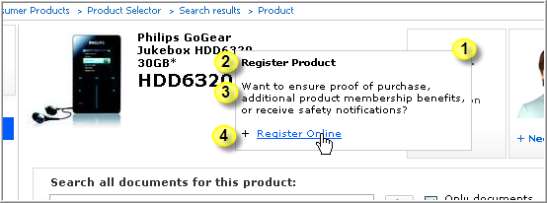  Figure 16: Register Product box - 2  </ RD-P4C--NAV-0290>

☞ | < RD-P4C-NAV-0600  section=”Navigation”  title=”MenuLayout”  subtitle=”middle”  >  The middle navigation box should be created as following:  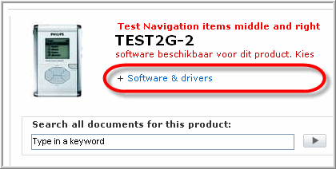  Figure 17: Middle navigation box  - Each link will be prefixed with a plus sign  - Multiple links will be shown from left to right  - Selected link will be shown in normal font  </ RD-P4C-NAV-0600>

Product Header
The product header contains the meta data around the CTN.

☞ | <RD-P4C-PRODHEAD-0000  section=”Product”  title=”Header”  subtitle=”Elements”  >  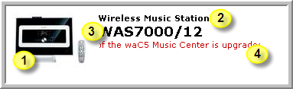  Figure 18: Product Header  Content header contains:  - a product image  - Translated product description  - CTN  - Alert ticker tape (document type PAF in AA5)  ToDo: Second CTN (Chassis)  </RD-P4C-PRODHEAD-0000>

☞ | <RD-P4C-PRODHEAD-0010  section=”Product”  title=”Header”  subtitle=”ProductImage”  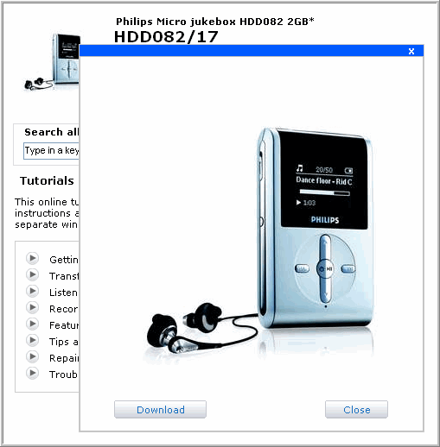  >  The product image is shown in the left top corner of the content. The image has a dimension of 100x100.  When user clicks on the image, a bigger image (396x396) will be shown with a possibility to download.  If there is no product image available, this will be omitted and the other items of the content header will be shifted to the left.  Figure 19: Product image popup  </ RD-P4C-PRODHEAD -0010>

☞ | <RD-P4C-PRODHEAD-0020  section=”Product”  title=”Header”  subtitle=”Alert Ticker Tape”  >  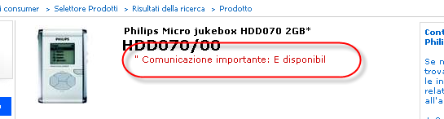  Figure 20: Ticker tape  The Alert Ticker Tape is only shown when a document is available of document type PAF (AA5) for the product and selected country. The document is expected to contain a text string. This text string is displayed in red type as a ticker tape under the CTN.  </RD-P4C-PRODHEAD-0020>

Content

☞ | <RD-P4C-CONTENT-0010  section=”Content”  title=”ContentAll”  >  The content is divided into 2 parts:  - Content header  - content title  - print page button  - Content pane  - description of the content page (if configured)  - content  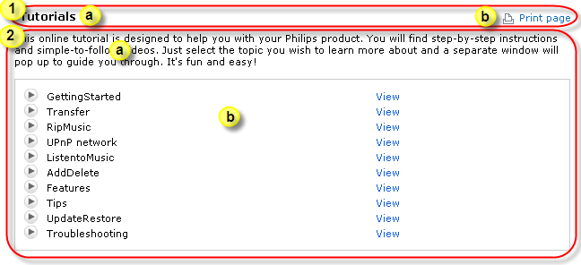  Figure 21: Page content  </RD-P4C-CONTENT-0010>

Content header
The content header (see Figure 21: Page content) usually holds the title (point 1a) for the content page and the print button (point 1b). The title can also be a download button (see the functionality on Download in paragraph 4.8.2.4).

☞ | <RD-P4C-CONTENT-0110  section=”Content”  title=”ContentTitle”  title=”LandingPage”  >  Figure 22: Landing page title  If the Product Support page is called with only the CTN, language and country a landing page is created. If the landing page does not correspond to an existing navigational link the title of the page will be the translation of ‘Product Support Information’.  </RD-P4C-CONTENT-0110>

☞ | <RD-P4C-CONTENT-0120  section=”Content”  title=”ContentTitle”  title=”MenuLink”  >  Figure 23: Menu link title  If the product support information page is called with a navigational link Content Title will be the text for the label that correspond with the navigational link (the value of parameter ‘mid’ will have the suffix ‘_header’).  </RD-P4C-CONTENT-0120>

☞ | <RD-P4C-CONTENT-0130  section=”Content”  title=”ContentTitle”  title=”Download”  >    Figure 24: Download button  If:  - parameters ‘mid’, ‘dct’ and ‘did’ are available in the URL,  and  - for the values of ‘dct’ and ‘did’ there is exactly one document available,  and  - the record for these values (mid and dct are primary key) has a related document type defined,  then:  - create a download button for the document found for ‘dct’ and ‘did’  (For the download button see 4.8.2.4)  </RD-P4C-CONTENT-0130>

Content Pane
The content pane can be filled with all sorts of content. What content is to be shown is defined by parameters in the URL, or when the URL only holds the basic information (CTN, language, country) the application will decide on a landing page.

Select module for content
What has to be displayed in the content part of the Product support page depends how the support page is called. The parameters in the URL Main parameter to determine the content pane is the parameter ‘mid’. This parameter refers to the navigation configuration where the MID defines what content or what link is to be used for the content pane. Another important parameter is parameter ‘mode’, used for other functionality like contact info, search results or for generating an I-Frame.

When the content pane has to be created the application has to decide what content, overview of content, or other data has to be displayed. The P4C application has the following fucntionalities:
- Landing page
- Listing (overview of documents)
- Download page (Show content of a document, can be with download button)
- OLEE-page (list of OLEE’s, e.g. FAQ’s or Tutorials)
- Contact information
- I-Frame
- Overview of related CTN’s, like Refurbished product or Chassis (for P4S)

☞ | <RD-P4C-CONTENT-SELECTION-0100  section=”Content”  title=”SelectFunction”  >  The following rules govern the process to select what functionality has to be chosen to generate the HTML for the content pane (assuming that the URL holds at least a valid CTN, and possibly a country (scy) and/or a language (slg):  - Go to the landing page if URL does not hold a  </ RD-P4C-CONTENT-LANDING-0110>

Landing page
The content area is filled with different content based on the type of visitor, selected country and/or language and the available data for the product.
The following requirements contain the details of what should be displayed in the content area.

☞ | <RD-P4C-CONTENT-LANDING-0100  section=”Content”  title=”Landing”  subtitle=”SelectPage”  >  Show the following content in this order of availability for the type of user:  - Web users (users without a cookie or with cookie of type ‘webuser’):  - If cookie is ‘cddb’ and product has GraceNoteDataBase (GDU) then show menu item holding doctype GDU.  - Contents of document Product News (doctype PNW) if available for product and selected country  - For MP3/MP4 players (Category code ‘MP3_PLAYERS_CA’):  - Show latest additions page  - Product image  - Philips Cube  - All other products  - Menu item holding doctype TUT (Tutorials)  - Menu item holding doctype FAQ (Freq. asked questions)  - Product Image  - Philips Cube  - Call Center Agents  - Menu item holding doctype FAQ (Freq. asked questions)  - Menu item holding doctype TUT (Tutorials)  - Listing of all doctypes in Menu item holding doctype DFU (Manuals)  - Listing of all doctypes in Menu item holding doctype PSS (Product Information)  - Product Image  - Philips Cube  - Servicers (users with A cookie of type ‘servicer’)  - Related CTN’s (from Product/Chassis list) if >1 related CTN’s exist for the CTN (no data is shown before a related CTN is selected).  - Listing of all doctypes in Menu item Mandatory Recall (Cookie_Mandatory_Recall)  - Listing of all doctypes in Menu Item Mandatory Rework (Cookie_Mandatory_Rework)  - Listing of all doctypes in Menu item holding doctype SMA (Service Manual)  - Product image  - Nothing (empty)  </ RD-P4C-CONTENT-LANDING-0100>

☞ | <RD-P4C-CONTENT-LANDING-0110  section=”Content”  title=”Landing”  subtitle=”DefautlText”  >  If a landing page is shown (no listing or MP3/4 page or OLEE) a text is displayed. The text is dependent on what is available in the document set.  If the document set holds at least a document in AA2:  Display: Online Support information for this product is available from the menu left.  If the document set holds only country related document(s) and the user has not selected a country (global context), add the following line:  To see all information available for your product, please select your country  If the document set is empty:  Display: For this product we have no documentation available!  </ RD-P4C-CONTENT-LANDING-0110>

MP3/4 landing page
For MP3 and MP4 products a special landing page is designed. This landing page shows documents for four (4) links (only if content is available for a link) in the content frame and a list of latest updates.
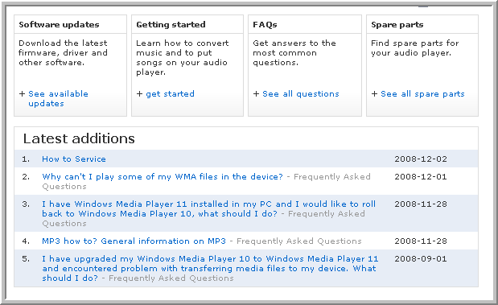
Figure 25: MP3/4 landing page

☞ | <RD-P4C-CONTENT-LANDING-0110  section=”Content”  title=”MP3/4-Landing”  subtitle=”LatestUpdates”  >  Show a list of latest updates for the product, sorted on date with the latest on top.  The item must contain the following elements:  - If the doctype is OLEE,  - show the question, followed by a hyphen, followed by the document type description (see Figure 25: MP3/4 landing page addition number 2)  - else  - show the document type description (see Figure 25: MP3/4 landing page addition number 1)  - show the date in format yyyy-mm-dd  The display is in 2 columns, where the date is in the right column.  </ RD-P4C-CONTENT-LANDING-0110>

☞ | <RD-P4C-CONTENT-LANDING-0120  section=”Content”  title=”MP3/4-Landing”  subtitle=”WhenToShowContentBox”  >  If content available show a content box for:  - Software Updates  - Getting Started  - FAQ’s  - Spare Parts  The box is using a corresponding link in the link configuration. If the document set holds data for the link, then the content box is created.  </ RD-P4C-CONTENT-LANDING-0120>

☞ | <RD-P4C-CONTENT-LANDING-0120  section=”Content”  title=”MP3/4-Landing”  subtitle=”ContentBox”  >  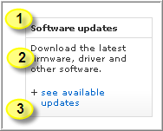  Figure 26: Content Box  A content box is a box of about 150 pixels (width and height) to increase visibility of content for a navigation link placed in the content pane.  The box consists of the following elements:  - A title related to the navigational link  - A short sentence explaining about the content  - The link to open this content in the content pane.  The box has a slight grey gradient to stand out from the back.  </ RD-P4C-CONTENT-LANDING-0120>

Listing
A listing is created for a link from the navigation configuration that has one or more documents available for the product. The link will not be available when there are no documents available (see paragraph on Navigation for rules about Link-creation).

☞ | <RD-P4C-CONTENT-LISTING-0200  section=”Content”  title=”Listing”  subtitle=”WhenIsListingModuleCalled”  >  The listing module is called when:  - Condition set 1:  - The parameter ‘mid’ is a link in the navigation configuration  - AND the link has a list of document types,  - AND at least one document is found for the product and list of document types.  - Where the documents for AA5 are filtered on the selected country.  - Condition set 2:  - The URL contains a parameter DCT  - AND the value for DCT is a document type configured for a link in navigation configuration  - AND at least one document is found for the product and list of document types.  - Where the documents for AA5 are filtered on the selected country.  - Condition set 3:  - The landing page has to be displayed  - AND the landing page contains a listing of documents.  </ RD-P4C-CONTENT- LISTING-0200>

☞ | <RD-P4C-CONTENT-LISTING-0210  section=”Content”  title=”Listing”  subtitle=”NoDocuments”  >  When  - the listing module is called  - AND no documents are available for the document types for the specified link  Then  Show the landing page.  </ RD-P4C-CONTENT- LISTING-0210>

☞ | <RD-P4C-CONTENT-LISTING-0220  section=”Content”  title=”Listing”  subtitle=”List of document type boxes”  >  When a link is clicked for which a number (one or more) of document types are configured in the navigation configuration and there is at least one document found for these document types, then:  - Per document type a document type box is created that gives access to all documents available for that document type.  </ RD-P4C-CONTENT- LISTING-0220>

☞ | <RD-P4C-CONTENT-LISTING-0230  section=”Content”  title=”Listing”  subtitle=””  >  </ RD-P4C-CONTENT- LISTING-0230>

Document type box
The listing module must generate document type boxes that display all documents for a specific document type. Document types can be in different Application Area’s and for each Application Area there is a different set of requirements.
The links to the actual files in the document type boxes will have a target setting. The next requirement deals with this target setting.

☞ | <RD-P4C-CONTENT-LISTING-0240  section=”Content”  title=”Doctypebox-Link”  >  The link to a document is either the link as delivered in the document record, or the link is generated. The following rules apply:  </ RD-P4C-CONTENT-LISTING-0240>

☞ | <RD-P4C-CONTENT-LISTING-0241  section=”Content”  title=”Doctypebox-Link-Target”  >  The target settings for the document links in a document type box (all Appl. Area’s <10) follow this decision tree:  - If the general settings contain a target for this doctype  use the target from general settings configuration  - Else  - read the target from the navigation configuration file for the ‘Link-Label (mid) and the document type that is processed (dct).  - If the file extension is HTM/HTML/TXT  - if ‘dct’ is present in the generalsettings-doctypetargets  use this doctypetarget  else  set target to ‘_self’  else  if the target is ‘_self’ the target is set to ‘_blank’  - If the target is set to ‘_self’  create link to the script with ‘dct’ and ‘did’  else  use the symlink  </ RD-P4C-CONTENT-LISTING-0241>

☞ | <RD-P4C-CONTENT-LISTING-0250  section=”Content”  title=”Listing”  subtitle=”Basic-DocumentTypeBox”  >  A document type box shows the document for a specific document type and makes the other instances (language versions for document types in AA2) available for this document type accessible.  </RD-P4C-CONTENT-LISTING-0250>

☞ | <RD-P4C-CONTENT-LISTING-0260  section=”Content”  title=”Listing”  subtitle=”AA2-DocumentTypeBox - Public”  >  For a language related document (document type in AA2) all language versions will be available and one language will be shown.  The language that is shown is subject to the following flow:  - If a document for the current site language (SLG) is available  - Show document for current site language  - Else if British English is present  - Show document for British English (ENG)  - Else  - Sort documents on language label in current language (SLG)  - Show first document  The other available languages can be selected using the language selection box in the document type box.  The selected language in the language selection box in the document type box must be set to the language that is shown.  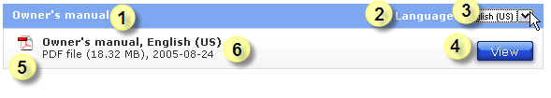  Figure 27: Document Type box for AA2 - Public  The items to show in the doctype box are:  - The translated description of the document type in the selected language  - A translated label ‘Language’  - A drop down box with all the languages the document is available for  - The View/Download button  - The label is ‘View’ (translated) if the document can be shown in the browser (PFD, HTML, TXT or Image type)  - The label is ‘Download’ (translated) in all other cases.  - A small image representing the file type  - A block of meta data for the document with the following items:  - Translated Document type description (doctypes table)  - The translated language label (from Languages table)  - A file type description (translation available in Local-Text table)  - The file size (in MB with one decimal, in KB when size smaller then 100KB)  - Date of upload in format yyyy-mm-dd  When selecting another language in the language selection box (3) two thins will happen:  - the language indication in 6.b will change to the description of the new selected language in the current language of the web site.  - The link on the button will change to target the file in the selected language.  NB: Currently on P4C boxes are created for all available languages, and only the box for the selected language is displayed: all other translations of this document type are hidden. When another language is selected for this doctype a general JavaScript routine will be called to hide the current box and display the new box (no server trip).  </RD-P4C-CONTENT-LISTING-0260>

☞ | <RD-P4C-CONTENT-LISTING-0270  section=”Content”  title=”Listing”  subtitle=”AA2-DocumentTypeBox - Restricted”  >  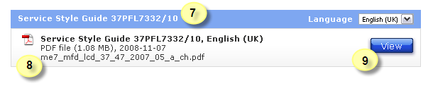  Figure 28: Document Type box for AA2 - Restricted  For a restricted document type there are some additional elements to be shown in the document type box, but only when the user-type is ‘servicer’ (see the evaluation to user-type described in paragraph 3.4.2):  - If there is a second CTN (Chassis) the CTN for which the asset is uploaded is added to the doctype description in the header and the block of meta data of the doctype box if there is a product/Chassis relation (if the CTN is in the list of product/Chassis assets for both CTN’s are shown),  - The original filename is added as a third line in the block meta data,  - The link to the asset is constructed with the sget-script, because there is no symbolic link. Please refer to the link generation in RD-P4C-CONTENT-LISTING-0240.  </RD-P4C-CONTENT-LISTING-0270>

☞ | <RD-P4C-CONTENT-LISTING-0280  section=”Content”  title=”Listing”  subtitle=”AA5-DocumentTypeBox”  >  A country related document will only be shown when a document for the selected country is available. Only the document for the selected country is shown, the others are filtered out the initial document set for the CTN.  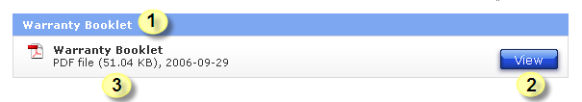  Figure 29: Document Type box for AA5 - Public  The items to show in the doctype box are:  - The translated description of the document type in the selected language  - The View/Download button  - The label is ‘View’ (translated) if the document can be shown in the browser (PFD, HTML, TXT or Image type)  - The label is ‘Download’ (translated) in all other cases.  - A block of meta data for the document with the following items:  - A small image representing the file type  - Translated Document type description (doctypes table)  - A file type description (translation available in Local-Text table)  - The file size (in MB with one decimal, in KB when size smaller then 100KB)  - Date of upload in format yyyy-mm-dd  </RD-P4C-CONTENT-LISTING-0280>

☞ | <RD-P4C-CONTENT-LISTING-0290  section=”Content”  title=”Listing”  subtitle=”AA5-DocumentTypeBox - Restricted”  >  For the restricted version of the document box for AA10 the same rules apply as for the restricted AA2 box (see RD-P4C-CONTENT-LISTING-0270).  </RD-P4C-CONTENT-LISTING-0290>

☞ | <RD-P4C-CONTENT-LISTING-0300  section=”Content”  title=”Listing”  subtitle=”AA10-DocumentTypeBox”  >  A document for a document type in AA10 does not have a country, nor has a language. In the dataset there will only be one document for this document type. The document type box will show the document with all the elements a document needs to show, there will be no language selection.  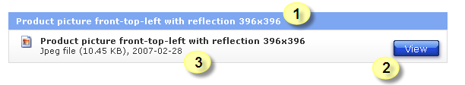  Figure 30: Document Type box for AA10 - Public  The items to show in this doctype box are:  - The translated description of the document type in the selected language  - The View/Download button  - The label is ‘View’ (translated) if the document can be shown in the browser (PFD, HTML, TXT or Image type)  - The label is ‘Download’ (translated) in all other cases.  - A small image representing the file type  - A block of meta data for the document with the following items:  - Translated Document type description (doctypes table)  - A file type description (translation available in Local-Text table)  - The file size (in MB with one decimal, in KB when size smaller then 100KB)  - Date of upload in format yyyy-mm-dd  </RD-P4C-CONTENT-LISTING-0300>

☞ | <RD-P4C-CONTENT-LISTING-0310  section=”Content”  title=”Listing”  subtitle=”AA10-DocumentTypeBox - Restricted”  >  For the restricted version of the document box for AA10 the same rules apply as for the restricted AA2 box (see RD-P4C-CONTENT-LISTING-0270).  </RD-P4C-CONTENT-LISTING-0310>

☞ | <RD-P4C-CONTENT-LISTING-0320  section=”Content”  title=”Listing”  subtitle=” DocumentTypeBox - Version”  >  When a version is available for a document the first line of the meta data block will contain also a translated label for ‘Version:’ and then the version number will be printed as found in the record for the document.  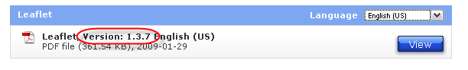  Figure 31: Document Type box - Version number  The version number will be printed together with the label between the doctype description and the language description.  This behavior is the same in all application area’s for file documents (2, 5 and 10) for both restricted and public documents.  </RD-P4C-CONTENT-LISTING-0320>

☞ | <RD-P4C-CONTENT-LISTING-0330  section=”Content”  title=”Listing”  subtitle=” DocumentTypeBox - LongDescription”  >  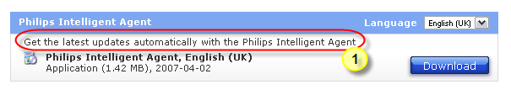  Figure 32: Document Type box - Long doctype description  When there is a long description available for the document type, then the translated description has to be printed in the doctype box, under the element title and above the block of meta data. The whole width of the doctype bx is available for the text.  </RD-P4C-CONTENT-LISTING-0330>

☞ | <RD-P4C-CONTENT-LISTING-0340  section=”Content”  title=”Listing”  subtitle=”Related document type”  >  When a ‘related’ document type is defined in the navigation configuration for the current link/document-type this related document is treated as a readme file and an extra link is created (see ‘10’ in the figure below).  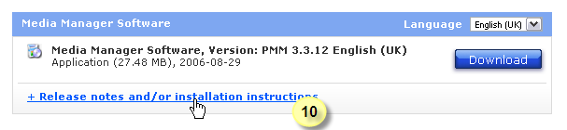  Figure 33: Document Type box - Related document type  The Readme file can be in HTML/TXT or in PDF format. Based in the file-type the link will be different.  - The HTML or TXT file can be rendered in-page, so the link will be back to the product support page to show the download + the contents of the readme file in the content area of the Product Support page. See the Download section (paragraph 4.8.2.4) for more details on displaying the readme file in page.  - A PDF file cannot be rendered in-page so a link is created that will open a new window (target=”_blank”) and a link is to the cpcontent.pl script. This script will generate a frameset with te download button in the top frame and the readme-file in the lower frame. For more details see paragraph 4.8.3  The text of the link is from one label. The text is translated in all languages for the web site.  ToDo: If document for readme file is not in requested language, deliver ENG  </RD-P4C-CONTENT-LISTING-0340>

☞ | <RD-P4C-CONTENT-LISTING-0350  section=”Content”  title=”Listing”  subtitle=”DownloadButtonText”  >  For all boxes:  The text on the button to open the file is:  - ‘View’, if the file has one of the extensions HTM, HTML, TXT or PDF, or  -  ‘Download’, with any other extension.  </RD-P4C-CONTENT-LISTING-0350>

Download Page
To find out when this module is targeted please read paragraph 4.8.2.1 specification RD-P4C-CONTENT-SELECTION-0100.

A so-called ‘download’ page is created when we have to show the contents of a document in the content pane of the product support page. This can only be done when the document is in HTML or TXT format.

In case of a Readme file for software we must not only show the contents of the Readme-file, but also show the software as a downloadable item (hence the term Download page).
But this module is also used to:
- show a document in-page in the content pane when a link in the menu is configured to do this,
- but is also used in the landing page when a Product News is available.

The contents of a document can be displayed in-page, when the format is in HTM(L) or TXT format. For other formats (typically pdf) the contents have to be shown in a separate window.

When the Readme-file for software is in PDF-format the link will be to the cpcontent-script to show the PDF-file and the download button in a separate window. See paragraph 4.8.3 about the cpcontent-script.
To show the contents of a document can be requested from a menu item (see paragraph 4.6.3 spec RD-P4C-NAV-0020), or from a document type box (see paragraph on listing in the content area).

The same effect (showing the content of a document in the content pane of the Product Support page) can also be achieved by defining an external link to a document somewhere on the internet and activate the I-Frame for that link. With this mechanism any file or application can be displayed in the content pane of the Product Support page. See the I-Frame functionality in paragraph ).

☞ | <RD-P4C-CONTENT-DOWNLOAD-0300  section=”Content”  title=”Download”  subtitle=”DownloadPage”  >  Only describe the showing of the contents of the file. The download button is tackled in the content header  If selected language is not available take ENG or AEN  </ RD-P4C-CONTENT-DOWNLOAD-0300>

OLEE
When the parameter ‘mid’ is read from the navigation configuration and the document type for this mid is an OLEE doctype (application area 11, 12 or 13) the document records for this document type are fetched from the document set. If the records contains a country the records are filtered against the country selected by the user. The result is one record (there is only one record if the country column is empty).
From this record that remains the hyperlink is taken. This hyperlink is a link to the OLEE-list script for the correct Application Area. Via a sub-request the list is created and the resulting HTML is placed in the content area of the product support page.

The OLEE mechanism to create a list renders the List of OLEE’s (FAQ’s, Tutorials, etc), with for each OLEE in the list a link to the individual OLEE.
The mechanism to create a view renders an individual OLEE (an instance of an FAQ or one Tutorial).
For document types in Application Area 11, 12 and 13 (OLEE’s) a list of instances is generated, but we do not call that a document type box. We could call it an OLEE box.
For the specs on OLEE boxes please go to chapter 4.9.

Contact
For the Contact page the contact data for a product is retrieved using a SOAP-request to the CDLS, which is a service on the MRS. This SOAP-request must hold data on the categorization (support) of the product, the Supra-feature and the country and language.
There is a document defining the SOAP-request.
☞ | <RD-P4C-CONTENT-CONTACT-0020  section=”Content”  title=”Contact”  subtitle=”GetDataFromCDLS”  >  - Create SOAP-request to CDLS  - Receive response from SOAP-request  - Process and render data from SOAP-request  </ RD-P4C-CONTENT-CONTACT-0020>

☞ | <RD-P4C-CONTENT-CONTACT-0030  section=”Content”  title=”Contact”  title=”SOAP-Request”  >  </ RD-P4C-CONTENT-CONTACT-003->

☞ | <RD-P4C-CONTENT-CONTACT-0040  section=”Content”  title=”Contact”  subtitle=”SOAP-Response”>  </ RD-P4C-CONTENT-CONTACT-0040>

☞ | <RD-P4C-CONTENT-CONTACT-0050  section=”Content”  title=”Contact”  subtitle=”PhoneNumberDisplay”  >  </ RD-P4C-CONTENT-CONTACT-0050>

☞ | <RD-P4C-CONTENT-CONTACT-0060  section=”Content”  title=”Contact”  subtitle=”ChatDisplay”  >  </ RD-P4C-CONTENT-CONTACT-0060>

☞ | <RD-P4C-CONTENT-CONTACT-0070  section=”Content”  title=”Contact”  subtitle=”SendmailLink”>  </ RD-P4C-CONTENT-CONTACT-0070>

☞ | <RD-P4C-CONTENT-CONTACT-0080  section=”Content”  title=”Contact”  subtitle=”Link2MailForm”  >  Create link to web form generator with language. Country, categorization, supra-feature, etc)  </ RD-P4C-CONTENT-CONTACT-0080>

☞ | <RD-P4C-CONTENT-CONTACT-0090  section=”Content”  title=”Contact”  subtitle=”Pre-emptiveResults”  >  </ RD-P4C-CONTENT-CONTACT-0090>

I-frame
To display content from another web site in the Product Support page an I-frame mechanism is available. By configuring the link and the I-Frame option in the web-configuration the I-Frame can be used.

☞ | <RD-P4C-CONTENT-IFRAME-0010  section=”Content”  title=”I-Frame”  >  </ RD-P4C-CONTENT-IFRAME-0010>

Product image

☞ | <RD-P4C-CONTENT-PRODIMAGE-0010  section=”Content”  title=”ProdImg”  >  </ RD-P4C-CONTENT-PRODIMAGE-0010>

Philips Cube

☞ | <RD-P4C-CONTENT-CUBE-0010  section=”Content”  title=”Cube”  >  </ RD-P4C-CONTENT-CUBE-0010>

Related CTN’s
If showing related CTN’s for Product/Chassis (restricted) then show no product data, only selection list. Selection must be made for 2nd CTN, then all data for both CTN’s is shown. Per Item the CTN is shown for which it is uploaded.
For related CTN’s for Product/Refurbished (public) the list is shown in-page with all product data for the current CTN.

☞ | <RD-P4C-CONTENT-RELATED-0010  section=”Content”  title=”RelatedCTNs”  >  </ RD-P4C-CONTENT-RELATED-0010>

Display new window for download with readme file (cpcontent.pl)
With available software there is usually a readme file. This readme file is available in the software package, but to see the contents of this readme file you will have to download the software package, unpack it and open the readme file. Since these software packages are usually large files it is sensible to have the readme file available as a separate file and show the contents of this file to the end user together with a download button for the software. For this functionality the functionality of the related doctype was created. Business uploads the software package for the correct document type and also the readme file for another document type. CMST configure these doctypes as separate doctypes in the CCR and define the software doctype in the web configuration for a menu link and the readme file document type as a related document type for this menu-link/doctype.
When the document type box must be created the program checks if this menu-link/doctype has a related doctype, and if so the file extension of the file for the related document type is checked. If the file extension of the file for the related document type (see paragraph 3.4.6) is not HTML or TXT the contents of the file cannot be displayed in-page. When the extension is not HTML or TXT it is usually PDF.
This extension defines if the link.

is back to the script to show the contents of the related file in-page, or the link is to a new window (target=”_blank”) to show the download button next to the contents of the related file.
The top frame is filled by the cpindex-script with a special mode to only generate the content-top part.

☞ | <RD-P4C-WINDOW-README-0010  section=”Window”  title=”DownloadAndReadme”  >  </ RD-P4C-WINDOW-README-0010>

EULA script
When software is offered to end users there is often an End Users License Agreement (EULA) involved.

☞ | <RD_P4C_SOFTWARE_EULA_0010  section=”Software”  title=”EULA”  >  </ RD_P4C_SOFTWARE_README_0010>

OLEE documents
The CCR has two different concepts for content, the documents and the OLEE’s. The documents are content elements that are uploaded to the CCR as files with the Upload tooling (Upload Wizard and CCR-Batch). The OLEE’s are content elements that are created in the OLEE-application which is sitting right on top of the Database.

The OLEE document types are divided over 3 Application Area’s for restricted FAQ’s (AA11), Public FAQ’s (AA12) and Tutorials (AA13). See chapter 3 on page 8 for more details on Application Area’s.
The display for OLEE’s (both lists and individual OLEE’s) is generated by separate scripts (which share a common library with all the main functionality).

Deployment of OLEE’s
To make the OLEE’s available on the Support page each OLEE is transformed into an XML-file during the deployment process. An application on P4C will read this XML and transform it to HTML (Perl) using a template. Transformation is done on the server side and HTML will be sent to the browser. In this transformation process the proper links will be created to the attachments in the OLEE (files referred to in the OLEE and in-line images). The XML-file and all attachments are transferred to the P4C server in the same deployment.

The OLEE list is in the document list for the product:
With each deployment the list of documents available on P4C is refreshed. Since OLEE’s are not downloadable files the OLEE’s are registered in a different file. But if OLEE’s for this document type are available for the product the documents file holds one (1) record for an OLEE doctype to indicate the presence f=of this type of OLEE’s for the product. The record created in the documents file contains a link to the script that will generate the list of OLEE’s that are available for this product (will be one or more).

Multiple (OLEE) document types for one OLEE list:
An OLEE has a document type. A list of OLEE’s can be composed from OLEE’s with several document types. There is a parent child relation in the Document-Types table.
If an OLEE list is requested the document type from the request is used to retrieve the child document types. These child doctypes are added to the list of document types to retrieve from the OLEE-prods table. All OLEE’s will be retrieved for the CTN, document types and if the record is country related also for the country. From these results the list of OLEE’s for the requested language is created. If the requested language is not available a list of available languages is created.

Presentation of OLEE
For OLEE a list of items has to be created, based on the items found for the product. The OLEE’s are created and maintained in the OLEE application. In this application also the translations are maintained and the relations to countries and products. Currently an OLEE can only be related to a product, not to a tree-element (or branch).
When an OLEE is related to one or more countries this OLEE should only be visible in these specified countries. If the OLEE has no related countries it can be shown in any country.

Templates
The OLEE presentation is based on templates. Each application area has a standard template to display the list of OLEE’s and a standard template to show the individual OLEE.
The template that is used is defined by the rules in the following spec:

☞ | <RD-P4C-OLEE-Template-0001  Section=”OLEE”  Title=”Template”  SubTitle=”TemplateSelection”  >  Rules:  - If a template is defined in the URL and the template is available use the specified template.  - If a template is available for the document type this template must be used.  - If no template is defined and there is no template for the doctype, use the standard template for the Application Area.  </ RD-P4C-OLEE-Template-0001>

☞ | <RD_P4C_OLEE_Template_0002  Section=””  Title=””  SubTitle=””  >  </ RD_P4C_OLEE_Template_0002>

OLEE List
When a product has OLEE’s a link is available on the product support page. This link will target a list of OLEE’s that will list the individual OLEE’s in the selected language.

NB: The list will list only the OLEE’s available in the selected language. This might not be the complete list of OLEE’s, because some OLEE’s have not been translated (yet).
☞ | <RD-P4C-OLEE-0050  section=”OLEE”  title=”listPrepare”  subtitle=”CheckLanguageCode”  >  Check if the language code in the request is a 3-letter code, else find the 3-letter code based on requirement RD_P4C_BASICCONCEPTS_0010.  </RD-P4C-OLEE-0050>

☞ | <RD-P4C-OLEE-0010  section=”OLEE”  title=”listPrepare”  subtitle=”fetchListOfOLEERecords”  >  Generate a list of OLEE’s for a document type, product and country after the following filters:  - Create a list of document types from the specified document type (get all children if there are any and add them to the doctypes-to-search-for list, but delete the doctypes the user is not authorized for)  - fetch all OLEE’s from the OLEE-Prods table for the product, language, and the document types  - Filter all country related OLEE’s that do not have the selected country in their country-list  </RD-P4C-OLEE-0010>

☞ | <RD-P4C-OLEE-0020  section=”OLEE”  title=”listPrepare”  subtitle=”ChooseListFormat”  >  When you have the records to create a list with, the format of the list depends on the Application Area of the requested document type and the type of user.  - For document type in Application Area 11 there is the Servicer format  - For document type in Application Area 12 there is the FAQ format  - For document type in Application Area 13 there is the Tutorial format  If another template is defined for the requested document type this will overrule the default template (this is in place for the Call Center Scripts and Call Center Tips).  </RD-P4C-OLEE-0020>

☞ | <RD-P4C-OLEE-0025  section=”OLEE”  title=”listPrepare”  subtitle=”GetENGifnotAEN”  >  If not AEN use ENG  </RD-P4C-OLEE-0025>

☞ | <RD-P4C-OLEE-0030  section=”OLEE”  title=”ListFormat”  subtitle=”AA11-Standard”  >  The list for Symcures has 3 different sorting:  Catogory:  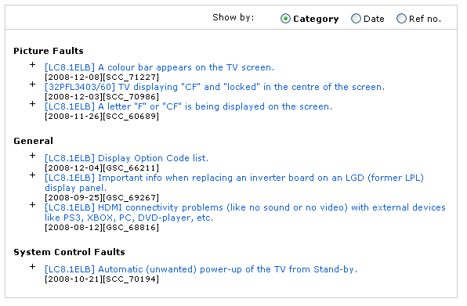  Figure 34: Standard list template for document types in AA11 (sorted on Category)  Date:  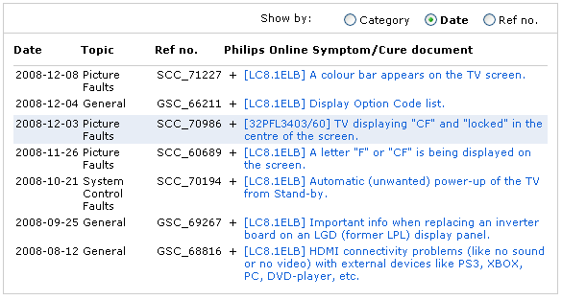  Figure 35: Standard list template for document types in AA11 (sorted on Date)  Reference Number:  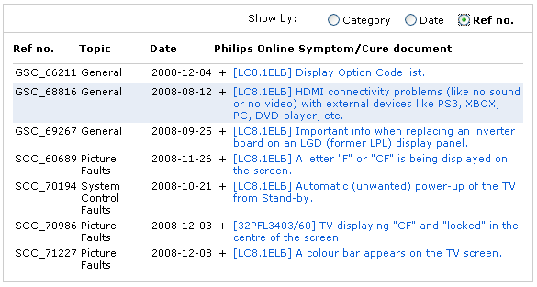  Figure 36: Standard list template for document types in AA11 (sorted on Reference number)  Elements that are displayed per OLEE are:  - Related CTN  - Symptom (question)  - Date  - Problem area  - Reference Number (NB: is not the ID)  As defined in the screen shots the views for Date and RefNo are in a table view withcolumn headers. The view on Category shows the OLEE’s per category.  </RD-P4C-OLEE-0030>

☞ | <RD-P4C-OLEE-0040  section=”OLEE”  title=”ListFormat”  subtitle=”AA11-CallCenter”  >  For Calll Center Scripts (document type CCS) and Call Centre Tips (document type CCT) a special layout is created. This layout is based on Category layout, where the categories are expandable and collapsible. The different views are substituted by a selection box containing the categories and two options to show all and to hide all.  The start view is that all categories are collapsed:  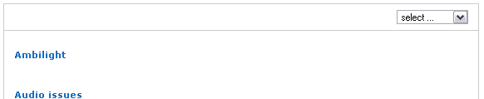  Figure 37: Call Center Script template (based on document type CCS) - Colllapsed  When a category is clicked or selected from the selection box in the top-right corner the category expands (all other categories that were expanded are collapsed):  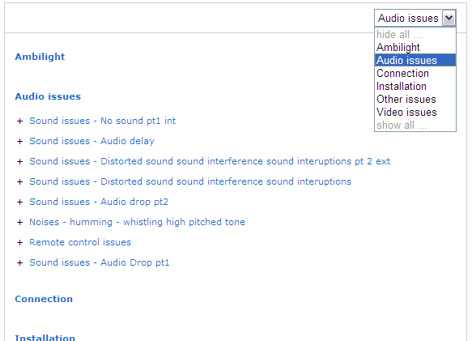  Figure 38: Call Center Script template (based on document type CCS) - Expanded  </RD-P4C-OLEE-0040>

☞ | <RD-P4C-OLEE-0050  section=”OLEE”  title=”ListFormat”  subtitle=”AA12-Standard”  >  The Document types in Application Area 12 have the FAQ-format as a default format. The view in this format has 2 options:  - the Topic view which groups the OLEE’s per problem area  - the Populatiry view, that sorts the OLEE’s on popularity, the ones most visited on top of the list. This list is split In 2 parts. The upper part contains OLEE’s from the last week (new or changed), and the 2nd part contains all OLEE’s older than one week. Ranking in both parts is done the same. No visual clue is given to divide the parts.  Topic view:  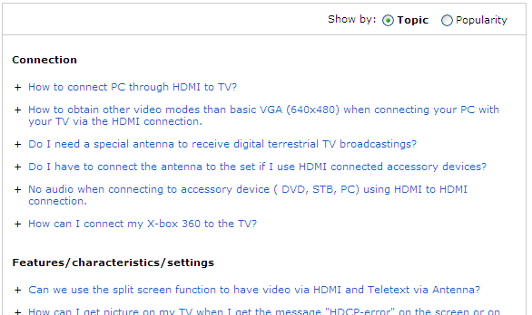  Figure 39: Appl Area 12 doctype - Standard list template – Topic view  Popularity view:  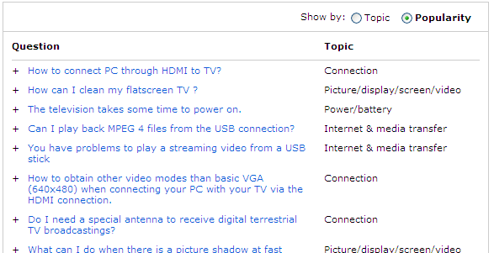  Figure 40: Appl Area 12 doctype - Standard list template - Popularity view  Elements for both views are the same:  - Problem Area  - Question  </RD-P4C-OLEE-0050>

☞ | <RD-P4C-OLEE-0060  section=”OLEE”  title=”ListFormat”  subtitle=”AA13-Standard”  >  A tutorial is an OLEE, but only the Question is shown. The important part is the Flash file which is attached to the OLEE. This flash file contains the content and must be show instead of the Answer.  The list of Tutorial OLEE’s (Application Area 13) shows the question (which is called ‘Title’) and has one of the following links, or both:  - Link to the Tutorial in a new pop-up window  - Link to a ZIP-file with the flash file  The problem area of the OLEE is used to rank the OLEE/doctype for this product. The ranking is done with an alphanumeric sort on the problem area value (a->z).  Tutorials list:  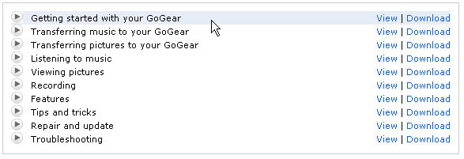  Figure 41: Appl Area 13 doctype - Standard list template  Note that the line is highlighted when hovered.  If there is an SWF-file in the attachments, then create a view link  If there is an ZIP-file in the attachments, then create a download link  </RD-P4C-OLEE-0060>

☞ | <RD-P4C-OLEE-0070  section=”OLEE”  title=”listFormat”  subtitle=”ChooseLanguage”  >  When a product has OLEE’s, but they are not in the requested language the list generator will generate a list of languages for which these selected OLEE’s are available. Each language in the list has a link that will reload the product support page in the selected language.  List of languages that have FAQ’s (in Danish):  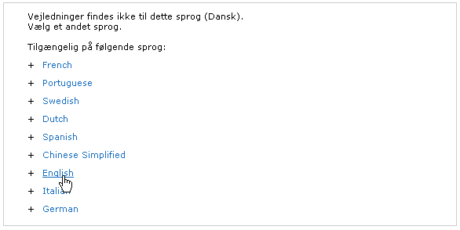  Figure 42: Language pick list template  </RD-P4C-OLEE-0070>

☞ | <RD-P4C-OLEE-0080  section=”OLEE”  title=”list”  subtitle=”LinkToOLEE”  >  Each entry in the list is an individual OLEE and needs a link that will open this OLEE.  The link to the OLEE must contain the following parameters:  - refnr Reference number (see data model: Symcure_ID in OLEE-Prods)  - ctn CTN  - slg Language (can be 2-letter code, will be translated to 3-letter code by combining language and country)  - scy Country  - dct Document type  - session Session-ID: If the session parameter is not yet available is should be created (see RD_P4C_Session_0010)  </RD-P4C-OLEE-0080>

OLEE view
When an OLEE is clicked in the list the OLEE-view script kicks into action to present the OLEE with all its details. The data for the OLEE is contained in one XML-file that is present on the P4C file system. The OLEE record from the OLEE-Prods table contains a URL where the XML-file is located (from the document root without the leading slash). The XML file is read and the view script creates the HTML based on a view template defined for the Application Area (default). If a view template is created for the document type then this template will override the default template.

Files attached to an OLEE
An OLEE can refer to an external file that is attached to the OLEE. This can be an attachement or an in-line image. All files attached to an OLEE are stored in the back-office database and during deploy they are written to the file system with a name generated by the system (according to the rules for file name convention in the CCR). The original filename is registered in the XML for the OLEE.
The in-line images are used in the text of the answer/cure.
The attachements are offered in a separate box for Attachments.

The attached files must have a public link (see paragraph on symbolic links), but in the XML-file the attached files only have their physical link, so these links need to be mapped to their public (symbolic) link. The mapping of these links can be found in the file symcure_p4c_attachments.txt.
The attachements must not only map their link, but since they have to be deliverd with their original filename we must do more, since the mapping does not restore the original filename. To deliver the attachments with their original filename, found in the XML, the Get-script is used to deliver the file. With the Get-script the HTTP-response header can be manipulated to offer the file to the user with the original filename.
Option in the header is: Content-Disposition:·attachment;·filename=file.ext

Ranking on populatiry
When an OLEE is viewed the hit is recorded in a separate list used for ranking the OLEE’s on popularity when creating a list.

☞ | <RD-P4C-OLEE-0100  section=”OLEE”  title=”ranking”  >  Record a hit on an OLEE for OLEE-ID and CTN, which can be read again when a new list of OLEE’s has to be created.  </RD-P4C-0100>

☞ | <RD-P4C-OLEE-0002  section=”OLEE”  title=”viewPrepare”  subtitle=”CheckLanguageCode”  >  Check if the language code in the request is a 3-letter code, else find the 3-letter code based on requirement RD_P4C_BASICCONCEPTS_0010.  </RD-P4C-OLEE-0002>

☞ | <RD-P4C-OLEE-0105  section=”OLEE”  title=”header”  >  The header for a stand-alone OLEE in all Application area’s hold at least the following items:  - The Philips Logo  - The product image  - A ‘Close Window’ link and image  - A ‘Print page’ link and image  </RD-P4C-OLEE-0105>

☞ | <RD-P4C-OLEE-0110  section=”OLEE”  title=”ViewFormat”  subtitle=”AA11-Standard”  >  The display of an OLEE in Application Area 11 (Restricted FAQ or Symptom-Cure) holds the following items:  - The translated CTN description  - the CTN  - The reference number (prefixed with a translated description for label ‘Reference no:’.  - The translated label for ‘Symptom’  - The translated symptom description  - The translated label for ‘Cure’  - The translated cure description  - If no attachments are present print the attachment box with the label ‘No attachments’.  Here is a screen shot of an OLEE in Application Area 11:  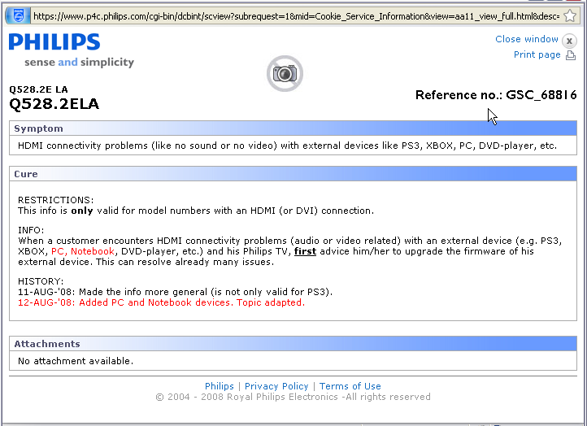  Figure 43: AA11 doctype - Standard view template  </RD-P4C-OLEE-0110>

☞ | <RD_P4C_OLEE_0120  section=”OLEE”  title=”ViewFormat”  subtitle=”AA12-Standard”  >  The display of an OLEE in Application Area 12 (Public FAQ) holds the following items:  - The translated CTN description  - the CTN  - The translated Problem Area description  - The translated label for ‘Question’  - The translated question  - The translated label for ‘Answer’  - The translated answer  - If there is an attachment a translated label for ‘Attachments’  - A table with the following column headers:  - translated label ‘Language’  - translated label ‘File size’  - translated label ‘File date’  - translated label ‘File name’  - This table holds per rule an attachment with:  - the translated language description (if a language is defined)  - the file size in MB  - The date in format yyyy-mm-dd  - A file type image and the original file name (file name during upload). This file has a hyperlink that will open the file with the original filename by using the get-script with parameters ‘url’ and ‘ofn’ (please refer to the functional specs for the Get-script).  Here is a screen shot of an FAQ with an attachment:  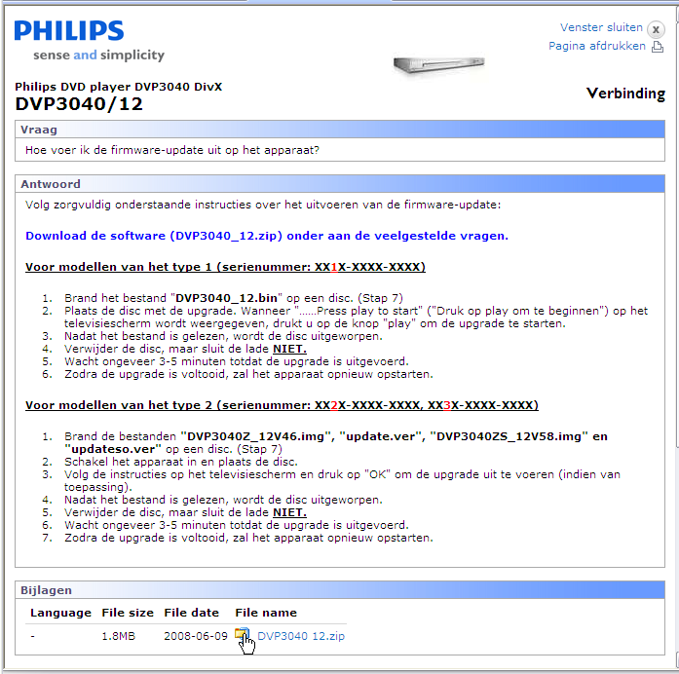  Figure 44: AA12 doctype - Standard view template  When there is no attachment the attachment box is not created.  </RD_P4C_OLEE_0120>

☞ | <RD-P4C-OLEE-0130  section=”OLEE”  title=”ViewFormat”  subtitle=”AA13-Standard”  >  </RD-P4C-OLEE-0130>

☞ | <RD-P4C-OLEE-0140  section=”OLEE”  title=”AttachmentBox”  >  The attachment box is the same for AA11 and AA12. For AA13 there is never an attachment box (the attachments are the Flash of Flash movie file).  The attachment box contains the files uploaded for an OLEE as an attachment.  If there are no attachements, but the attachment box is shown, the box will contain a transated message there are no attachments. See the screen shot below:  Figure 45: Attachment box with no Attachment message  If there are attachments the box will be displayed and will hold the following items:  - A translated label for ‘Attachments’  - A table with the following column headers:  - translated label ‘Language’  - translated label ‘File size’  - translated label ‘File date’  - translated label ‘File name’  - This table holds per rule an attachment with:  - the translated language description (if a language is defined)  - the file size in MB  - The date in format yyyy-mm-dd  - A file type image and the original file name (file name during upload). (for the link please refer to the functional specs in this section for links to external files in an OLEE).  Below a screen shot of an attachments box with attachments:  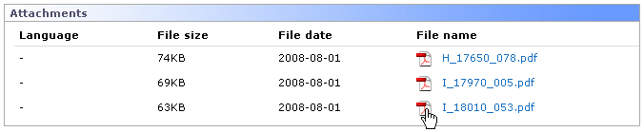  Figure 46: Attachment box with attachments  </RD-P4C-OLEE-0140>

☞ | <RD-P4C-OLEE-0150  section=”OLEE”  title=”Inline images”  subtitle=”procedure”  >  The text for the answer/cure can contain images for OLEE’s in Appl. Area 11 and 12 (for OLEE’s in Appl. Area 13 the answer/cure is not used). The images are not physically in the XML, but a reference to the physical file is available. Each in-line image also has an ID that is also found in the text where the image should appear.  When building the HTML for the OLEE the text is scanned for a string between 2 @-symbols. If this string coincides with an in-line image ID an IMG-tag is created with a URL to the image. For creation to the URL’s to external files please read the functional spec for creating links to external files in this section.  </RD-P4C-OLEE-0150>

☞ | <RD-P4C-OLEE-0160  section=”OLEE”  title=”externalFiles”  subtitle=”createLink”  >  Files specified in the XML for an OLEE are files attached to this OLEE, either as attachment or as in-line image. The path and filename in the XML-file are to the physical file, defined from the document root. This URL is not available for end users and the URL needs to be mapped to an accessible URL.  For Public OLEE’s a symbolic link is available for the file. The URL found in the XML-file is used to search for the symbolic link in the OLEE-Attachments table.  For Restricted OLEE’s a version of the Get-script is used, the sGet-script. This sGet-script will test the authorization cookie and deliver the file with the original filename. The check that is done must check if the user is authorized for the doctype of the OLEE.  </RD-P4C-OLEE-0160>

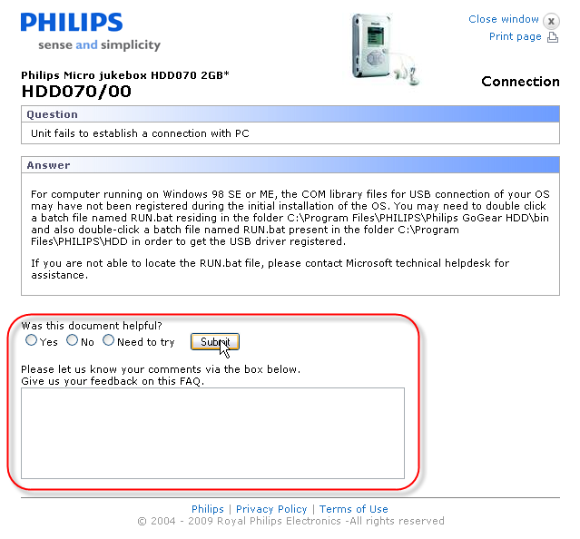
Figure 47: Feedback on teh FAQ page

Feedback
The feedback script used in the FAQ’s uses data from the parameter ‘pars’ to save extra call center information to the feedback data written to symcure_log.

For feedback a script is available that will write the feedback information on the P4C servers. This script can be called from the page with the data to be written and a base filename to write the data in. The script will check the domain where it is called and check the domain against a list of authorized domains.

Currently the feedback option is available in the FAQ’s.

☞ | <RD_P4C_OLEE_0170  section=”Feedback”  title=””  subtitle=””  >  The standard template for Application Area 12 (see RD_P4C_OLEE_0120) has a feedback form included (see RD_P4C_FEEDBACK_0100).  The feedback form in this template has the following fields:  - ctn log_01product  - scy log_02country  - slg log_03language  - tmp log_04site  - dct log_06dct  - refnr log_07refnum  - SR_NUM log_08sr_num  - session log_09session  - searchtxt log_10searchtxt  - rating log_11rating  - feedback log_12freeText  </RD_P4C_OLEE_0170>

Feedback script
The feedback script is used to catch user feedback and write this feedback to a file on the server.

☞ | <RD_P4C_FEEDBACK_0100  section=”Feedback”  title=”implemenation”  subtitle=”formVariables”  >  For feedback purposes user data has to be captured in certain situations. This functionality must be available based on a standard web form. In the web form the following parameters need to be present to create a feedback item on the P4C server:  - ctn CTN  - dct Document type  - slg Language  - scy Country  - donotlog_log Logfile filename  - donotlog_logdir Logfile directory  - log_nnxxxx Log entries for the record to be logged  The records will be stored in a (text) file on the server. The path and filename will be determined in the donotlog-fields. The starting point of the path is defined in the script. The ‘..’ to rise in the directory structure is filtered out.  The items that start with ‘log_nn’ will be logged, where ‘nn’ is the number that will determine in what order the fields will be in the record. Also empty fields will create a (empty) column in the record.  </RD_P4C_FEEDBACK_0100>

Interfaces
The Product Support pages use a number of interfaces. For an overview of interfaces please refer to the document on Interfaces ‘Total list of interfaces systems Migration P4C-ATG.doc’. Some of these interfaces are already described above, but others that relate directly to the Product support page and are necessary for the web site to function properly are not.
To function properly the product support site needs the following interfaces:
- Nr. 3 - deployment of content, metadata and configuration (mind that this deployment also has some processing to make files publically available)
- Nr. 23 - Deliver parameter data to Metrixlab (scy and slg, maybe some others)
- Nr. 73 - Data for reporting cubes in Cognos is extracted from the web server log files.

Interface nr. 3: Content deployment
All data described in the data model in the Appendix is delivered by the CCR in interface nr. 3. This set of content files, metadata files with data on products and documents, and configuration files is an integral set which should not be ripped apart to guard the integrity of the data set.

Interface nr. 23: MetrixLab integration

Interface nr. 3: Reporting data
For reporting on the Product Support page the web server log files (access_log and ssl_access_log) from all servers running the Product Support page are processed and the data is sent to Cognos to create a number of Reporting Cubes. The process that handles the web server log files is running on the CCR (nlvu052) and retrieves the log files of all P4C servers before processing them.
On the web servers the log files are rotated at midnight (server time; time zone is EST). Half an hour later the process to fetch the files is started.

Also for Free-text reporting the user feedback is

Appendix

Data model
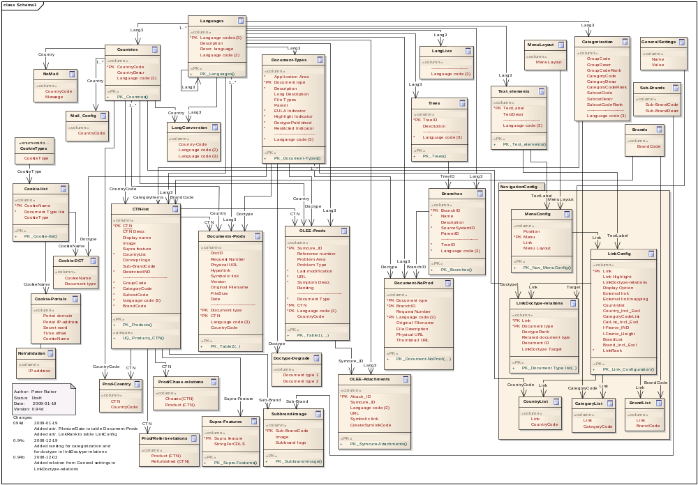

Links to P4C
From a variety of sources links exist into the Product Support Pages or to documentation.

Siebel
Link from Siebel are:
- Direct links to the Manual (DFU)
- Direct links to the Leaflet (PSS)
- Link to the Product Support page with the FAQ’s
- Link to the Product Support Page with the Call Center Scripts
- Link to the Product Support Page

Siebel data
Siebel will add a variable (containing several data element; e.g. the Service request number) to the URL to P4C. These variables need to flow through the pages to be delivered to the FAQ. When an agent sends feedback in the feedback box in the FAQ the values are placed in the feedback data. This data is gathered by the process that generates the data for Cognos reporting. Cognos uses this data to create the FAQ/Feedback reporting (free-text reporting)

The URL’s to the FAQ-list’s and the Productt Support Site that are made available to the call centers by the CCR all end with the string ‘&pars=’. Siebel will add the data elements to this string is a predefined format. Each name/value pair is divided by a colon and prefixed with the string ‘,VARSET=’.

Example:
,VARSET=SR_NUM:50-304135922,VARSET=AGENT_LOGIN:EUSEURT,VARSET=AGENT_ID:1E-1V08AV,VARSET=ACTIVITY_ID:1E-512OS4

Since the value is parameter ‘pars’ will hold the equal sign (‘=’) care has to be taken when processing this parameter to pass it on.

Call Centers China, and India
The Call Centers in China and India do not use Siebel, but have the same links as Siebel has. It is not know if they add the Call Center data described in 6.2.1.1.

Reporting
Reporting for the Product Support page is done both in Omniture and in Cognos.

The reporting in Cognos for Free-Text-Reporting (the feedback on FAQ’s) is a necessary report, since this feedback is used to maintain the FAQ’s.
Next to this also the downloads report is important. This report creates an overview of the number of downloads (dimensions are Financial structure, document type, etc.)
To create these reports Cognos needs to be fed some text files with aggregated data from the servers running the Product Support pages and OLEE. This data is retrieved from the web server log files and the log files for the feedback. The process to retrieve the relevant data uses the URL and the parameters in the URL.

The list of web-user doctypes is necessary to be able to show the restricted documents for web-users when the user does not have a cookie set, e.g. the gracenote database. This is the To-Be situation. In the current P4C code this step is skipped).

