# **Automated Tendertexts: set-up in STEP**

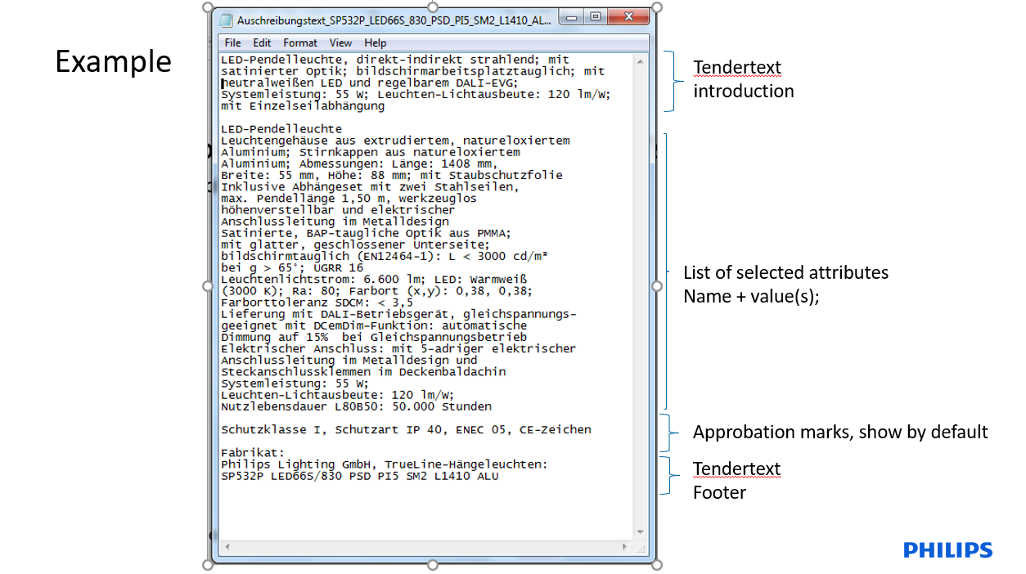

Instructions were done on MCM B2B QA, for GB

Product used for writing instructions:

* FP-910504101203, SP480P LED35S/840 PSD ACC-MLO SWZ SM1.
* Belongs to COMF-1705295, SmartBalance Suspended, SpaceWise

Leaflet of this product:



# **Instructions Workbench**

Tendertext can be set-up in the Workbench, by Central Data Management, or in the WebUI, by Local Editors.

## Step 1: Set-up the footer text

1. Select the right context to work in (Global English or a local context)
2. On the highest node of the Product Maintenance tree, you can set-up the footer text for the tendertext, which will be used as default for all tendertexts in a certain locale. E.g. “Signify, <http://www.lighting.philips.co.uk>”. This text can be overwritten for a certain Final Product if needed.

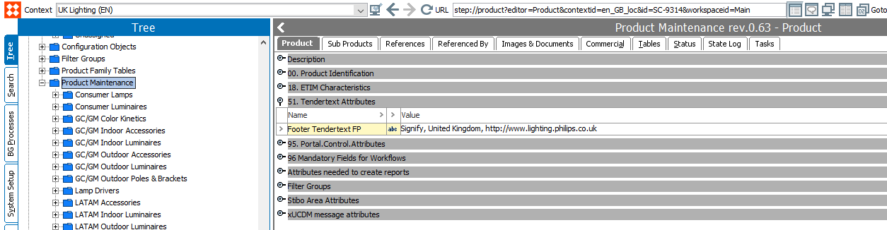

## Step 2: Introduction text and attribute selection

You can do this in Global English, in that case the introduction text will be included in the translation of the commercial family, for all countries where this Commercial Family is used.

The selected attributes are country dependent, so you can select them in Global English, to make sure this works for the entire world, or select them in the local context, to create a list only for a particular country. Also, you can overwrite the global list with a local version if needed.

1. Select the right context to work in (Global English or a local context)
2. Go to the primary Commercial Family of the Final Product that you want to generate a tendertext for
3. Enter an introduction text for the tendertext
4. Select the attributes you want to show in the tendertext file  
   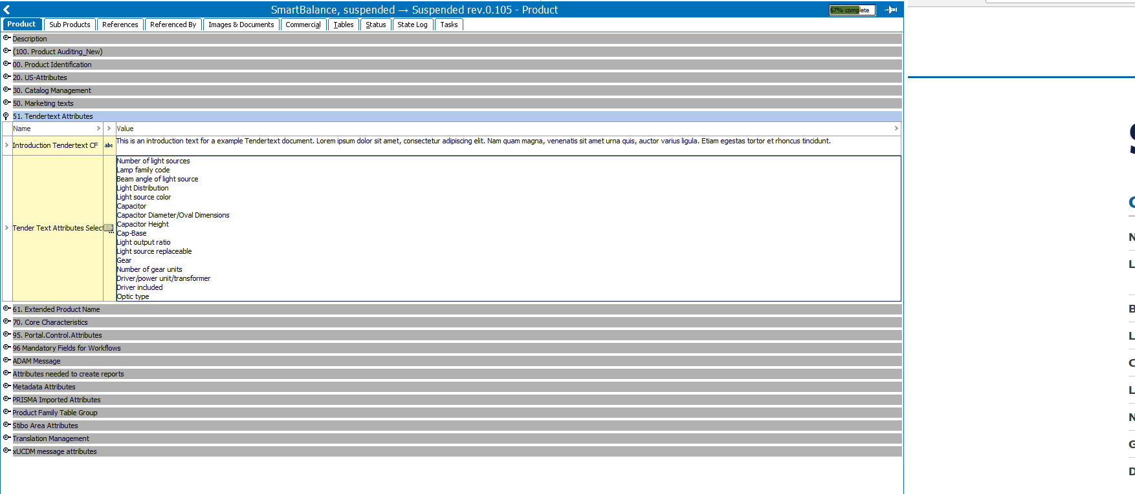
5. Approve the CF.
6. If you want to use the same text or list for multiple CFs you can just copy-paste the text or the list of attributes from one CF to another, so there is no need to re-select the entire list for the second CF.

## STEP 3: Introduction text and attribute selection

1. Open the related Final Product that you want to publish the tendertext for
2. Check the content:  
   **Introduction text:** If you want to change it you can use the field “Introduction Tendertext FP” to overwrite the text added to the family, and create a specific tendertext for this product only. **List of Attributes:** If you want to change the list of attributes for this specific FP, you can make a new list in the “Tender Text Attributes Selection List FP” field. *Tip*: If the list is mostly the same as the one from the CF, go back to the Primary CF, copy the values from that attribute list, and paste those in the attribute of the FP. You can then update that list (add/remove attributes).

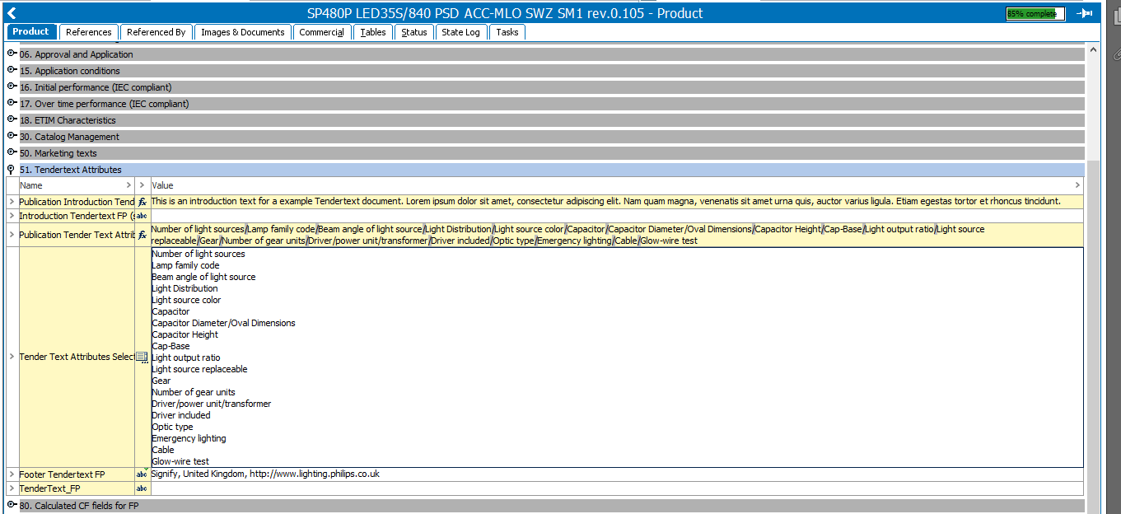

1. Approve the Final Product

## STEP 4: Processing of the tendertext content

1. The tendertext content will be included in the overnight export to STEA, our middleware system. There the generation of the tendertext file will be done.
2. When the file is generated, it will be stored in ADAM
3. ADAM then sends the information back to STEP, so the FP in STEP knows there is a tendertext generated for it
4. When the tendertext file is linked to the product in STEP, the information is exported to the website and published.

## Result:

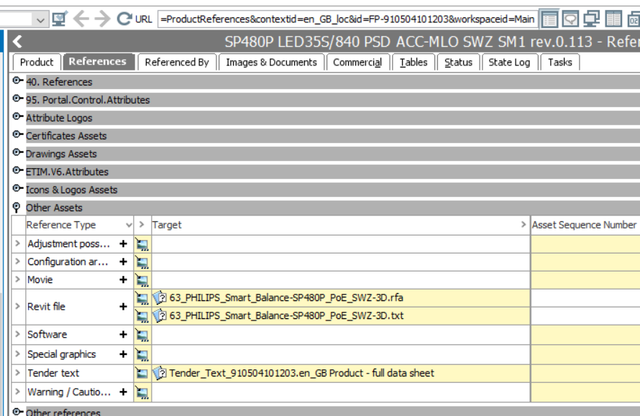

In SAL:

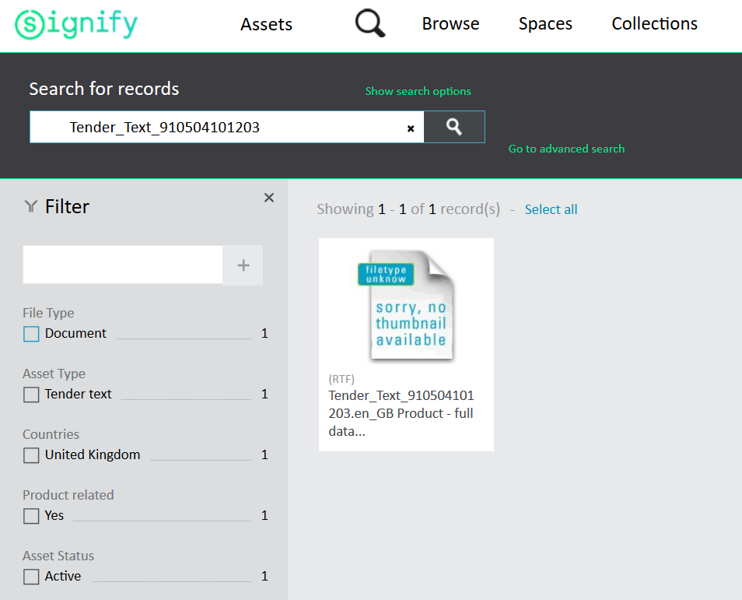

File: 

## WebUI:

Search for product, see tab “Tendertext”.

Global Portal:

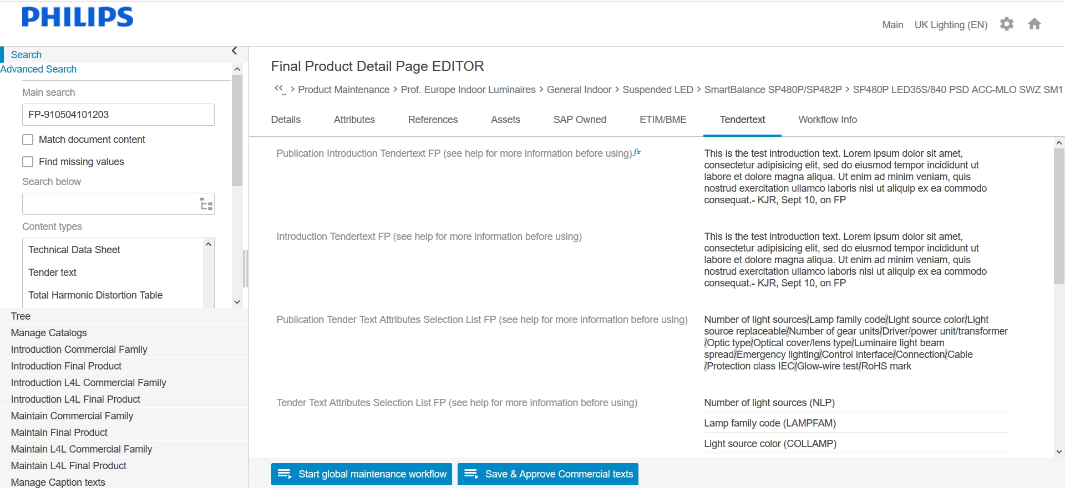

Changed can be made via the Maintenance workflow, but you cannot edit all fields:

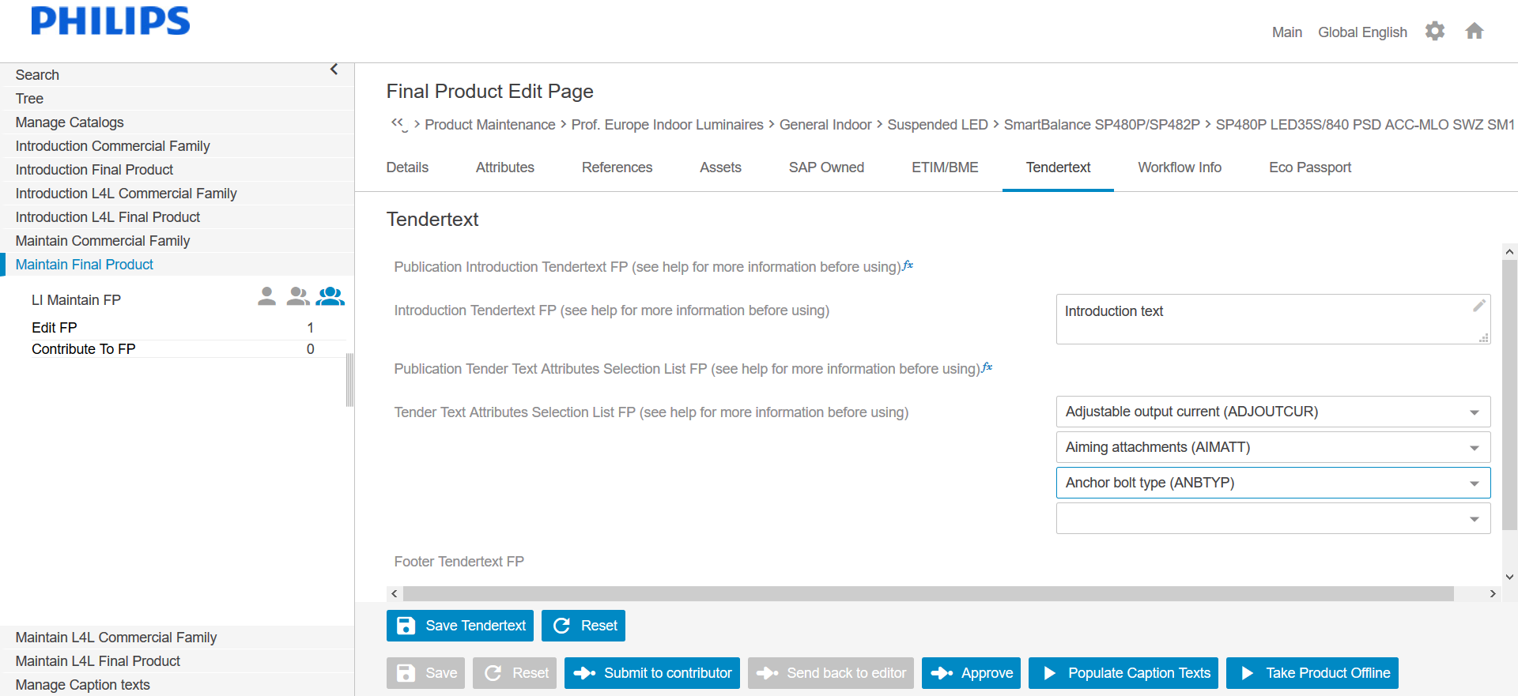

* Show fields of CF (introduction text, attributes), like in Workbench
* Make Footer editable. (Should be entered on high level, but you should be able to overwrite it here)

Local Portal:

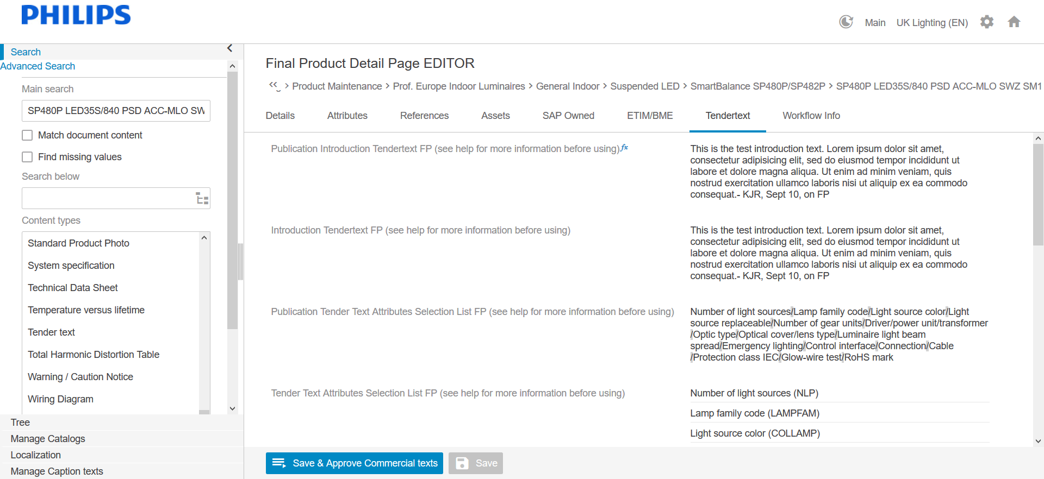

Edit via [TBD]

File itself is on tab Assets > Other > Tender text

