Bùi Việt Hoàng – 1CC

ID:2201140031

REPORT OF COMPLETION

1. Create a website, decorate your html using css and submit your assignment on time.

Make sure that you follow Universal design

* Color scheme : [Glacier Gradient Color Scheme » Blue » SchemeColor.com](https://www.schemecolor.com/glacier-gradient.php)
* Font size :14-50px
* Layout :Header, Main content. Footer

=> DONE

2. Mobile-friendly: State your site is mobile-friendly:

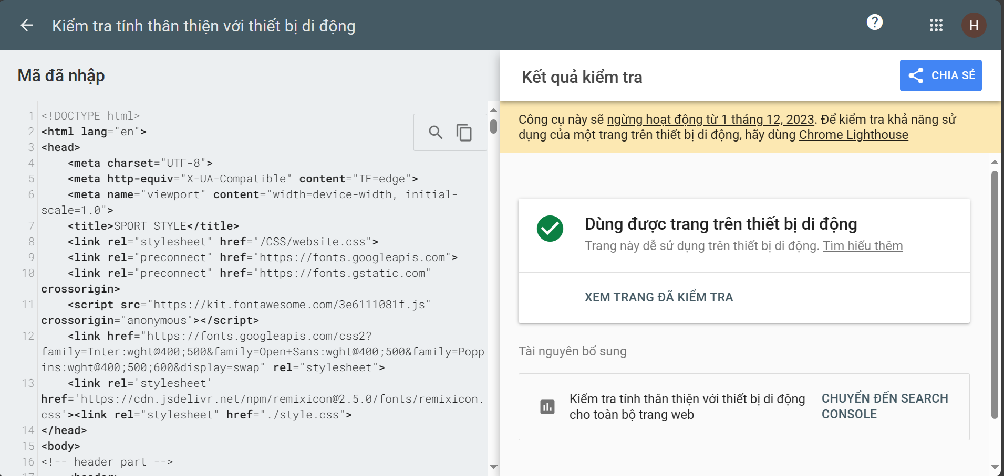

=>DONE

3. Responsive: Make sure your site working well on different resolutions, by pressing F12 from your browser, you can check your responsiveness or go to <http://responsivetesttool.com/>

* Iphone
* Desktop
* Laptop
* Ipad
* Android …

=>DONE

4. Accessibility: make sure your site is for targeted audience and is assessible by as many users of possible (the young, the elderly, the disabled people....). (All links in your site can be accessed/focused by tab button on the keyboard).

=>DONE

5. Make sure your site is standardized: <https://jigsaw.w3.org/css-validator/>

U[se](https://lms.fit.hanu.vn/mod/resource/view.php?id=6203) creative common photos, cite your photos.

* Photos: Link.
* If photos are yours, state that.

=>DONE

