* Hoang Bui [bvhoang91@gmail.com](mailto:bvhoang91@gmail.com)

1. Configuration

Please add main directory (include stdax.h), In this case, I add ./ directory. If not, you must to add full path when include “stdax.h” at all AlliedUI-file. I add src/AllicedUI too, It allow me include AlliedUI-file at AlliedUITest without directory.

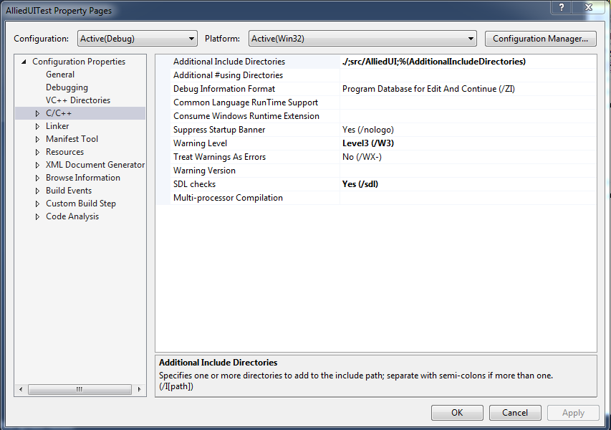

1. File
   * AlliedUI.h/cpp class AlliedUI inherit from CWnd
   * AlliedUIUtil.h/cpp support funcs.
   * AllicedUIDefile.h Defile structures.
   * Defile.h Defile something else, (remove if not necessary)